The Government of the Republic of Zambia
Enhancement of the Electronic Government Procurement System - CR16

End user Administrator Manual
Issue 01
Version 1.0

EUROPEAN DYNAMICS S.A.



Modification History

Date | Version | Author | Comments
21/10/2024 | 1.0 | ED | Initial version

Table of Content

1 Minimum and Recommended System Requirements 10
2 General Functionality 11
2.1 General Usage Guidelines 11
2.2 The Tender Menu Functionality 12
2.3 Main Page 13
2.3.1 Login Section 13
2.3.2 Search Section 14
2.4 Login to the System 14
2.5 Login to the System for the First Time 16
2.6 Logout from the Platform 17
2.7 Password Recovery 17
2.8 Maintenance of User’s Profile 19
2.9 XLS File Format Support 22
2.10 XLS File Upload Validation 22
3 Searching Functionality 23
3.1 Simple Search 23
3.2 Advanced Search 24
3.3 Latest Tenders Search 27
3.4 CSV Export 28
4 Procuring Entity Management 29
4.1 Register PE 29
4.2 Edit Organisation Details 32
4.3 View the Users Belonging to the Procuring Entity 33
4.4 Insert a New User in a Procuring Entity 34
4.5 Edit user’s details. 35
4.6 Login Notifications 37
5 Unlocking user accounts 39
6 Approving registrations 41
7 Manage Administrators 44
8 Supplier Registration 47
8.1 Add Supplier User 51
8.2 Edit Supplier Organisation 53
8.3 Download Supplier Registration Certificate 55
8.4 Edit Supplier user 55
8.5 Synchronise with OSSIS database 57
9 Auditor, Appeal and Attorney General Users 58
9.1 Auditor General Authority 58
9.2 Add Auditor General User 59
9.3 Edit Auditor General User 61
9.4 Appeal Body Authority 62
9.5 Add Appeals Body User 63
9.6 Edit Appeals Body User 65
9.7 Attorney General Body Authority 66
9.8 Add Attorney General Body User 67
9.9 Edit Attorney General Body User 68
10 System Properties 70
10.1 Manage Thresholds 70
10.2 Manage fees 71
10.3 Payment Reconciliation 73
10.4 Payments 74
11 Template Library 78
11.1 View Folder / Subfolder / Content 79
11.2 Create Subfolder 81
11.3 Edit/Delete Subfolder 83
11.4 Create Document 83
11.5 Edit / Delete Document 86
11.6 Create Dynamic Document 86
11.7 Search Template Library 87
12 Auditing 88
13 Configure Passwords 91
14 Manage Information Area 94
15 Contact us page 97
16 Manual Notifications 100
17 Contract Management 101
18 Online Chat 104

Table of Figures

Figure 1: Example of a table header 11
Figure 2: The Tender Menu (collapsed) 12
Figure 3: The Tender Menu (expanded) 12
Figure 4: Main page 13
Figure 5: Login panel 13
Figure 6: Search panel 14
Figure 7: User login 14
Figure 8: Wrong credentials 15
Figure 9: Confirmation email received during registration. 16
Figure 10: The transaction number 16
Figure 11: Confirmation of the user agreement 17
Figure 12: Logout functionality 17
Figure 13: Password recovery/change 17
Figure 14: Email containing a registration transaction and unique access link 18
Figure 15: Resetting the password 18
Figure 16: Edit user’s profile option 19
Figure 17: Edit User’s Profile 20
Figure 18: Password Configuration Rules 21
Figure 19: Simple Search Option 23
Figure 20: Simple search for Tender 24
Figure 21: Advanced search option 24
Figure 22: Advanced search for a Tender 25
Figure 23: Advanced search for a Procuring Entity 25
Figure 24: Advanced search for a Supplier organisation 26
Figure 25: Advanced search for Procuring Entity users 26
Figure 26: Advanced search for Supplier users 26
Figure 27: Advanced search for a contract 27
Figure 28: Advanced search for an annual procurement plan entry 27
Figure 29: Latest Tender search 27
Figure 30: Register PE option 29
Figure 31: Register PE –Step 1 29
Figure 32: Register PE - Step 2 30
Figure 33: Register PE - Step 2 31
Figure 34: Management of Procuring Entity details 31
Figure 35: Editing Organisation details 32
Figure 36: View user option 33
Figure 37: Display of users belonging to the procuring entity. 33
Figure 38: Insert a new user in a procuring entity 34
Figure 39: Editing user details 36
Figure 40: Login notifications 37
Figure 41: Login notifications administrator action confirmation e-mail 37
Figure 42: Login notification e-mail 38
Figure 43: Account activation for a user 39
Figure 44: Account activation, preview user details 40
Figure 45: Account activation 40
Figure 46: Pending registration option/ list of registrations 41
Figure 47: Approve specific Supplier 42
Figure 48: Pending supplier registration payment 42
Figure 49: Approve pending registration 43
Figure 50: Administrators panel, Manage administrators 44
Figure 51: System administrators list 44
Figure 52: Registration of a system administrator 46
Figure 53: Register Supplier link 47
Figure 54: Register Supplier - Step 1 48
Figure 55: Register Supplier - Step 2 49
Figure 56: UNSPSC code selection 49
Figure 57: Register Supplier - Step 3 50
Figure 58: Add Supplier user link 51
Figure 59: Add Supplier user 52
Figure 60: Edit supplier organization link 53
Figure 61: Edit supplier organization 54
Figure 62: Download supplier registration certificate 55
Figure 63: Edit supplier user profile 56
Figure 64: Synchronize suppliers with OSSIS 57
Figure 65: Start OSSIS synchronization 57
Figure 66: Auditor General Authority menu selection 58
Figure 67: View Auditor General Authority organization details 58
Figure 68: View Auditor General users link 59
Figure 69: List of Auditor General Body Authority users 59
Figure 70: Add Auditor General Authority user 60
Figure 71: Edit Auditor General Authority user profile 61
Figure 72: Appeal Body Authority menu selection 62
Figure 73: View Appeal Body Authority organisation details 62
Figure 74: View Appeal Body Authority users link 63
Figure 75: List of Appeal Body Authority users 63
Figure 76: Add Appeal Body Authority user 64
Figure 77: Edit Appeal Body Authority user profile 65
Figure 78: Attorney General Body Authority menu selection 66
Figure 79: View Attorney General Body Authority organisation details 66
Figure 80: View Attorney General Body Authority users link 67
Figure 81: List of Attorney General Body Authority users 67
Figure 82: Add Attorney General Body Authority user 68
Figure 83: Edit Attorney General Body Authority user profile 69
Figure 84: Manage Thresholds menu option 70
Figure 85: Manage Thresholds – Select Procurement Type 71
Figure 86: Manage Thresholds for a specific procurement type (i.e Works) 71
Figure 87: Manage fees menu option 72
Figure 88: Manage system parameters 72
Figure 89: Payment reconciliation menu option 73
Figure 90: Update payment status 73
Figure 91: Payment reconciliation failure 74
Figure 92: Payments option menu 75
Figure 93: Payments search criteria 75
Figure 94: Payments results 77
Figure 95: Export as CSV option 77
Figure 96: Template library link 78
Figure 97: View template library root folder 78
Figure 98: View folder / subfolder links 79
Figure 99: View Root folder details (1) 79
Figure 100: View Root folder details (2) 80
Figure 101: View Folder Contents Link 80
Figure 102: View Folder Contents 81
Figure 103: Create Subfolder under the root folder 82
Figure 104: Create Subfolder Link 82
Figure 105: Create Subfolder page 83
Figure 106: Edit/delete Subfolder link 83
Figure 107: Create document link 84
Figure 108: Create document page 84
Figure 109: Procurement method drop-down field 85
Figure 110: Copied draft document from Template Library 85
Figure 111: Edit / Delete document links 86
Figure 112: Dynamic Document Parameters 86
Figure 113: Template Guide link 87
Figure 114: Search Template Library link 87
Figure 115: Search Template Library Parameters 87
Figure 116: Administration drop-down menu, auditing reports 88
Figure 117: Auditing activities 89
Figure 118: Auditing report 90
Figure 119: Administration drop-down menu, Configure passwords 91
Figure 120: Configure passwords, uppercase/lowercase letters configuration 92
Figure 121: Configure passwords, numbers, other characters and parameters configuration 93
Figure 122: Information drop-down menu, Manage Information Area 94
Figure 123: Displayed information 94
Figure 124: Management of information area 95
Figure 125: Upload a News item 95
Figure 126: Information area, list of news items 96
Figure 127: Manage contact us details option 97
Figure 128: Manage contact us details page 98
Figure 129: Select Save option 99
Figure 130: Select cancel option 100
Figure 131: Send manual notification option 100
Figure 132: Send manual notification page – Send notification button 101
Figure 133: PE Contracts option 101
Figure 134: PE Contracts page 102
Figure 135: Contracts details page 103
Figure 136: Associated Contract Managers option 104
Figure 137: Associated Contract Managers page 104
Figure 138: Select CAS button – SA Access to chat functionality 105
Figure 139: Chat in progress - View conversation list 105
Figure 140: Answer message 106
Figure 141: Revert Button 106
Figure 142: Provide New Submission Deadline 107
Figure 143: Tender status upon selecting the “ok” button 107
Figure 144: Revert tender under cancellation 108

Table of Tables

Table 1: Pagination options 11
Table 2: Additional options 11

Acronyms / Abbreviations

Acronym / Abbreviations | Meaning
APP | Annual Procurement Plan
PE | Procuring Entity
PEHP | Procuring Entity Head of Procurement
PEPCO | Procuring Entity Chief Procurement Officer
PEPO | Procuring Entity Procurement Officer
CfT | Call for Tender
DB | Direct Bidding
ED | European Dynamics SA
EOI | Expression of Interest
e-PPS | European Dynamics electronic Public Procurement System
FA | Framework Agreement
FBS | Fixed Budget Selection
ITB | Invitation to Bid
LB | Limited Bidding
LCS | Least Cost Selection
LSI | Limited Selection
MT | Mini Tender
OBI | Open Bidding International
OBN | Open Bidding National
OSI | Open Selection International
OSN | Open Selection National
PO/ES | Procurement Officer / Evaluation Staff (member of the evaluation committee)
PO/ESR | Procurement Officer / Evaluation Staff Responsible (leader of the evaluation committee)
PO/OS | Procurement Officer / Opening Staff (member of the tender opening committee)
PO/TC | Procurement Officer / Tender Coordinator (member of the coordination committee)
QBS | Quality Based Selection
QCBS | Quality-Cost Based Selection
RFP | Request for Proposal
RFQ | Request for Quotation
SA | System Administrator
SB | Simplified Bidding
SO | Supplier Organisation
TPIN | Tax Payers’ Identification Number
UNSPSC | United Nations Standard Products and Services Code
XLS | Microsoft 2003 Excel Spreadsheet
ZMW | Zambian Kwacha
ZPPA | Zambian Public Procurement Authority

Minimum and Recommended System Requirements

 | Minimum requirements:  Relatively recent Operating System (e.g. Windows XP or 7, or equivalent)  Office tools (e.g. MS Office support MS Word, MS Excel, or equivalent)  Email client (e.g. MS Outlook, or equivalent) with access to the end-user's mailbox  Browser: Internet Explorer (11 or higher), or Firefox (40 or higher), or Opera / Chrome / Safari (latest)  Session Cookies: enabled  Window Resolution: 1024 x 768  PDF viewer (e.g. Adobe PDF Reader, or equivalent)  Compression/decompression software (e.g. 7zip, winrar, or equivalent)  JavaScript enabled, for full end-user experience  Access to the Internet through HTTP/HTTPS  A valid e-mail address  Pop-up blockers disabled  Recommended requirements:  Windows 7, or above  MS Office 2003, or above  Email client (e.g. MS Outlook, or equivalent) with access to the end-user's mailbox  Browser: Internet Explorer (11 or higher), or Firefox (45.0.1 or higher)  Session Cookies: enabled  Window Resolution: 1024 x 768  PDF viewer (e.g. Adobe PDF Reader, or equivalent)  JavaScript enabled, for full end-user experience  Compression/decompression software (e.g. 7zip, winrar, or equivalent)  Access to the Internet through HTTP/HTTPS  A valid e-mail address  Pop-up blockers disabled

General Functionality

General Usage Guidelines

The procurement modules of the e-GP system will provide the following common navigation behaviour/functionality:

Tabular display. Any data displayed in tabular format will have a header which helps the user to navigate.

Figure 1: Example of a table header

The arrows are used for sorting the results (in ascending/descending order) by the corresponding field. The button  is used to hide/ show a number of fields in the table.
Any search query or list, with more than a page of results, will include the following navigation buttons.

Table 1: Pagination options
 | First Page
 | Last Page
 | Previous Page
 | Next Page

The following buttons are also widely used within e-GP.

Table 2: Additional options
 | Calendar Button. Selecting this button opens a calendar enabling the user to select a date
 | Search Button. Selecting this button opens a searching window enabling the user to search for various codes (e.g. UNSPSC codes)
 | Clear Button. This button clears the selection of the user

The Tender Menu Functionality
During the creation and manipulation of a tender, the Tender Menu contains all available choices to the user. The Tender Menu is collapsed by default.

Figure 2: The Tender Menu (collapsed)

If the user selects the Tender Menu, it will be expanded to show all available functionalities. The user can select any of the provided functionalities.
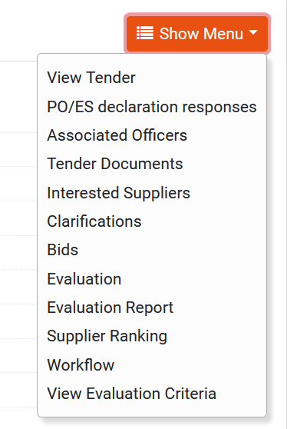

Figure 3: The Tender Menu (expanded)

Selecting the Tender Menu, again, will collapse it (Figure 2).

Main Page
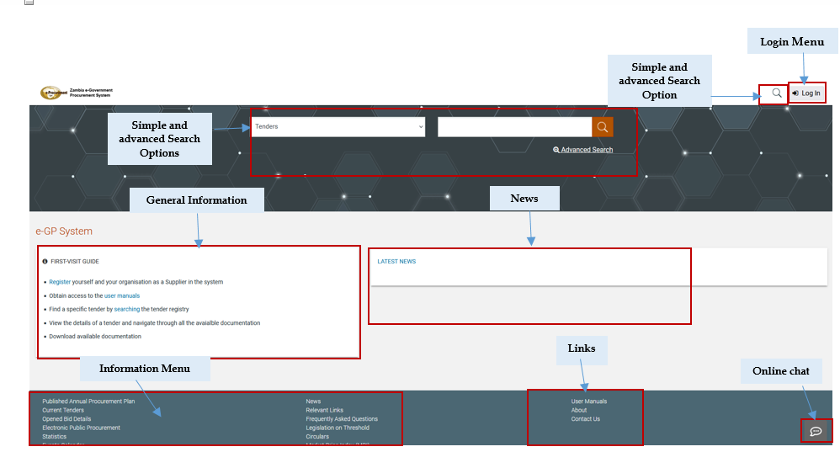
Figure 4: Main page

The main page of the e-GP system consists of the following elements:
- Top column, which contains the Login panel, Homepage Panel and Search option Panel.
- Central column, which contains general information regarding the system, the Suppliers and the users of the Procuring Entity as well as the “Register” button that supplier organization will be in position to self-register in the system. Furthermore, it lists any uploaded news about the system usage.
- Bottom column, which contains the Information menu panel, helpful links and functionalities which are available within all pages of e-GP. Additionally the aforementioned column contains the button for online chat that guest users will be in position to contact live with helpdesk users providing their requests.

The following are the most important sections within the main page.

Login Section
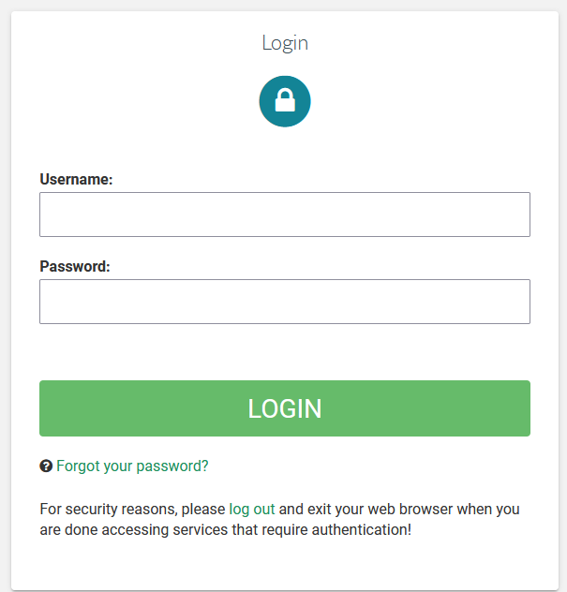
Figure 5: Login panel

In this section, functionality is provided to enable all users (Procuring Entity, Suppliers and Administrators) to login in the system providing that they use the correct credentials (username and password). Furthermore, functionality to recover a user’s password is included by selecting the “Forgot your password” option.

Search Section
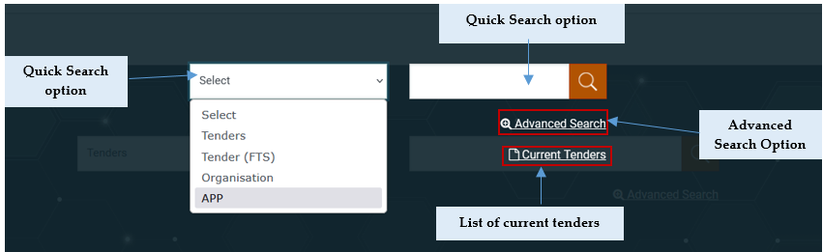
Figure 6: Search panel

The users can use this section to search for Tenders, Organizations, Users, Contracts and Annual Procurement and Disposal Plan entries. Advanced searching functionality, (by selecting the  button) is also provided (Figure 6). Finally, the users also can search for Current Tenders.

Login to the System
All users of the e-GP module should have an appropriate user name and password. In order for a user to login to the system, he must provide his/her credentials in the login section of the main page.

Figure 7: User login

If the user provides incorrect credentials (either user name or password) an error message will be displayed.

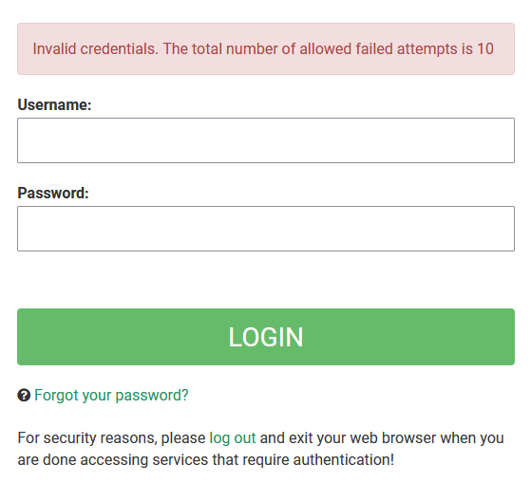
Figure 8: Wrong credentials

If the user provides an incorrect password for a username more than the allowed login failures (that is defined by SA user), his/her account will be temporally locked and a message will be displayed.

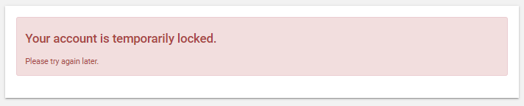

Login to the System for the First Time
The following steps are available, when the user logs in to access the e-GP services for the first time.
As a first step, the user will have to provide the transaction number (which is received by email after his successful registration on the platform).

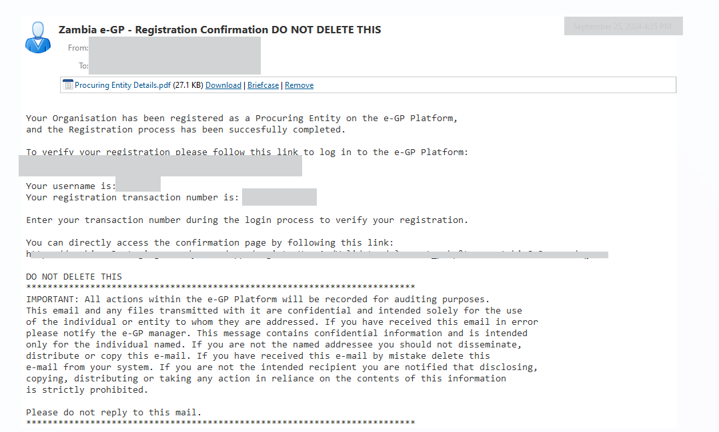
Figure 9: Confirmation email received during registration.

After providing his user credentials, the user is requested to provide the transaction number received during the registration.

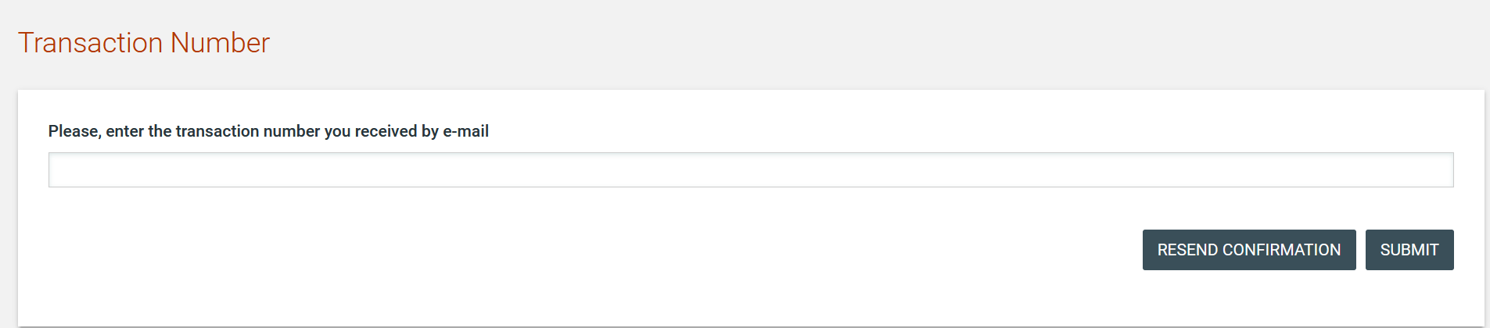
Figure 10: The transaction number

If the user has misplaced the e-mail with the transaction number, it can be resent to the registered e-mail address by clicking on the  button.

Finally, the user is prompted to read and accept the System User Agreement.

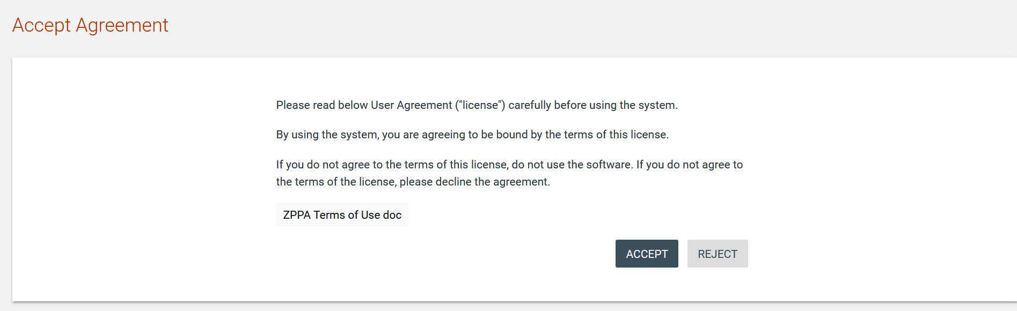
Figure 11: Confirmation of the user agreement

Logout from the Platform
The user can exit the e-GP services by selecting the “Logout” functionality.

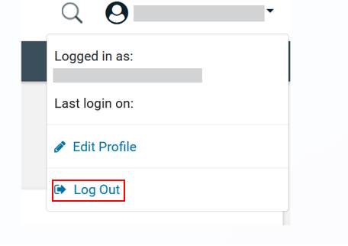
Figure 12: Logout functionality

Password Recovery
The user can recover his password from the “Forgot your password” functionality (Figure 5) available from the home page.

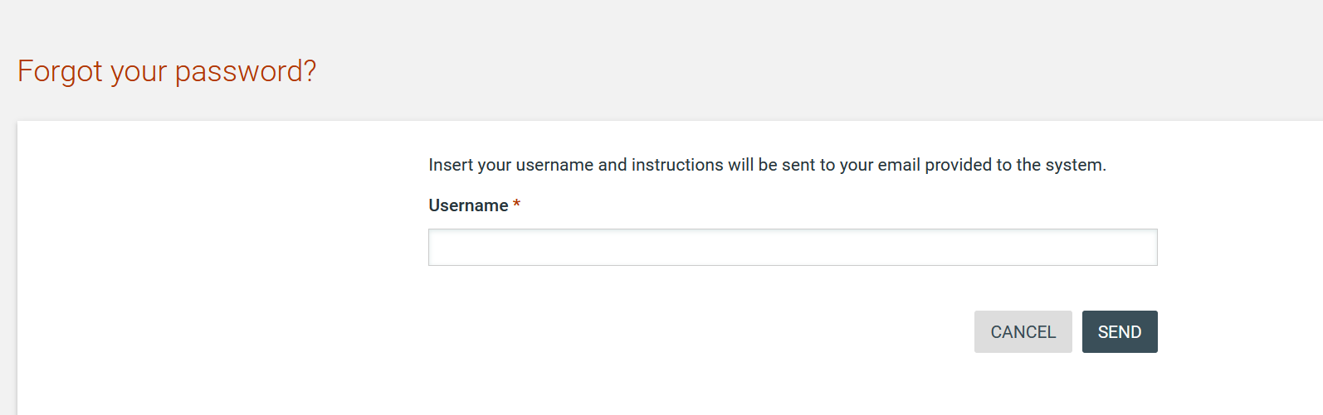
Figure 13: Password recovery/change

If the provided details are valid, the system sends an email to the associated address, containing a transaction number and a unique generated access link.

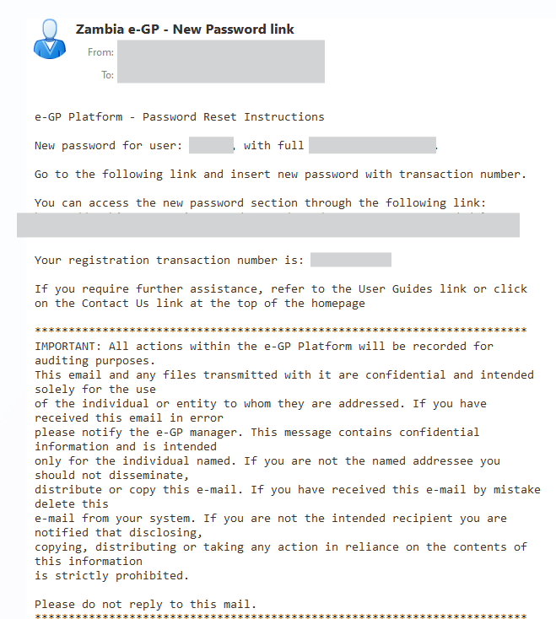
Figure 14: Email containing a registration transaction and unique access link

In order to reset the password, the user accesses the displayed link. To trigger the password reset functionality, the system requires the user to provide:

- New password
- Password confirmation
- Transaction Number
- Secret question response

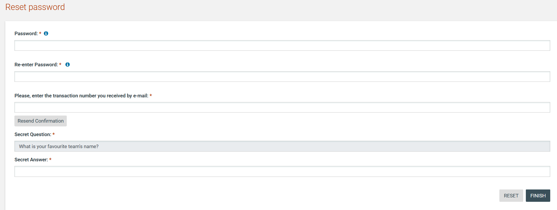

Figure 15: Resetting the password

Maintenance of User’s Profile
After successful authentication the user can edit their profile by selecting the “Edit Profile” functionality accessible from the right drop-down menu.

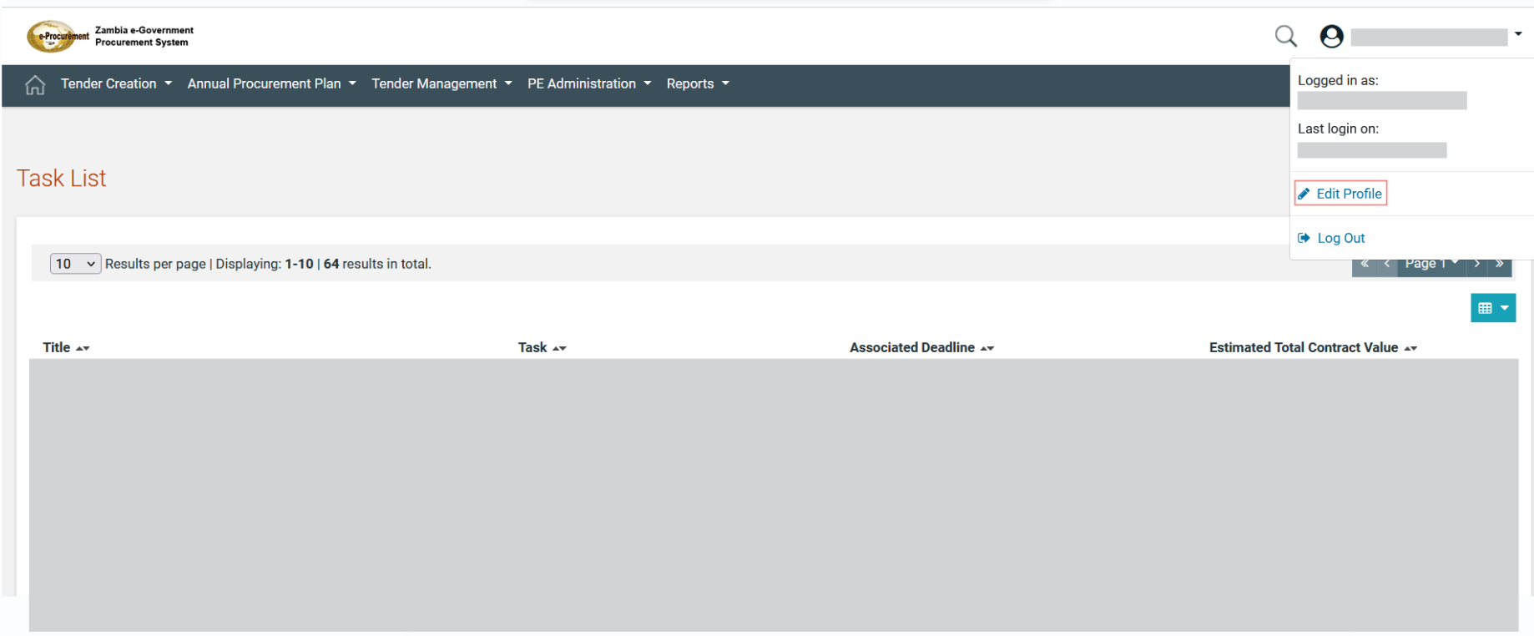

Figure 16: Edit user’s profile option

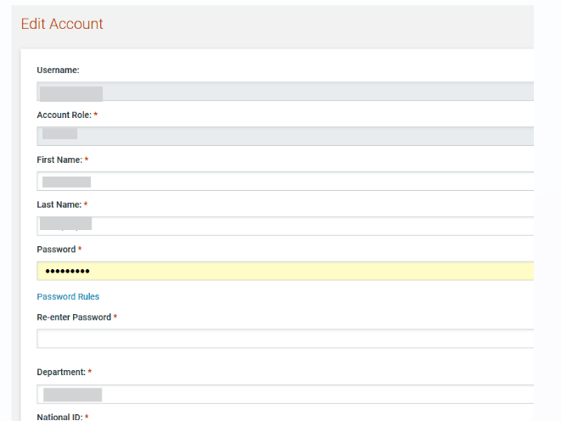
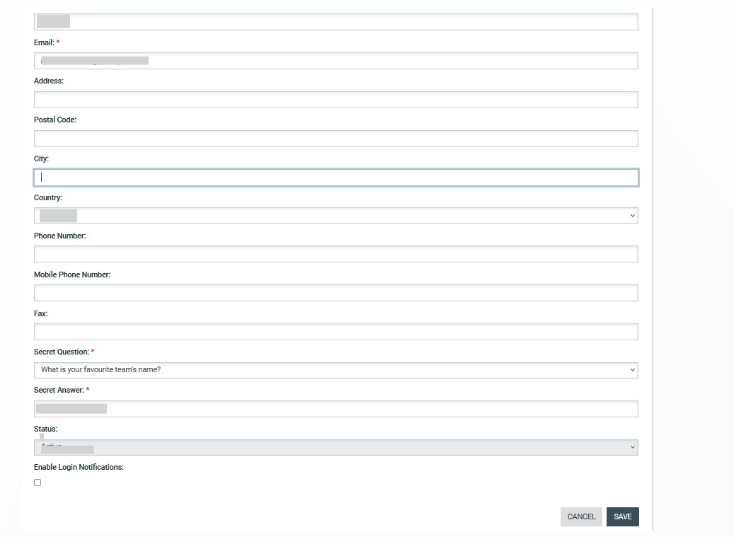

Figure 17: Edit User’s Profile

The password should follow a specific configuration. To view the password rules the user should click on the link “Password Rules” (Figures Figure 16 and Figure 17). The password configuration rules consist of:
- Letters (upper case/lower case) allowed to be used
- Numbers allowed to be used
- Characters allowed to be used
- Allowed login failures
- Password lifetime
- Password length (min/max)
- Password history
- Password strength (weak/normal/ medium/strong/ very strong)

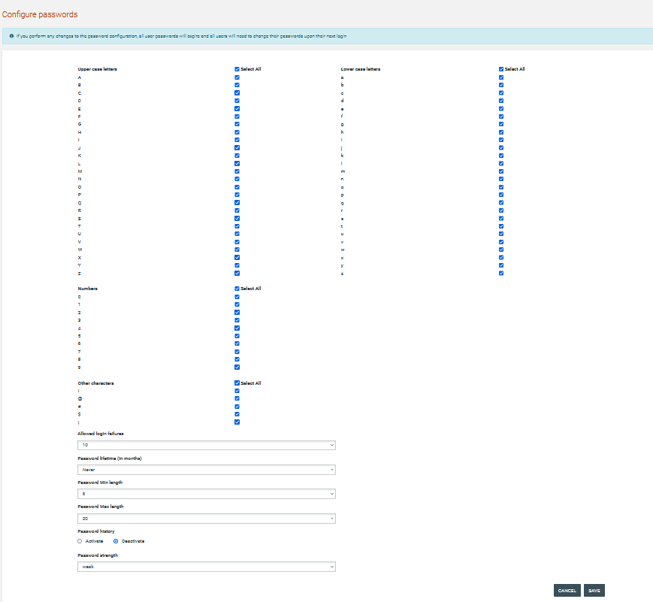
Figure 18: Password Configuration Rules

In case the password does not follow the password configuration the following message appears.

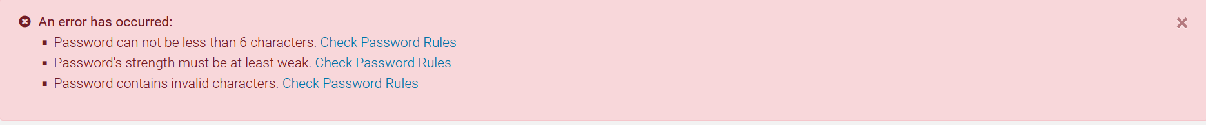

XLS File Format Support
All XLS files uploaded to the e-GP system must abide to the Microsoft Office Excel 2003 format.

 | All XLS files must abide to the Microsoft Office Excel 2003 format.  Users that have later versions should save their files in 2003 format (Save as type and select the option “Excel 97-2003 Workbook”).

XLS File Upload Validation
Every time a new XLS file is uploaded onto the e-GP system, the system performs validation checks to ensure that the uploaded file abides to the pre-defined template for the upload. There are several different templates supported by the system, namely:
- Annual Procurement Plan XLS
- Evaluation Report XLS

Whenever an invalid XLS file is uploaded onto e-GP, the system will either present to the end-user the reasons for not accepting it (e.g. invalid format), or will grant the end-user access to download an Error Report XLS, which details the precise reasons rendering the XLS invalid.

Searching Functionality

The e-GP system provides both Simple and Advanced search mechanisms. Both functionalities allow searching for Tenders, Organisations, Users, Contracts (available only to SA users) and Annual Procurement Plan entries.

Simple Search
The simple search functionality covers searching for available Tenders, registered Organisations, registered Users and published Annual Procurement Plan entries.

Simple search queries are performed by:
- Select the search icon  on the right side of the page
- Selecting the type of searching (Tenders, Organisations, Users, Contracts, Plan) from the selection list.
- Providing the full name of the required record or part of it using the “*” wildcard.
- Selecting the Search  button.

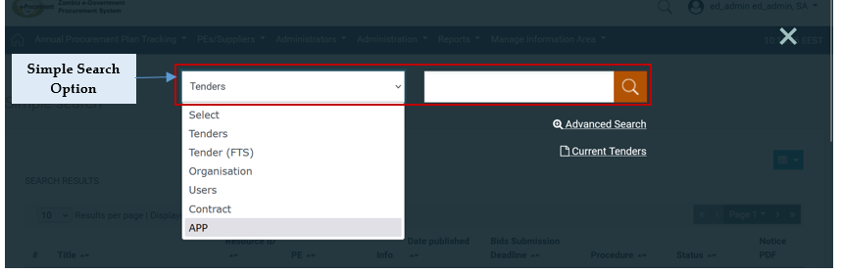
Figure 19: Simple Search Option

The results, if any, are then presented in a tabular form.

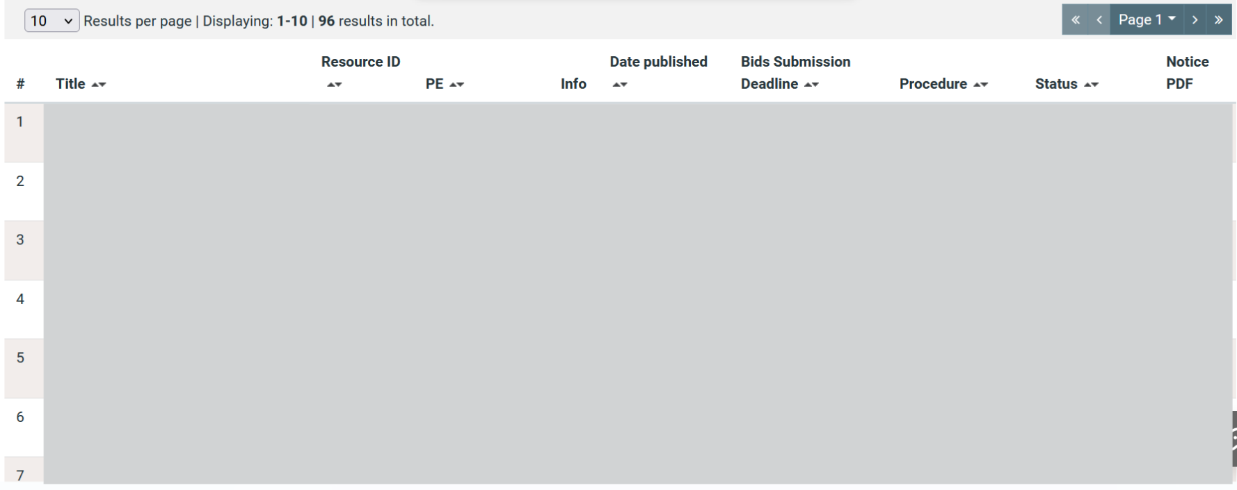
Figure 20: Simple search for Tender

Advanced Search
The advanced search functionality enables searching for Tenders, Organisations, Users, Contracts and Annual Procurement Plan entries. In addition, the functionality supports searching Organisations that fulfil a specific supplier profile. In order to perform an advanced search query, the user should:
- Select the search icon on the right side of the page
- Select the  advanced search button

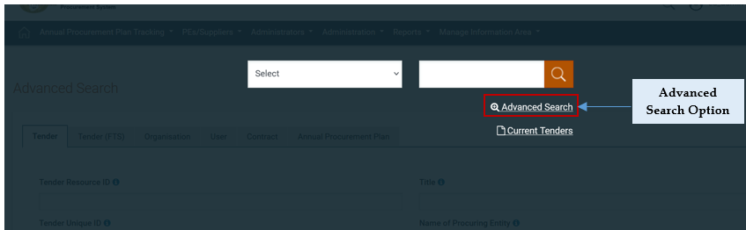

Figure 21: Advanced search option

- Select the type of the search by using the appropriate button
- Provide information in one or more fields (use of * wildcard is also enabled).
- Select the button “Search”

For further information on each criterion select the respective info icon 
The results, if any, will be presented in a tabular form.

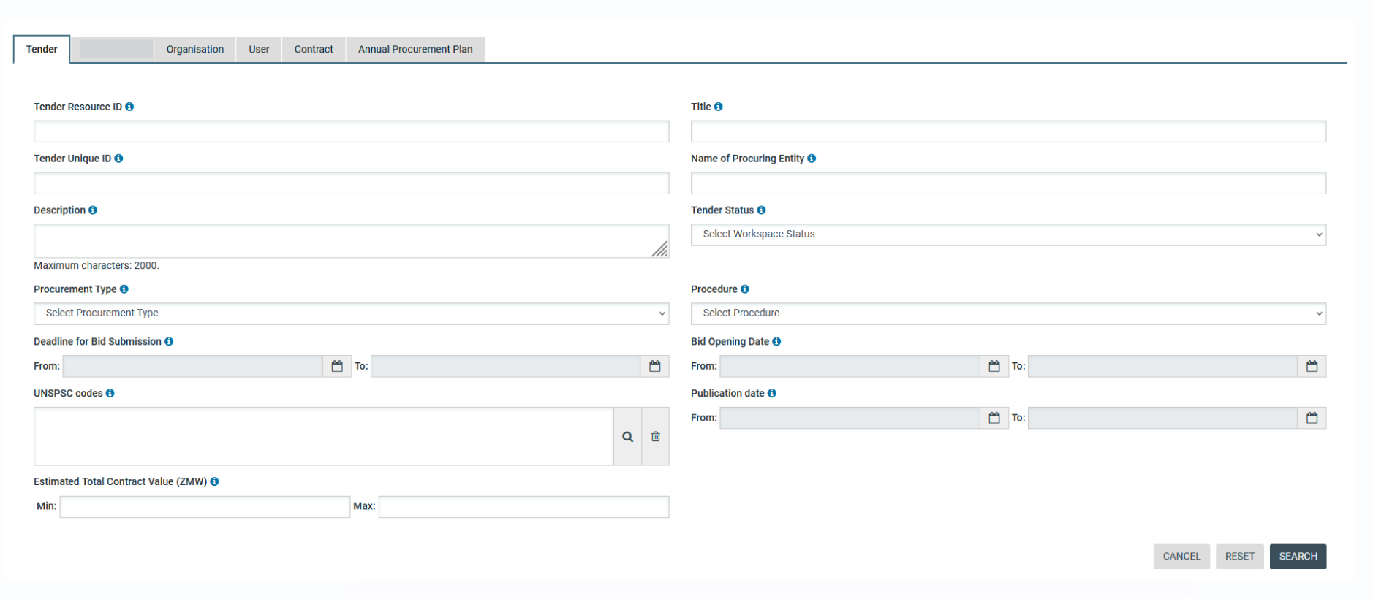
Figure 22: Advanced search for a Tender

In order to search for an organisation, the user needs to first provide the organisation type (Procuring Entity/ Supplier).

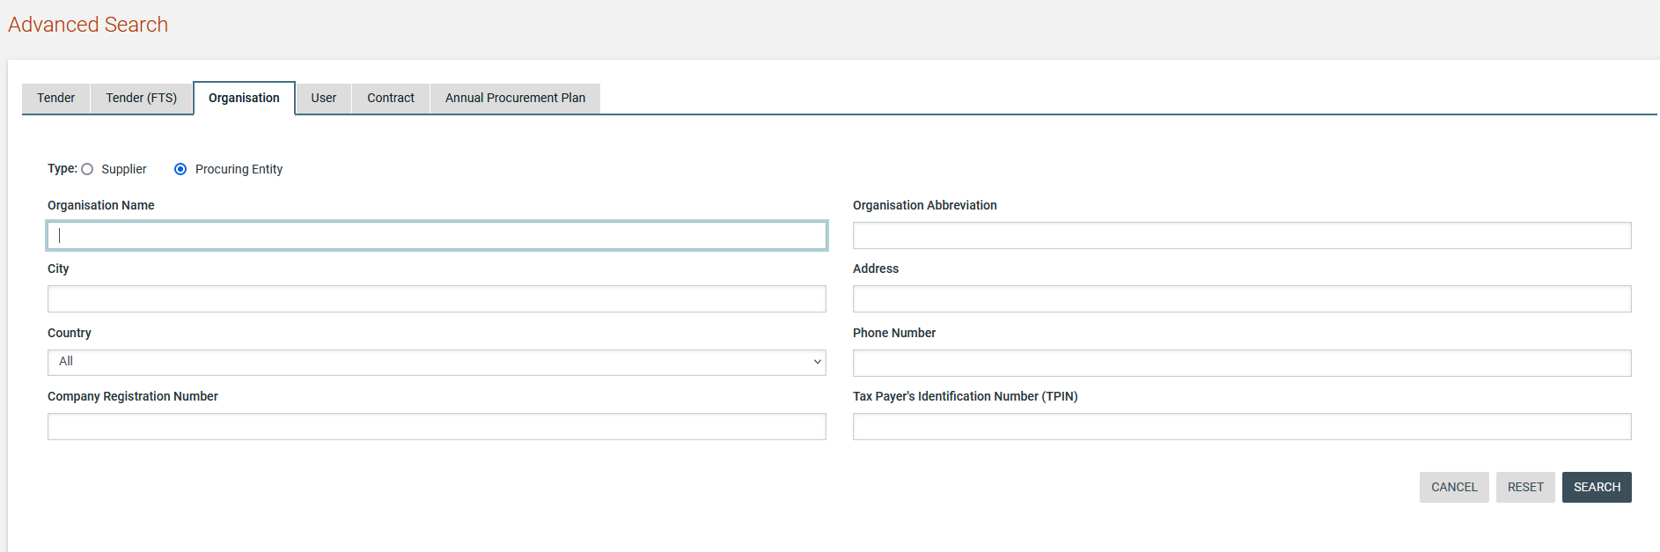
Figure 23: Advanced search for a Procuring Entity

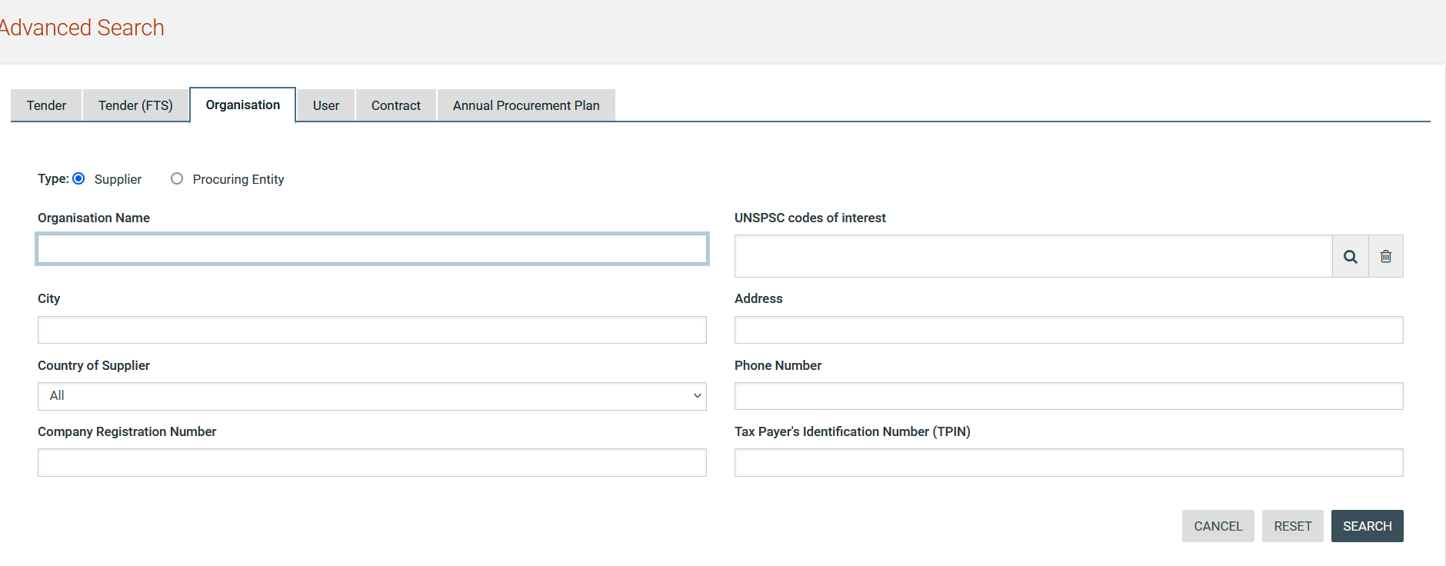
Figure 24: Advanced search for a Supplier organisation

In order to search for a user the organisation type (Procuring Entity or Supplier) must also be selected.
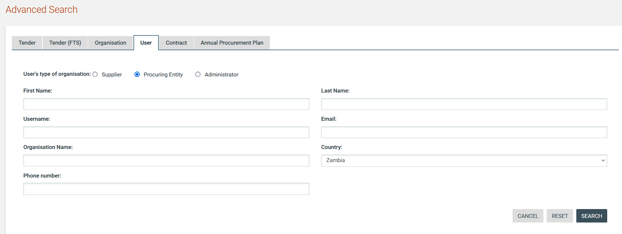

Figure 25: Advanced search for Procuring Entity users

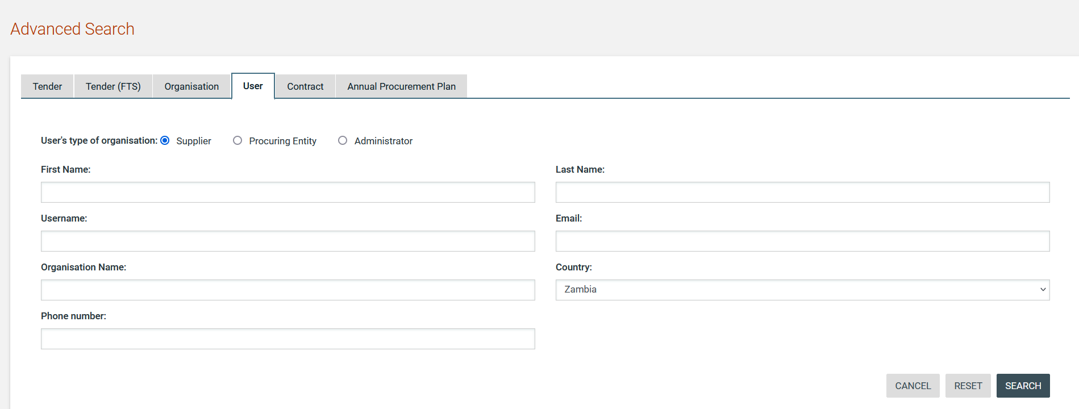
Figure 26: Advanced search for Supplier users
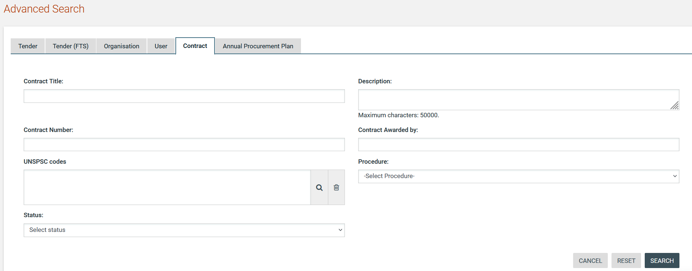

Figure 27: Advanced search for a contract

Annual procurement plan entries can be filtered by any combination of the publication date, the procurement type, the procurement method, the UNSPSC code or the procuring entity.

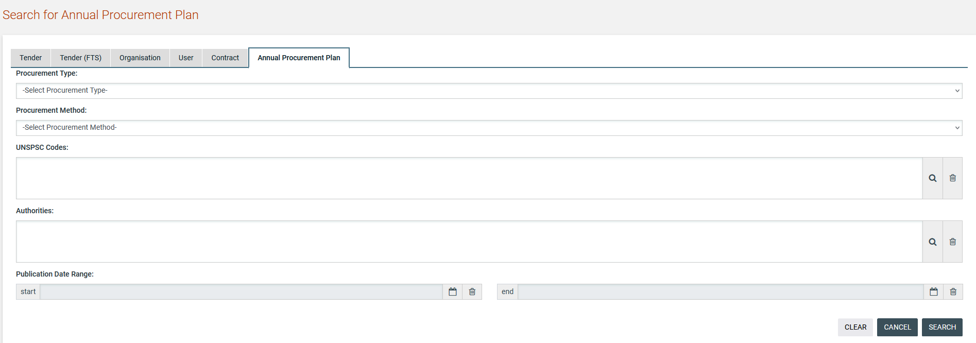
Figure 28: Advanced search for an annual procurement plan entry

Latest Tenders Search
In order to view the latest tenders published within the service, the user can click on the “Current Tenders” link, as depicted in Figure 28. This will automatically present the list of the latest tenders that are available to the user (depending on his/her access rights).

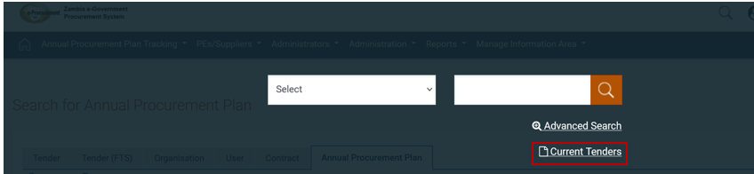
Figure 29: Latest Tender search

CSV Export
In order to download the search results with the retrieved list of Tenders/users/organisations, the user can click on the button.

The exported file includes the full details of the organisation or user accounts exported e.g. name, username, department and organisation they belong to, status of system registration, system role, phone and fax numbers including mobile, full postal address, email address, and registration validity date.

Procuring Entity Management
SA users can perform the following management activities for the procuring entities registered within the system:
- Register PE
- Edit PE details
- View the users registered within the procuring entity
- Add new users in the procuring entity
- Edit user’s details

Register PE
SA user clicks on the respective link under “PEs/Suppliers” on the top menu in order to proceed with the registration of a new procuring entity.

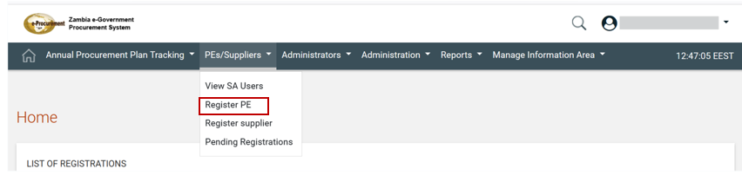
Figure 30: Register PE option

SA must fill in all mandatory information and click “Next”. The SA will also need to create the first user of the PE (i.e. the PEHP user).

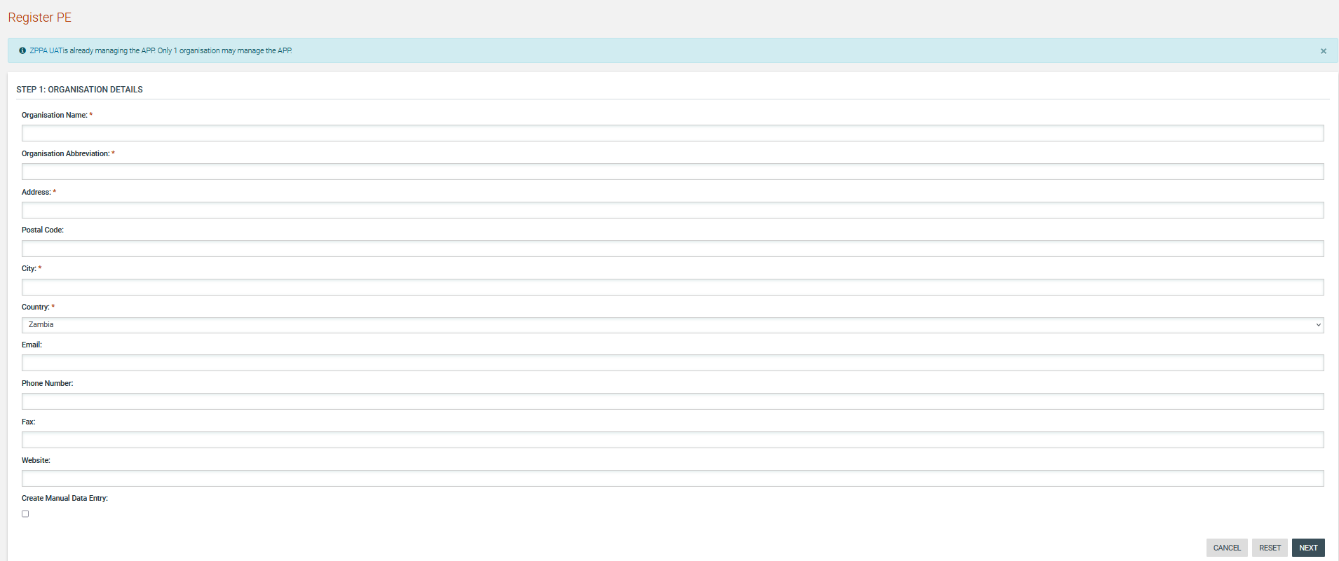

Figure 31: Register PE –Step 1

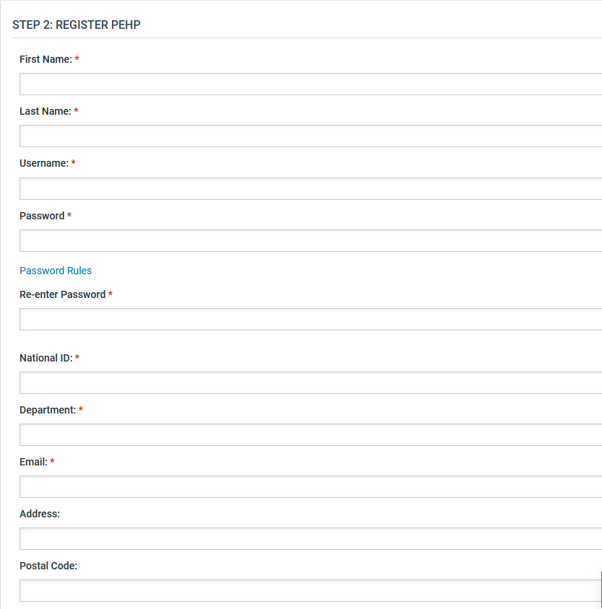
Figure 32: Register PE - Step 2

SA fills in all mandatory information and clicks “Create”. Upon selecting the aforementioned option the PE has been created successfully.

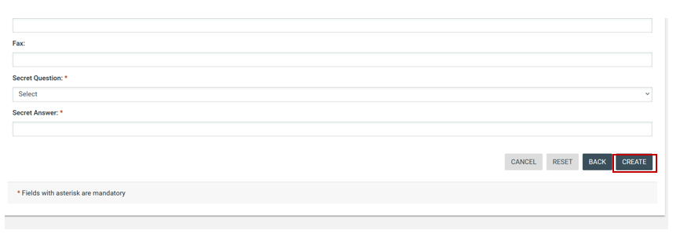
Figure 33: Register PE - Step 2

In order to manage the details of a Procuring Entity, the SA needs to use the searching functionality to find the Procuring Entity of interest.

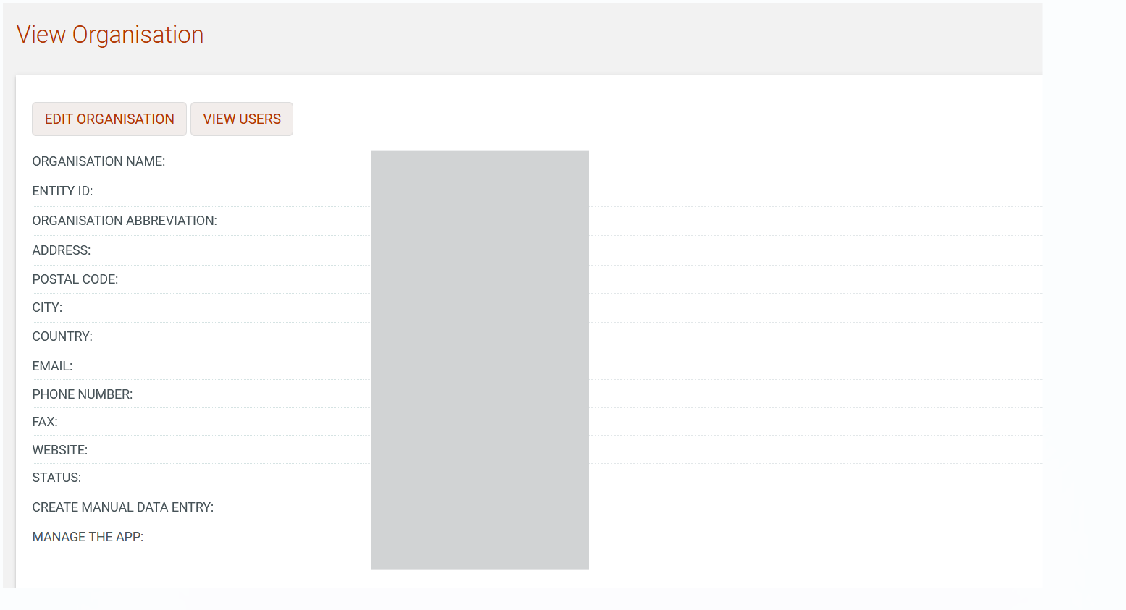
Figure 34: Management of Procuring Entity details

Edit Organisation Details
Selecting “Edit Organisation” allows the SA to edit the organisation’s details.

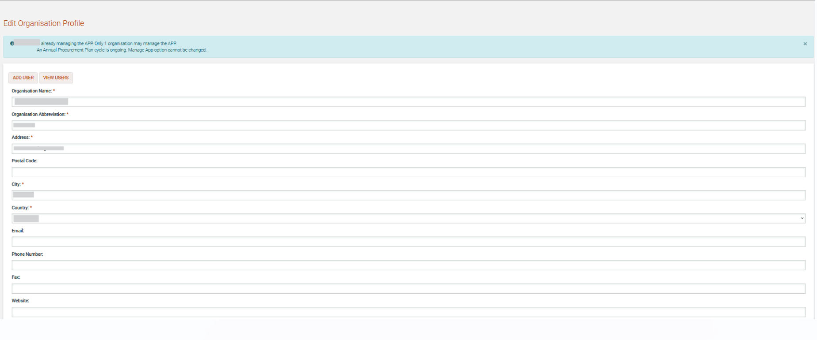
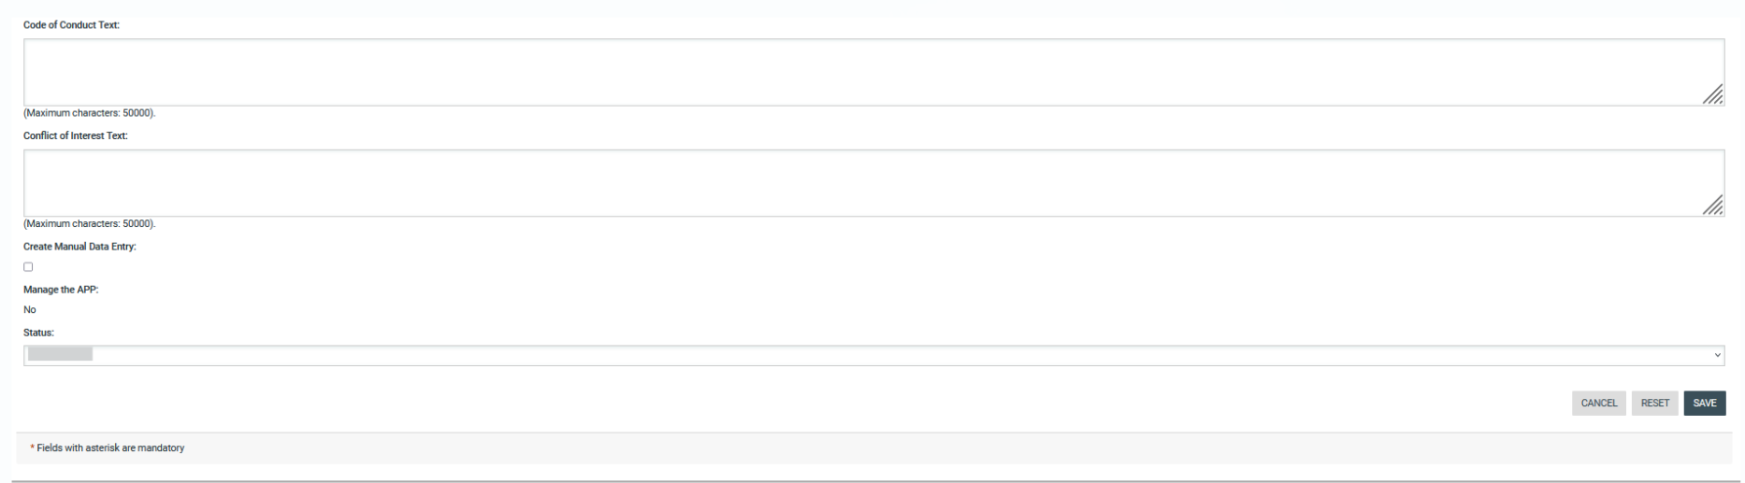

Figure 35: Editing Organisation details

View the Users Belonging to the Procuring Entity
Selecting “View Users” functionality allows the listing of all the users registered within the selected procuring entity.

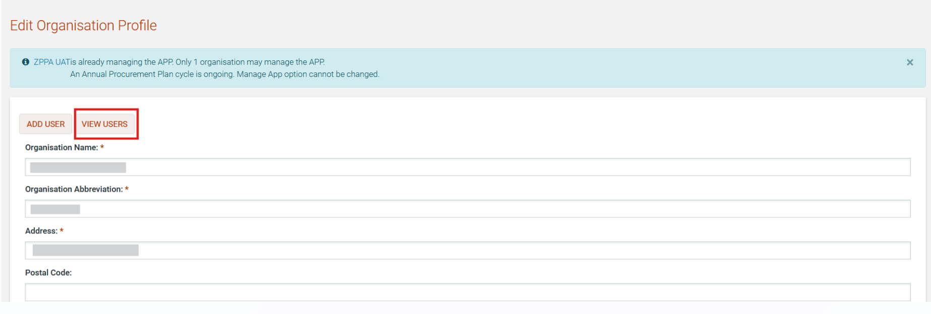
Figure 36: View user option

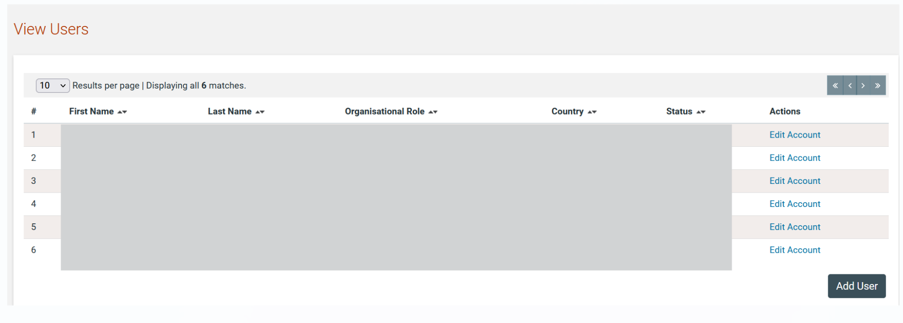
Figure 37: Display of users belonging to the procuring entity.

The name, the role and the current status (active, inactive, deactivated, etc) of each user are displayed.

The following user roles are supported:
- Controlling Officer (CO): Such a user has access rights to manage the Procurement Committee members, to conclude the evaluation and to respond to appeals.
- Head of Procurement (PEHP): Usually assigned to leading officers of a PE. Such a user has access rights to manage the PE and its users and has increased visibility on tender details (i.e. evaluation reports etc.).
- Chief Procurement Officer (PECPO): Such a user has similar access rights to the PEHP and acts as a PEHP assistant.
- Procuring Entity Procurement Officer (PEPO): Usually assigned to officers that do not require increased level of access. These form a “pool” of officials that may be associated with a specific tender for performing specific activities for the tender.
- Procurement Committee Member (PC): Such a user will not be allocated any tasks in the ZEGP. They are created solely for record-keeping purposes so that other users of the PE can identify the current members of the Procurement Committee.
The following roles are only available in the organisation that has been selected to manage the Annual Procurement Plan:
- Head Compliance Officer (HCO): Such a user is assigned the task to review APP submissions and is allowed to publish accepted APP files at the end of the APP cycle. This user is also allowed to allocate CMO users to the “Auditor” role on any tender in the system.
- Compliance Monitoring Officer (CMO): Such a user is assigned the task to review APP submissions and can also be allocated the Auditor role on any tender in the ZEGP.

Insert a New User in a Procuring Entity
The SA can insert a new user in a particular procuring entity by providing all of the following details, by selecting the option “Add User”.

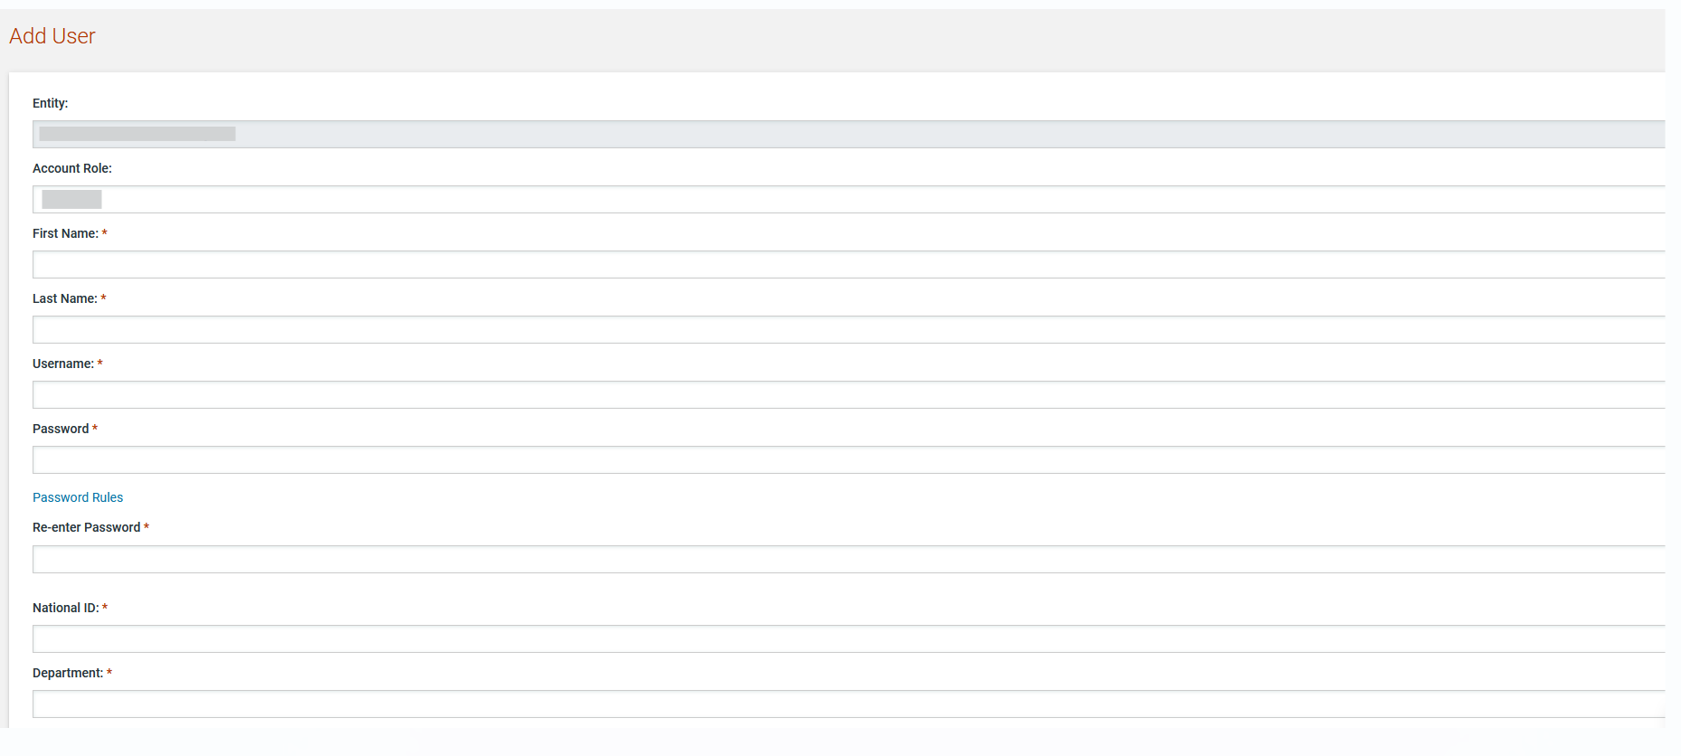

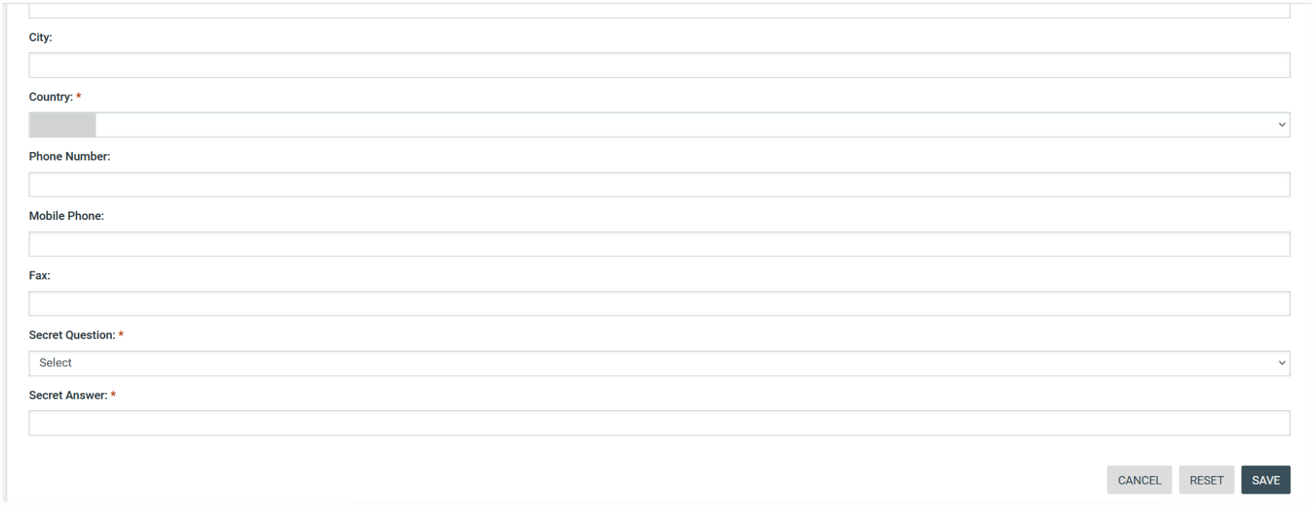

Figure 38: Insert a new user in a procuring entity

Edit user’s details.
The SA can edit the details of a specific user.

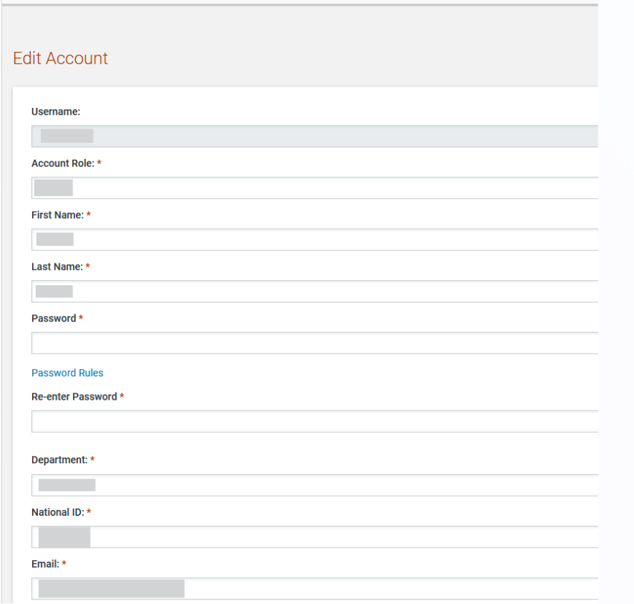
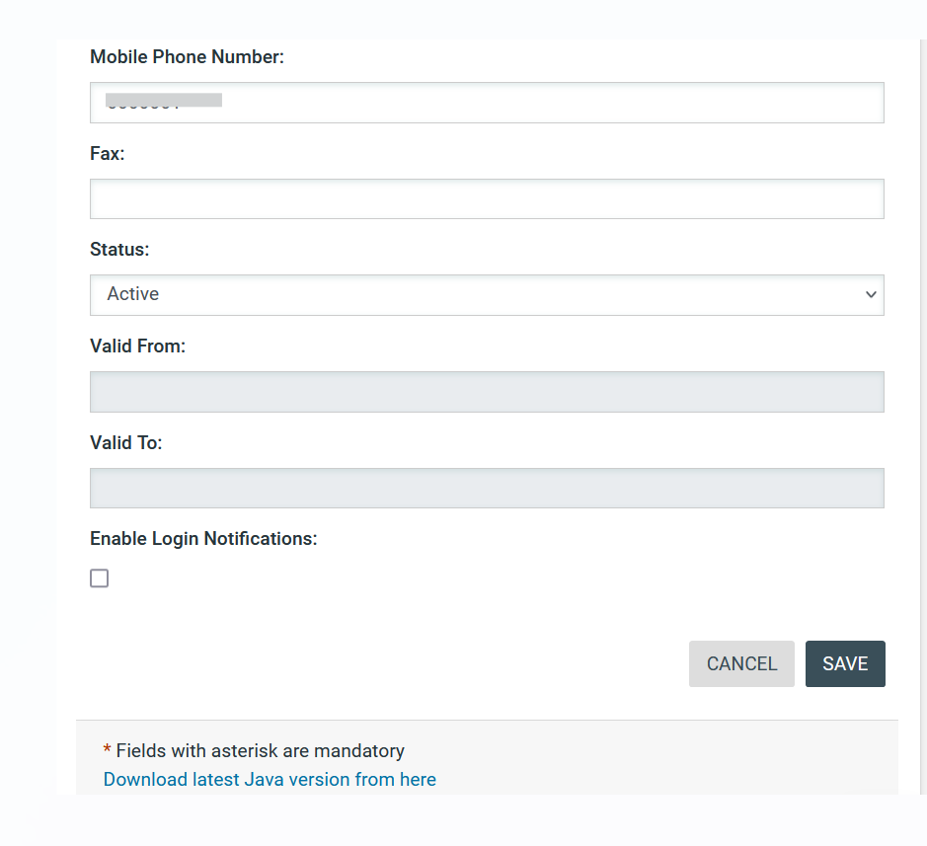
Figure 39: Editing user details

Login Notifications
The SA can modify a user account to enable the user to be notified by e-mail whenever their credentials are used to login to the e-GP system. This is accomplished on the Edit Profile page by selecting the checkbox to enable login notifications.

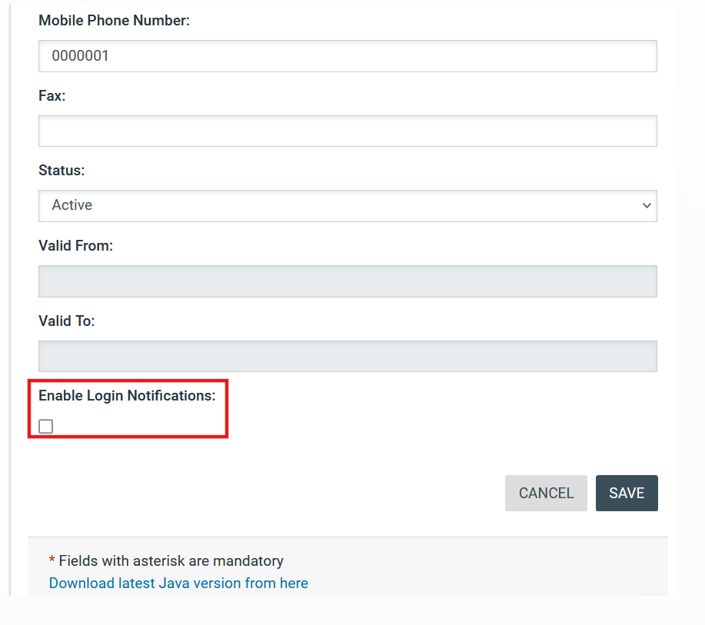
Figure 40: Login notifications

When the SA enables/disables the flag for a particular user, the user receives an e-mail notification that their profile has been modified.

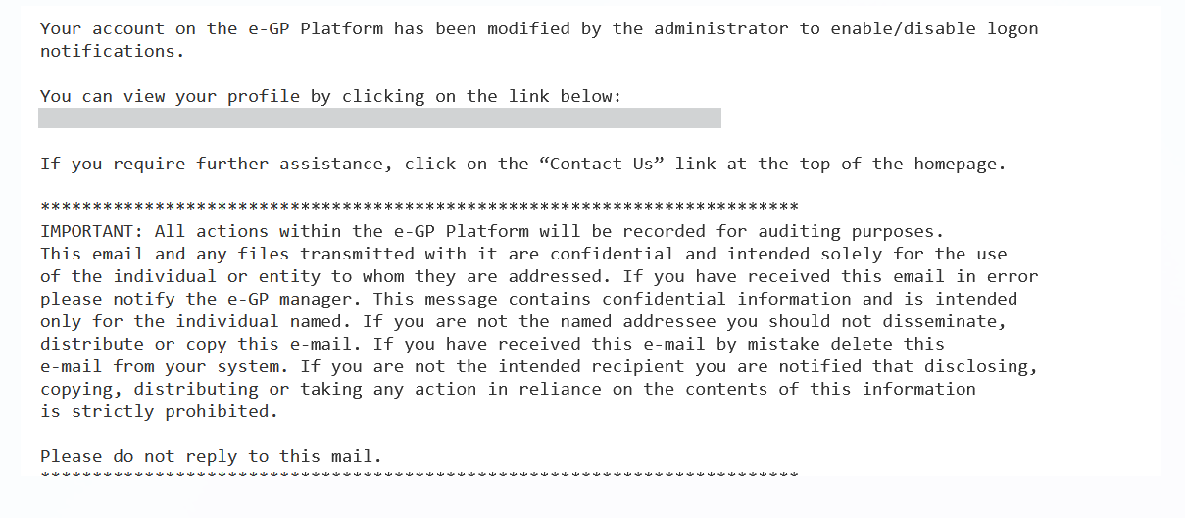
Figure 41: Login notifications administrator action confirmation e-mail

When login notifications are activated, each time the user’s credentials are used to login to e-GP, an e-mail notification is sent to the registered e-mail address of the user.

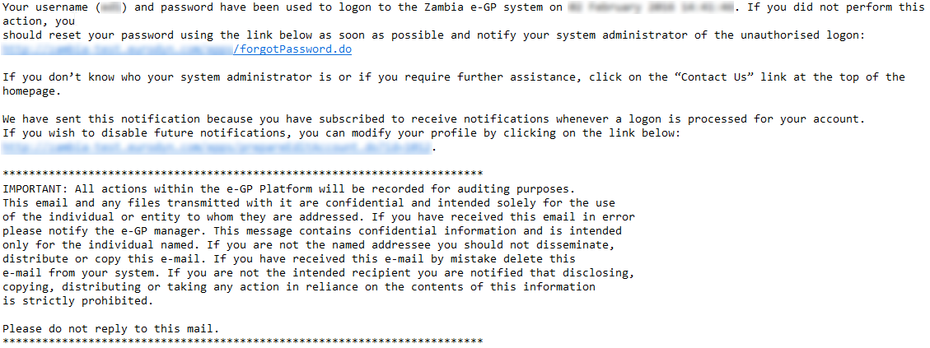
Figure 42: Login notification e-mail

Unlocking user accounts

When a user attempts to login to the system using wrong credentials for more than 10 times (or the number of attempts that the SA user defined), the user account is automatically de-activated. The SA is responsible to activate any such accounts.

The first step in the activation procedure is to search for the de-activated user (Figure 43). The column “Status” will display the status of the user.

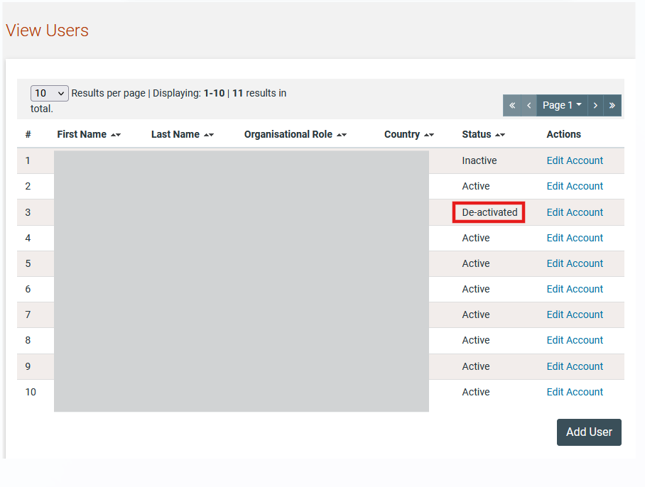
Figure 43: Account activation for a user

The SA should select the link in the column “First Name” to preview the user’s details (Figure 44).

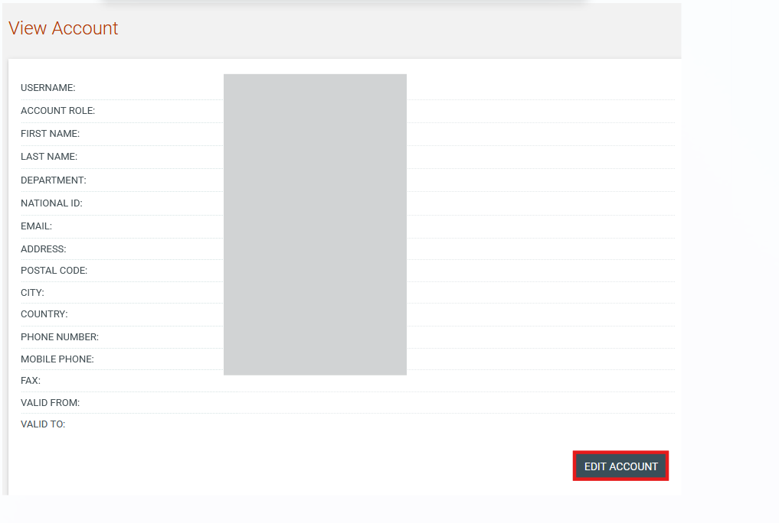
Figure 44: Account activation, preview user details

In order to activate the user account, the SA needs to select the “Edit Account” button (Figure 44). The system displays a page which allows the SA to change the details of the user. Moreover, the SA can change the “Status” of the user from “De-activated” to “Active’ (Figure 45).

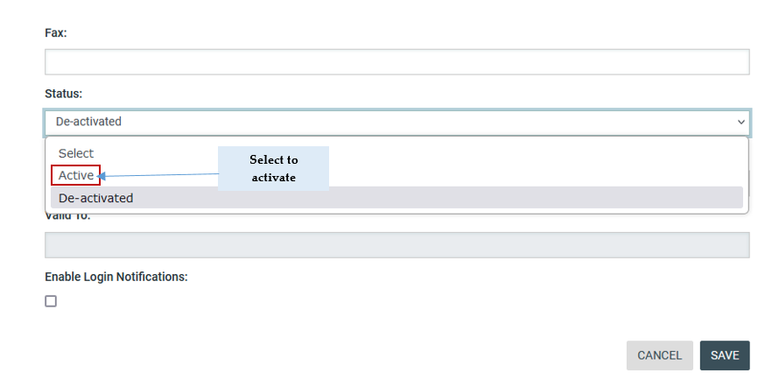
Figure 45: Account activation

Approving registrations
After the registration of a Supplier and the subsequent payment of the registration fee, the SA is required to approve the validity of the newly registered organisation. The user selects the “Pending Registrations” option in the “PEs/Suppliers” panel. Also the list of registrations is available on homepage of SA user.

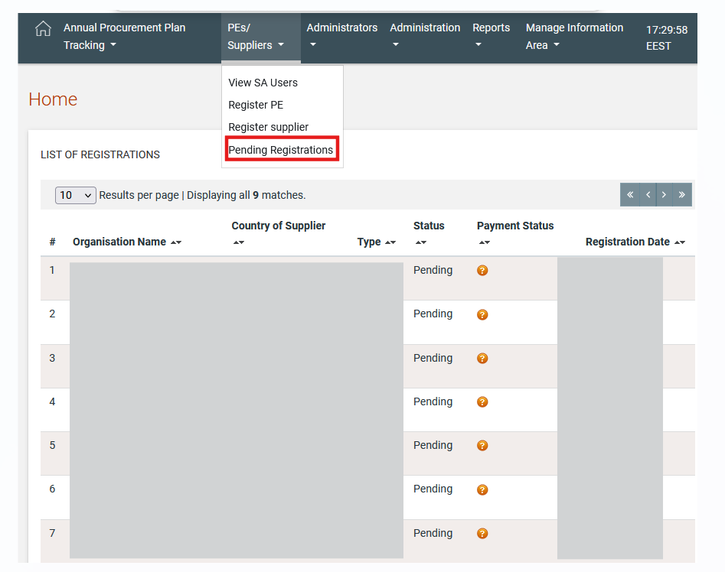
Figure 46: Pending registration option/ list of registrations

The system displays a list of registrations pending further actions (Figure 41). The following status symbols are used:

Pending for approval by the System Administrator

In order to approve a pending registration, the SA selects the relevant link in the “Organisation Name” column. The system displays the details of the organisation (Supplier) pending approval.

Instead of navigating through a long list of pending registrations, the SA user can search for a specific supplier through the Advanced Search capability. For Suppliers in ‘Pending’ status, the SA user can click on the “Approve Organisation” button to go directly to the approval.

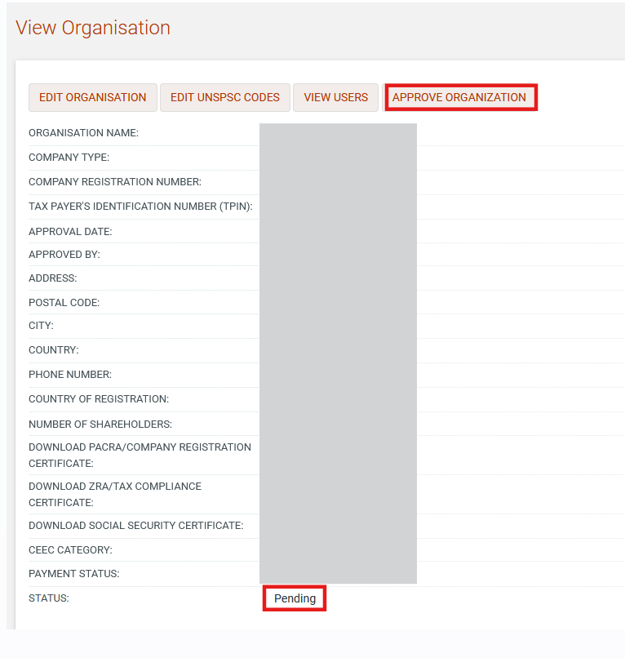
Figure 47: Approve specific Supplier

If the supplier has not yet paid their registration fee, the SA is notified that the supplier cannot be activated at this point in time.

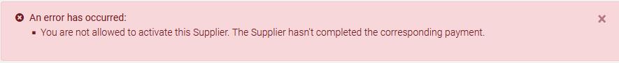
Figure 48: Pending supplier registration payment

The SA can “Approve” or “Reject” the registration (Figure 49). In case the administrator rejects a Supplier all the details of the organisation including the registered user, are deleted from the system.

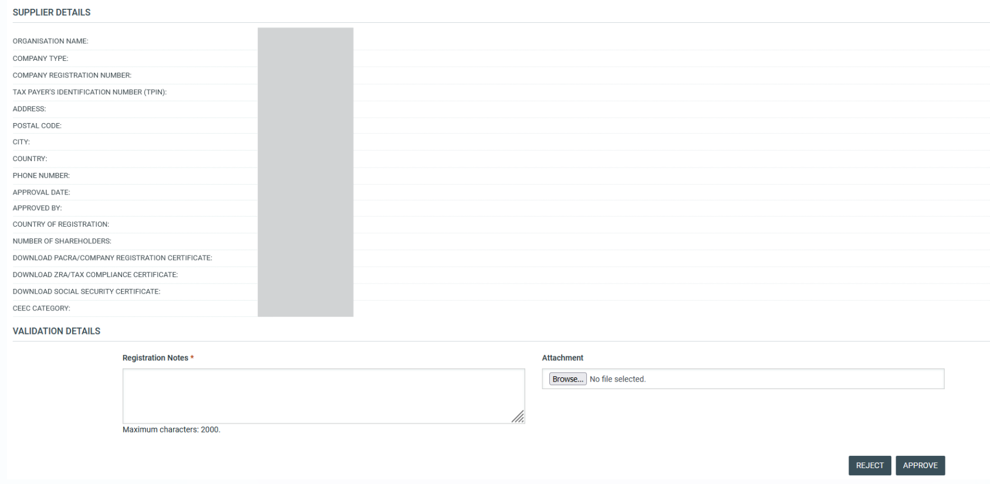
Figure 49: Approve pending registration

Manage Administrators

SA users can perform the following management activities for the administrators registered within the system:
- View the users registered as system administrators
- Add new system administrator users
- Edit user’s details

The SA is able to manage all the users registered as SA users through the “View SA Users” option in the Administrators panel.

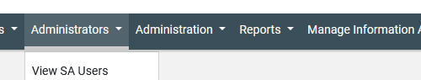
Figure 50: Administrators panel, Manage administrators

The administrators appear in a tabular form:

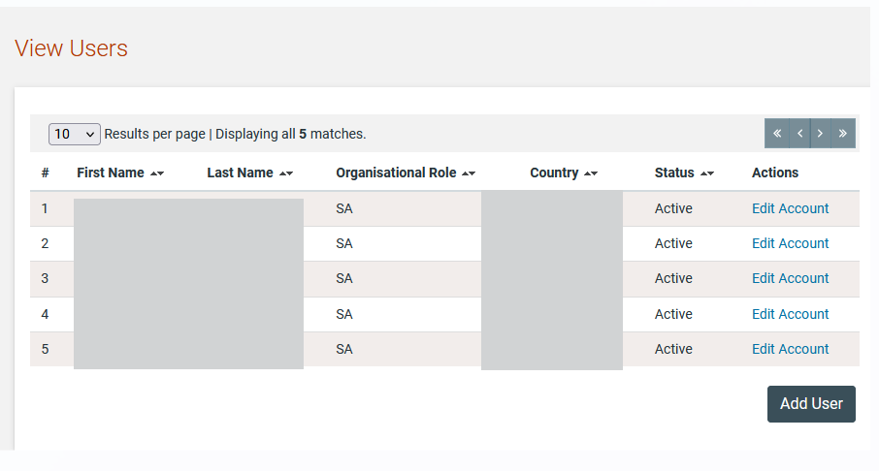
Figure 51: System administrators list

In order to create a new administrator the system administrator clicks on the “Add User” button and fills in the details of the new user (Figure 52). The following information should be provided:
- First Name
- Last Name
- Username
- Password
- National ID
- Email
- Address
- Postal Code
- City
- Country
- Phone Number
- Mobile phone
- Fax
- Secret Question
- Secret Answer

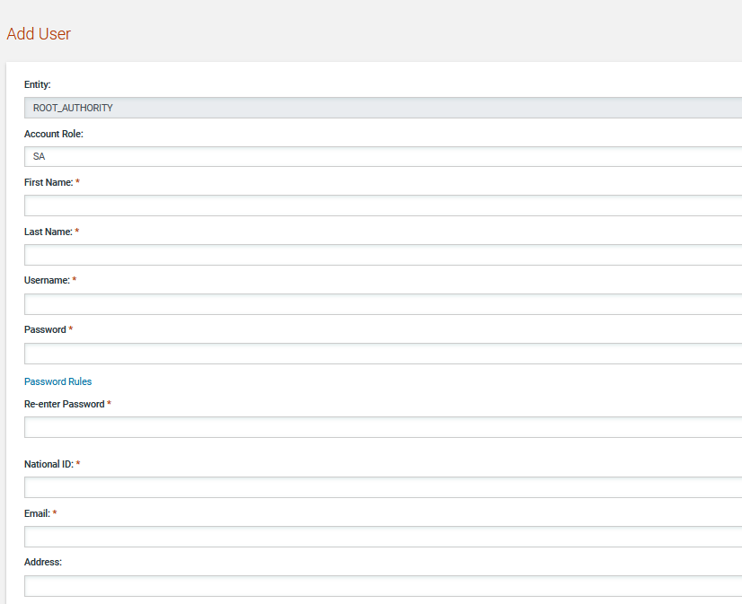
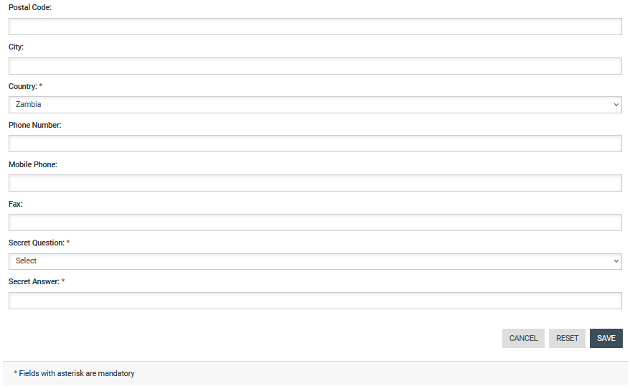
Figure 52: Registration of a system administrator

To edit the details of an existing user the administrator clicks the “Edit Account” hyperlink for that user (Figure 51). To view the details of a user the administrator clicks on the user’s first name.

Supplier Registration
SA users may also register Suppliers in e-GP.

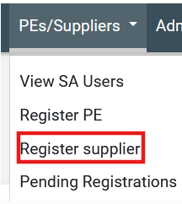
Figure 53: Register Supplier link

The system presents the user with the Supplier registration form. SA needs to correctly fill in all mandatory information of all registration steps.

In the first phase of the registration procedure the SA user registers the Supplier organisation by providing the following information (Figure 54):
- Company Registration Number
- Tax Payer’s Identification Number (TPIN)

The user can then click on  to retrieve company information registered with the corresponding authorities in Zambia (PACRA and Zambia Revenue Authority). This ensures that the e-GP system contains the same data as that provided during registration of the business.

If the organisation is not found on the OSSIS system, the user can proceed with the registration process manually by providing the following information:
- Company Registration Number
- Tax Payer’s Identification Number (TPIN)
- Organisation Name
- Company type
- Address
- Postal Code
- City
- Country
- Phone Number
- Country of Registration
- Number of Shareholders
- Attach PACRA/Company Registration Certificate (this field is populated and displayed in case the country of registration is Zambia)
- Attach ZRA/Tax Compliance Certificate (this field is populated and displayed in case the country of registration is Zambia)
- Attach Social Security Certificate (this field is populated and displayed in case the country of registration is Zambia)
- CEEC category
- Attach CEEC Certificate (this field is displayed in case the user selects one of the options from drop-down field CEEC category)
- Captcha code
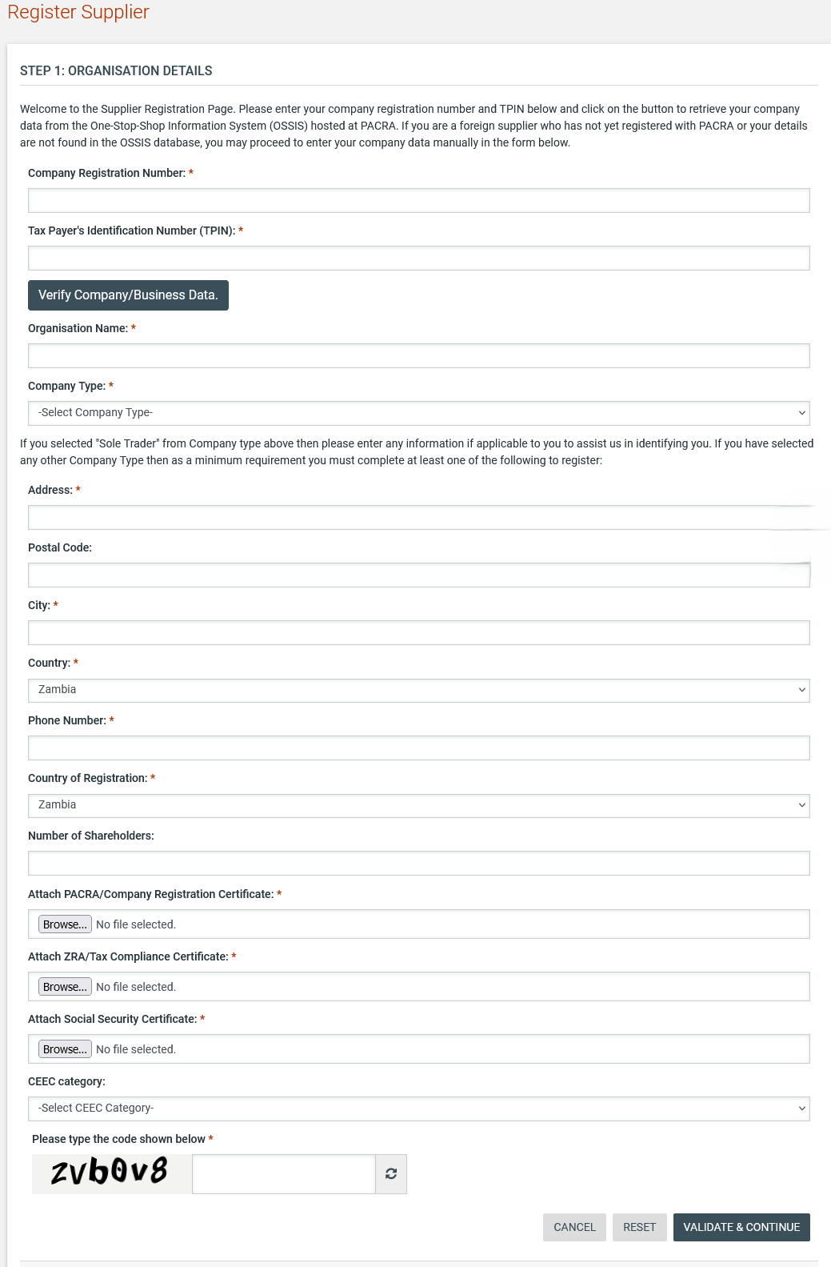
Figure 54: Register Supplier - Step 1

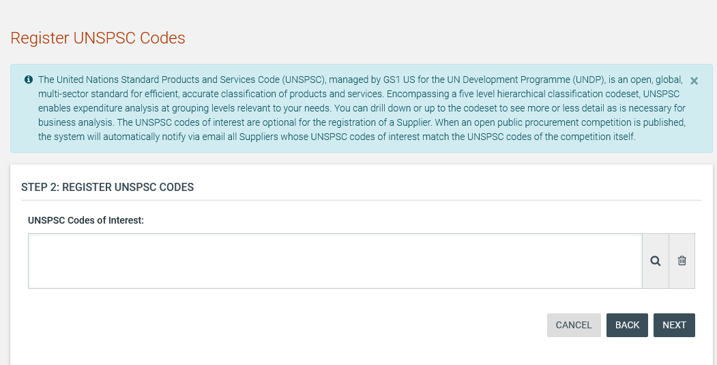
Figure 55: Register Supplier - Step 2

After clicking on the button, the user is presented with a pop-up window to select UNSPSC codes Up to 5 codes can be selected to be linked to the supplier profile, with at least 1 code being required to be linked during the registration process.

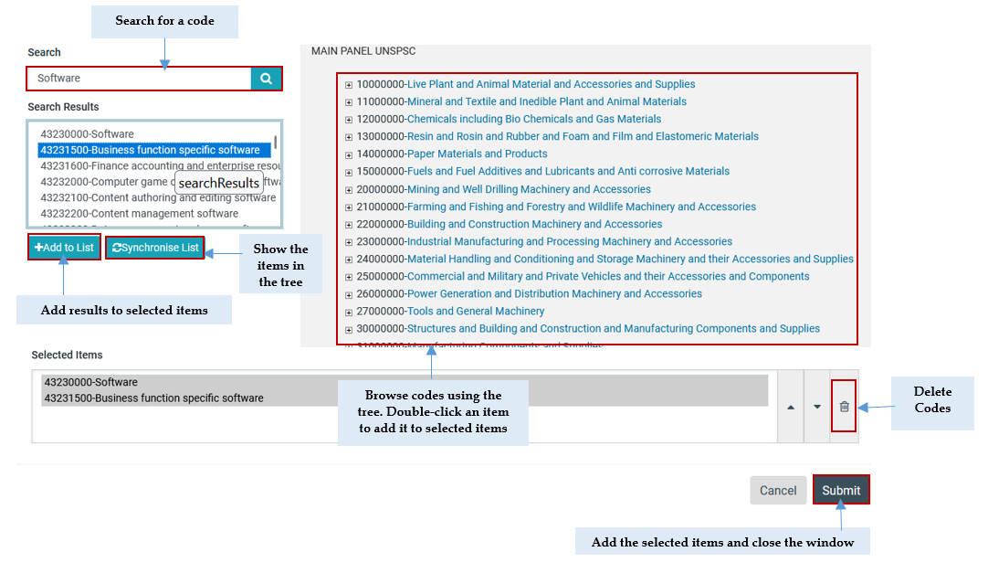
Figure 56: UNSPSC code selection

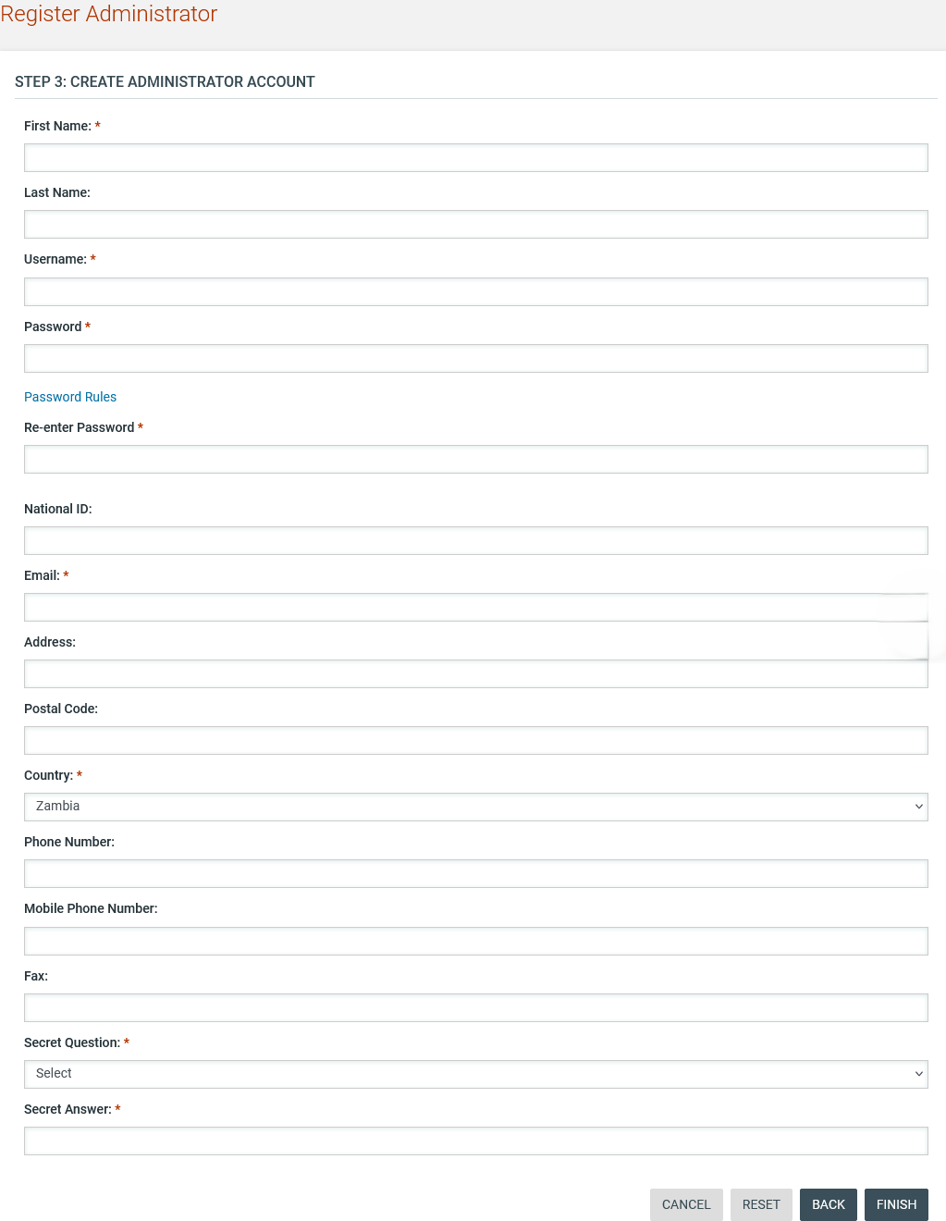
Figure 57: Register Supplier - Step 3

Add Supplier User
When viewing the details of a Supplier organisation the user has the proper rights that enable him/her to add new users to the organisation.

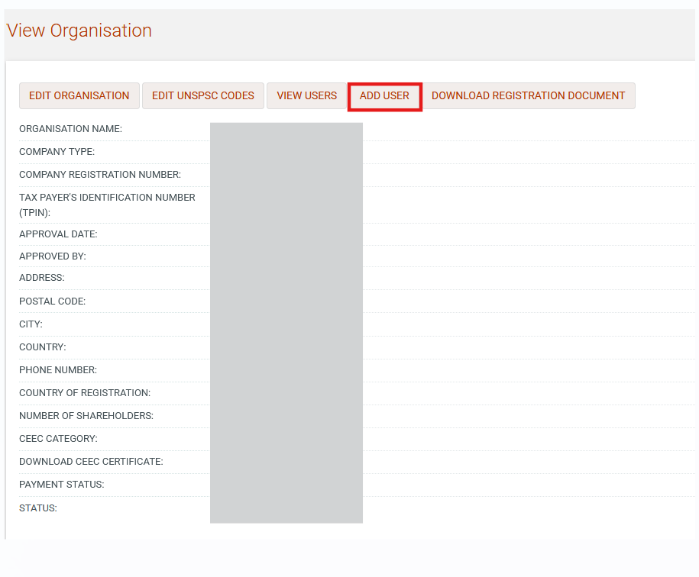

Figure 58: Add Supplier user link

SA fills in all mandatory information and submits the form. The user will receive the respective activation information through email in order to activate the user account.

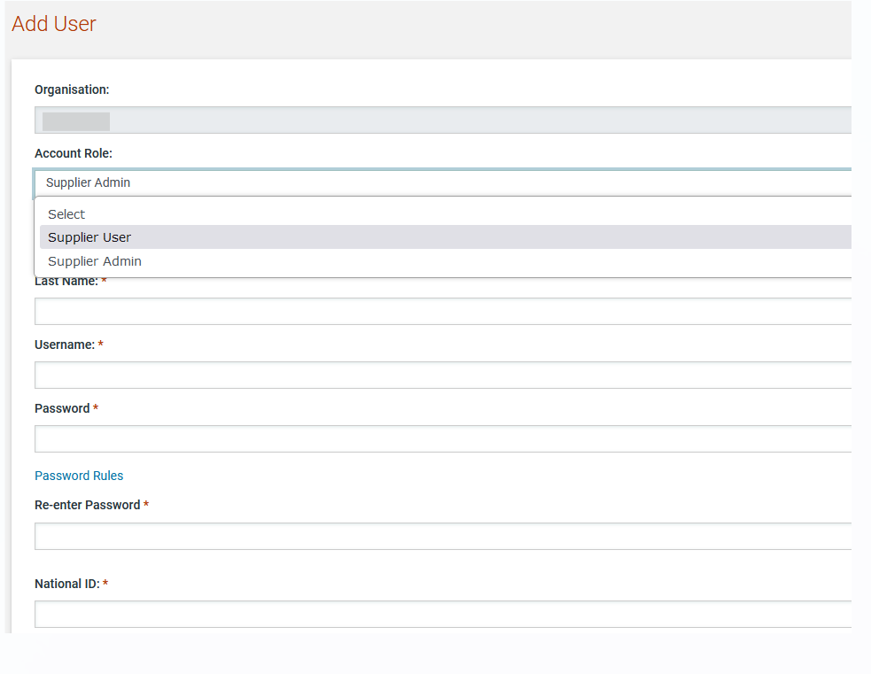
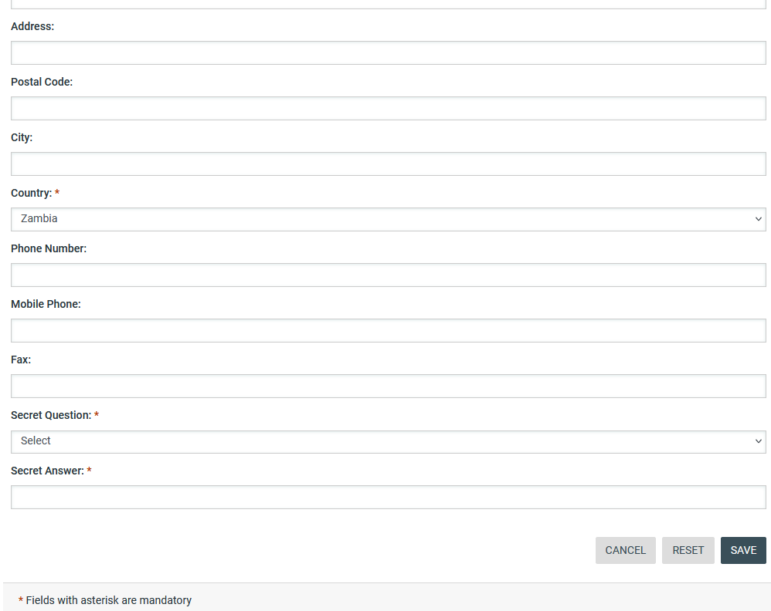
Figure 59: Add Supplier user

Edit Supplier Organisation
SA may also proceed in updating the Supplier organisation information.

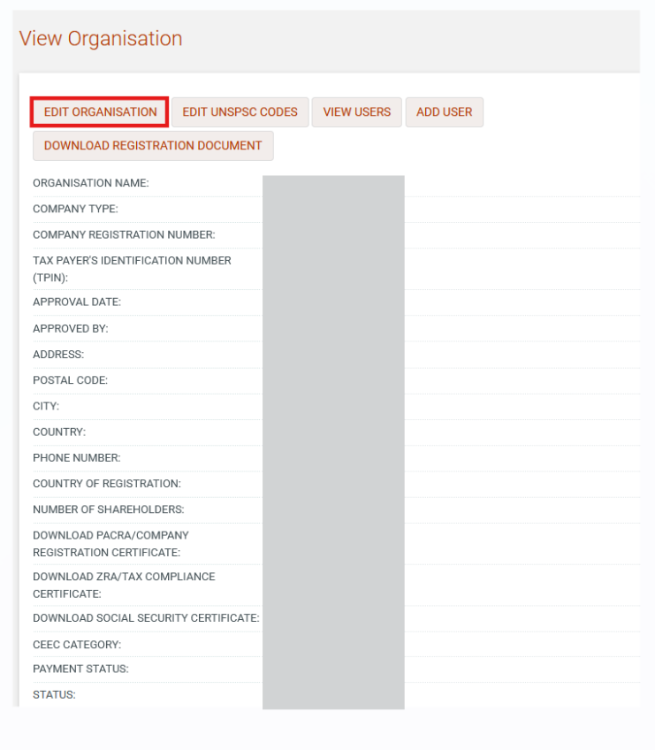
Figure 60: Edit supplier organization link

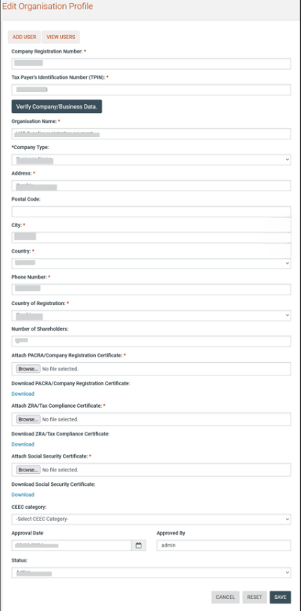
Figure 61: Edit supplier organization

All fields of supplier organization are editable from SA user (even for supplier with Zambia country of registration).

Download Supplier Registration Certificate
Selecting the option “Download Certificate” allows the user to save the registration certificate as a PDF document to their local file system.

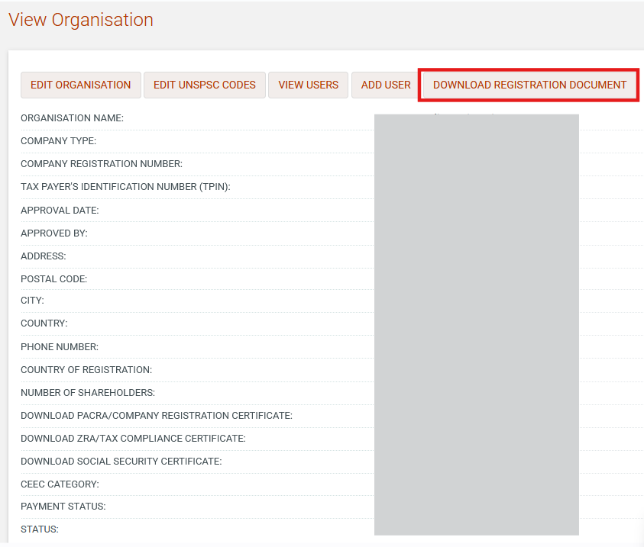
Figure 62: Download supplier registration certificate

Depending on the user’s browser settings for handling PDF documents, the user will either be prompted whether they would like to view or save the certificate or the certificate will automatically be opened in a new browser tab.

Edit Supplier user
SA user may view a specific Supplier user and proceed in amending his/her profile. In case the SA amends the user’s password, the System will automatically dispatch a notification to the Supplier’s email to notify him/her of the change. In case the Supplier’s email address is modified, for security purposes, the System will dispatch an email to the old email address to notify the owner of the previous address that the user profile has been amended.

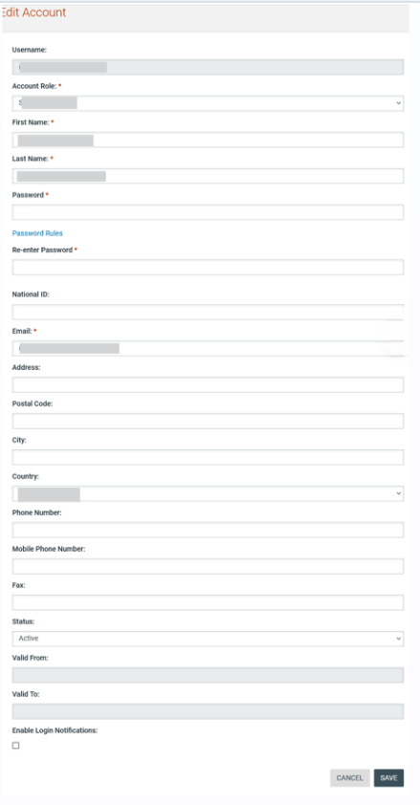
Figure 63: Edit supplier user profile

Synchronise with OSSIS database
Instead of editing Supplier profiles one at a time, the SA user can request a bulk update of all Suppliers that have been retrieved from the OSISS database. The SA can synchronise Supplier details with OSSIS on a bulk basis by selecting the “Synchronise Suppliers with OSSIS” link in the “Administration” menu (Figure 64).

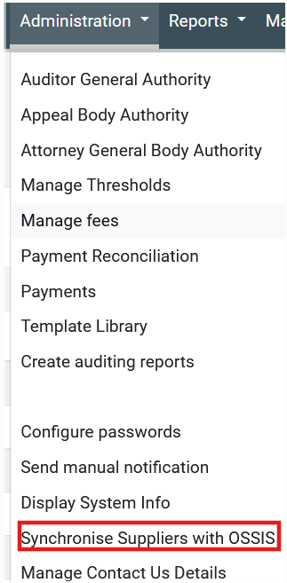
Figure 64: Synchronize suppliers with OSSIS

A new page will be presented where the SA can initiate the synchronisation process by clicking on the “Start OSSIS Synchronisation” button (Figure 65). This process can only be initiated if the status is ENDED. If a current synchronisation is still running, a second cannot be initiated.

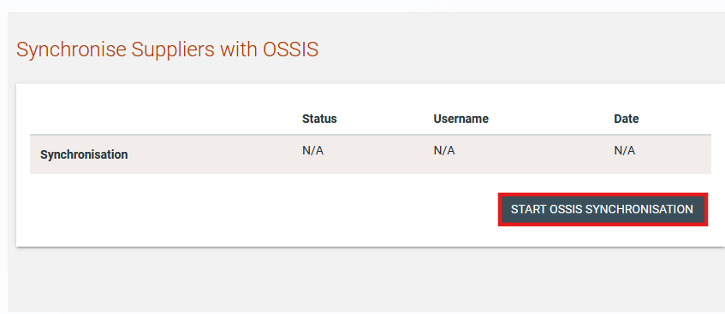
Figure 65: Start OSSIS synchronization

Auditor, Appeal and Attorney General Users
The SA can register users into three special organisations in e-GP:
- Auditor General Authority
- Appeal Body Authority
- Attorney General Body Authority

Auditor General Authority
Users in the Auditor General can be allocated to the auditor role for any tender in e-GP by the tender co-ordinator of that tender. These users have read access to the tender information, documents and its audit trails in order to be able to complete their auditing tasks. The SA can view the details of the Auditor General Authority by selecting the “Auditor General Authority” link in the “Administration” menu (Figure 66).

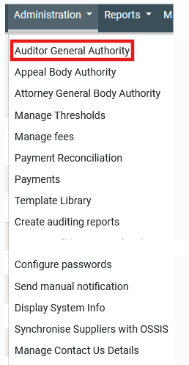
Figure 66: Auditor General Authority menu selection

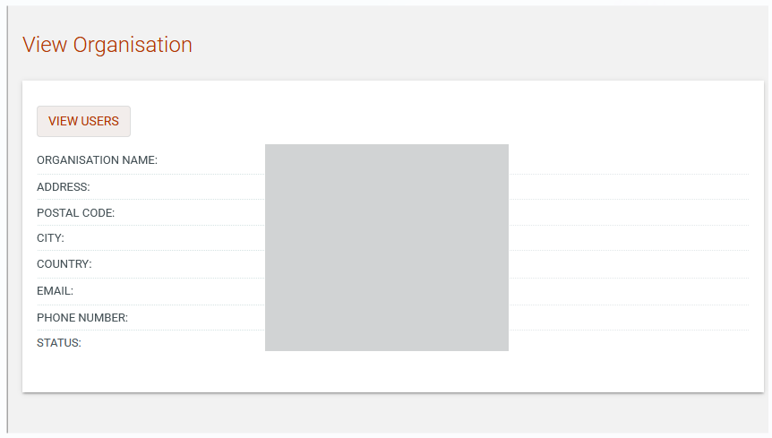
Figure 67: View Auditor General Authority organization details

Add Auditor General User
When viewing the details of the Auditor General organisation the SA user has the proper rights that enable him/her to add new users to the organisation. The list of users can be accessed by clicking on the “View Users” button.

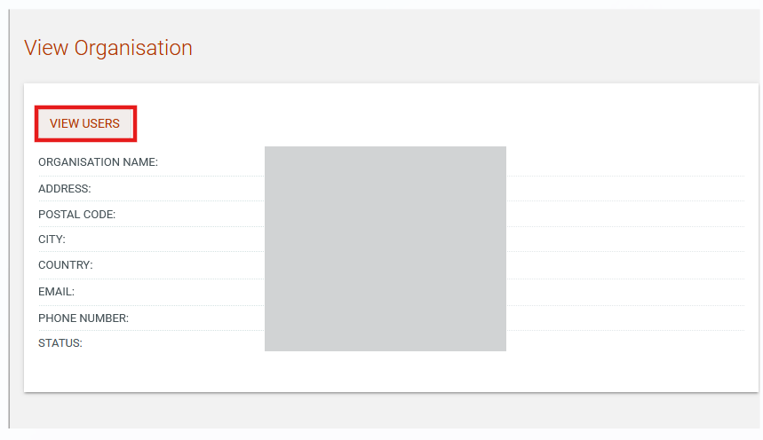
Figure 68: View Auditor General users link

The organisation users are presented in a table layout.

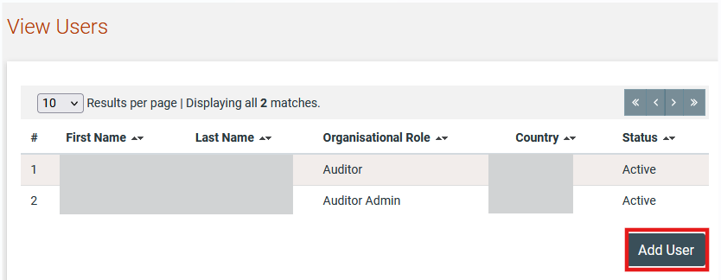
Figure 69: List of Auditor General Body Authority users

A new user can be added by clicking on the “Add User” button.

SA fills in all mandatory information and submits the form. The user will receive the respective activation information through email in order to activate the user account.

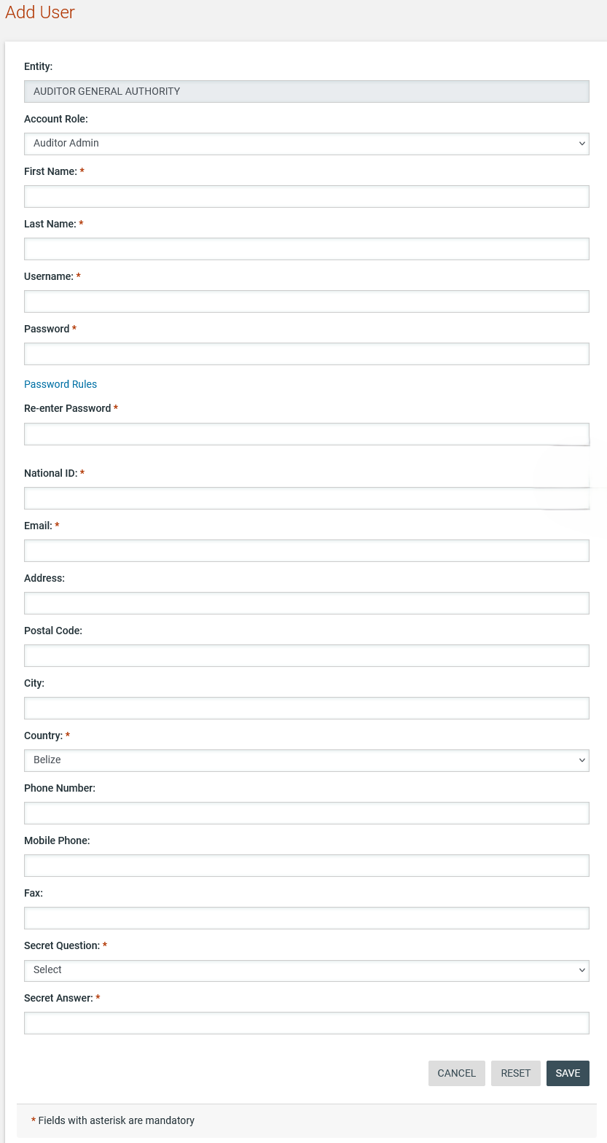
Figure 70: Add Auditor General Authority user

Edit Auditor General User
The SA can edit the auditor users. In case the SA amends the user’s password, the System will automatically dispatch a notification to the user’s email to notify him/her of the change. In case the user’s email address is modified, for security purposes, the System will dispatch an email to the old email address to notify the owner of the previous address that the user profile has been amended.

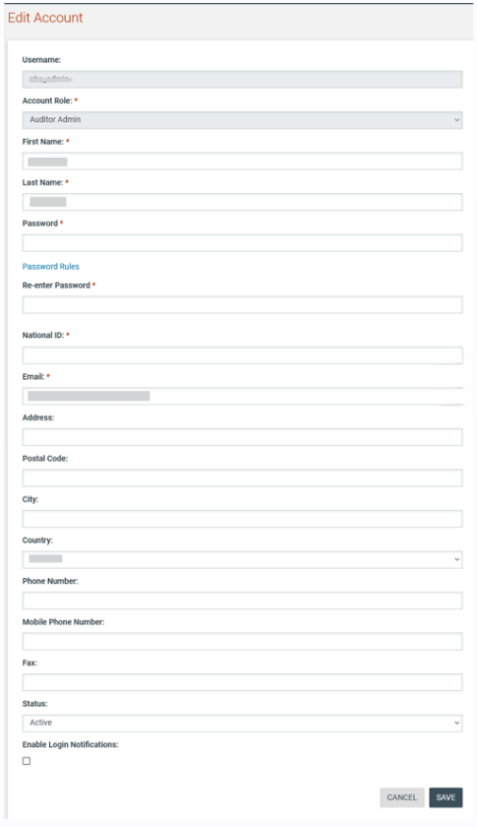
Figure 71: Edit Auditor General Authority user profile

Appeal Body Authority
Users in the Appeal Body can be allocated to the Appeals role for any tender in e-GP by the tender co-ordinator of that tender. These users represent the Appeals Panel in the event that an appeal is lodged against a tender. The SA can view the details of the Appeal Body Authority by selecting the “Appeal Body Authority” link in the “Administration” menu (Figure 72).

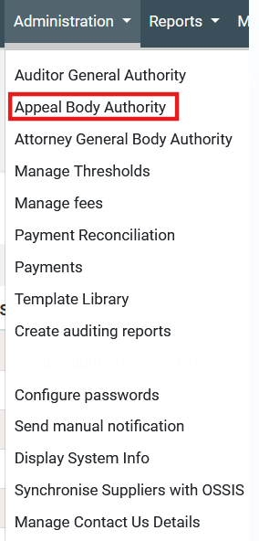
Figure 72: Appeal Body Authority menu selection

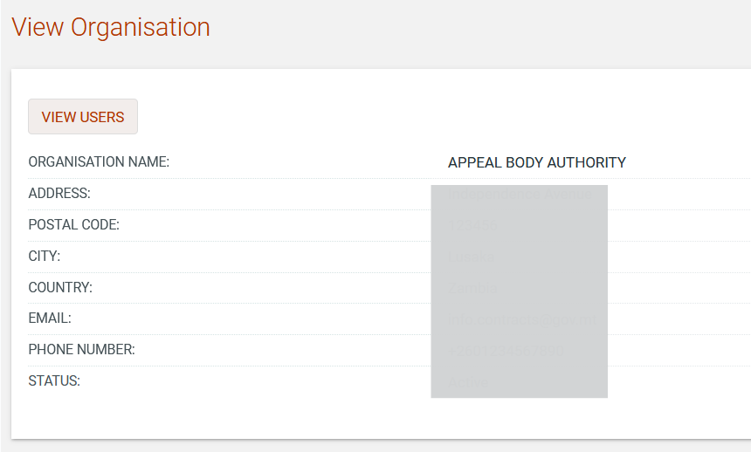
Figure 73: View Appeal Body Authority organisation details

Add Appeals Body User
When viewing the details of the Appeal Body organisation the SA user has the proper rights that enable him/her to add new users to the organisation. The list of users can be accessed by clicking on the “View Users” button.

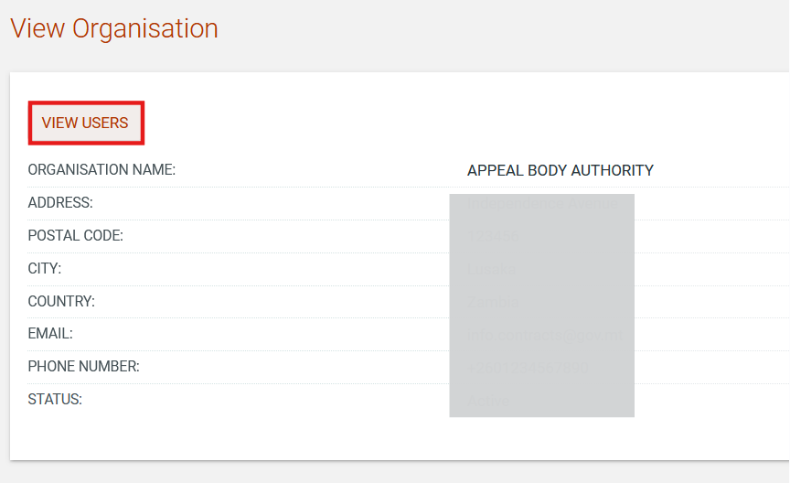
Figure 74: View Appeal Body Authority users link

The organisation users are presented in a table layout.

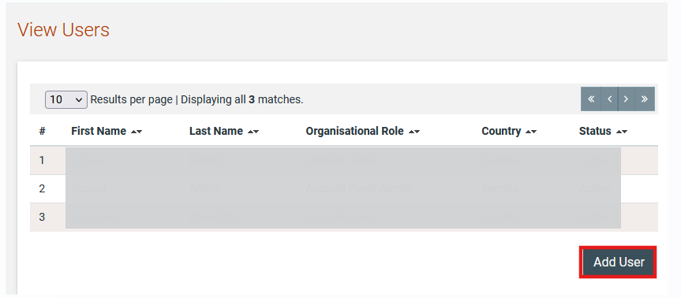
Figure 75: List of Appeal Body Authority users

A new user can be added by clicking on the “Add User” button.

SA fills in all mandatory information and submits the form. The user will receive the respective activation information through email in order to activate the user account.
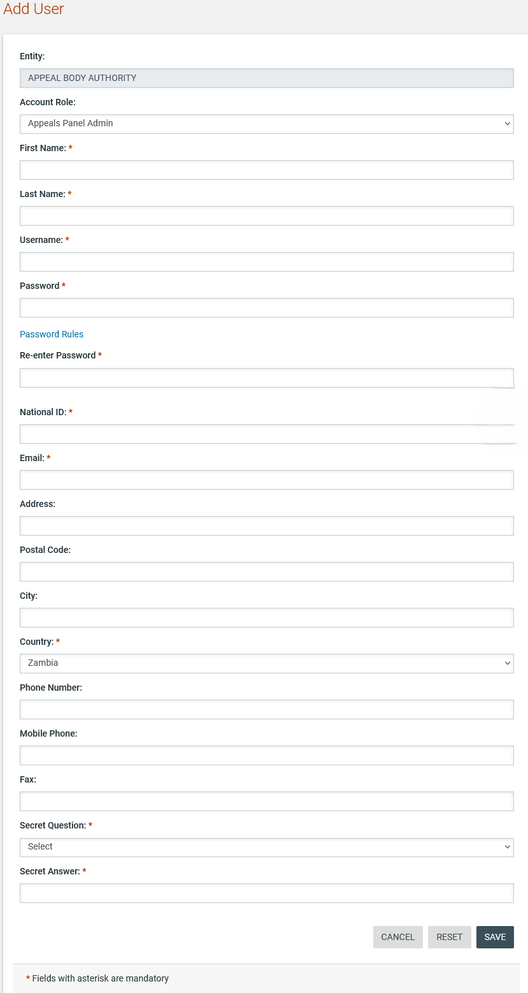

Figure 76: Add Appeal Body Authority user

Edit Appeals Body User
The SA user can edit the details of Appeal users. In case the SA amends the user’s password, the System will automatically dispatch a notification to the user’s email to notify him/her of the change. In case the user’s email address is modified, for security purposes, the System will dispatch an email to the old email address to notify the owner of the previous address that the user profile has been amended.

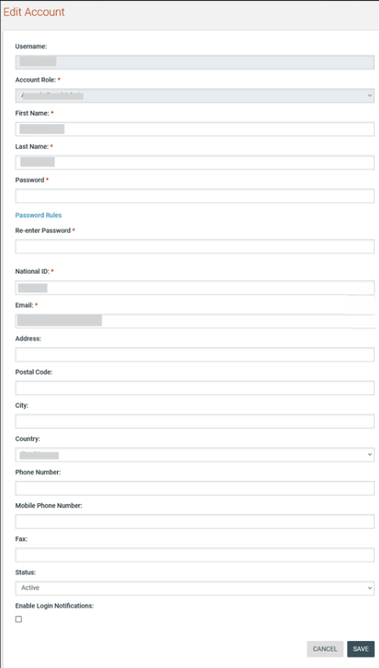

Figure 77: Edit Appeal Body Authority user profile

Attorney General Body Authority
Users in the Attorney General Body can be allocated to the Attorney General role for any tender in e-GP by the tender co-ordinator of that tender. These users are involved in the contract review process during the awarding phase of a tender. The SA can view the details of the Attorney General Body Authority by selecting the “Attorney General Body Authority” link in the “Administration” menu (Figure 78).

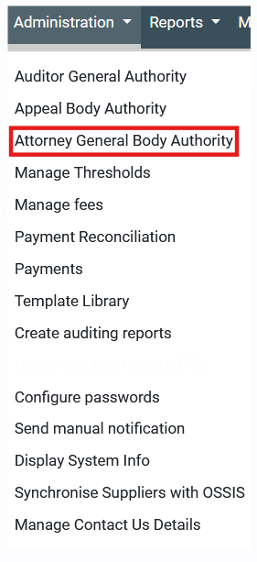
Figure 78: Attorney General Body Authority menu selection

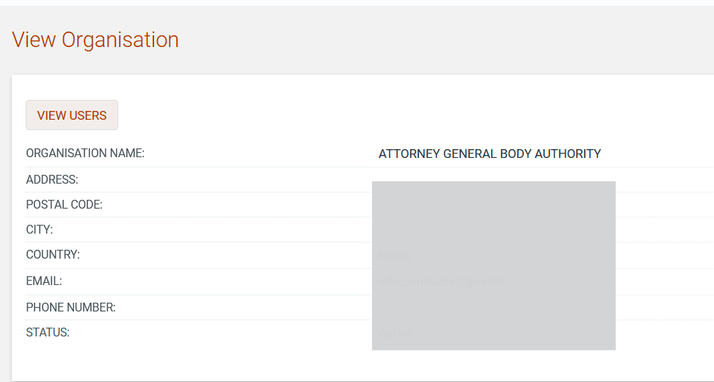
Figure 79: View Attorney General Body Authority organisation details

Add Attorney General Body User
When viewing the details of the Attorney General Body organisation the SA user has the proper rights that enable him/her to add new users to the organisation. The list of users can be accessed by clicking on the “View Users” button.

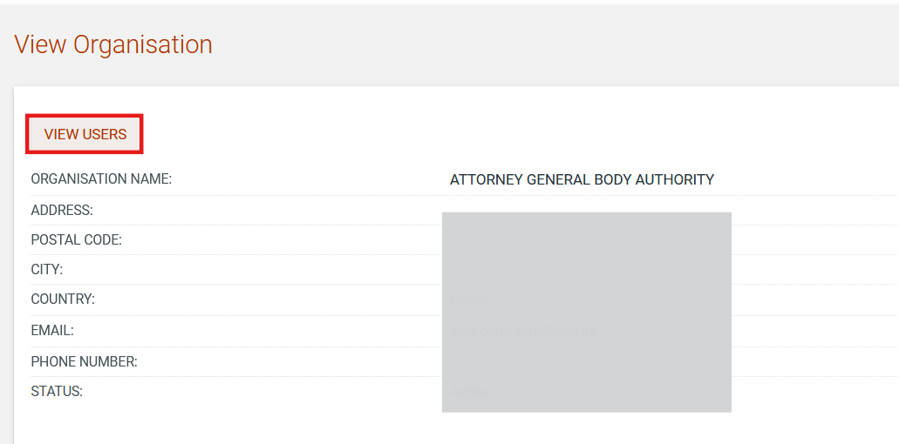

Figure 80: View Attorney General Body Authority users link

The organisation users are presented in a table layout.

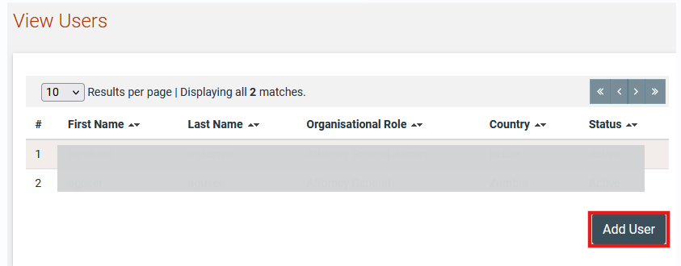

Figure 81: List of Attorney General Body Authority users

A new user can be added by clicking on the “Add User” button.

SA fills in all mandatory information and submits the form. The user will receive the respective activation information through email in order to activate the user account.

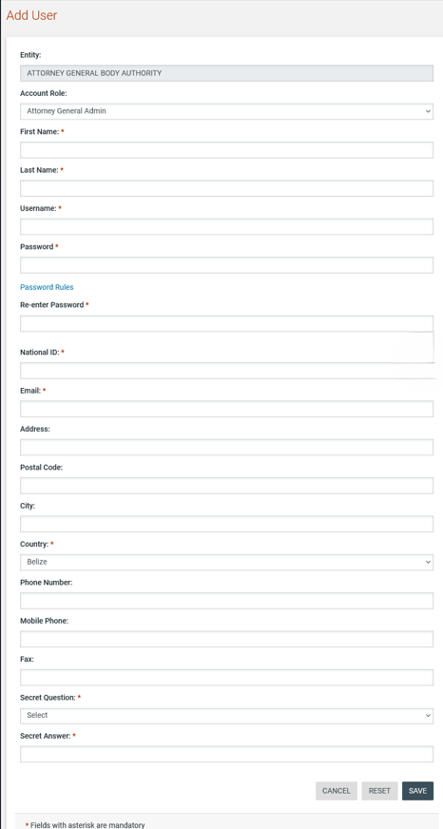
Figure 82: Add Attorney General Body Authority user

Edit Attorney General Body User
The SA user can edit the Attorney General users profile. In case the SA amends the user’s password, the System will automatically dispatch a notification to the user’s email to notify him/her of the change. In case the user’s email address is modified, for security purposes, the System will dispatch an email to the old email address to notify the owner of the previous address that the user profile has been amended.

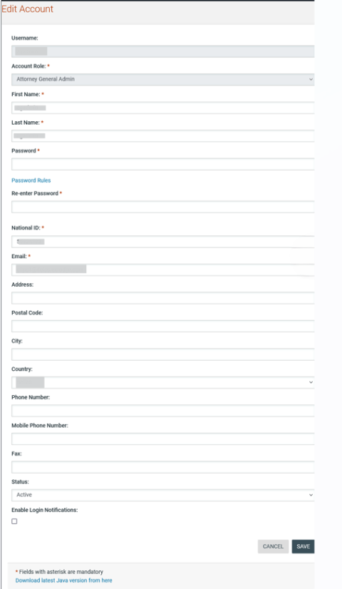

Figure 83: Edit Attorney General Body Authority user profile

System Properties
The SA user has the rights to configure certain properties in the system that determine value limits for procurement procedures, the approval threshold for PEHP users in relation to the Procurement Committee/Controlling officer as well as the amounts that Suppliers must pay for initial registration, renewal of registration and the appeal fee.

Manage Thresholds
To define the upper and lower limits for the various procurement procedures as well as the approval threshold for the Procurement Committee and Controlling Officer the SA user selects the “Manage Thresholds” option in the “Administration” menu (Figure 84).

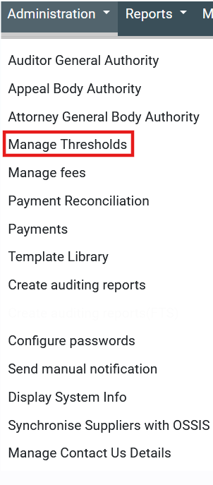
Figure 84: Manage Thresholds menu option

The lower limits for the procurement procedures as well as the approval threshold for the Procurement Committee and Controlling Officer can be defined from SA user separately for each procurement type. The SA user selects a procurement type, provides all required values and submits the form. A value can provided for the upper and lower limit for each property that can be configured. These values are used by the system when validating Annual Procurement Plan entries as well as when validating the details of a new tender. The corresponding procurement method may only be selected if the budgeted amount for the tender falls between the upper and lower limits as defined by the SA for that procurement method. Where no value has been captured, no validation takes place.

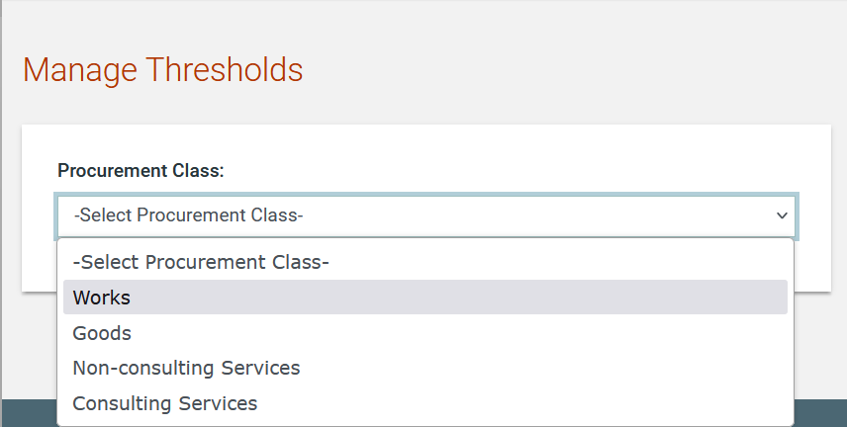

Figure 85: Manage Thresholds – Select Procurement Type

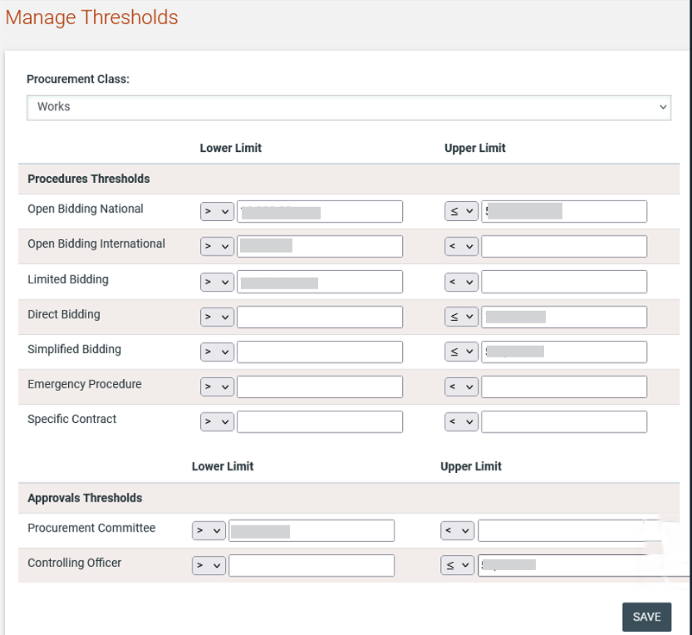

Figure 86: Manage Thresholds for a specific procurement type (i.e Works)

Manage fees
In order for the SA to set the payment amounts for initial Supplier registration, registration renewal as well as the fee to be paid when an appeal is lodged the “Manage fees” option must be selected in the “Administration” menu (Figure 87).
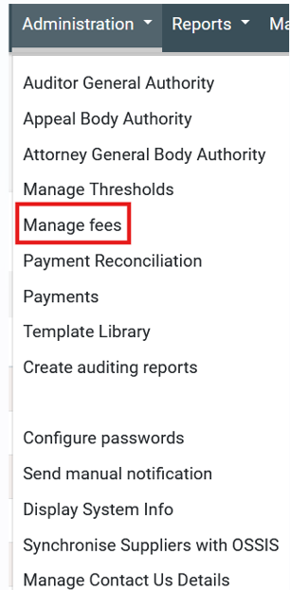

Figure 87: Manage fees menu option

The SA user completes all required values (in Zambian Kwacha) and submits the form. Where no value has been saved, the System will not request a payment for that particular event.

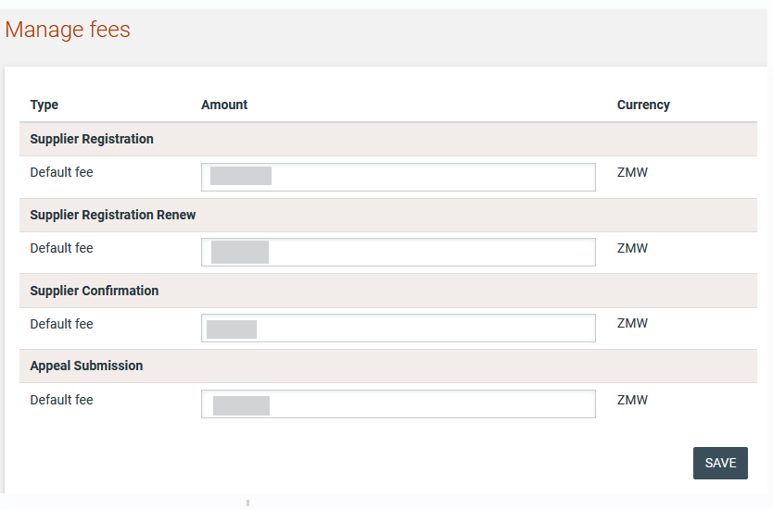
Figure 88: Manage system parameters

Payment Reconciliation
In the unlikely event that the e-GP system is not notified by the banking provider that a particular payment has been processed, the SA user has the right to confirm that a particular payment has been received (Figure 89). The receipt of the payment should be verified by the finance department before any action is taken in the e-GP system.

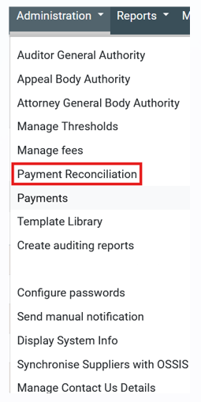
Figure 89: Payment reconciliation menu option

The SA user must provide the amount that has been paid, the reference number as well as the reason and provide an attachment.

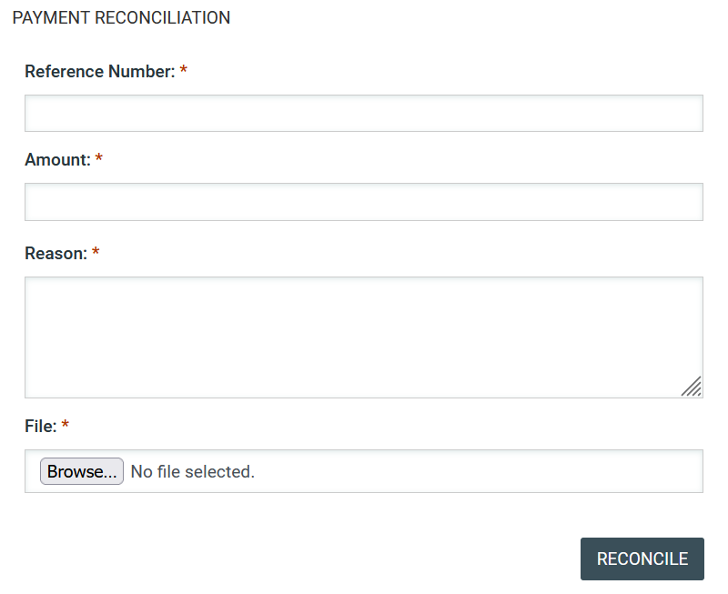
Figure 90: Update payment status

Only outstanding payments can be updated through this mechanism. If the payment has already been processed by the system or if the amount does not match that expected for the supplied reference number, the SA user will be provided with an error message indicating that the transaction number is invalid.

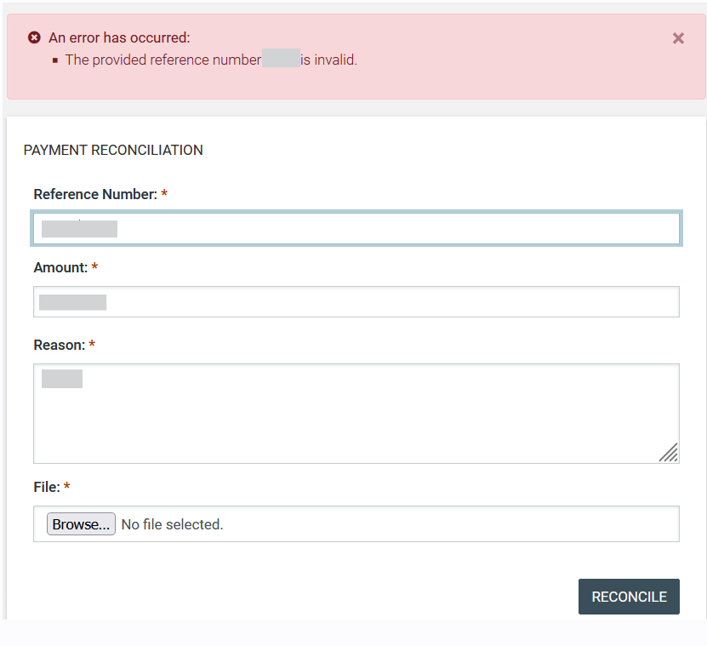
Figure 91: Payment reconciliation failure

Payments

The SA user role has access to the system generated payments by selecting the option “Payments” on administration drop-down menu.
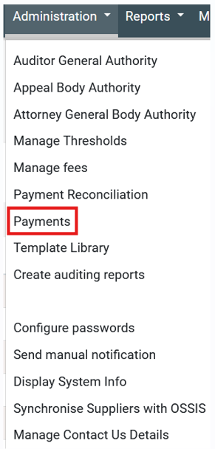

Figure 92: Payments option menu

In the “Payments” page all the system generated payments will be displayed and the SA user will be in position to filter the results per status (completed/ pending), Payment ID and per Supplier organisation.

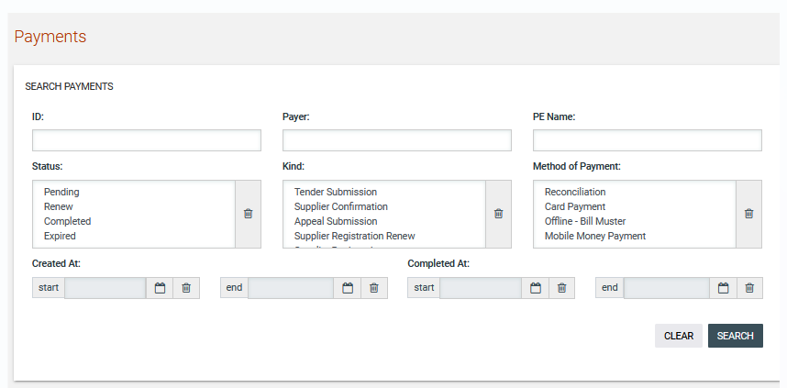

Figure 93: Payments search criteria

The below search criteria will be available to admin user.

- Payment ID
- Payer: the supplier organisation that the payment was generated;
- PE name
- Payment Status
- “Pending”: referring to payments that are pending to be paid from supplier organisation;
- “Renew”: referring to renewal payments;
- “Completed”: referring to payments that the amount has be paid;
- “Expired”: referring to payments that has been expired;

- Kind of Payment
- “Tender submission”: referring to tender participation fee for a specific tender that supplier needs to pay in order to proceed with bid submission;
- “Appeal Submission”: referring to the fee that supplier organisations pay in order to be able to submit an appeal;
- “Supplier registration Renew”: referring to the fee that supplier organisations pay for registration renewal;
- “Supplier registration”: referring to the fee that supplier organisations pay on initial registration;
- “Supplier Confirmation”: tracking the supplier confirmation/renewal for registration certificate;
- Method of Payment
- “Reconciliation”: referring to payment that is completed with manual reconciliation by SA user;
- “Card Payment”: payment that is completed from supplier organisation by card;
- “Offline – Bill Muster”: payment that is completed from supplier organisation offline;
- “Mobile Money Payment”: payment that is completed from supplier organisation by mobile;
- Payment Creation date
- Payment Completion date

The user will be in position to search by selecting specific criteria. The result are displayed on tabular form under payment criteria by selecting the  button.

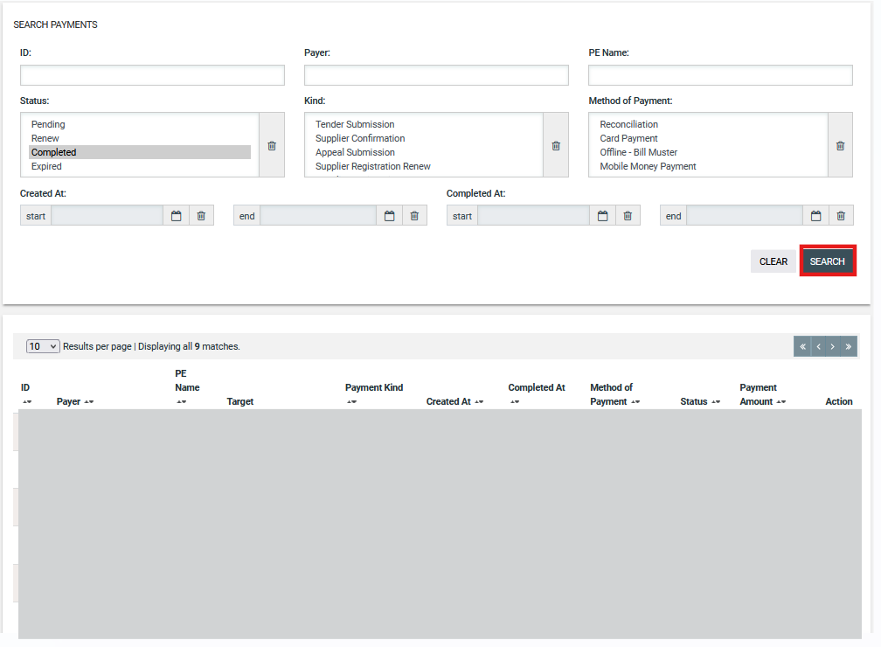

Figure 94: Payments results

The SA user is able to extract payment details downloading on csv format the results of the table under the “payments” page by selecting the “Export Results as CSV” button.

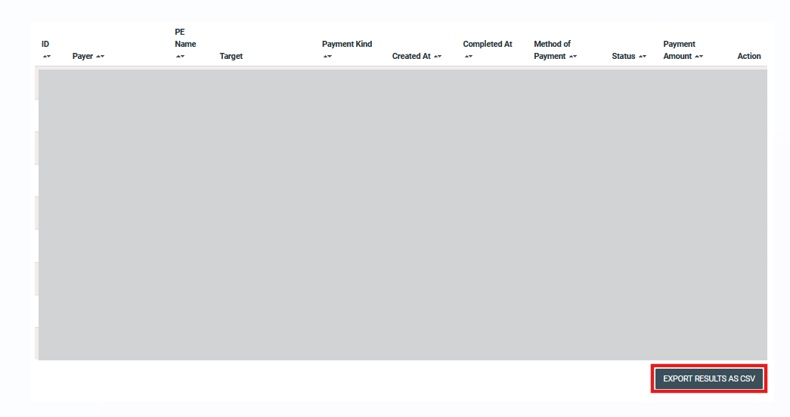

Figure 95: Export as CSV option

Template Library
The SA user may visit the Template Library section and manage the Standard Bidding Documents. The user is able to upload, create and edit simple or dynamic documents and organise them into subfolders.
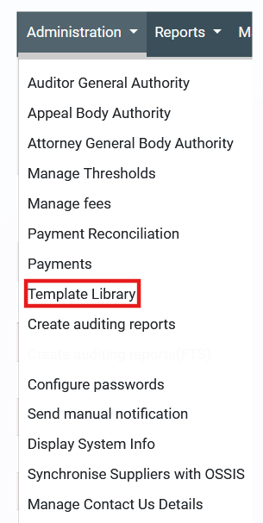

Figure 96: Template library link

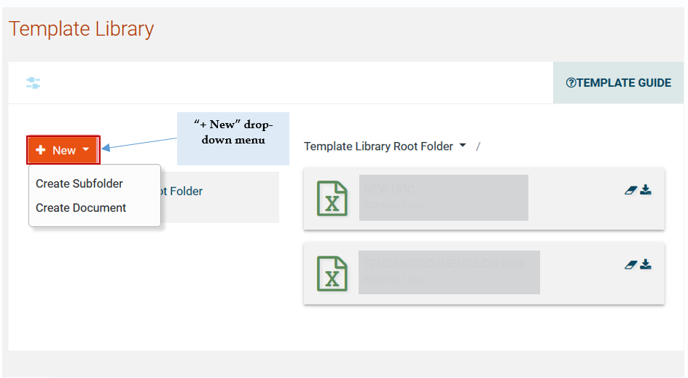
Figure 97: View template library root folder

View Folder / Subfolder / Content
The user has access to the folder details by selecting the “View folder” link for the details of the current folder or the “Title” link of any other subfolder or document, in order to see the details.

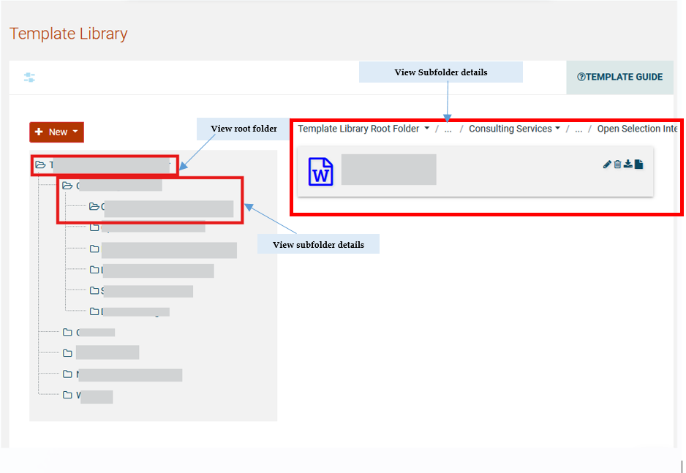

Figure 98: View folder / subfolder links

The user can see the folder content (subfolders or documents) under the Template Library Root Folder Section on the right.

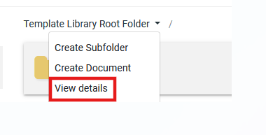
Figure 99: View Root folder details (1)

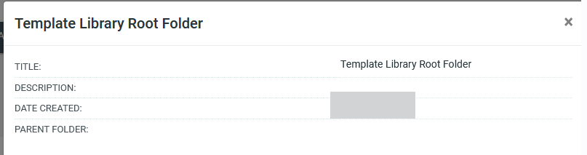

Figure 100: View Root folder details (2)

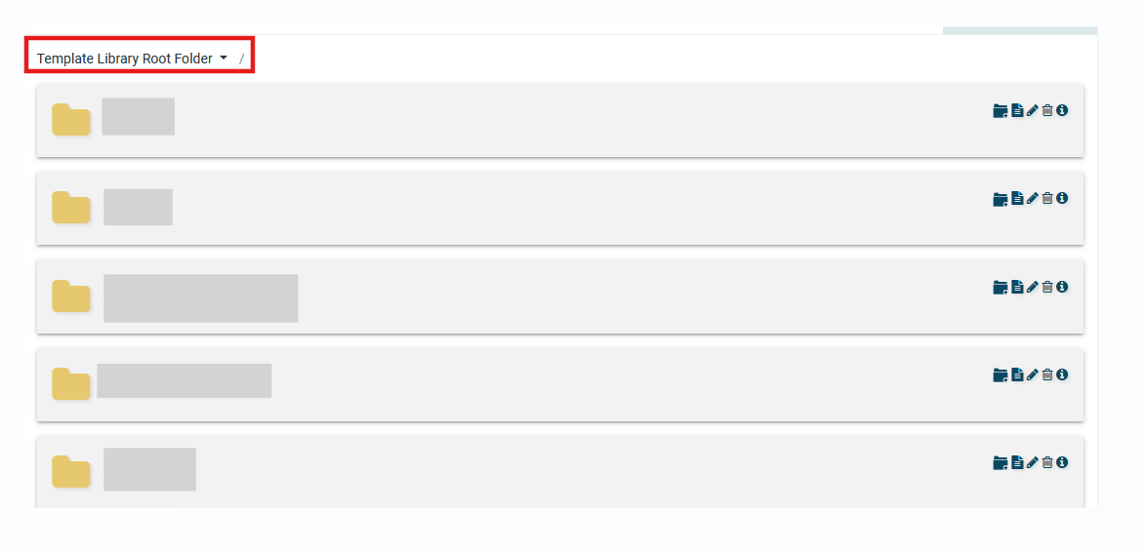

Figure 101: View Folder Contents Link

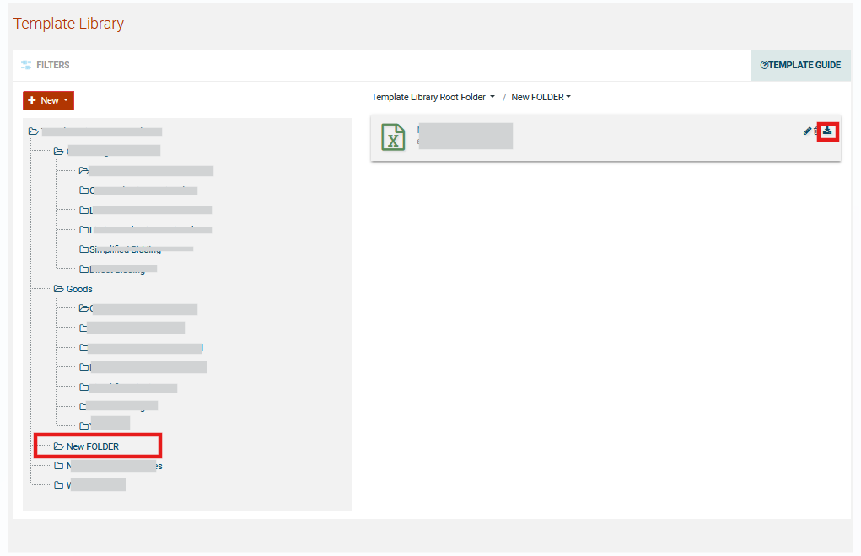
Figure 102: View Folder Contents

Create Subfolder

The user can create a new subfolder under an already existing folder by selecting the “Create Subfolder” option or a subfolder under another subfolder by selecting the option in the red box.

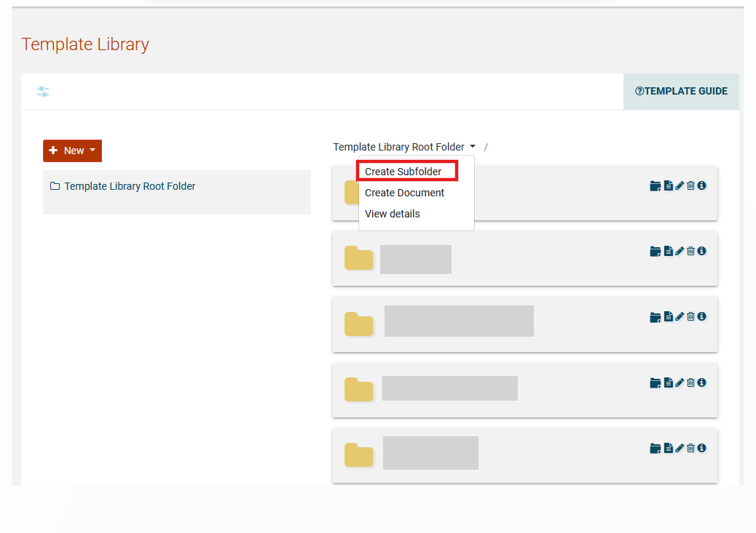

Figure 103: Create Subfolder under the root folder

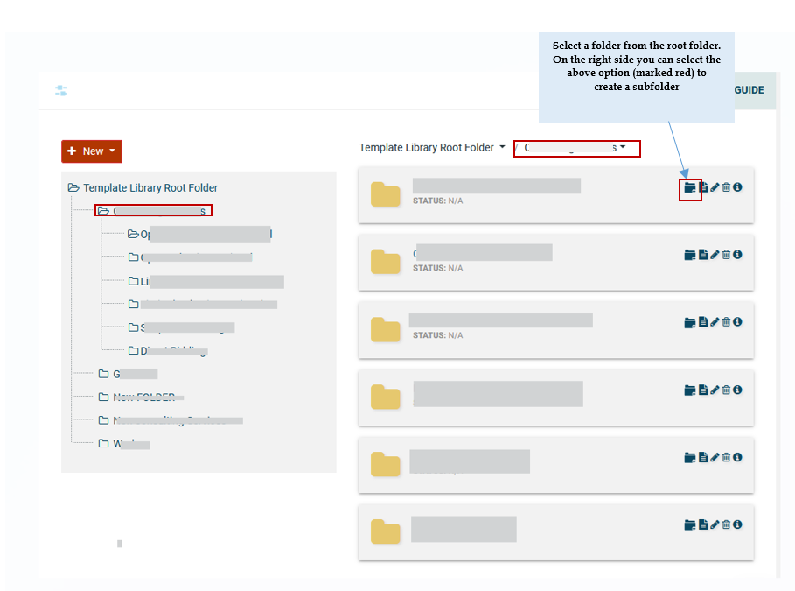

Figure 104: Create Subfolder Link

The user provides a title and description of the new subfolder through the respective page and selects “Save”.

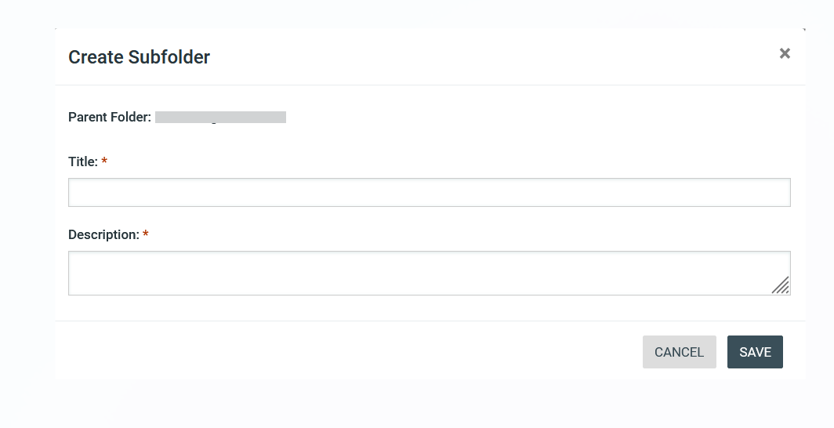
Figure 105: Create Subfolder page

Edit/Delete Subfolder
The user may edit or delete a subfolder by selecting the respective buttons.

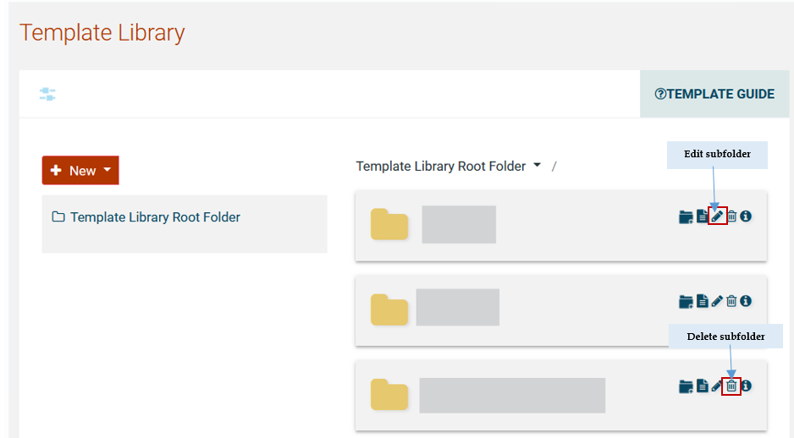

Figure 106: Edit/delete Subfolder link

Create Document
The user can create a new document within a folder by selecting the respective button.

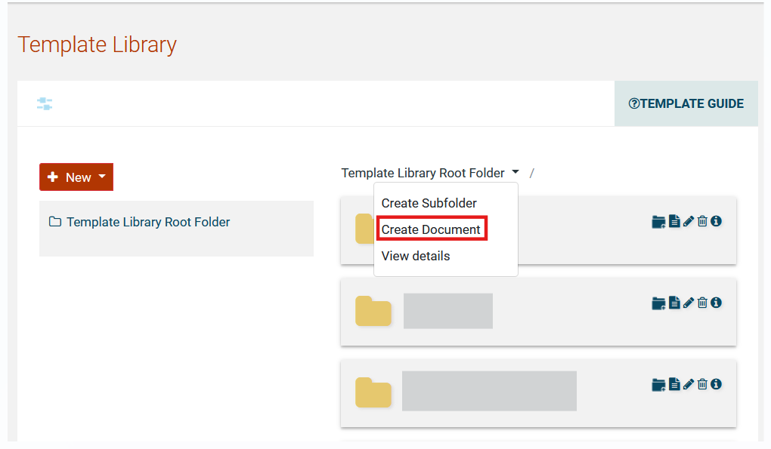
Figure 107: Create document link

SA user populates all the mandatory fields and click on the ‘’Save Draft’’ button.

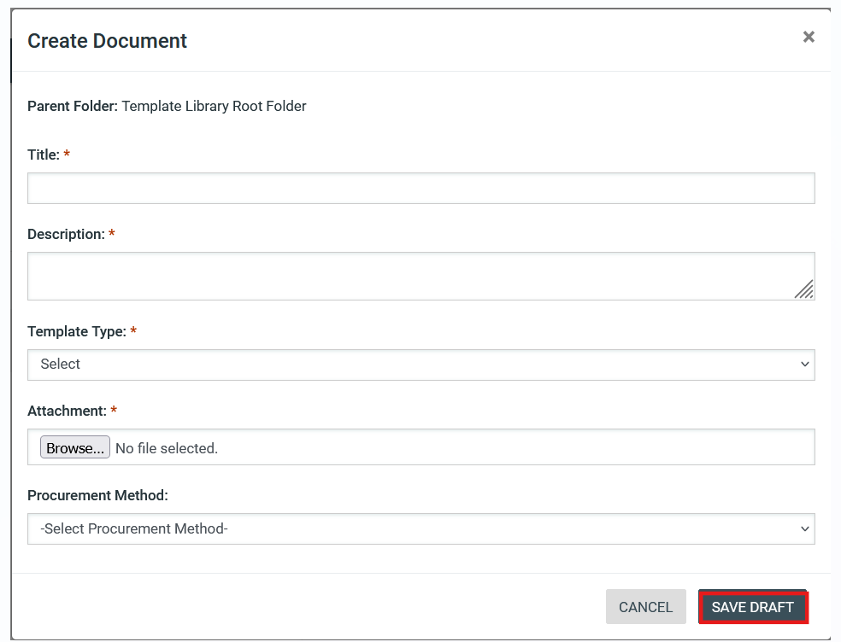
Figure 108: Create document page

The user also can select a specific procurement method (“Procurement method” drop-down field) in order the document to be displayed on document page for tenders that were defined with the specific procurement method. The aforementioned drop-down list contains all the available procurement procedures of the e-GP system.

Following the definition of workflow for a new Tender, the e-GP system will check for all the Documents that the corresponding procurement procedure has been selected for them and copy them within the Tender Documents Area as draft.

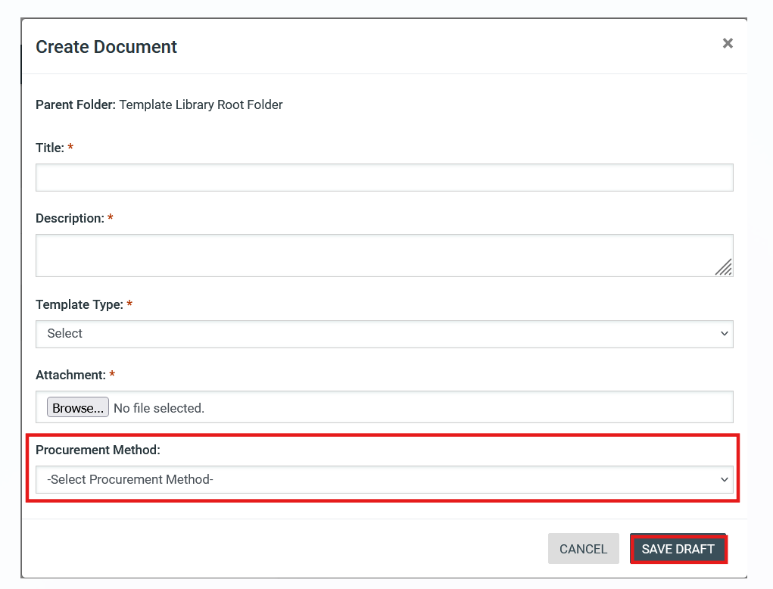

Figure 109: Procurement method drop-down field

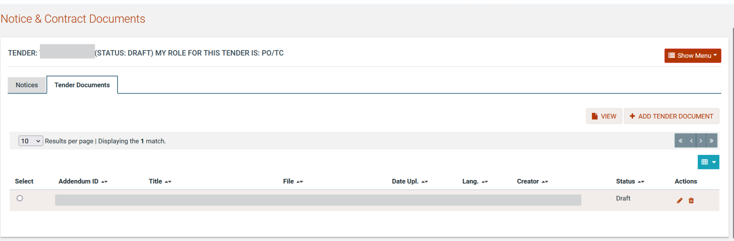

Figure 110: Copied draft document from Template Library

Edit / Delete Document
The SA user may edit or delete a competition document, as long as it is in “Draft” status, by selecting the respective buttons.

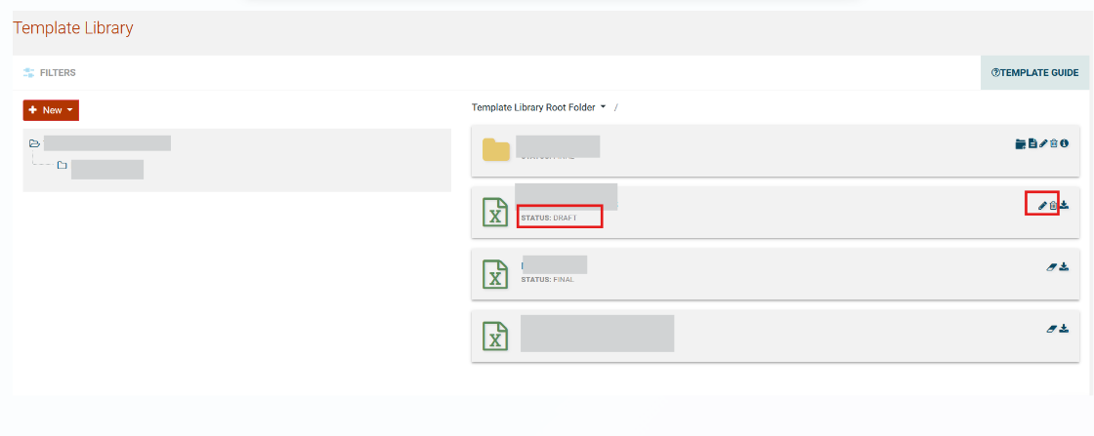

Figure 111: Edit / Delete document links

Create Dynamic Document
The SA user can create bidding documents using the parameters shown in Figure 101, by adding the keywords under the “Name” column among the text, where necessary. These fields will be fed from the tender details and be auto-populated with the respective values of the tender, whenever a procurement officer selects to add a dynamic bidding document to the contract documents of a tender.

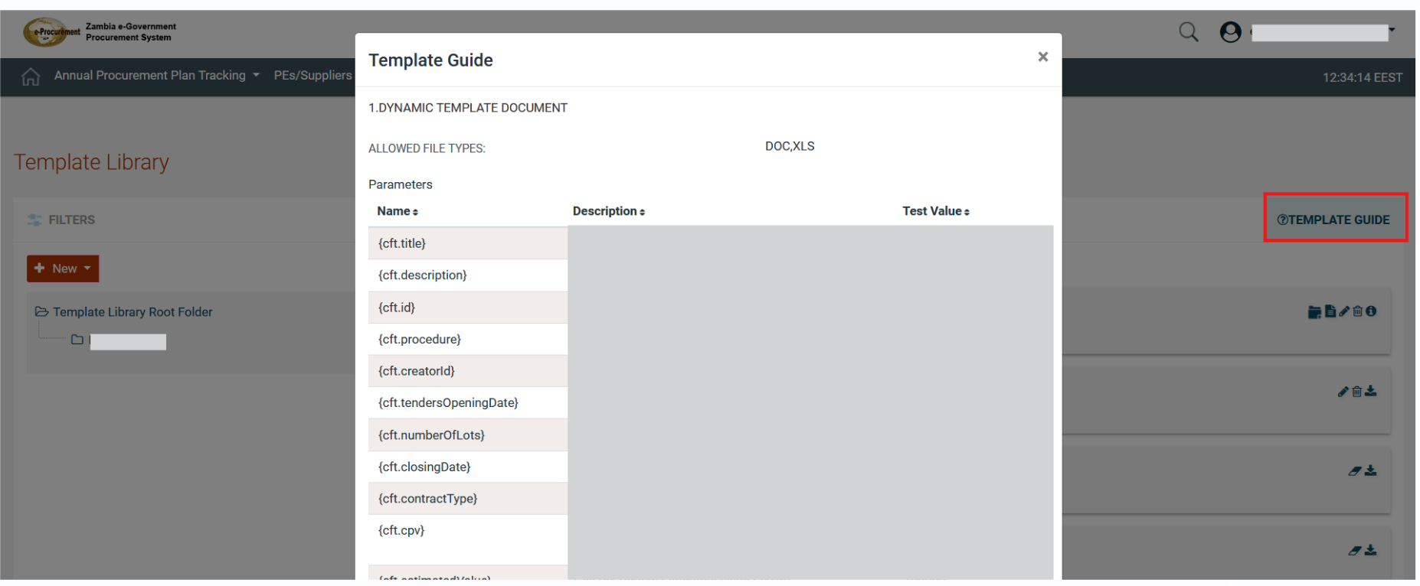

Figure 112: Dynamic Document Parameters

The user can access the aforementioned parameters page by selecting the “Template Guide” button.

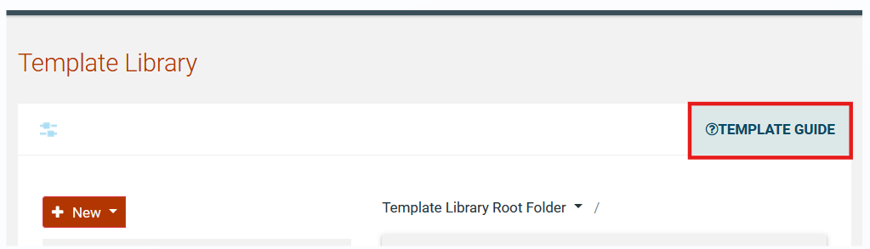

Figure 113: Template Guide link

Search Template Library
The SA user may search through the template library for a folder or document by inserting specific criteria.

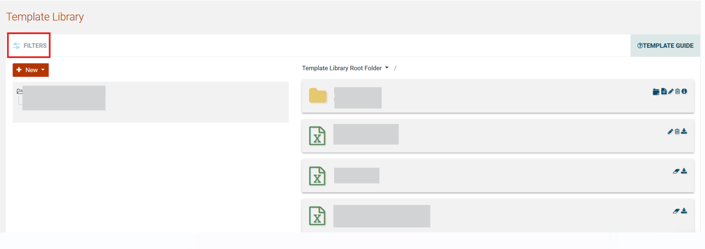

Figure 114: Search Template Library link

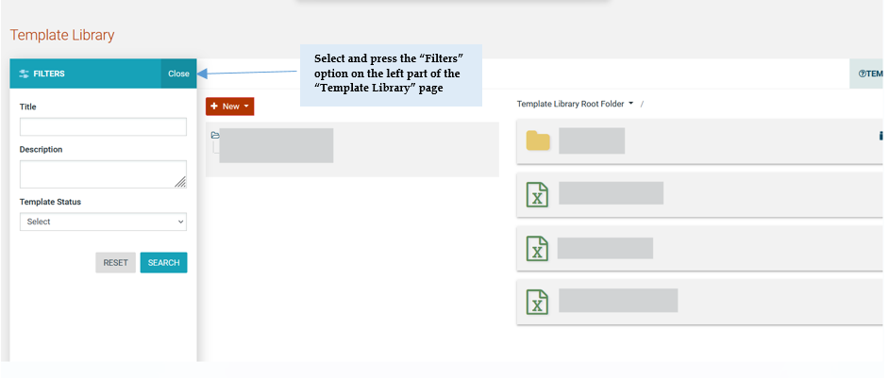
Figure 115: Search Template Library Parameters

Auditing

In order to preview all user actions, the SA selects the option “Create auditing reports” in the Administration drop-down menu.

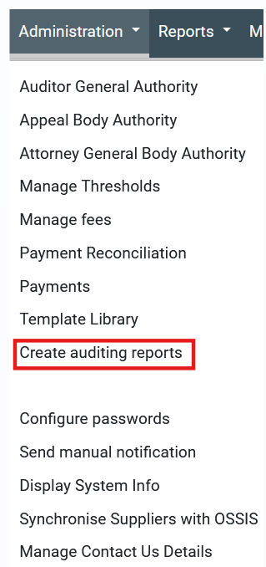

Figure 116: Administration drop-down menu, auditing reports

The system displays a page which allows the SA user to create queries regarding user actions. The user can narrow the range of the results by defining the from/to date period, the type of activity, the tender as well as the Procuring Entity for which user actions would be retrieved. At selection of the “View” button, the system will generate an auditing report listing all user actions which fulfil the specified search criteria.

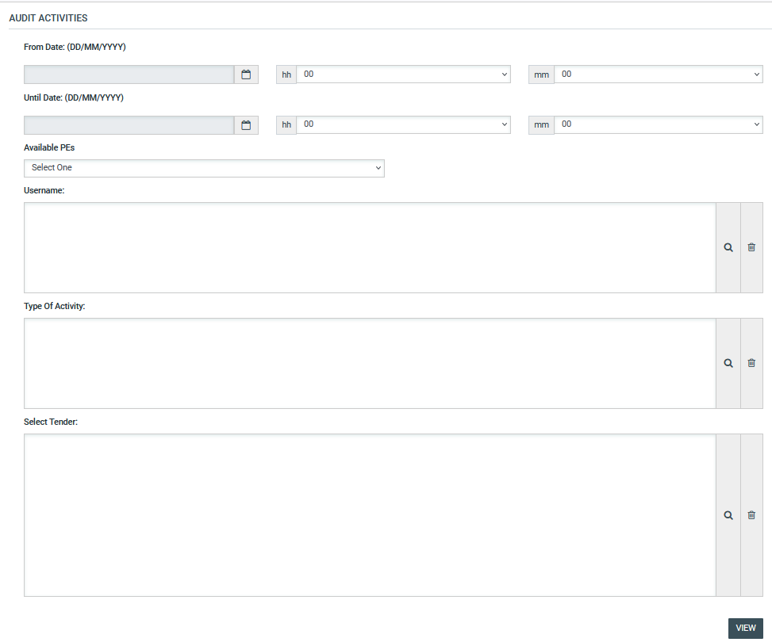
Figure 117: Auditing activities

The auditing report can be saved in CSV format by selecting the button “Export Results as CSV” (Figure 118).

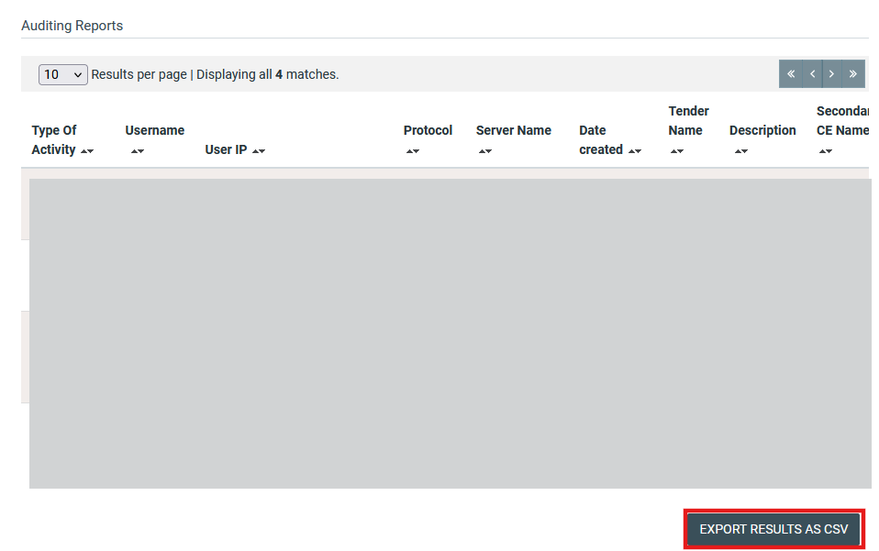
Figure 118: Auditing report

Configure Passwords
The system administrator is entitled to define the configuration of passwords used by each user category (PE, EO, Administrator users). The password configuration functionality is accessible through the “Configure passwords” option in the Administration drop-down menu.

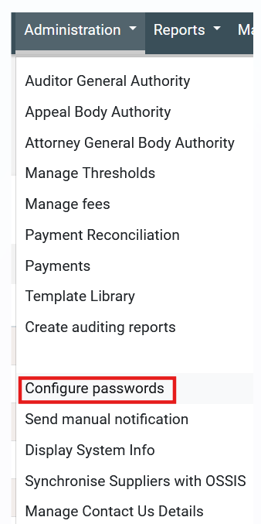

Figure 119: Administration drop-down menu, Configure passwords

The system displays a page which allows the SA user to perform the following configurations on the passwords:
- Specify which letters (uppercase/lowercase), numbers or characters will be used in passwords.
- Allowed login failures: determines the maximum login failures. When the maximum number exists the account is deactivated.
- Password lifetime (in months): determines the validity period of a password. At the end of this period the password expires, and new password should be defined.
- Password min length: determines the minimum size of a password.
- Password max length: determines the maximum size of a password.
- Password history: enables/disables the password history functionality. In the case that the functionality is enabled, once a password has expired for a specific user account then the user must provide a new password that has never been used for the respective user account. Password history mechanism automatically stores the date and time of any changes that are performed for a user’s password, which is also used for checking the date of expiration of the password.

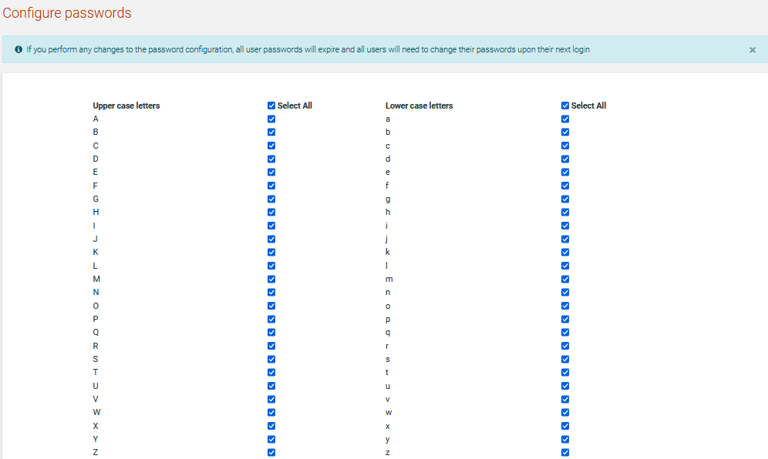

Figure 120: Configure passwords, uppercase/lowercase letters configuration

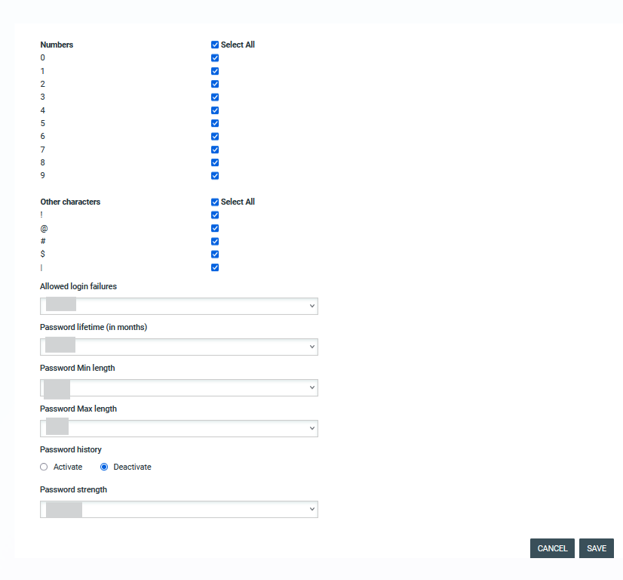
Figure 121: Configure passwords, numbers, other characters and parameters configuration

Manage Information Area
The SA can manage the content displayed in the information area of the system (Figure 112). In order to manage content of information which is displayed in the system the SA selects the option “Manage Information Area” in the “Information” drop-down menu:

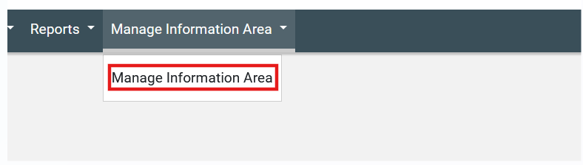
Figure 122: Information drop-down menu, Manage Information Area
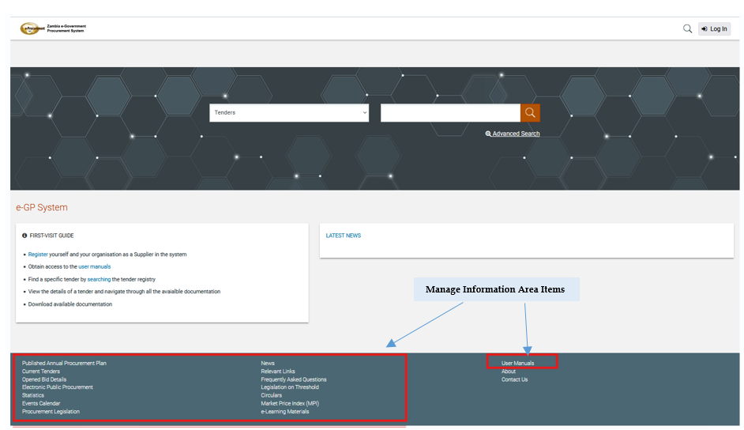

Figure 123: Displayed information

New items in the information area are introduced by selecting the section of their content and, then, the button “Add Item” (Figure 110). New items can be added in the following sections:
- News
- Procurement legislation
- Electronic public procurement
- Statistics
- Relevant Links
- Frequently asked questions
- User guides
- Events Calendar
- User manuals
- Legislation on Threshold
- E-learning materials
- Circulars
- Market Price Index (MPI)

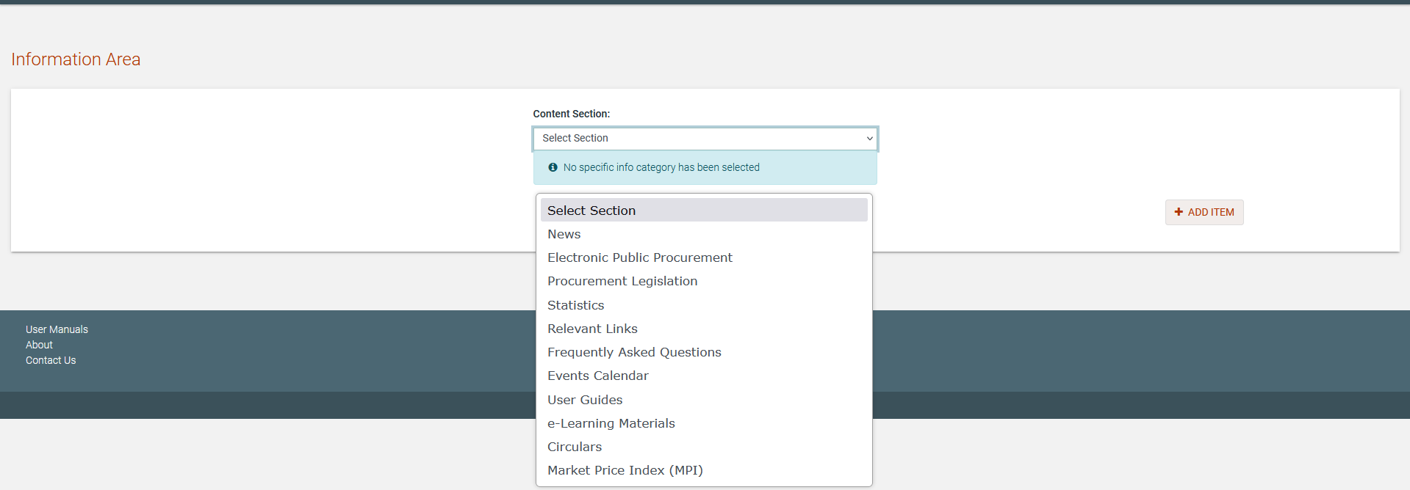
Figure 124: Management of information area

In order to add a new item (e.g. “News”) the SA user provides its title and a description. Furthermore, an optional attachment can be also provided. Selecting the button “Upload” stores the new item in the system (Figure 111). The user may select whether the added item will be visible to all users or only the PE users of the system.

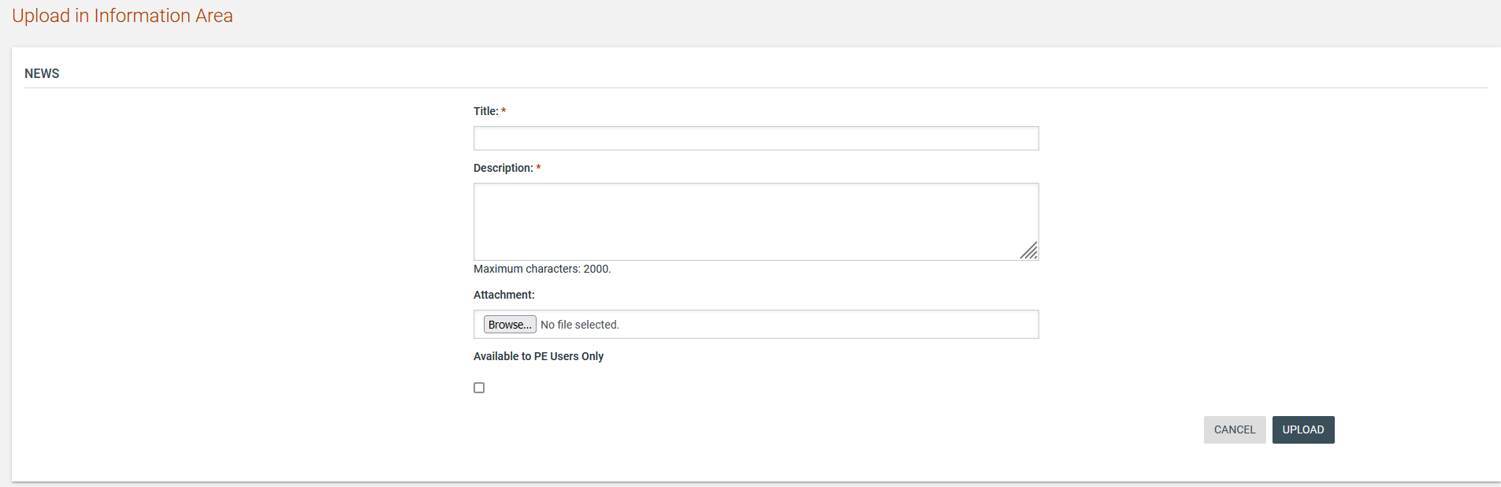
Figure 125: Upload a News item

After successful upload, the system lists all uploaded “News” items. The SA can add new items by selecting the “Add Item” button and delete a selected item by using the “Delete” button (Figure 126).

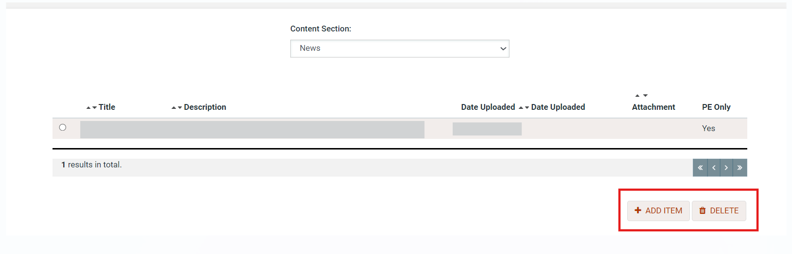

Figure 126: Information area, list of news items

Contact us page

The SA user will be able to change the following contact details of contact us page (Email, Telephone, WhatsApp) by selecting the option "Manage Contact Us Details" on "Administration" section.

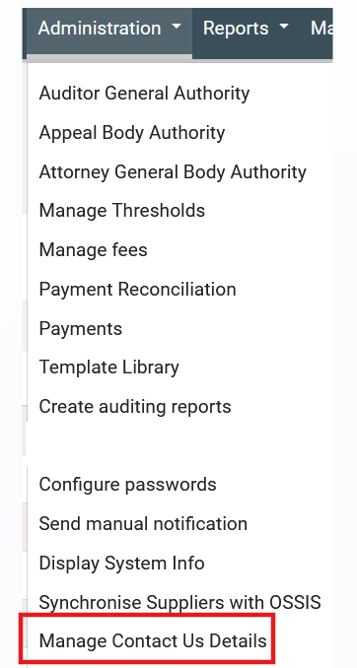

Figure 127: Manage contact us details option

Upon selecting the relevant option the "Manage Contact Us Details" page will be displayed
On "Manage Contact Us Details" page SA user will be able to view the existing contact details for the following fields.
- Email
- Telephone
- WhatsApp
On Manage Contact Us Details page a form with following fields and buttons will be displayed in order the SA user to provide the new contact details. The below field will be predefined with existing contact details.
- Email, text field;
- Telephone, text field;
- WhatsApp, text field;
Alongside the email address egphelp@yahoo.com on sp2 SA user can edit the "Email" field by providing an additional email address. SA user can provide more than one Telephone numbers on "Telephone" fields using comma and space ("Telephone Number1", "Telephone Number2" etc.). SA user can provide more than one WhatsApp numbers on "WhatsApp" fields using comma and space ("WhatsApp Number1", "WhatsApp Number2" etc.).

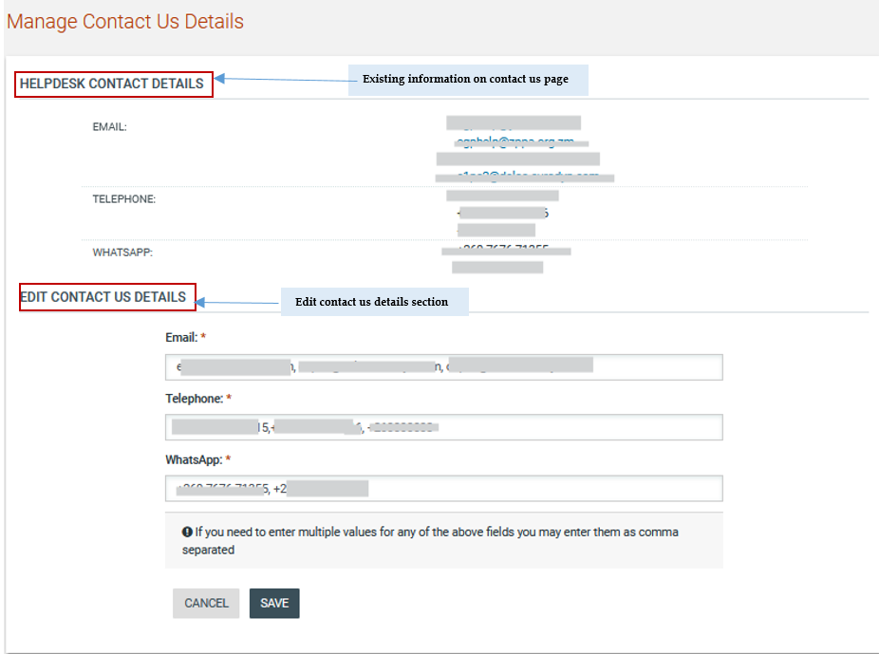

Figure 128: Manage contact us details page

Upon SA user providing new contact details and selecting the option "Save" the new contact details will be changed and the message "Your changes have been saved successfully." will be displayed. The new contact details will be displayed on "contact us" page.
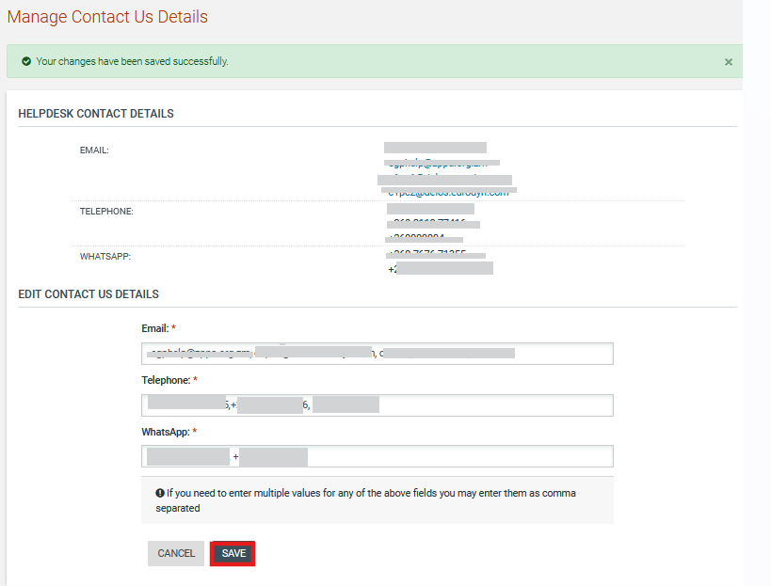

Figure 129: Select Save option

Upon SA user selecting the "Cancel" option the contact details will not be changed and the homepage will be displayed.

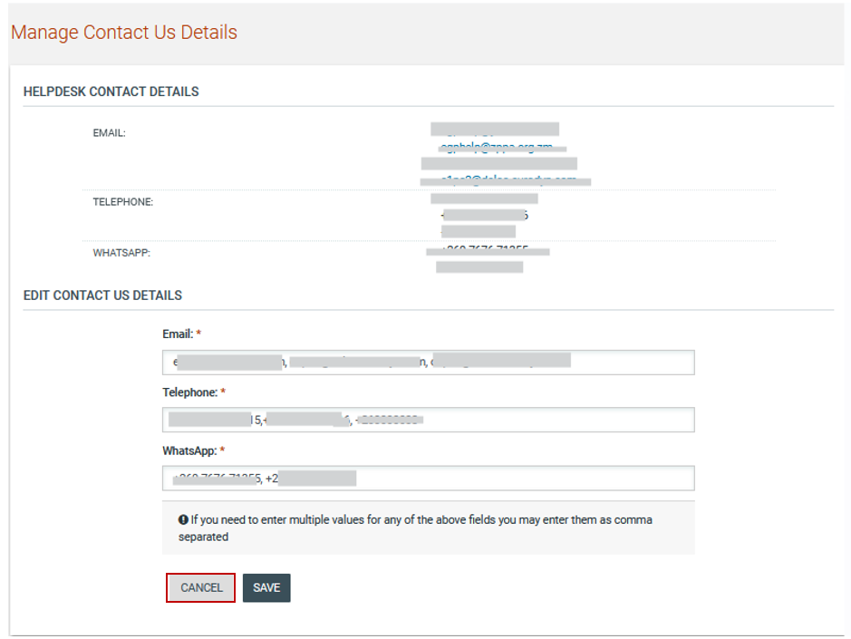

Figure 130: Select cancel option

Manual Notifications

The SA user can send manual notifications to specific users, to Supplier users, to PE users and to all Supplier administrators. The “Send Manual Notifications” option is available on “Administration” drop-down menu.
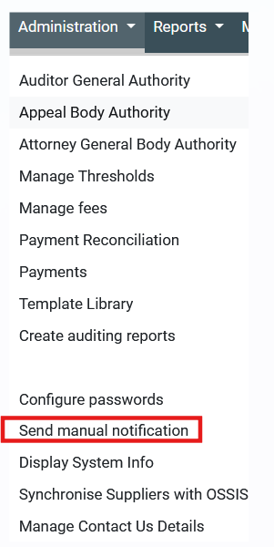

Figure 131: Send manual notification option
SA user can send a manual notification to a combination of the aforementioned categories of users, by populating at least all the mandatory fields and clicking on the “SEND NOTIFICATION” button.

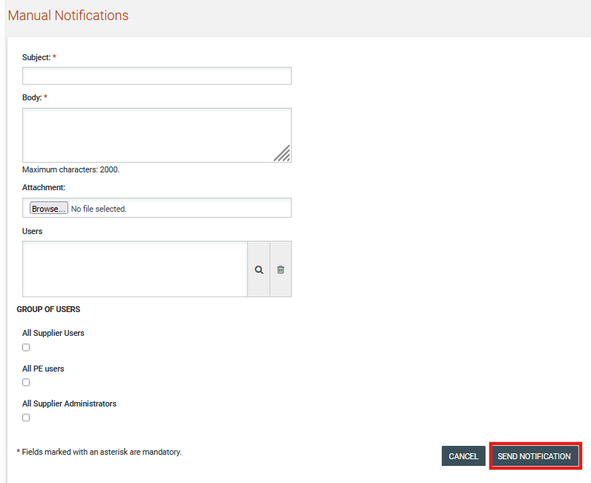

Figure 132: Send manual notification page – Send notification button

Contract Management

SA user can also view the contracts created by PEs by selecting the option “PE contracts” available on “Administrators” drop-down menu.

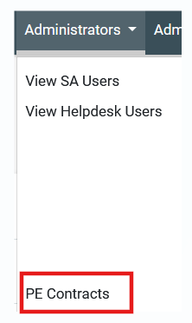
Figure 133: PE Contracts option
On “PE Contracts” the list of contracts are available. The user selects the contract link for a specific contract available on “Contract Title” column. The details of contract are available

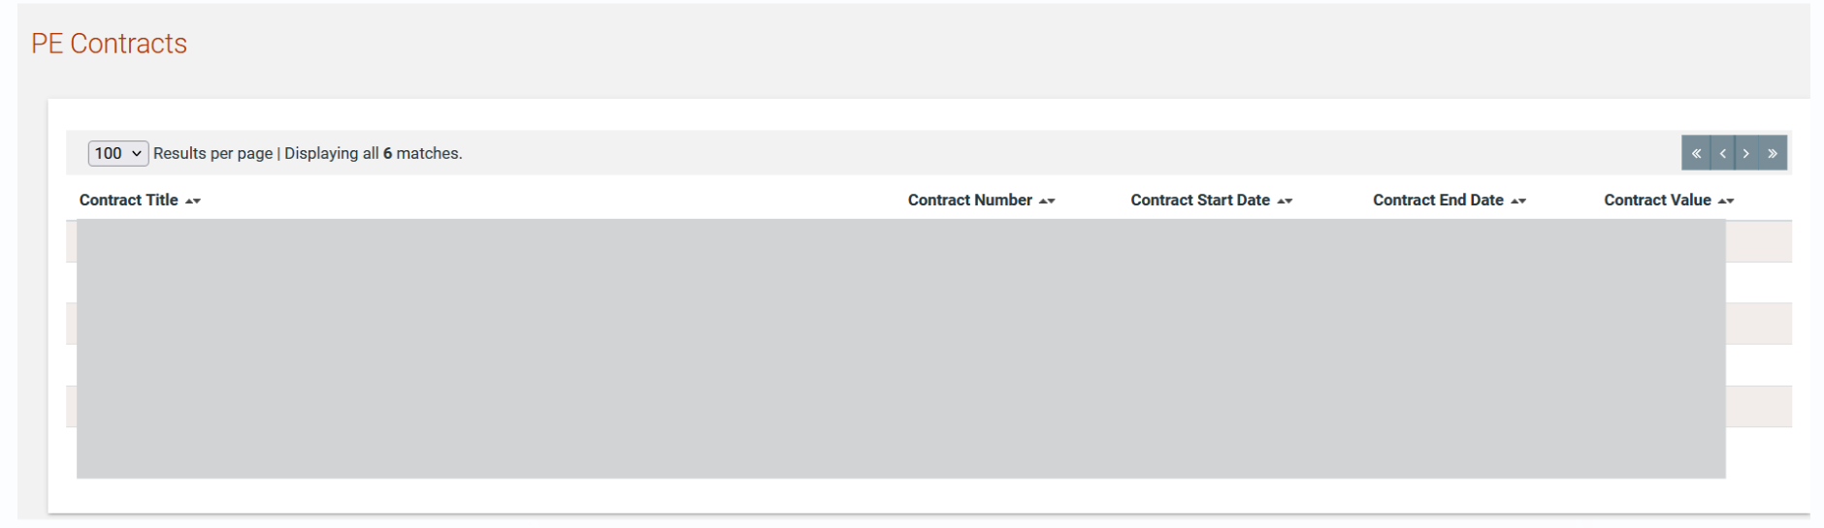

Figure 134: PE Contracts page

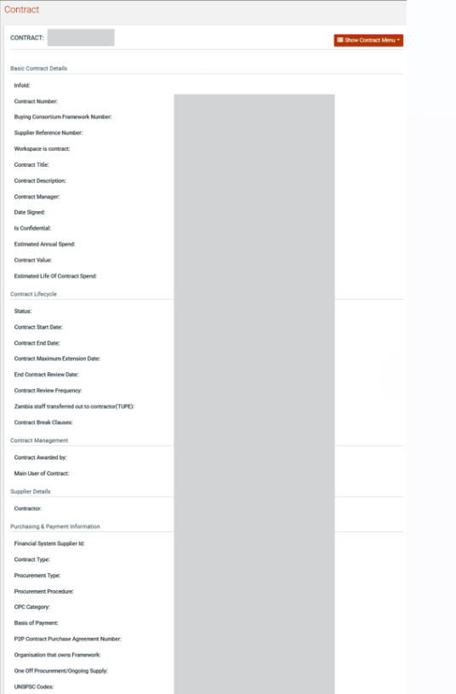

Figure 135: Contracts details page
SA user can view the detail of users associated of a specific contract by selecting the option “Associated contract managers” available under the “Show contract menu” drop-down menu.

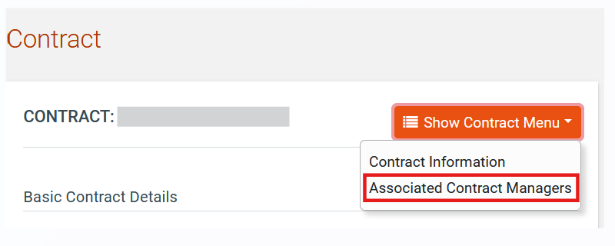
Figure 136: Associated Contract Managers option

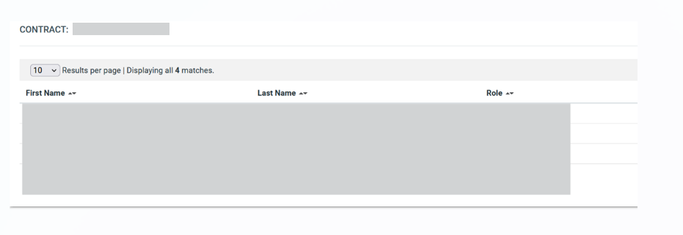

Figure 137: Associated Contract Managers page

Online Chat

The online chat functionality is accessible to each user on the e-GP for technical assistance reasons.
Users can initiate a request by submitting their name, their email, the type of issue (help to Buyers/Suppliers etc.) and they can type a message, to request for help. Multiple System Administrators associated to the dedicated Chat Agent roles can handle these queries and provide their answers within the functionality, according to their queue.

SA user accesses on online chat functionality separately to e-GP and selects the “CAS” button.

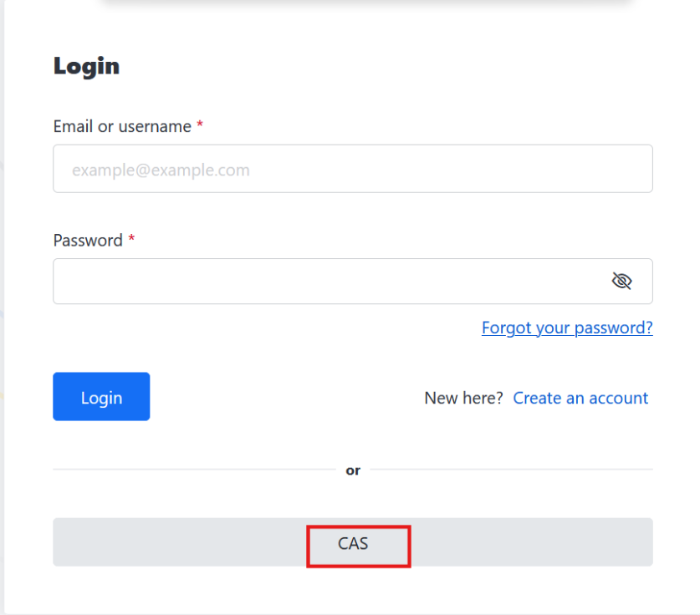

Figure 138: Select CAS button – SA Access to chat functionality

The user accesses to the conversation room. All available messages was sent by user are available to the left side of the page. User can select a specific conversation in order to answer the request.

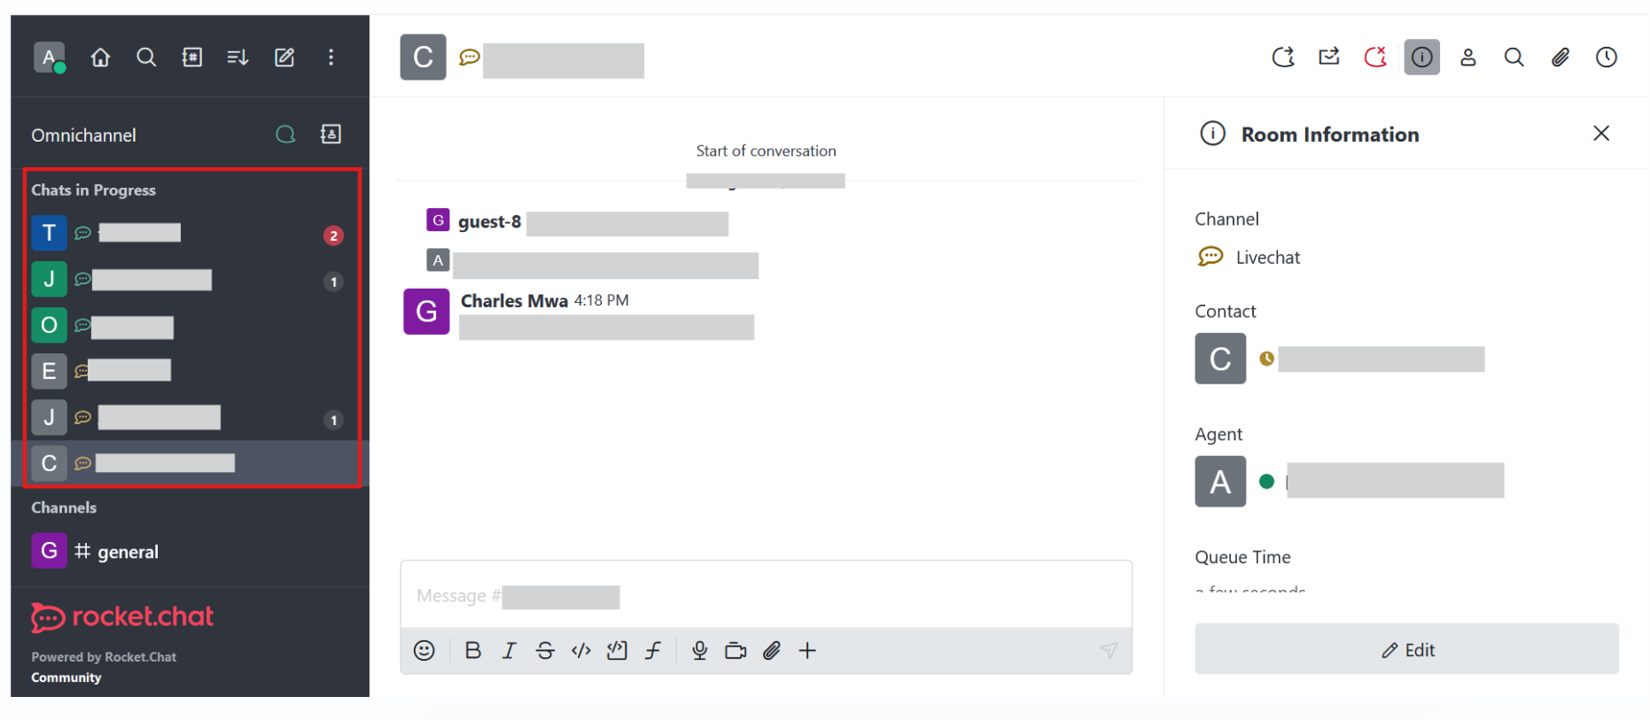
Figure 139: Chat in progress - View conversation list

The user can answer a message by selecting a specific conversation on the left side of the page.
Upon selecting the conversation he/she is able to view the request and type an answer.

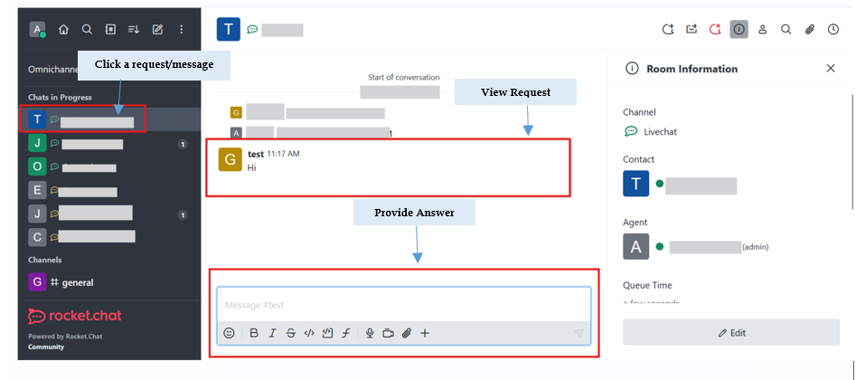

Figure 140: Answer message

Revert Tenders

SA user role will be able to revert to bid submission stage tenders which the current status is awaiting bid opening. For all tenders on “awaiting bid opening” status a “Revert” button will be available on “View Tender Details” page.

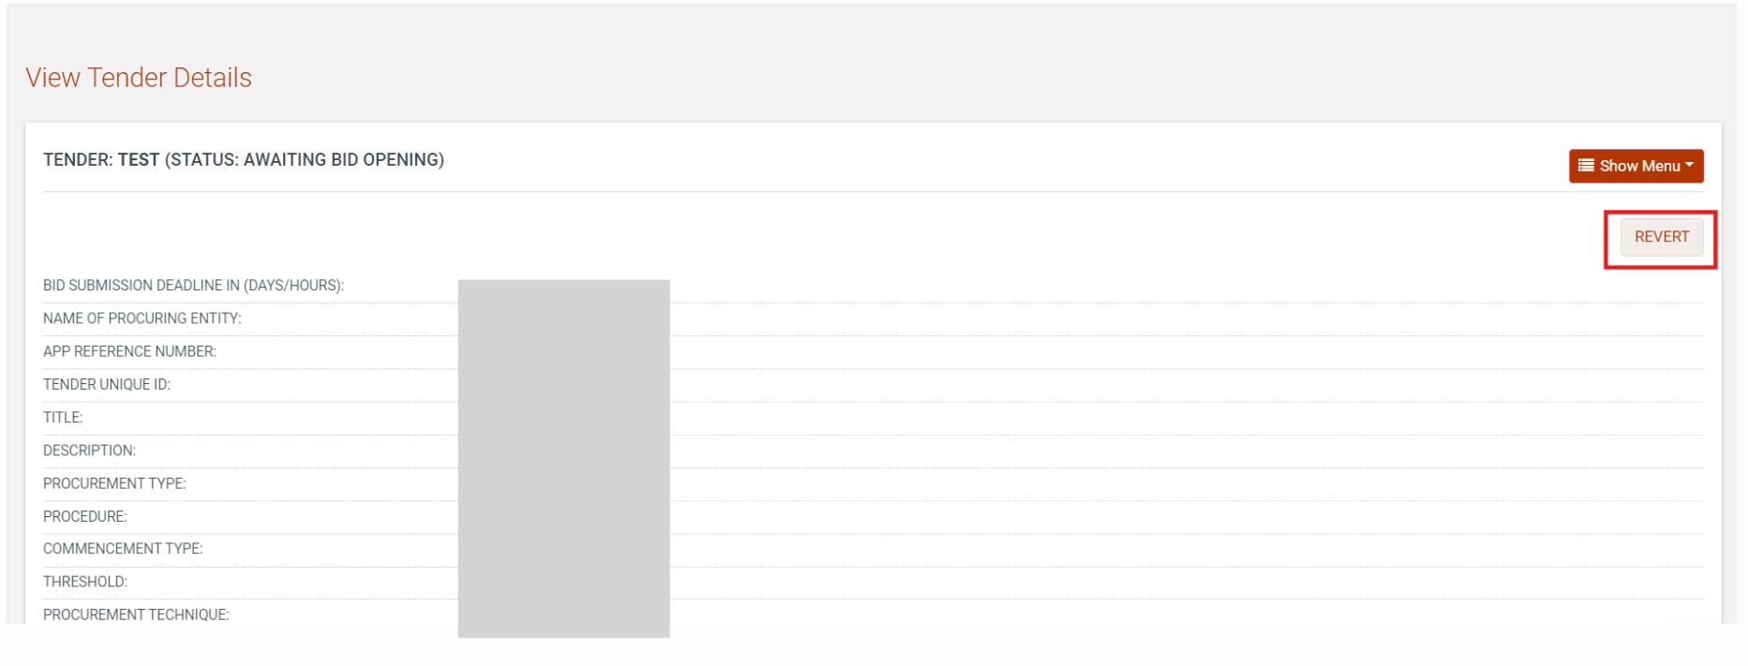

Figure 141: Revert Button

Upon SA user selecting the “Revert” button a message will be displayed “Are you sure you want to revert this tender?” and the following available options
“Ok”
“Cancel”
On the above message (modal), SA user will be able to edit the bid submission deadline date by providing a new one from message (modal) before he/she decide to revert the tender or not by selecting “Ok” or “Cancel” option.

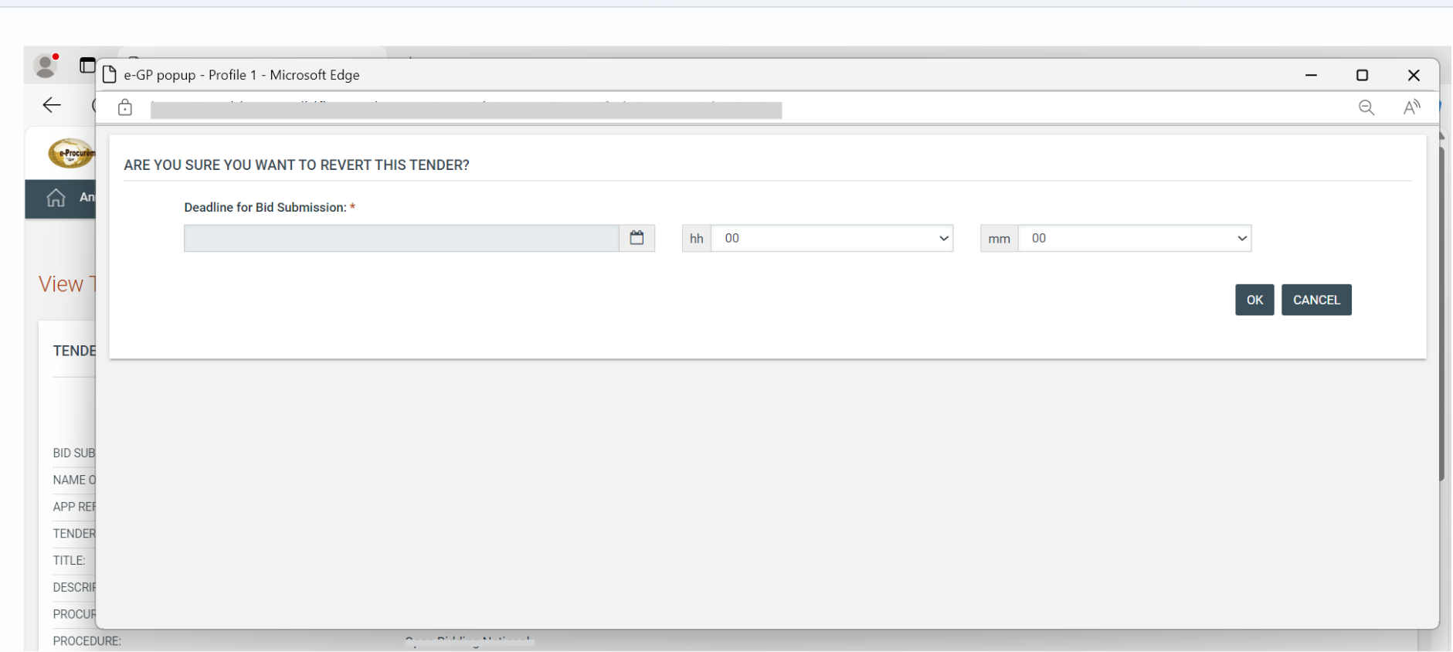

Figure 142: Provide New Submission Deadline

Upon SA user decide to revert the tender by selecting “ok” button the confirmation message “ Tender has been reverted successfully” will be displayed and the status of reverted tender will be changed to “Bid Submission”.
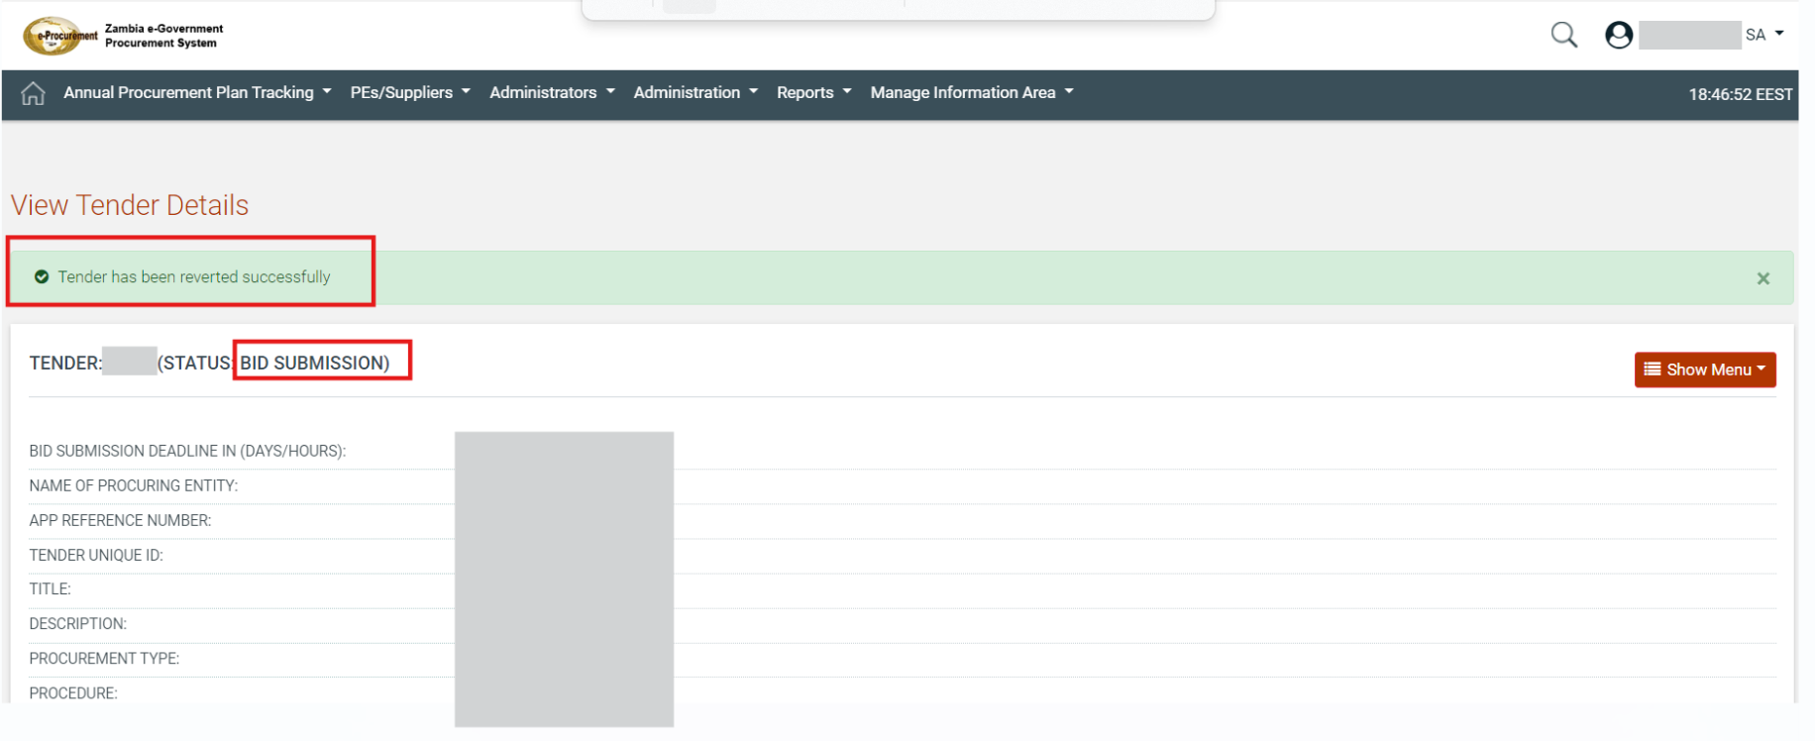

Figure 143: Tender status upon selecting the “ok” button

In case the tender is under cancellation that hasn’t been completed (addendum for tender cancellation hasn’t been published) the reported tender cannot be reverted by SA user. When SA user selects the “Revert” button a message “Tender cannot be reverted as it is under cancellation process” will be available on “view tender details” page and tender cannot be reverted.

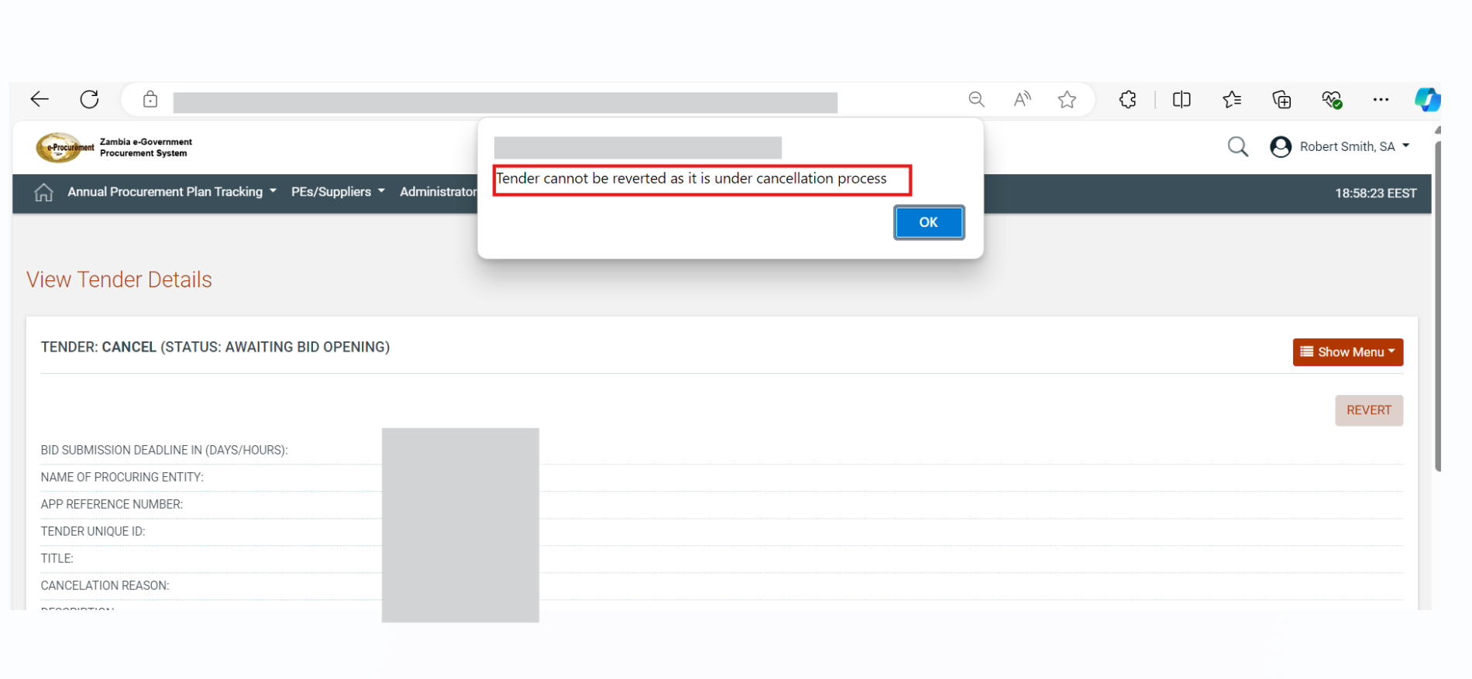
Figure 144: Revert tender under cancellation

