The Government of the Republic of Zambia
Enhancement of the Electronic Government Procurement System - CR16

End user Buyer Manual
Issue 01
Version 1.0

EUROPEAN DYNAMICS S.A.



Modification History

Date | Version | Author | Comments
21/10/2024 | 1.0 | ED | Initial version

Table of Content

1 Minimum and Recommended System Requirements 26
2 General Functionality 27
2.1 General Usage Guidelines 27
2.2 The Tender Menu Functionality 28
2.3 Main Page 29
2.3.1 Login Section 29
2.3.2 Search Section 30
2.4 Login to the System 30
2.5 Login to the System for the First Time 32
2.6 Logout from the Platform 33
2.7 Password Recovery 34
2.8 Maintenance of User’s Profile 35
2.9 XLS File Format Support 38
2.10 XLS File Upload Validation 38
3 Procuring Entity Management 39
3.1 Edit organisation details 40
3.2 View the Users Belonging to the Procuring Entity 40
3.3 Insert a new user in a Procuring Entity 41
3.4 Edit user’s details 42
3.5 Login Notifications 43
4 Searching Functionality 47
4.1 Simple Search 47
4.2 Advanced Search 48
4.3 Current Tenders Search 52
4.4 CSV Export 53
5 Supplier Evaluation Comments 54
6 Bidding/Tender Advertisement 55
6.1 Creation & Publication of an Advertisement 55
6.2 Editing of an Advertisement 57
7 Annual Procurement Plan (APP) 57
7.1 Create an Annual Procurement Plan Request 58
7.2 Respond to Annual Procurement Plan 59
7.3 Review APP Responses 60
7.4 APP Entry with Reduced Floatation Justification 61
7.5 Publish APP Responses 63
7.6 View Published APP Plans 64
8 Tender Workspace 65
8.1 Preparation of a Tender 66
8.2 Link APP on Tender Including the Reduced Floatation Justification 69
8.3 Association of Procuring Entity Users 69
8.4 Code of Conduct 71
8.5 Tender Documents 72
8.6 Define Workflow 74
8.7 Tender Documents Page – Draft Tender Document from Template Library 74
8.8 Define Evaluation Criteria 75
8.8.1 Import Criteria 75
8.8.2 Define Tender Criteria 76
8.8.2.1 Criterion Type: Text Field 78
8.8.2.2 Criterion Type: Text area 78
8.8.2.3 Criterion Type: Number 79
8.8.2.4 Criterion Type: File 81
8.8.2.5 Criterion Type: List 81
8.8.2.6 Criterion Type: Date 82
8.8.2.7 Supplier read only criteria 83
8.8.2.8 Definition of envelope weight 84
8.8.2.9 Financial Envelope 85
8.8.2.10 Definition of the financial element 85
8.8.2.11 Setting financial criteria 86
8.8.2.12 Validating and saving the Tender Structure 87
8.8.3 Create Tender Structure with Lots 87
8.8.3.1 Copy Lot Structure between Lots 88
8.9 Create / Publish Tender Notice 88
8.10 Invitations 89
8.11 Approval of Flotation Period – Limited Selection Procurement Method 90
8.12 Modify Tender Structure 94
8.13 Tender Cancellation 96
8.14 Clarifications 99
8.14.1 Create an Offline Request for Clarification 101
8.14.2 Creation of a Clarification Without Request 101
9 Bid Opening 102
9.1 Unlock Bids – 1st PO/OS 102
9.2 Offline Bids 103
9.3 Approve Unlocking – 2nd PO/OS 105
10 Evaluation of Bids 106
10.1 Conflict of Interest Declaration 106
10.1.1 Replace Evaluator 107
10.1.2 Disassociate Evaluator 109
10.2 Clarifications During Evaluation 109
10.3 Evaluation of Bids 111
10.4 Evaluation Report 115
10.5 Approve evaluation report 116
10.6 Manage Evaluation Report 118
10.7 Conclude Evaluation 121
10.8 Feedback 127
10.9 Final Ranking 129
10.10 Postqualification 131
10.11 Offline Evaluation Results 134
11 Framework Agreement 135
12 Contract Awarding 138
12.1 Draft Contract(s) 138
12.2 Submit to Supplier and Finalise contracts 139
13 Contract Award Notice Publication 142
14 Contract Management Functionality 144
14.1 Edit Draft Contract 148
14.2 Delete Draft Contracts 151
14.3 Finalise Contract 151
14.4 Edit Finalised Contract 154
14.5 View PE contracts 156
14.6 Show Contract Menu 157
14.7 Associated Contract Managers and Users 158
14.8 Manage Contract Documents 159
14.8.1 Add Contract Document 159
14.8.2 Edit Contract Document 161
14.8.3 Delete Contract Document 162
14.8.4 View Contract Document 162
14.9 Search Contract 163
15 Helpdesk contact details 165
16 Live Chat 166

Table of Figures

Figure 1: Example of a table header 14
Figure 2: The Tender Menu (collapsed) 15
Figure 3: The Tender Menu (expanded) 15
Figure 4: Main page 16
Figure 5: Login panel 16
Figure 6: Search panel 17
Figure 7: User login 17
Figure 8: Wrong credentials 18
Figure 9: Confirmation email received during registration. 19
Figure 10: The transaction number 19
Figure 11: Confirmation of the user agreement 20
Figure 12: Logout functionality 20
Figure 13: Password recovery/change 21
Figure 14: Email containing a registration transaction and unique access link 21
Figure 15: Resetting the password 22
Figure 16: Edit user’s profile option 22
Figure 17: Edit User’s Profile 23
Figure 18: Password Configuration Rules 24
Figure 19: PE management menu 26
Figure 20: Management of Procuring Entity Details 27
Figure 21: Editing Organisation details 27
Figure 22: Display of users belonging to the procuring entity. 28
Figure 23: Insert a new user in a procuring entity 29
Figure 24: Editing user details 30
Figure 25: Login notifications 31
Figure 26: Login notifications administrator action confirmation e-mail 32
Figure 27: Login notification e-mail 33
Figure 28: Simple search (1) 34
Figure 29: Simple search (2) 35
Figure 30: Simple search for Tender 35
Figure 31: Advanced search for a Tender 36
Figure 32: Advanced search for a Procuring Entity 36
Figure 33: Advanced search for a Supplier Organisation 37
Figure 34: Advanced search for Procuring Entity users 37
Figure 35: Advanced search for Supplier users 38
Figure 36: Advanced search for Contracts 38
Figure 37: Advanced search for Annual Procurement Plan 39
Figure 38: Access to Current Tender link (1) 39
Figure 39: Access to Current Tender link (2) 40
Figure 40: Export tender button 40
Figure 41: View Supplier evaluation comments 41
Figure 42: Evaluation Comments Page 42
Figure 43: Advertisements section 42
Figure 44: Create new advertisement 43
Figure 45: Select Advertisement 43
Figure 46: Populate advertisement 44
Figure 47: Publish Advertisement 44
Figure 48: Initiate "Annual Procurement Plan" Process 45
Figure 49: “Manage Plan Request” Page 45
Figure 50: "View Plan Submissions" Page 46
Figure 51: Respond to APP task 46
Figure 52: View Plan Submissions link 46
Figure 53: Upload APP response 47
Figure 54: APP submission validation 47
Figure 55: Review APP submission task 48
Figure 56: Review APP submission 48
Figure 57: APP feedback 48
Figure 58 View Reduce Floatation Justification – Select View Link (1) 49
Figure 59 View Reduce Floatation Justification – Select View Link (2) 49
Figure 60 View Reduce Floatation Justification – Select Download Link 50
Figure 61: Manage Plan Publication option 50
Figure 62: "Published Annual Procurement Plan" Page 51
Figure 63: Publish APP responses 51
Figure 64: Published APP in the main page 52
Figure 65: View published APP Plans 52
Figure 66: Launch tender creation 53
Figure 67: Tender Workspace 53
Figure 68: Search for APP entry to link to tender 54
Figure 69: APP search results 55
Figure 70: Save Changes 55
Figure 71: Associate officers 56
Figure 72: Define roles 57
Figure 73: Search for user to be associated with a specific role 57
Figure 74: Modifying the role of an associated user 58
Figure 75: Task to accept code of conduct 58
Figure 76: Code of conduct acceptance 58
Figure 77: View PO/ES declaration responses 59
Figure 78: PO/ES declaration responses 59
Figure 79: Menu option 59
Figure 80: Add tender documents 60
Figure 81: Create/load/edit document 60
Figure 82: Define Workflow 61
Figure 83: Tender Documents Page - Document from Template Library 62
Figure 84: Import evaluation criteria XML file 62
Figure 85: Template structures menu 63
Figure 86: Search for previous tenders 63
Figure 87: Template structures search results 63
Figure 88: Definition and Management Menus 64
Figure 89: Define Section 64
Figure 90: Criterion type: text field 66
Figure 91: Criterion type: text area 67
Figure 92: Criterion type: Number with linear evaluation formula 68
Figure 93: Criterion type: Number with step evaluation formula 68
Figure 94: Criterion type: file 69
Figure 95: Criterion type: List 70
Figure 96: Criterion Type: Date 71
Figure 97: Supplier read only criterion 72
Figure 98: Technical Envelope’s weight 73
Figure 99: Financial Envelope’s weight 73
Figure 100: Example of the financial envelope 73
Figure 101: Definition of the financial element 74
Figure 102: Define Financial Criterion 75
Figure 103: Successful tender structure validation 75
Figure 104: Violation of a validation rule in a tender structure 75
Figure 105: Selection of Lot 76
Figure 106: Copy Lot Structure 76
Figure 107: Create Tender Notice 77
Figure 108: Form filling tool / notice details 77
Figure 109: Contract notice publication 77
Figure 110: Invitations tab / Create new invitation 78
Figure 111: Invitation page 78
Figure 112 Send invitation for Review 79
Figure 113 Invitation has been sent to CMO for Approval 80
Figure 114 Review the Authority Response Task 80
Figure 115 CMO approval flotation period page 81
Figure 116 Email Notification - Accept bid submission deadline 81
Figure 117 Email Notification – Reject Bid submission deadline 82
Figure 118 View Evaluation Criteria Option 82
Figure 119 Edit Button 83
Figure 120 Modify evaluation criteria 83
Figure 121 Finalisation of Pending Tender Structure Task 83
Figure 122 Finalise Modified Tender Structure 84
Figure 123 Cancel Tender 84
Figure 124 Create Addendum for CfT cancelation task 85
Figure 125 Create Addendum Notice (1) 85
Figure 126 Create Addendum Notice (2) 86
Figure 127 Edit/ Delete Addendum Notice 86
Figure 128 Edit/ Publish Addendum Notice 86
Figure 129 Publish addendum Notice 87
Figure 130: View clarification request 87
Figure 131: Reply to clarification request 88
Figure 132: Publish clarification request 88
Figure 133: View published clarifications 88
Figure 134: Offline request for clarifications 89
Figure 135: Clarification without a request 90
Figure 136: Open bids task 90
Figure 137: 1st PO/OS view 91
Figure 138: Confirm bids to be opened 91
Figure 139: 1st PO/OS view for offline bid submission 92
Figure 140: Add tender received offline 92
Figure 141: Search for the Supplier that submitted offline bid 93
Figure 142: View of bids to be opened for offline submission 93
Figure 143: 2nd PO/OS view 94
Figure 144: Opened bids list view and opening report 94
Figure 145: Conflict of interest task 95
Figure 146: Conflict of interest declaration 95
Figure 147: PO/ES declaration responses menu selection 96
Figure 148: Evaluation committee member declarations 96
Figure 149: Replace conflicted evaluator 97
Figure 150: Search for replacement evaluator 97
Figure 151: Disassociate conflicted evaluator 98
Figure 152: Clarifications link under the tender Menu 98
Figure 153: New clarification during evaluation 99
Figure 154: New task for clarification during evaluation 99
Figure 155: Evaluation clarifications list 99
Figure 156: Evaluation task 100
Figure 157: Preliminary Criteria Evaluation 101
Figure 158: Technical Criteria Evaluation 101
Figure 159: Commercial Criteria Evaluation 101
Figure 160: Financial Criteria Evaluation 102
Figure 161: Financial Value Pending Review from Supplier 102
Figure 162 Supplier Rejection – PO/ESR options 103
Figure 163 PO/ESR Supplier Financial Score Review 103
Figure 164: Review individual evaluations 104
Figure 165: Evaluation report task 104
Figure 166: Generate Evaluation report 105
Figure 167 PO/ESR Manage Evaluation Report Page – Approval Status of PO/ES 106
Figure 168 Send Reminder to PO/ES 106
Figure 169 PO/ES Email Notification 107
Figure 170: Approve as final/ Reject Evaluation Report 108
Figure 171 Reject and Request Re- evaluation Options 109
Figure 172 Apply Option 109
Figure 173 PO/TC Procurement Committee Comments Task 110
Figure 174 Procurement Committee Comments 111
Figure 175 CO Comments Task 111
Figure 176 CO Comments 112
Figure 177 Conclude evaluation task 112
Figure 178 Conclude evaluation 113
Figure 179 Reject and Request Re- evaluation Options 114
Figure 180 Apply Option 115
Figure 181 Announce evaluation results 115
Figure 182: Feedback menu item 116
Figure 183: List of feedback requests 117
Figure 184: Respond to feedback request 117
Figure 185 Post-standstill Ranking Task 118
Figure 186: Confirm post-standstill ranking 118
Figure 187 Reject and Request Re- evaluation Options 119
Figure 188 Apply Options 120
Figure 189: Postqualification menu selection 121
Figure 190: Postqualifications page 121
Figure 191: Request for postqualification 121
Figure 192 View Answer for Postqualification Task 122
Figure 193: View postqualification response 122
Figure 194: Conclude the postqualification phase 122
Figure 195: Provide offline evaluation results 123
Figure 196: Offline supplier ranking comments 123
Figure 197 FA – Award Contracts page 124
Figure 198 FA- Conclude FA task 124
Figure 199 Establish FA Page 125
Figure 200 Mini Tenders Option 125
Figure 201 Mini tenders page – Create mini tender option 126
Figure 202: Award contracts task 127
Figure 203: Proceed to awarding (through tender’s details page) 127
Figure 204: Tender contracts page 127
Figure 205: Awarding page 128
Figure 206 Edit /Delete Draft Contract 128
Figure 207 Submit to Supplier Button 129
Figure 208 Contract award has been rejected task 129
Figure 209 Cancel /Re – award Button 130
Figure 210 Cancel Tender/ Proceed to Awarding/ Re-award Buttons 130
Figure 211 Publish Contract Award Notice Task 131
Figure 212: Create Contact Award Notice 131
Figure 213 Steps to Access Notice 132
Figure 214: Form filling tool / notice details 132
Figure 215: Contract award notice publication 132
Figure 216 Create Contracts task 133
Figure 217 Create Contract link 133
Figure 218 Create Contract workspace 134
Figure 219 Save Contract as draft 136
Figure 220 Edit Contract button 137
Figure 221 Edit Contract Page 138
Figure 222 My Contracts Option 139
Figure 223 My contracts Page 139
Figure 224 Delete Contract Option 140
Figure 225 Finalize Contracts Option 140
Figure 226 Finalized Contract 142
Figure 227 Edit Finalized Contract 143
Figure 228 Edit finalized Contract Page 144
Figure 229 PE Contracts Option 145
Figure 230 PE contracts Page 145
Figure 231 Contract Title Links 146
Figure 232 Associated contract managers option 147
Figure 233 Associate Users 147
Figure 234 Disassociate Users 147
Figure 235 Contract Documents Option 148
Figure 236 Contract Documents Page 148
Figure 237 Add Contract Document Option 149
Figure 238 Add Contract Document 150
Figure 239 Edit Document Option 151
Figure 240 Delete Contract Document Option 151
Figure 241 View document option 152
Figure 242 View Document details page 152
Figure 243 Contract Search 153
Figure 244: Contact us link 154
Figure 245: Contact us form 154
Figure 246: Starting chat when an agent is online 155
Figure 247: Chat when an agent is Online 156
Figure 248: Starting chat when no agent is available 157

Table of Tables

Table 1: Pagination options 14
Table 2: Additional options 14

Acronyms / Abbreviations

Acronym / Abbreviations | Meaning
APP | Annual Procurement Plan
PE | Procuring Entity
PEHP | Procuring Entity Head of Procurement
PEPCO | Procuring Entity Chief Procurement Officer
PEPO | Procuring Entity Procurement Officer
CfT | Call for Tender
DB | Direct Bidding
ED | European Dynamics SA
EOI | Expression of Interest
e-PPS | European Dynamics electronic Public Procurement System
FA | Framework Agreement
FBS | Fixed Budget Selection
ITB | Invitation to Bid
LB | Limited Bidding
LCS | Least Cost Selection
LSI | Limited Selection
MT | Mini Tender
OBI | Open Bidding International
OBN | Open Bidding National
OSI | Open Selection International
OSN | Open Selection National
PO/ES | Procurement Officer / Evaluation Staff (member of the evaluation committee)
PO/ESR | Procurement Officer / Evaluation Staff Responsible (leader of the evaluation committee)
PO/OS | Procurement Officer / Opening Staff (member of the tender opening committee)
PO/TC | Procurement Officer / Tender Coordinator (member of the coordination committee)
QBS | Quality Based Selection
QCBS | Quality-Cost Based Selection
RFP | Request for Proposal
RFQ | Request for Quotation
SA | System Administrator
SB | Simplified Bidding
SO | Supplier Organisation
TPIN | Tax Payers’ Identification Number
UNSPSC | United Nations Standard Products and Services Code
XLS | Microsoft 2003 Excel Spreadsheet
ZMW | Zambian Kwacha
ZPPA | Zambian Public Procurement Authority

Minimum and Recommended System Requirements

 | Minimum requirements:  Relatively recent Operating System (e.g. Windows XP or 7, or equivalent)  Office tools (e.g. MS Office support MS Word, MS Excel, or equivalent)  Email client (e.g. MS Outlook, or equivalent) with access to the end-user's mailbox  Browser: Internet Explorer (11 or higher), or Firefox (40 or higher), or Opera / Chrome / Safari (latest)  Session Cookies: enabled  Window Resolution: 1024 x 768  PDF viewer (e.g. Adobe PDF Reader, or equivalent)  Compression/decompression software (e.g. 7zip, winrar, or equivalent)  JavaScript enabled, for full end-user experience  Access to the Internet through HTTP/HTTPS  A valid e-mail address  Pop-up blockers disabled  Recommended requirements:  Windows 7, or above  MS Office 2003, or above  Email client (e.g. MS Outlook, or equivalent) with access to the end-user's mailbox  Browser: Internet Explorer (11 or higher), or Firefox (45.0.1 or higher)  Session Cookies: enabled  Window Resolution: 1024 x 768  PDF viewer (e.g. Adobe PDF Reader, or equivalent)  JavaScript enabled, for full end-user experience  Compression/decompression software (e.g. 7zip, winrar, or equivalent)  Access to the Internet through HTTP/HTTPS  A valid e-mail address  Pop-up blockers disabled

General Functionality

General Usage Guidelines

The procurement modules of the e-GP system will provide the following common navigation behaviour/functionality:

Tabular display. Any data displayed in tabular format will have a header which helps the user to navigate.

Figure 1: Example of a table header

The arrows are used for sorting the results (in ascending/descending order) by the corresponding field. The button  is used to hide/ show a number of fields in the table.
Any search query or list, with more than a page of results, will include the following navigation buttons.

Table 1: Pagination options
 | First Page
 | Last Page
 | Previous Page
 | Next Page

The following buttons are also widely used within e-GP.

Table 2: Additional options

 | Calendar Button. Selecting this button opens a calendar enabling the user to select a date
 | Search Button. Selecting this button opens a searching window enabling the user to search for various codes (e.g. UNSPSC codes)
 | Clear Button. This button clears the selection of the user

The Tender Menu Functionality
During the creation of a tender, the Tender Menu contains all available choices to the user. The Tender Menu is collapsed by default.

Figure 2: The Tender Menu (collapsed)

If the user selects the Tender Menu, it will be expanded to show all available functionalities. The user can select any of the provided functionalities.
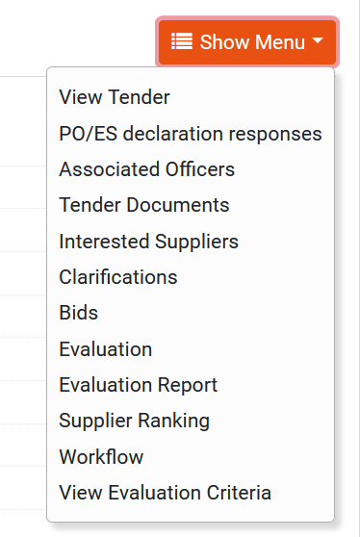

Figure 3: The Tender Menu (expanded)

Selecting the Tender Menu, again, will collapse it (Figure 2).

Main Page
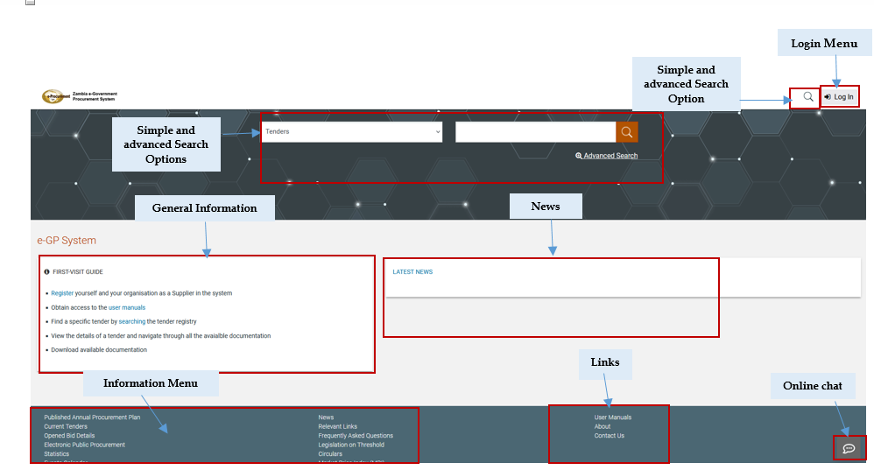
Figure 4: Main page

The main page of the e-GP system consists of the following elements:
- Top column, which contains the Login panel, Homepage Panel and Search option Panel.
- Central column, which contains general information regarding the system, the Suppliers and the users of the Procuring Entity as well as the “Register” button that supplier organization will be in position to self-register in the system. Furthermore, it lists any uploaded news about the system usage.
- Bottom column, which contains the Information menu panel, helpful links and functionalities which are available within all pages of e-GP. Additionally the aforementioned column contains the button for online chat that guest users will be in position to contact live with helpdesk users providing their requests.

The following are the most important sections within the main page.

Login Section
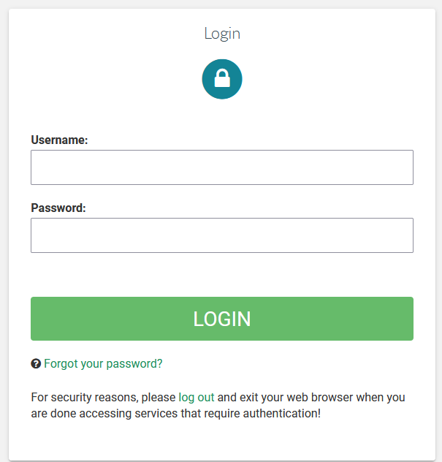
Figure 5: Login panel

In this section, functionality is provided to enable all users (Procuring Entity, Suppliers and Administrators) to login in the system providing that they use the correct credentials (username and password). Furthermore, functionality to recover a user’s password is included by selecting the “Forgot your password” option.

Search Section
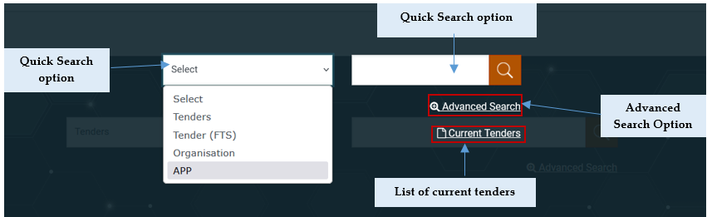
Figure 6: Search panel

The users can use this section to search for Tenders, Organizations, Users, Contracts and Annual Procurement and Disposal Plan entries. Advanced searching functionality, (by selecting the  button) is also provided (Figure 6). Finally, the users also can search for Current Tenders.

Login to the System
All users of the e-GP module should have an appropriate user name and password. In order for a user to login to the system, he must provide his/her credentials in the login section of the main page.

Figure 7: User login

If the user provides incorrect credentials (either user name or password) an error message will be displayed.

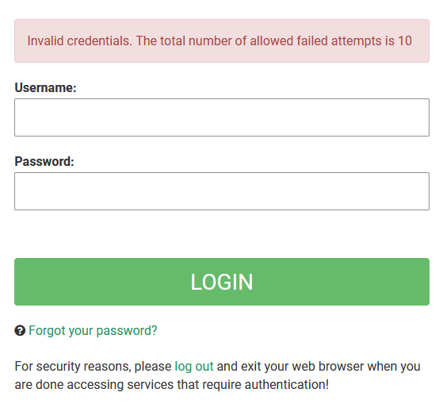
Figure 8: Wrong credentials

If the user provides an incorrect password for a username more than the allowed login failures (that is defined by SA user), his/her account will be temporally locked and a message will be displayed.

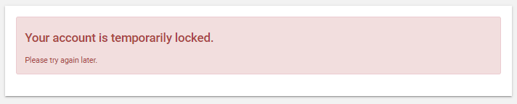

Login to the System for the First Time
The following steps are available, when the user logs in to access the e-GP services for the first time.
As a first step, the user will have to provide the transaction number (which is received by email after his successful registration on the platform).

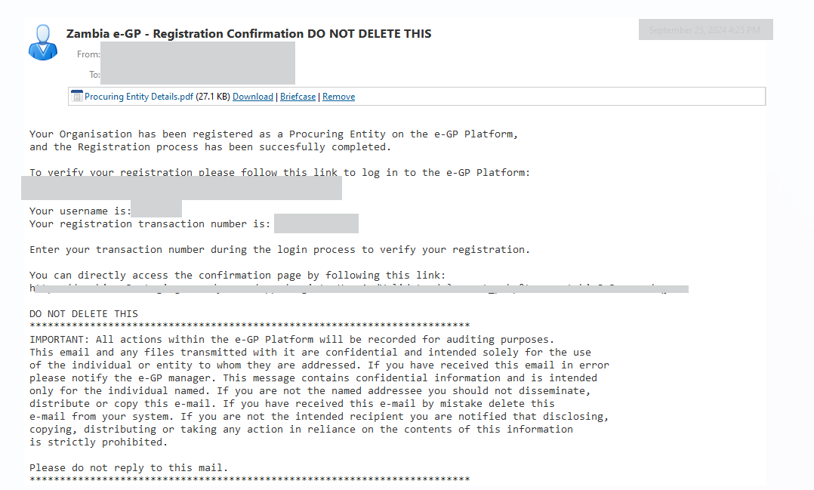
Figure 9: Confirmation email received during registration.

After providing his user credentials, the user is requested to provide the transaction number received during the registration.

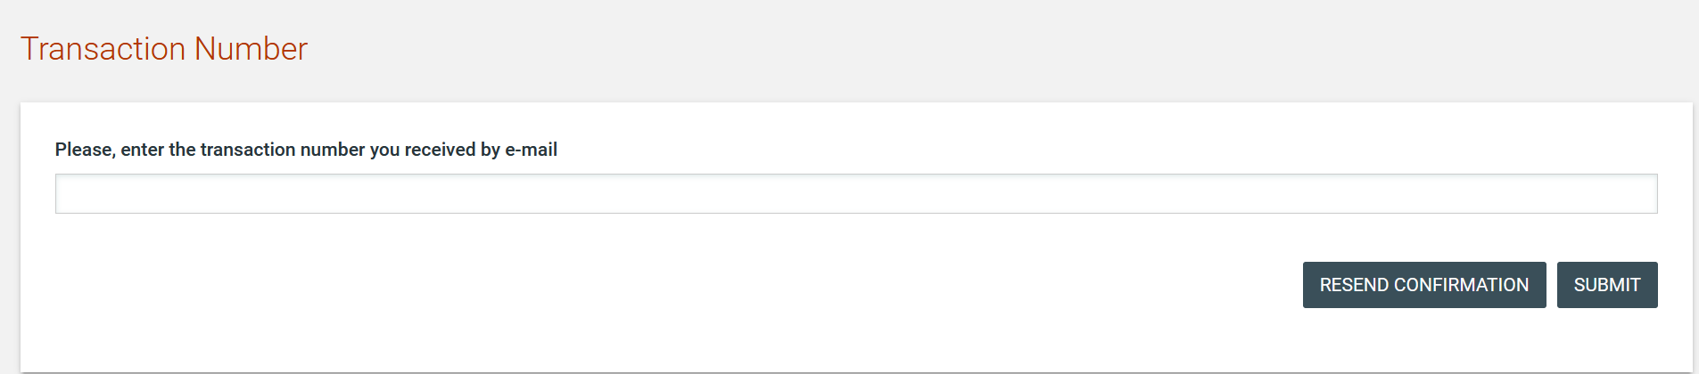
Figure 10: The transaction number

If the user has misplaced the e-mail with the transaction number, it can be resent to the registered e-mail address by clicking on the  button.

Finally, the user is prompted to read and accept the System User Agreement.

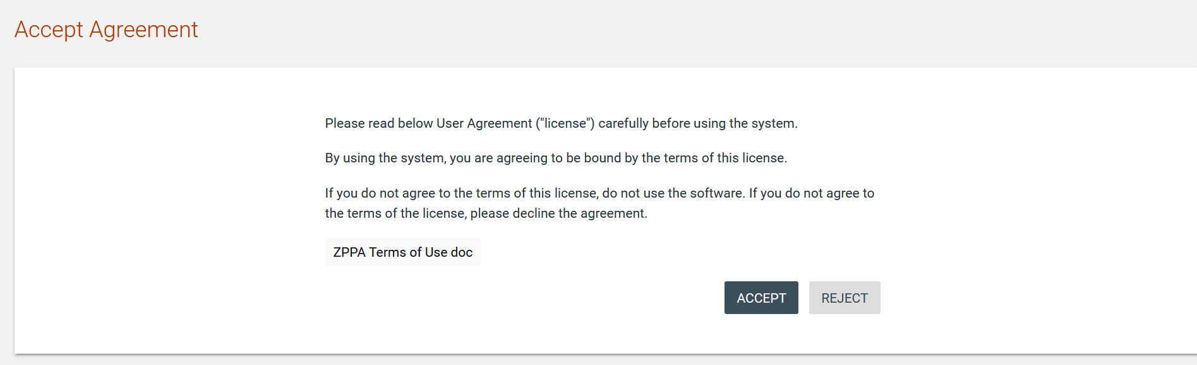
Figure 11: Confirmation of the user agreement

Logout from the Platform
The user can exit the e-GP services by selecting the “Logout” functionality.

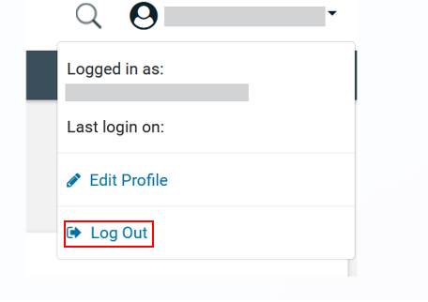
Figure 12: Logout functionality

Password Recovery
The user can recover his password from the “Forgot your password” functionality (Figure 5) available from the home page.

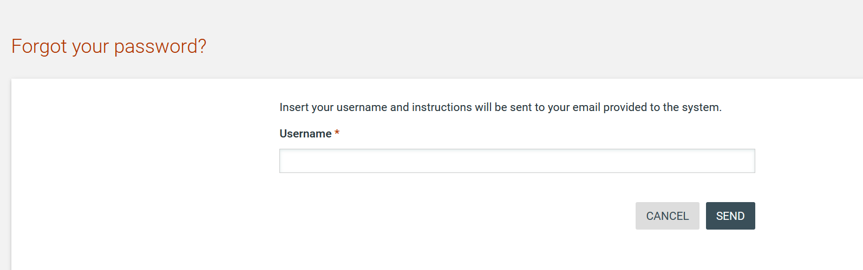
Figure 13: Password recovery/change

If the provided details are valid, the system sends an email to the associated address, containing a transaction number and a unique generated access link.

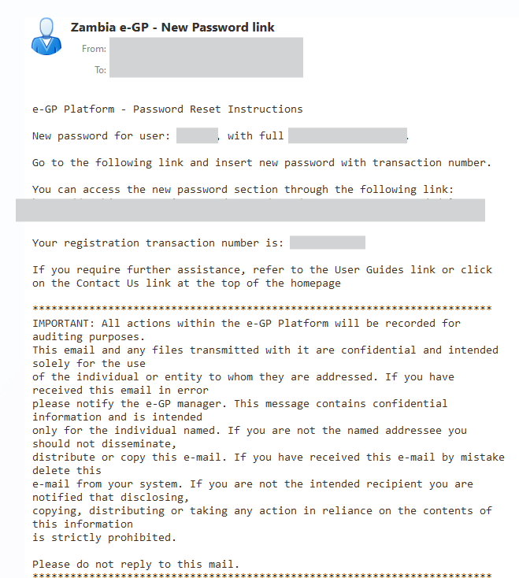
Figure 14: Email containing a registration transaction and unique access link

In order to reset the password, the user accesses the displayed link. To trigger the password reset functionality, the system requires the user to provide:

- New password
- Password confirmation
- Transaction Number
- Secret question response

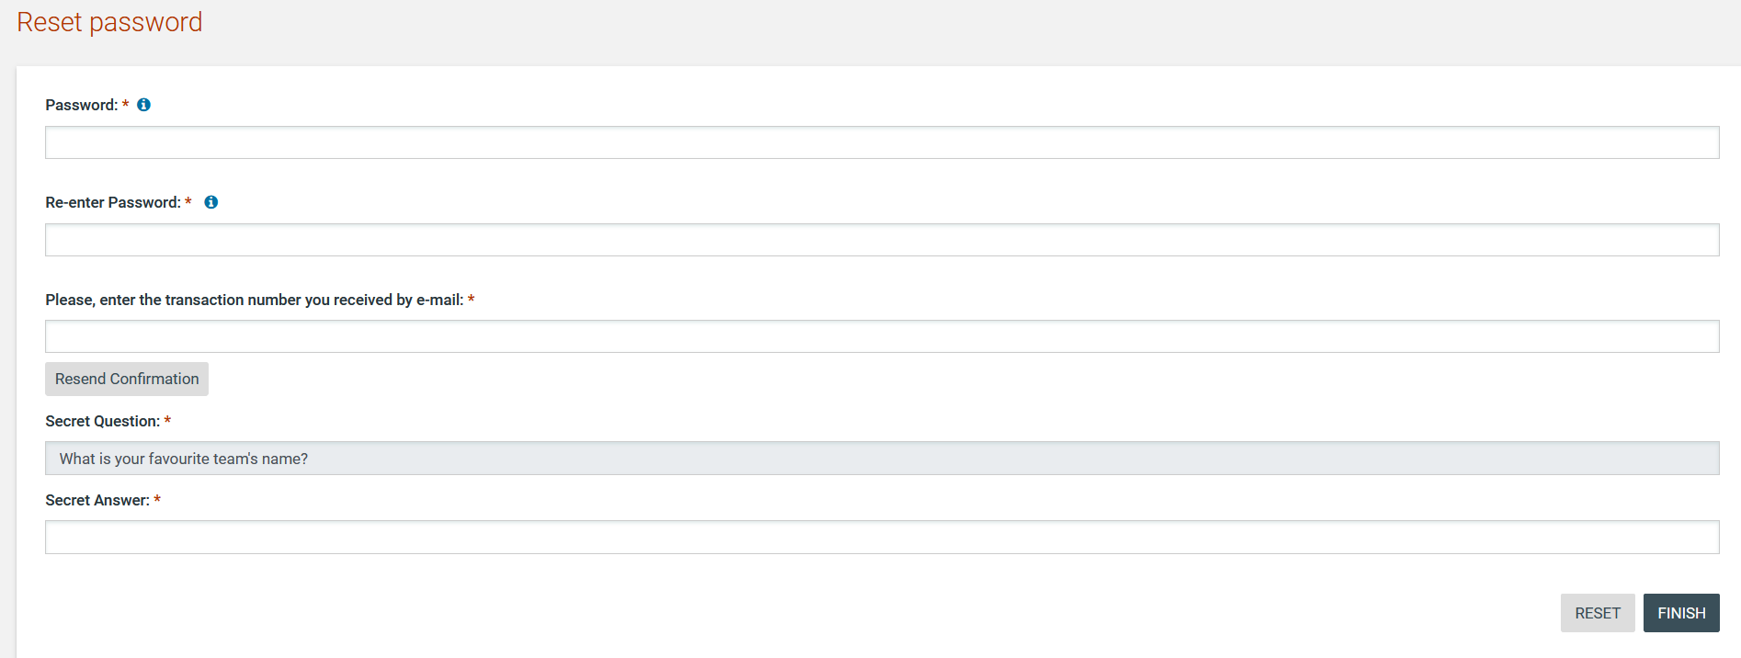

Figure 15: Resetting the password

Maintenance of User’s Profile
After successful authentication the user can edit their profile by selecting the “Edit Profile” functionality accessible from the right drop-down menu.

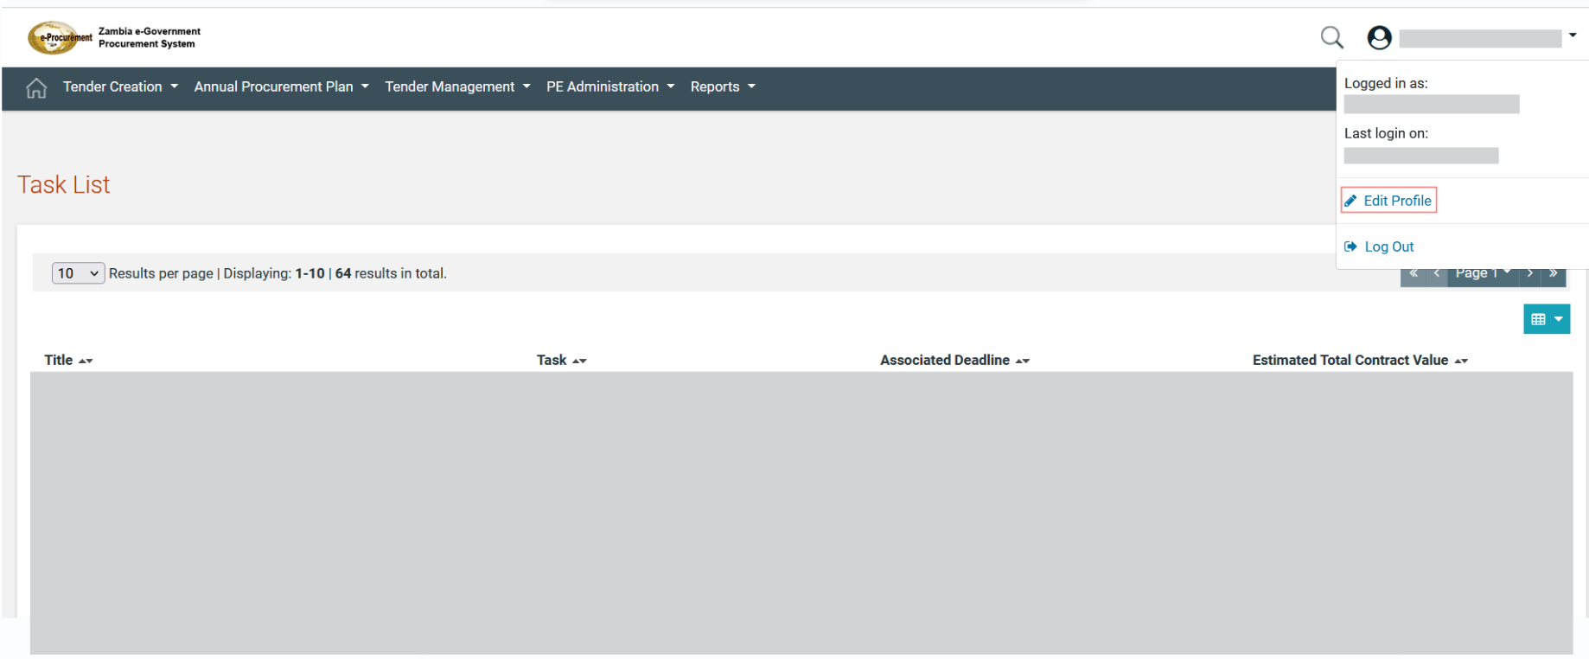

Figure 16: Edit user’s profile option

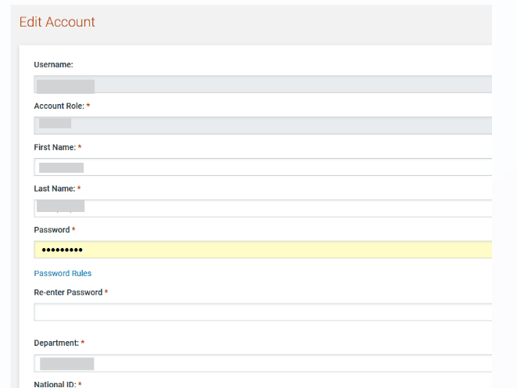
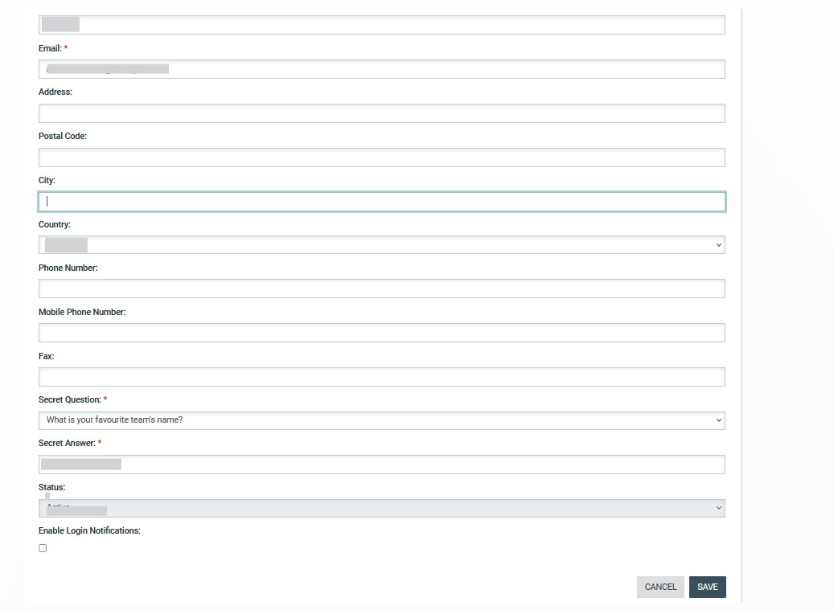

Figure 17: Edit User’s Profile
The password should follow a specific configuration. To view the password rules the user should click on the link “Password Rules” (Figures Figure 16 and Figure 17). The password configuration rules consist of:
- Letters (upper case/lower case) allowed to be used
- Numbers allowed to be used
- Characters allowed to be used
- Allowed login failures
- Password lifetime
- Password length (min/max)
- Password history
- Password strength (weak/normal/ medium/strong/ very strong)

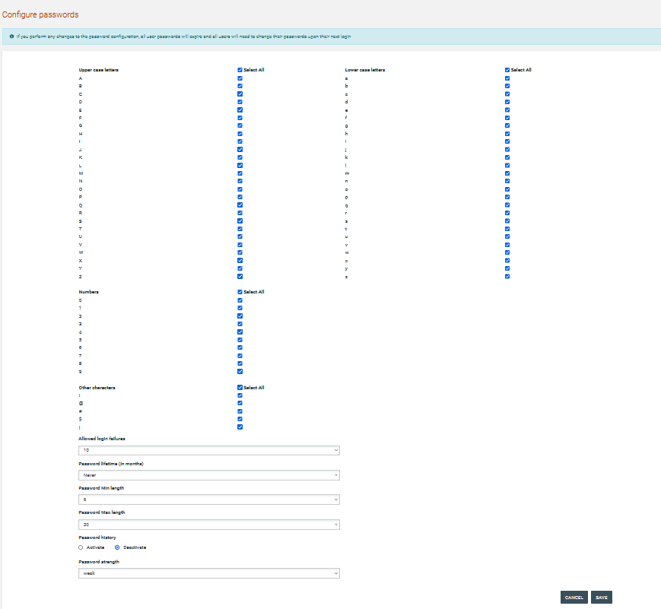
Figure 18: Password Configuration Rules

In case the password does not follow the password configuration the following message appears.

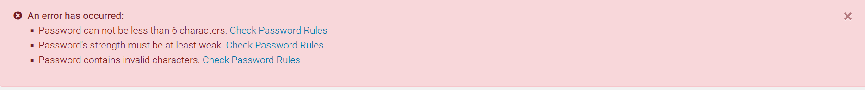

XLS File Format Support
All XLS files uploaded to the e-GP system must abide to the Microsoft Office Excel 2003 format.

 | All XLS files must abide to the Microsoft Office Excel 2003 format.  Users that have later versions should save their files in 2003 format (Save as type and select the option “Excel 97-2003 Workbook”).

XLS File Upload Validation
Every time a new XLS file is uploaded onto the e-GP system, the system performs validation checks to ensure that the uploaded file abides to the pre-defined template for the upload. There are several different templates supported by the system, namely:
- Annual Procurement Plan XLS
- Evaluation Report XLS

Whenever an invalid XLS file is uploaded onto e-GP, the system will either present to the end-user the reasons for not accepting it (e.g. invalid format), or will grant the end-user access to download an Error Report XLS, which details the precise reasons rendering the XLS invalid.

Procuring Entity Management
The Users with a role of PEHP or PECPO can perform the following management activities for their Procuring Entity:
- Edit organisation details
- View the users registered within the procuring entity
- Add new users to the procuring entity
- Edit user’s details

The Procuring Entity Management functionality is provided through the “PE Management” menu:

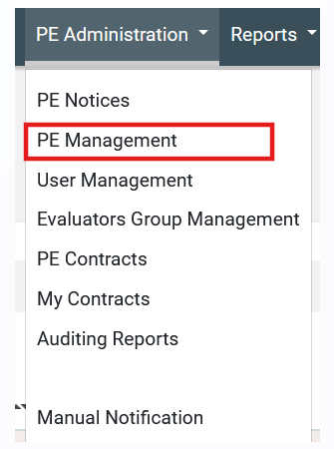
Figure 19: PE management menu

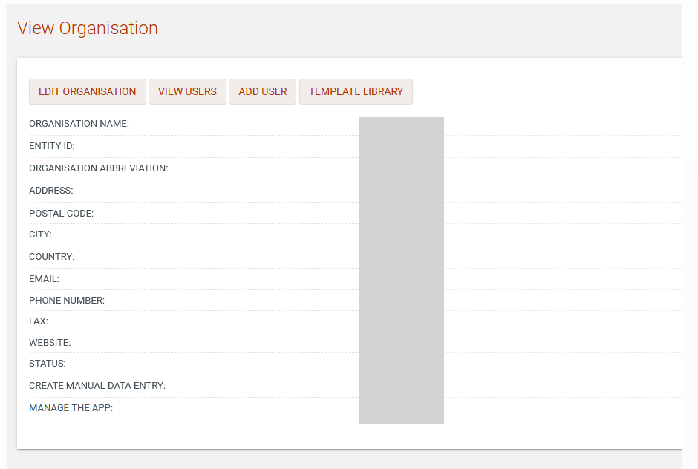
Figure 20: Management of Procuring Entity Details

Edit organisation details
Selecting “Edit Organisation” allows the user to edit the organisation’s details:

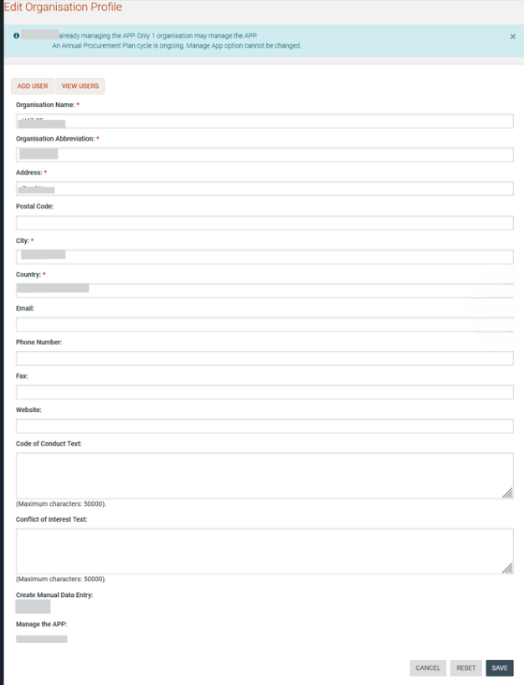
Figure 21: Editing Organisation details

View the Users Belonging to the Procuring Entity
Selecting “View Users” functionality allows displaying all the users registered within the selected procuring entity:

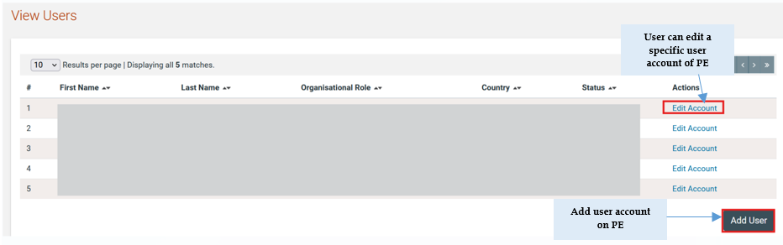
Figure 22: Display of users belonging to the procuring entity.

The name, the role, the country and the current status (active, inactive, deactivated, etc) of each user are displayed.

The following user roles are supported:
- Controlling Officer (CO): Such a user has access rights to manage the Procurement Committee members, to conclude the evaluation and to respond to appeals.
- Head of Procurement (PEHP): Usually assigned to leading officers of a PE. Such a user has access rights to manage the PE and its users and has increased visibility on tender details (i.e. evaluation reports etc.).
- Chief Procurement Officer (PECPO): Such a user has similar access rights to the PEHP and acts as a PEHP assistant.
- Procuring Entity Procurement Officer (PEPO): Usually assigned to officers that do not require increased level of access. These form a “pool” of officials that may be associated with a specific tender for performing specific activities for the tender.
- Procurement Committee Member (PC): Such a user will not be allocated any tasks in the ZEGP. They are created solely for record-keeping purposes so that other users of the PE can identify the current members of the Procurement Committee.

The following roles are only available in the organisation that has been selected to manage the Annual Procurement Plan:
- Head Compliance Officer (HCO): Such a user is assigned the task to review APP submissions and is allowed to publish accepted APP files at the end of the APP cycle. This user is also allowed to allocate CMO users to the “Auditor” role on any tender in the system.
- Compliance Monitoring Officer (CMO): Such a user is assigned the task to review APP submissions and can also be allocated the Auditor role on any tender in the ZEGP.

Insert a new user in a Procuring Entity
The PEHP/PECPO user can insert a new user in a particular procuring entity by providing all of the following details:
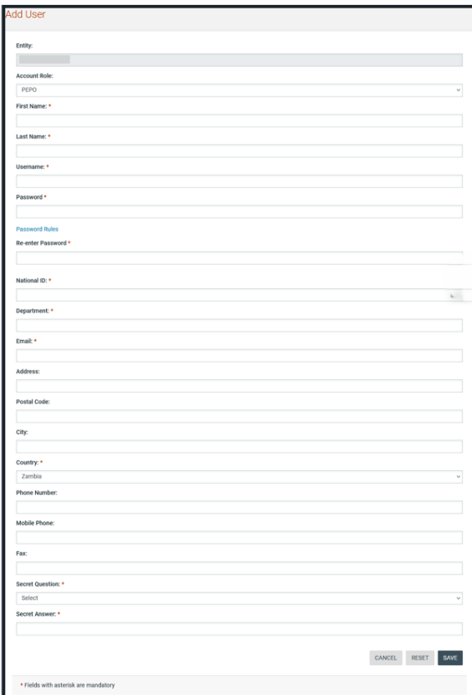

Figure 23: Insert a new user in a procuring entity

Edit user’s details
The user can select to edit the details of a specific user:

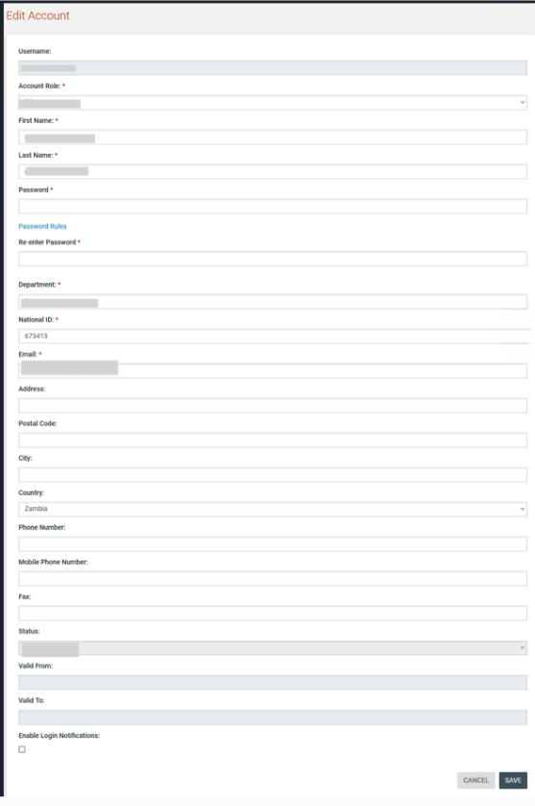
Figure 24: Editing user details

Login Notifications
A user can choose to be notified by e-mail whenever their credentials are used to login to the e-GP system. This is accomplished on the Edit Profile page by selecting the checkbox to enable login notifications.

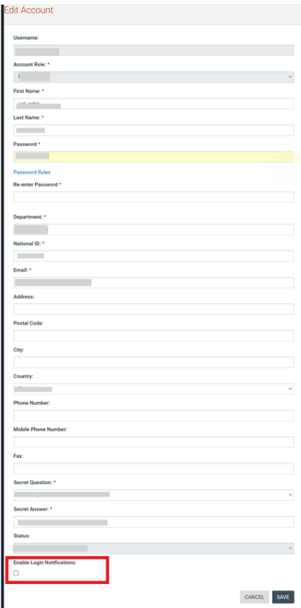
Figure 25: Login notifications

If the login notifications are enabled/disabled by an administrative user and not by the individual user, the user receives an e-mail notification that their profile has been modified.

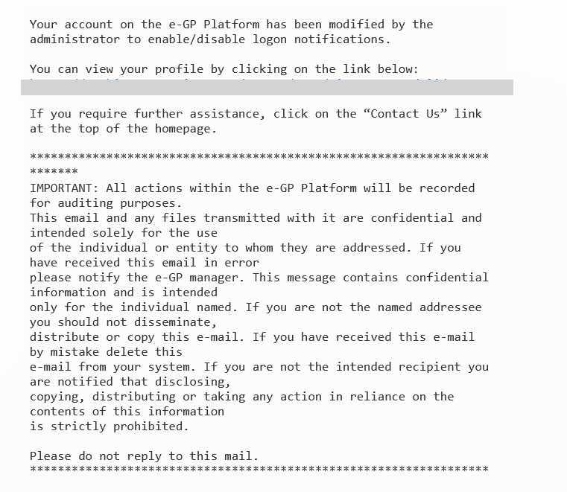

Figure 26: Login notifications administrator action confirmation e-mail

When login notifications are activated, each time the user’s credentials are used to login to e-GP, an e-mail notification is sent to the registered e-mail address of the user.

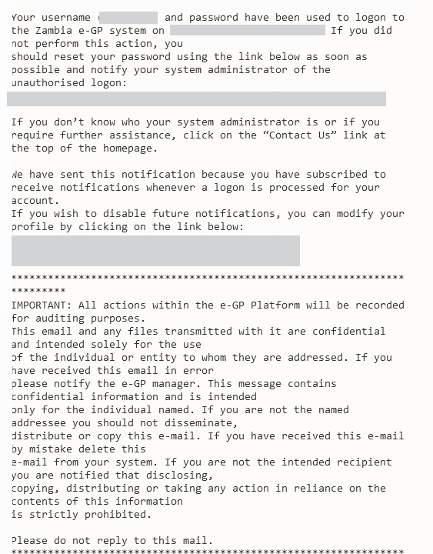
Figure 27: Login notification e-mail

Searching Functionality
The e-GP system provides both simple and advanced search mechanisms. Both functionalities allow searching for Tenders, Organisations, Users, Annual Procurement Plan entries and contracts.

Simple Search
The simple search functionality covers searching for available Tenders, registered Organisations, registered Users, published Annual Procurement Plan entries and contracts.

Simple search queries are performed by:

- Selecting the search  button from the right side of the page
- Selecting the type of searching (Tenders, Organisations, Users, Contracts, APP) from the selection list.
- Providing the full name of the required record or part of it using the “*” wildcard.
- Selecting the button  “Search”.

The results, if any, are then presented in a tabular form.

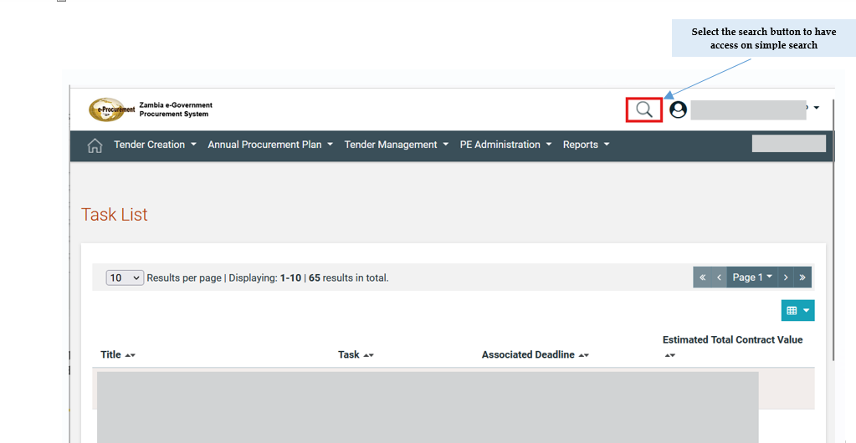

Figure 28: Simple search (1)

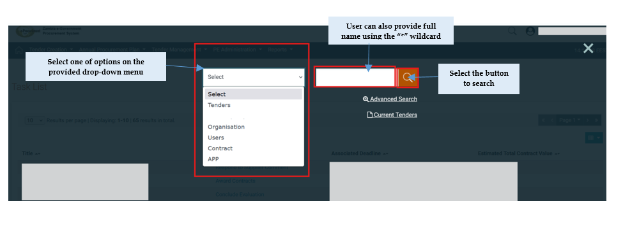

Figure 29: Simple search (2)

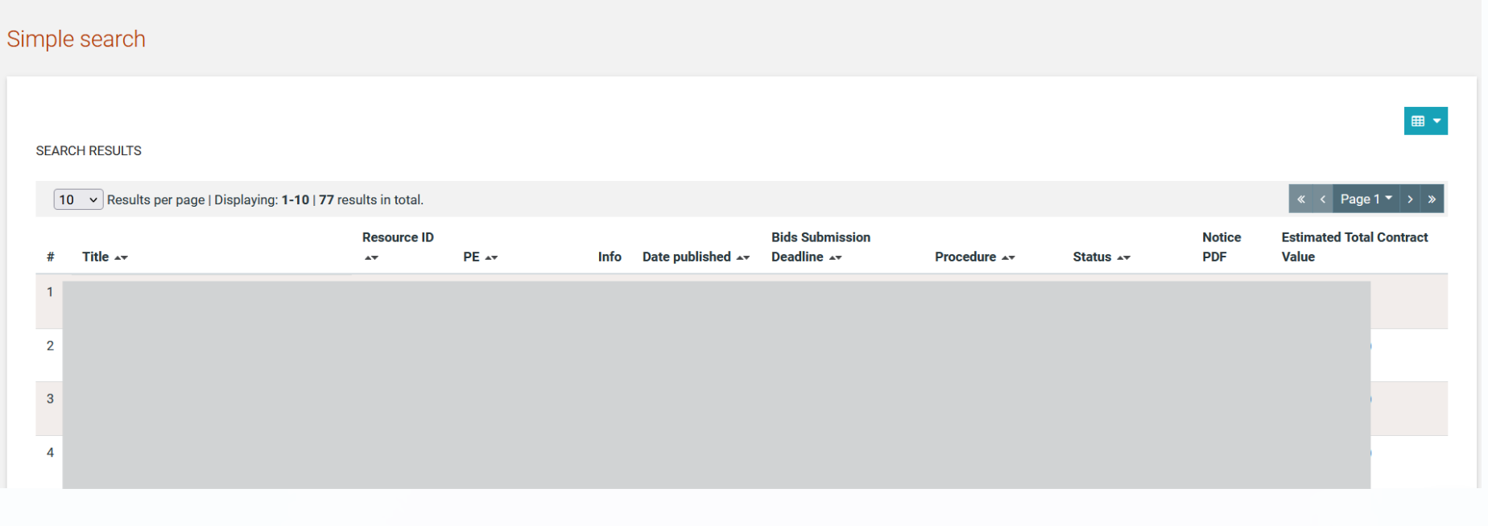
Figure 30: Simple search for Tender

Advanced Search
The advanced search functionality enables searching for Tenders, Organisations, Users, contracts and Annual Procurement Plan entries. In addition, the functionality supports searching Organisations that fulfil a specific supplier profile. In order to perform an advanced search query, the user should:
- Select the search button from the right side of the page
- Select the advance search  link
- Select the type of the search by using the appropriate button
- Provide information in one or more fields (use of * wildcard is also enabled).
- Select the button “Search”

For further information on each criterion select the respective info icon
The results, if any, will be presented in a tabular form.

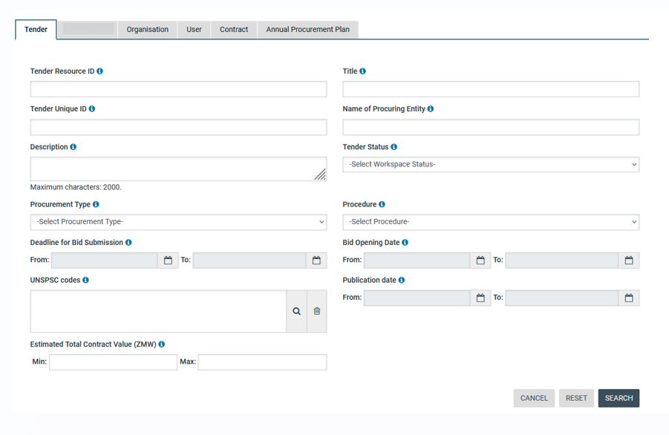
Figure 31: Advanced search for a Tender

In order to search for an organisation, the user needs to first provide the organisation type (Procuring Entity/ Supplier).

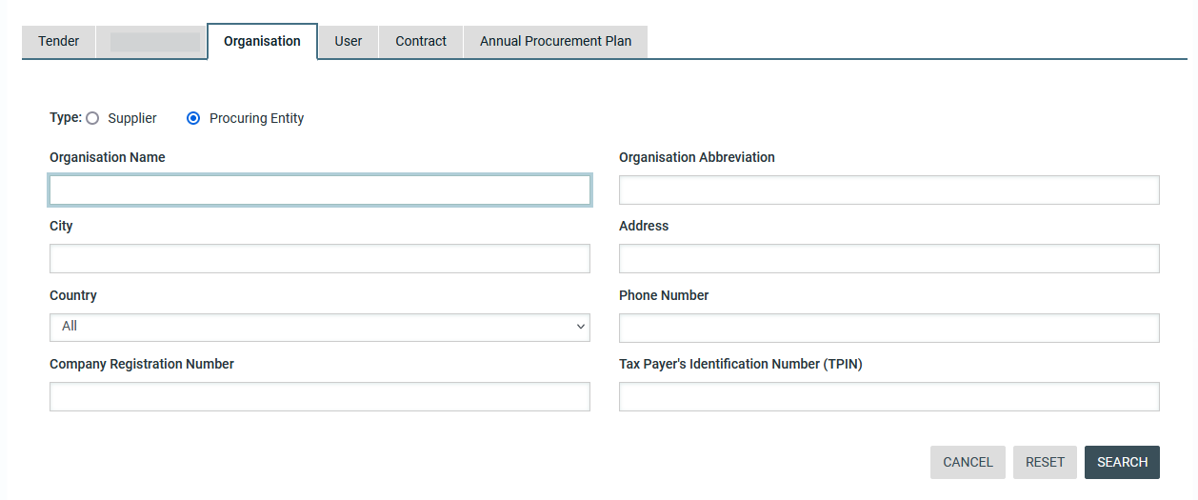
Figure 32: Advanced search for a Procuring Entity

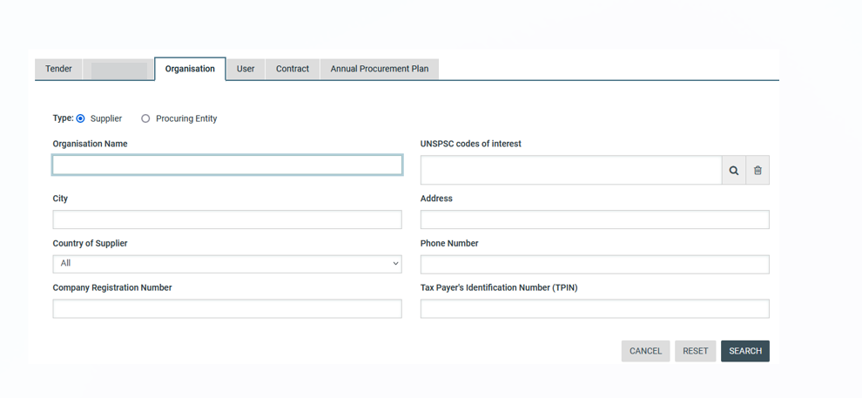
Figure 33: Advanced search for a Supplier Organisation

In order to search for a user the organisation type (Procuring Entity or Supplier) must also be selected.

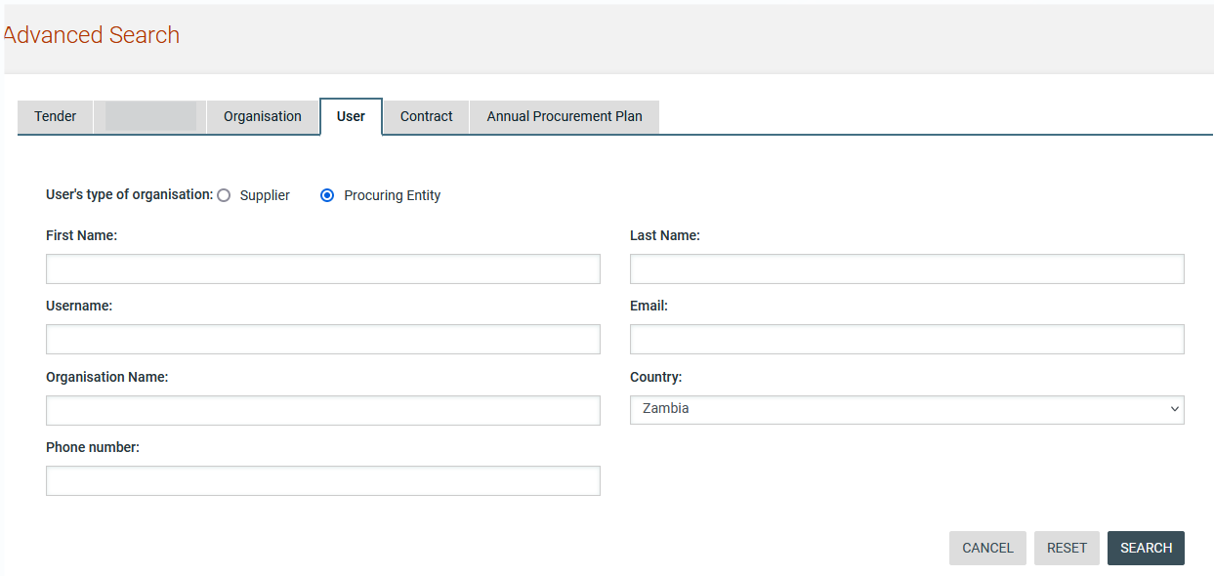
Figure 34: Advanced search for Procuring Entity users

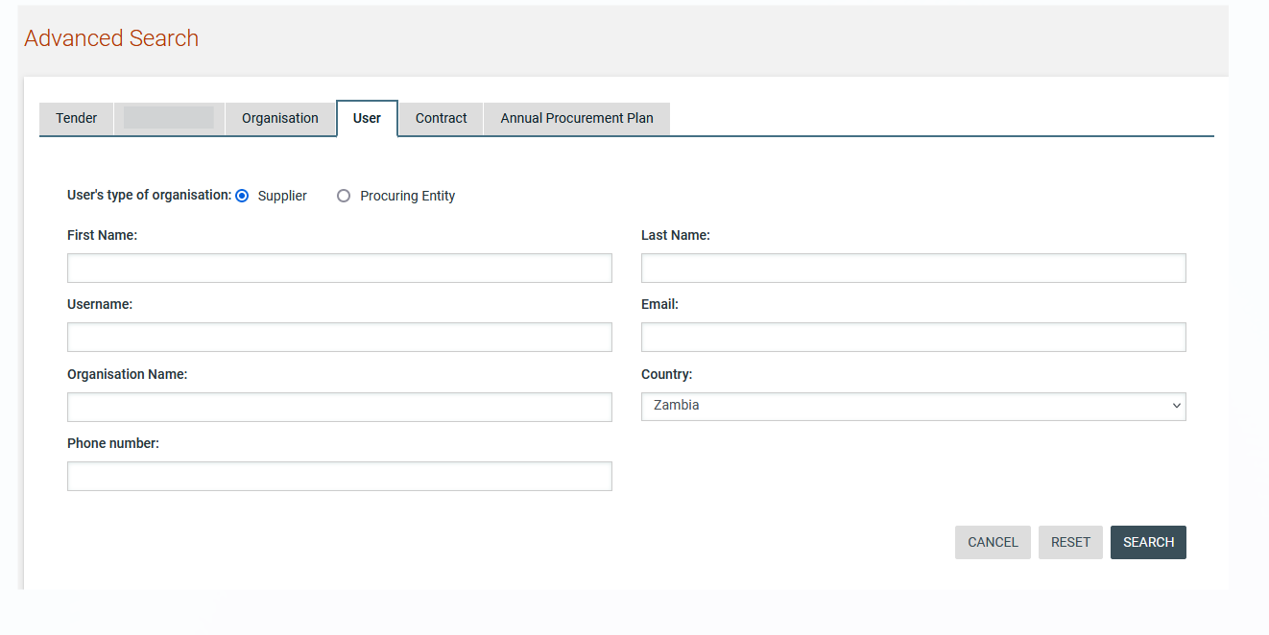
Figure 35: Advanced search for Supplier users

The user can search for a specific contract or contracts using also the advanced search.

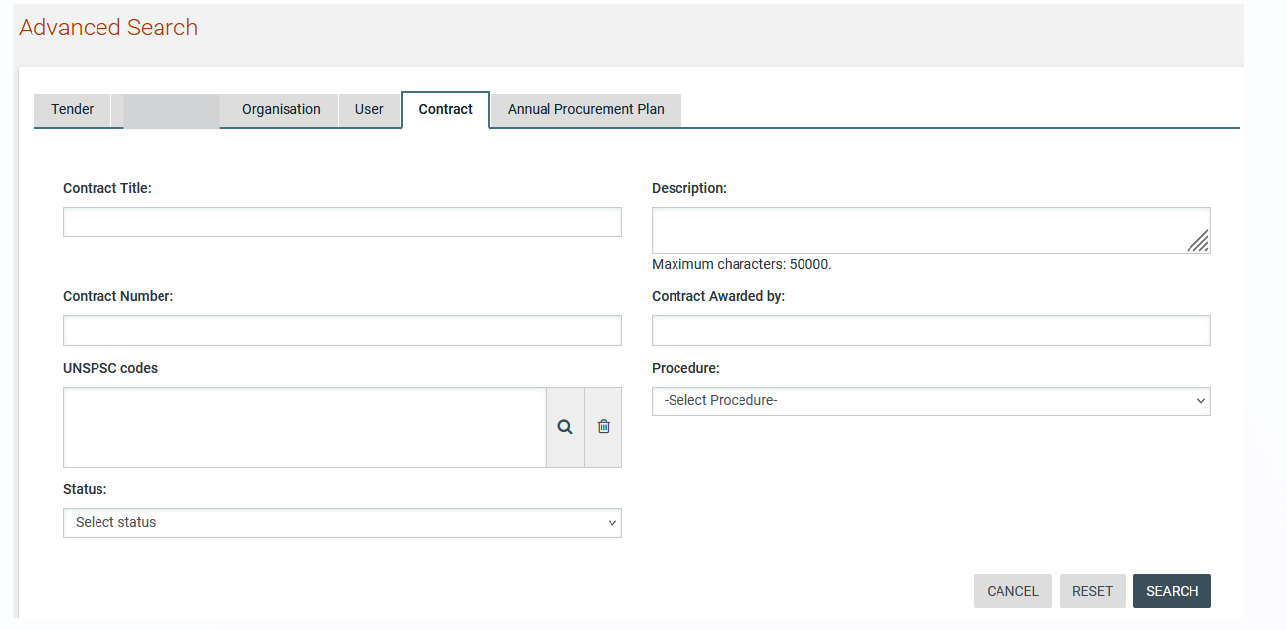

Figure 36: Advanced search for Contracts

Annual procurement plan entries can be filtered by any combination of the publication date, the procurement type, the procurement method, the UNSPSC code or the procuring entity.

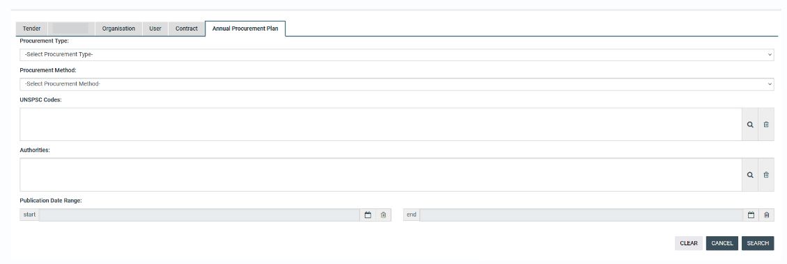

Figure 37: Advanced search for Annual Procurement Plan

Current Tenders Search
In order to view the latest tenders published within the service, the user can click on search icon. The “Current Tenders” link, as depicted in Figure 38 is displayed. This will automatically present the list of the latest tenders that are available to the user (depending on his/her access rights).
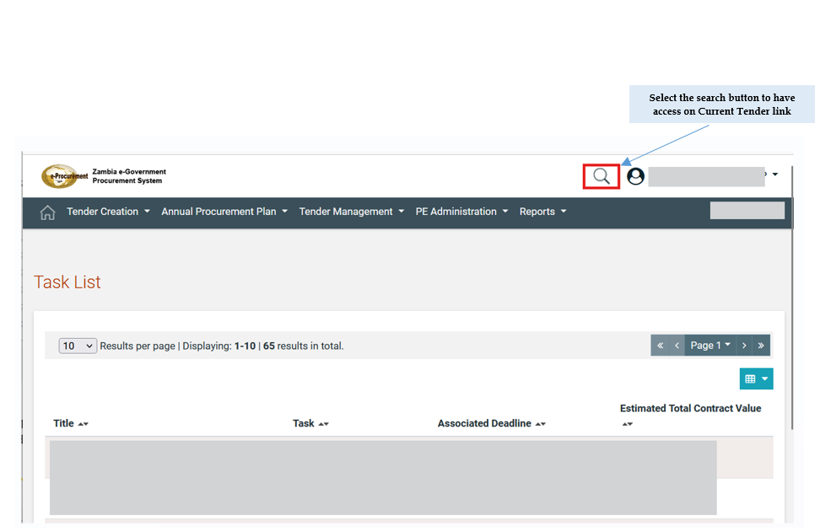

Figure 38: Access to Current Tender link (1)

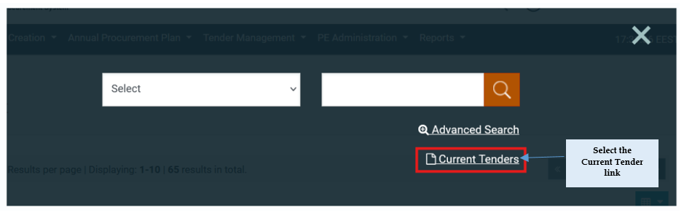

Figure 39: Access to Current Tender link (2)

CSV Export
In order to download the search results with the retrieved list of users/organisations, the user can click on the 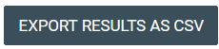 button.

The exported file includes the full details of the organisation or user accounts exported e.g. name, username, department and organisation

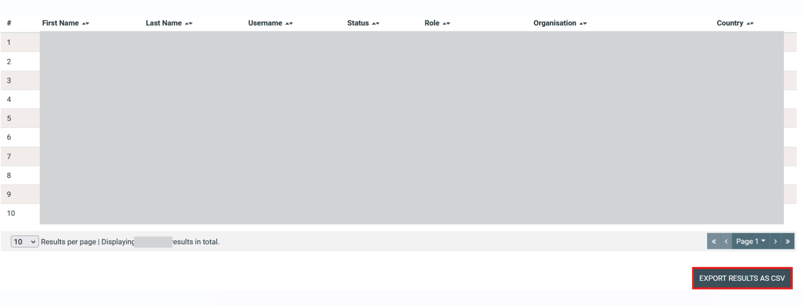
Figure 40: Export tender button

Supplier Evaluation Comments
A supplier may have received ratings and comments while participating in tenders. A procuring entity user can view these comments by using the search facility to locate the supplier and view their profile. 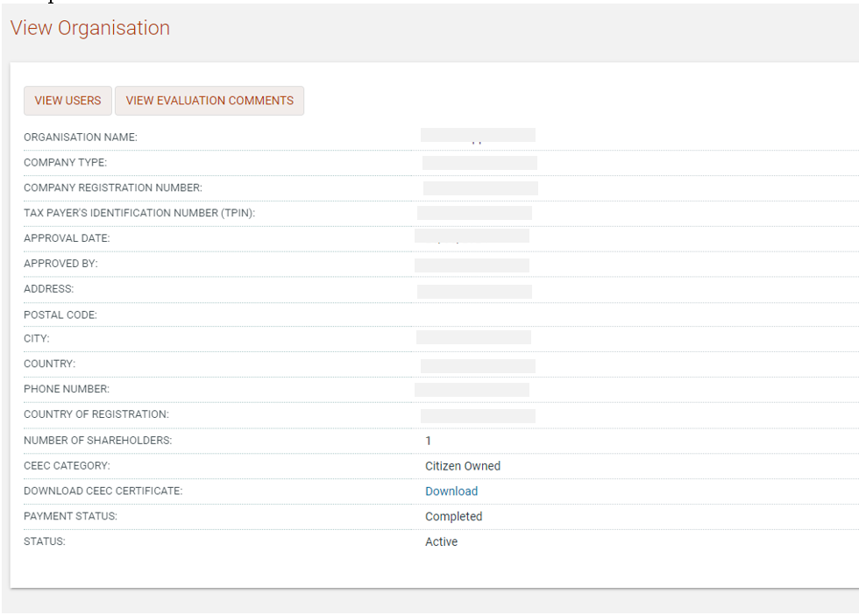
Figure 41: View Supplier evaluation comments

Clicking on the “View Evaluation Comments” button takes the user to a list of tenders. The comments received in that particular tender can be viewed by clicking on the tender name in the list. If the tender in question consisted of multiple lots and the supplier submitted a bid for more than one lot, each lot is visible in the results. The total number of suppliers that participated in the tender is shown together with the ranking achieved by the specific supplier. In addition, comments and a “Rating” can be provided by the Procuring Entity. The “Rating” is a subjective measure on a scale of 1 to 5, with 1 being the lowest rating.

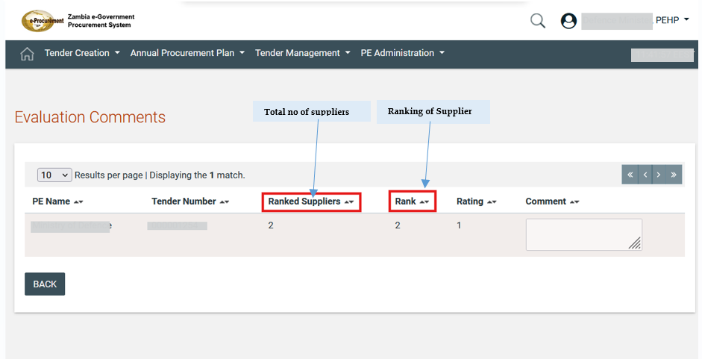

Figure 42: Evaluation Comments Page

These comments and ratings can be used by the Procuring Entity to obtain an indication of the performance of the supplier in previous tenders. This is useful, for example, when searching for suppliers to invite to participate in a Simplified Bidding or Direct Bidding tender. Inviting Suppliers who have previously performed well increases the chances of the procuring entity in obtaining the best value for money.

Bidding/Tender Advertisement
Tender advertisements are managed through the “PE Notices” menu item displayed in the “PE Administration” section. Selecting this option, the user can create the tender advertisement notice.

Creation & Publication of an Advertisement
As a PEHP user, navigate to the depicted top side menu.
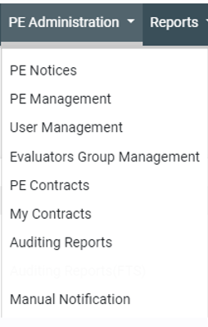
Figure 43: Advertisements section

From the Prior Information Notice page, the user can continue with the following activities:
- Create a tender advertisement notice
- Delete a tender advertisement notice
- Edit a tender advertisement notice
- Publish a tender advertisement notice

To create a new notice, click on the “Create Notice” button.

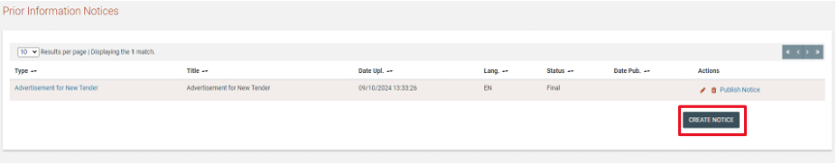
Figure 44: Create new advertisement

The System will pop-up a new window with one available option that the user needs to select and then enter the respective form by clicking the “Forms module” button.
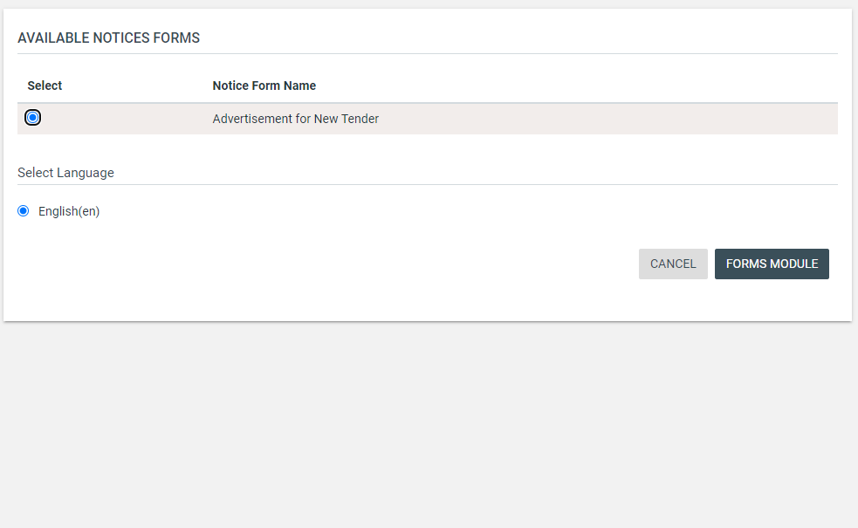
Figure 45: Select Advertisement

User needs to fill in the mandatory information and click “Next”.

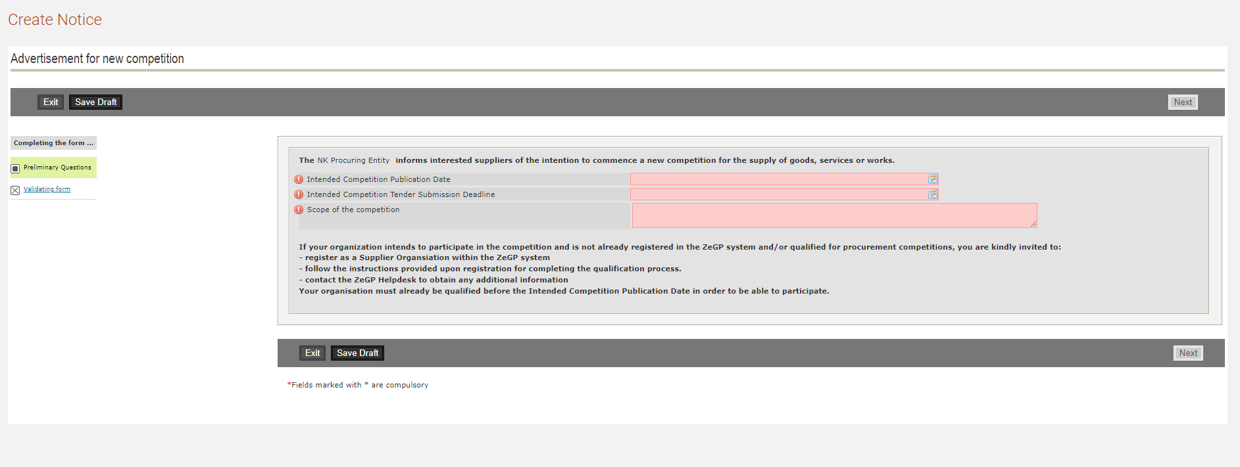
Figure 46: Populate advertisement

In the final screen the user saves the form as final and the system generates the advertisement that is ready to be published.

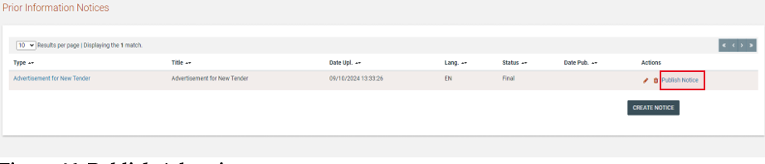
Figure 47: Publish Advertisement

User clicks on “Publish notice” button in order to make the notice available to all Suppliers.

Editing of an Advertisement
A created but not published advertisement can be edited by the user prior to publication. The user can select the advertisement that should be editing and click on the “Edit” button. The system will present to the user the respective form, pre-filled with the original data. The user may perform any changes before saving the advertisement as draft/final.

A created and published advertisement cannot be edited. Instead, a new advertisement must be published, which corrects the content of the initial advertisement. The user can select the advertisement that should be edited and click on the “Edit” button. The system will present to the user the respective form, pre-filled with the original data. The user may perform any changes before saving the advertisement as draft/final. Until the corrected advertisement is published, users will still only have access to the already published version of the advertisement. Upon publication, the new form will be available for end-users, in order to be informed about its new contents.

Annual Procurement Plan (APP)
The Annual Procurement Plan process is a prerequisite for the initiation of a tender procedure.

Create an Annual Procurement Plan Request
For launching a new APP process a HCO user of the Entity that has the “Manage the APP” option enabled will need to login to the e-GP. Under the “Annual Procurement Plan” tab the user may choose to create a new APP cycle by accessing the “Manage Plan Request” page.

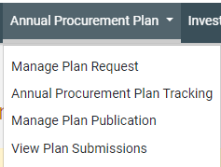
Figure 48: Initiate "Annual Procurement Plan" Process

Upon visiting the new page, the user will be required to fill in the following:
- Expires At: Mandatory field. Date until which the Procuring Entities may respond to the APP request before the consolidation of responses on to a National Level and publication takes place.
- Description: User provides a description for APP

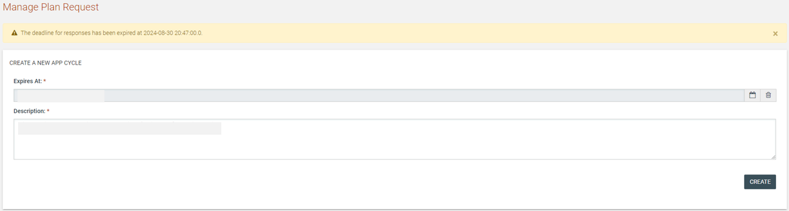
Figure 49: “Manage Plan Request” Page

Once the mandatory fields are populated the user clicks on the “Create” button. Once the APP request is dispatched, the Procuring Entities will be enabled to send their responses.

View which Procuring Entities have responded, and which ones have not yet responded to the APP request, under the “View Plan Submissions” page. The PEHP/PECPOs of these entities will be tasked to “Respond to Annual Procurement Plan Request” after the “Create” button is selected.

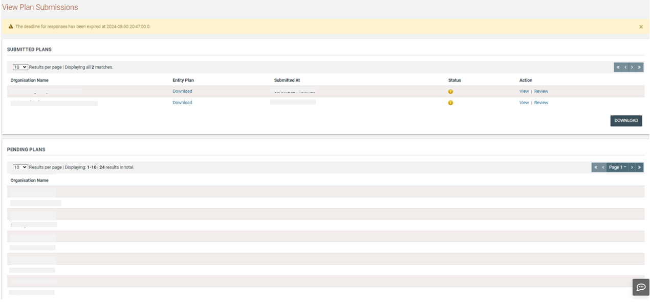
Figure 50: "View Plan Submissions" Page

Respond to Annual Procurement Plan

The PEHP/PEPCO users of all the Procurement Entities will be able to respond to the request for APP submissions. Either through the respective task or the available menu the user accesses the relevant page.

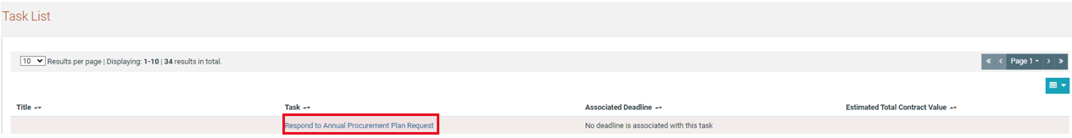
Figure 51: Respond to APP task

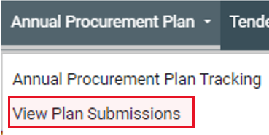
Figure 52: View Plan Submissions link

Please note that ONLY valid responses are accepted by the system. The user may download the APP template file, populate it and upload it as their APP response. Alternatively, the user may not upload any file and will not be included in the National Level Annual Procurement Plan after the consolidation process. In this case, it will not be possible to issue any tenders for this procuring entity as it is mandatory to link a tender to an Annual Procurement Plan entry.

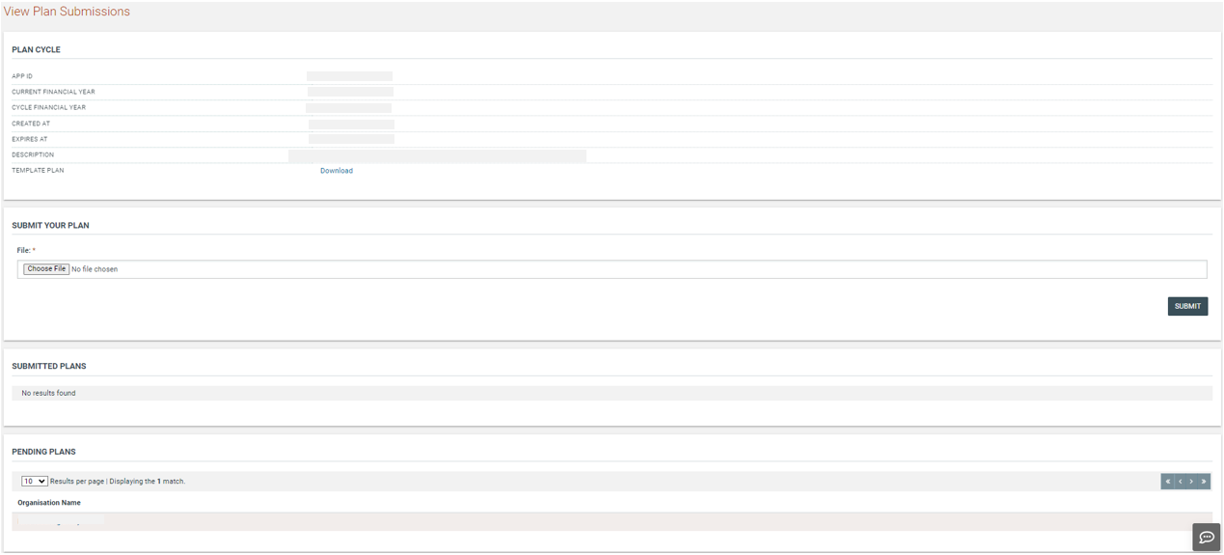
Figure 53: Upload APP response

After browsing for the completed response file (in XLS format), the user should select the “Submit” button. The entity’s response is now submitted to the entity managing the APP for review before eventually being consolidated into the national plan.

If any of the criteria mentioned in the first page of the XLS file are not met, the user is alerted to the fact that the submitted file contains errors (Figure 53) and a hyperlink is available to download the error report, which is also in XLS format. The error report contains details as to which cell and which row in the originally submitted APP XLS file failed validation.

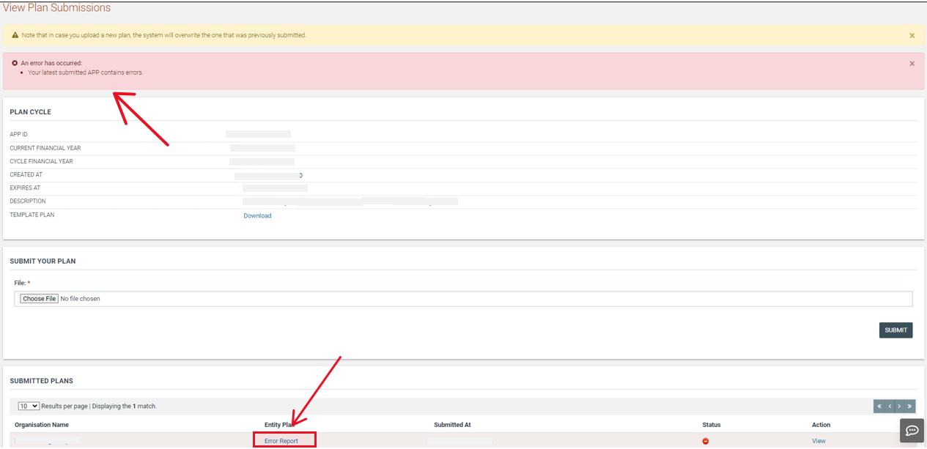
Figure 54: APP submission validation

Review APP Responses
As each procuring entity uploads its APP file, the HCO user of the Entity managing the APP will be tasked to review the uploaded files.

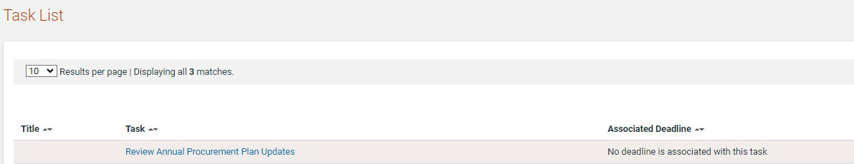
Figure 55: Review APP submission task

Each submitted plan can be opened by the user to view the contents of the APP by clicking on the “Download” link (Figure 55). Once the submitted file has been reviewed, the user needs to provide feedback to the entity that uploaded the plan by clicking on the “Review” link next to the submitted APP file (Figure 55).

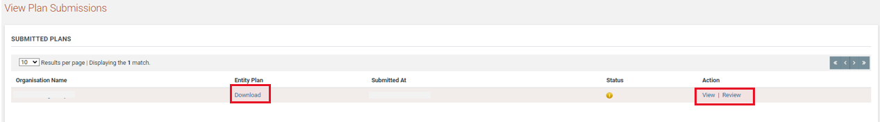
Figure 56: Review APP submission

When providing feedback, the user needs to select whether the file is Accepted or Rejected and must supply a comment in the Comment box.

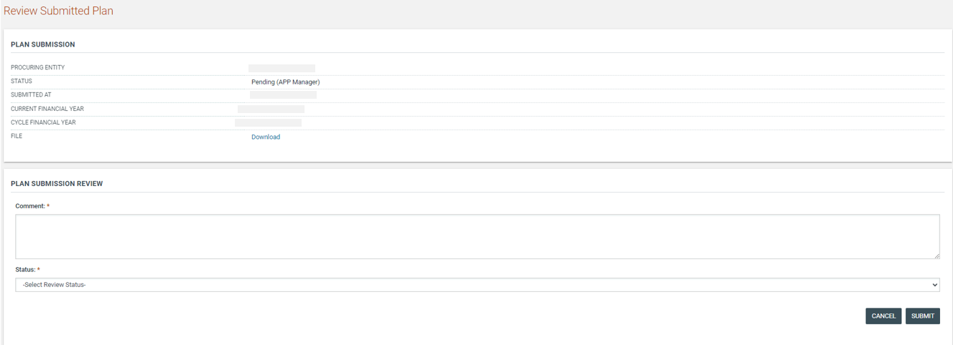
Figure 57: APP feedback

APP Entry with Reduced Floatation Justification

A new “Reduced Floatation Justification” column is added in the APP template. In case the aforementioned column is populated the system will not validate the timeframes that were specified for provided procurement procedure. The HCO user will be responsible to check the provided Justification and decide on whether to approve or not the submitted APP. HCO user is able to view the justification the APP by selecting the “view” link or the “download” link before proceed with his/her decision.

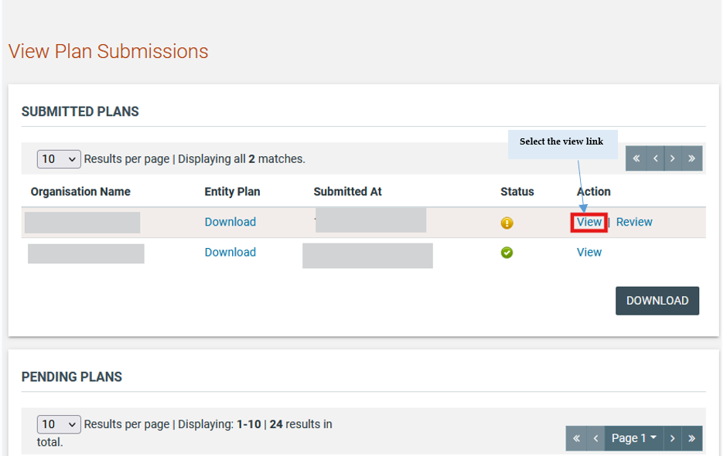

Figure 58 View Reduce Floatation Justification – Select View Link (1)

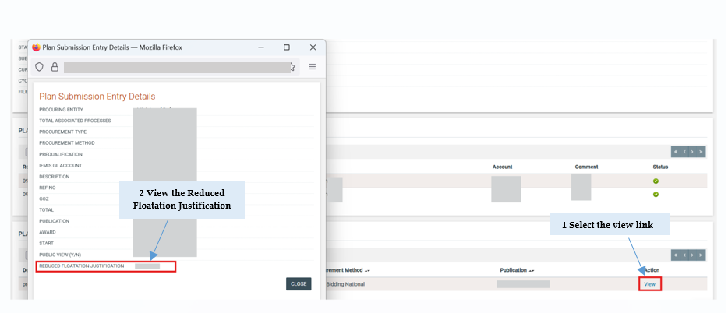

Figure 59 View Reduce Floatation Justification – Select View Link (2)

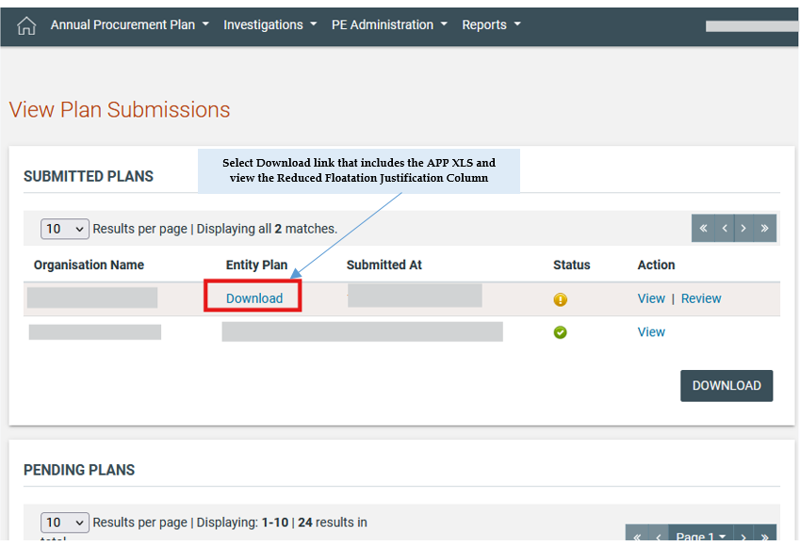

Figure 60 View Reduce Floatation Justification – Select Download Link

Publish APP Responses
The system will enable the HCO users of the PE that created the APP request to publish the responses received (if any) even before the deadline for APP Submission ends. The HCO User may navigate to the “Manage Plan Publication” Page.
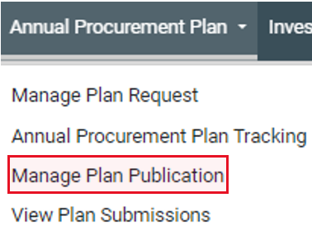
Figure 61: Manage Plan Publication option

In this page the User can view all the Plan Cycles, Information about the selected Plan Cycle, the Published Plans of the selected Cycle (if any) and if the User is viewing the current Cycle he can see the “Publishable Plans”.
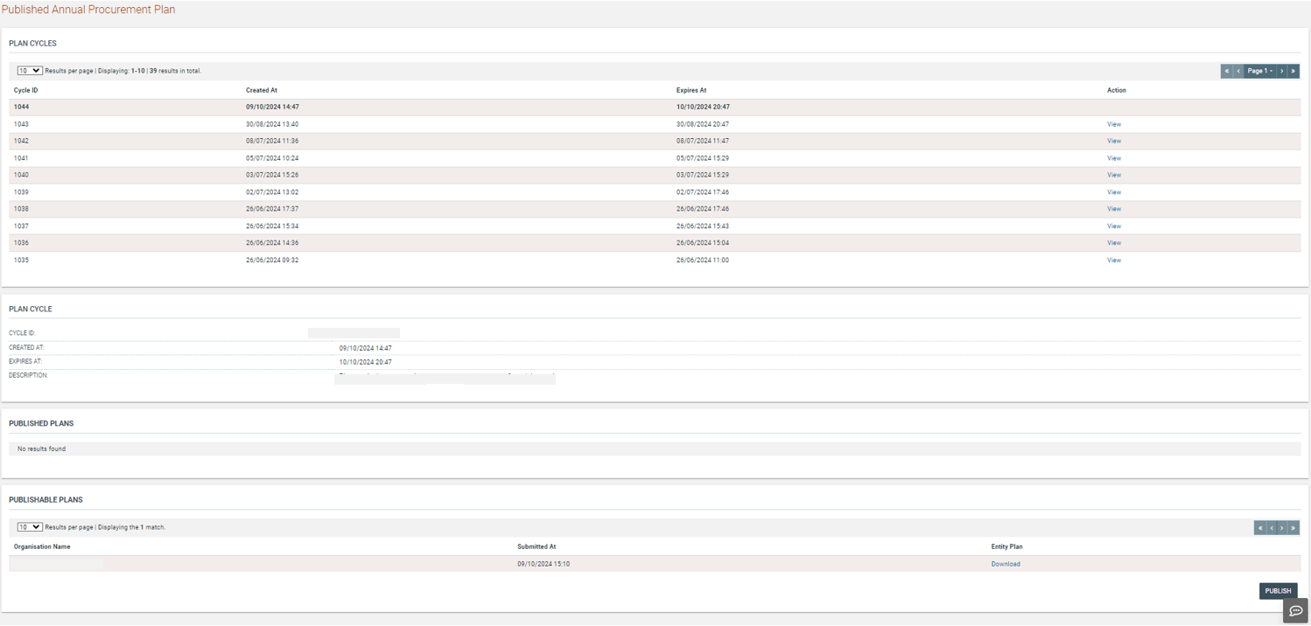
Figure 62: "Published Annual Procurement Plan" Page

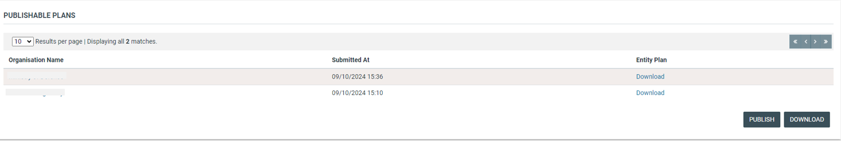
Figure 63: Publish APP responses

Individual plans can be downloaded by clicking on the “Download” hyperlink under the “Entity Plan” Column (Figure 59). In case the User wants to download a consolidated Plan for all the PEs that have submitted a plan, he/she can click on the button.

When the user is satisfied that all is in order with the submitted plans, they click on the “Publish” button to publish the individual plans. After the plans are published, procuring entities may initiate tenders linked to the items in their procurement plan and members of the public may view the published files or use the search functionality to find individual APP entries.

View Published APP Plans

The published APP Plans can be viewed by all Users as well as Guest Users that do not have a login to the System in the “Published Annual Procurement Plan” page (Figure 61) of the e-GP.
All Users, even Guest Users may find this Page in the footer of the main page. (Figure 60)
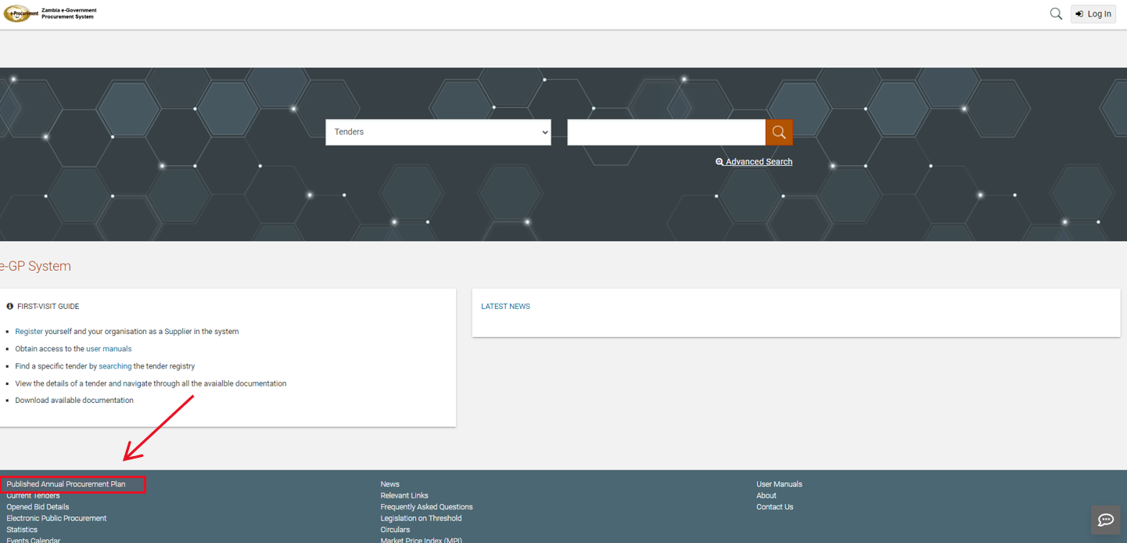
Figure 64: Published APP in the main page

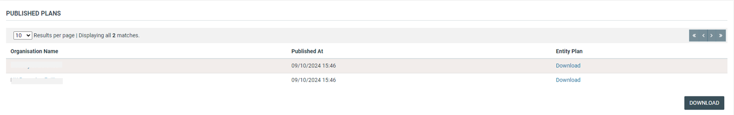
Figure 65: View published APP Plans

Tender Workspace
In order to issue a tender via e-GP, a tender workspace must be created and configured with the appropriate options.

Preparation of a Tender
Once the Annual Procurement Plan is published the PEHP/PEPCO user may click on the “Create New Tender” link in order to initiate the tender creation process. Upon clicking the aforementioned link, the system will automatically re-direct the user to a new page where a form containing the details of the new tender will be presented. Some default choices will have been made on the form. The remaining details on the form will need to be completed by the PEHP/PEPCO users.

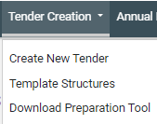
Figure 66: Launch tender creation

The user will need to provide all mandatory information.
The user must link the tender to an APP entry by clicking the search icon (Figure 63). The user can only choose from items that his organisation had included in their APP response. Any information included in the APP xls file, will be auto-populated in the form. Multiple tenders can be linked to the same APP entry, but a tender cannot be created without being linked to an APP entry.

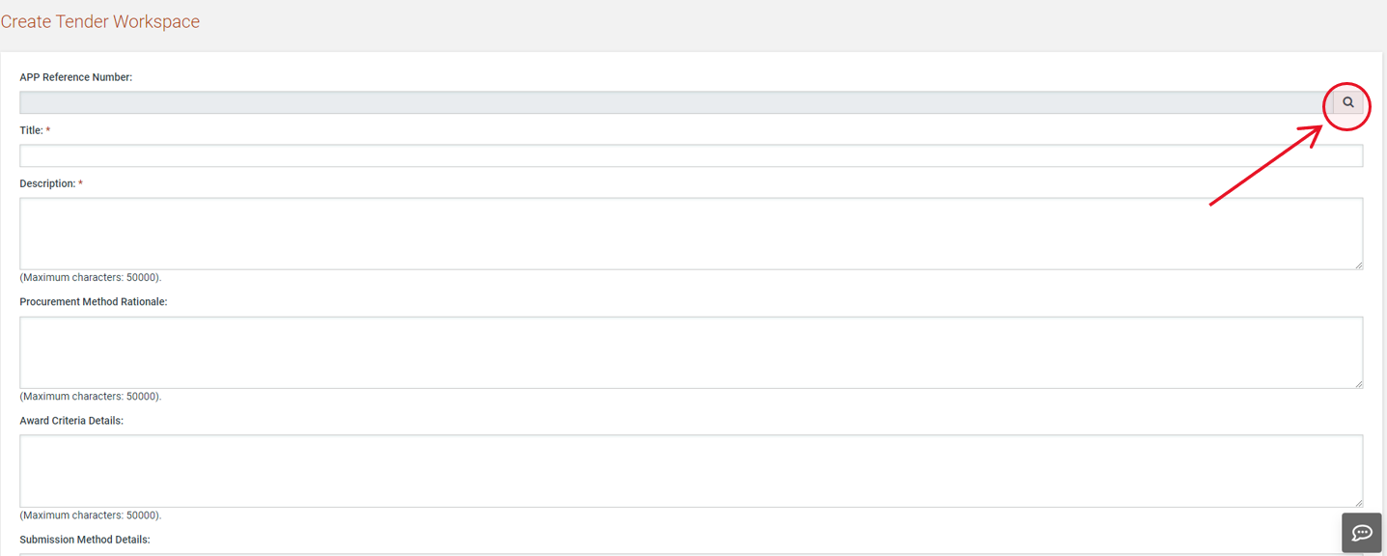
Figure 67: Tender Workspace

The APP items can be filtered by completing the search criteria on the form before clicking the “Search” button. Leaving all criteria empty, will return all the entries in the published version of the APP for the user’s Procuring Entity.

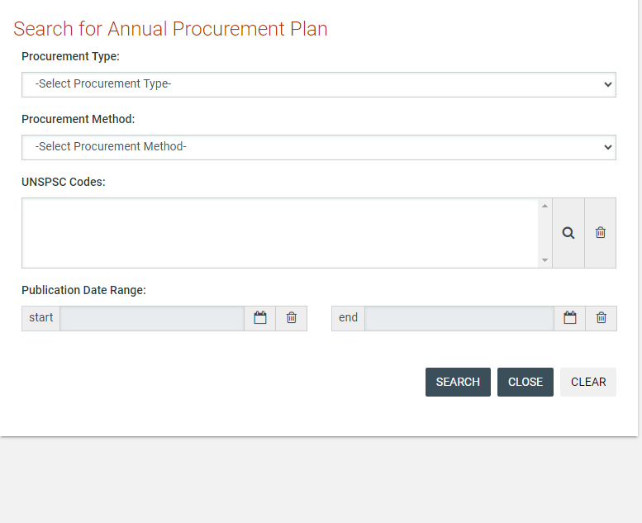
Figure 68: Search for APP entry to link to tender

The user can click on the “View” hyperlink next to each APP entry to see more details. When the correct entry has been identified, the user must click on the “Select” hyperlink to load the information from the APP item into the tender workspace (Figure 65).

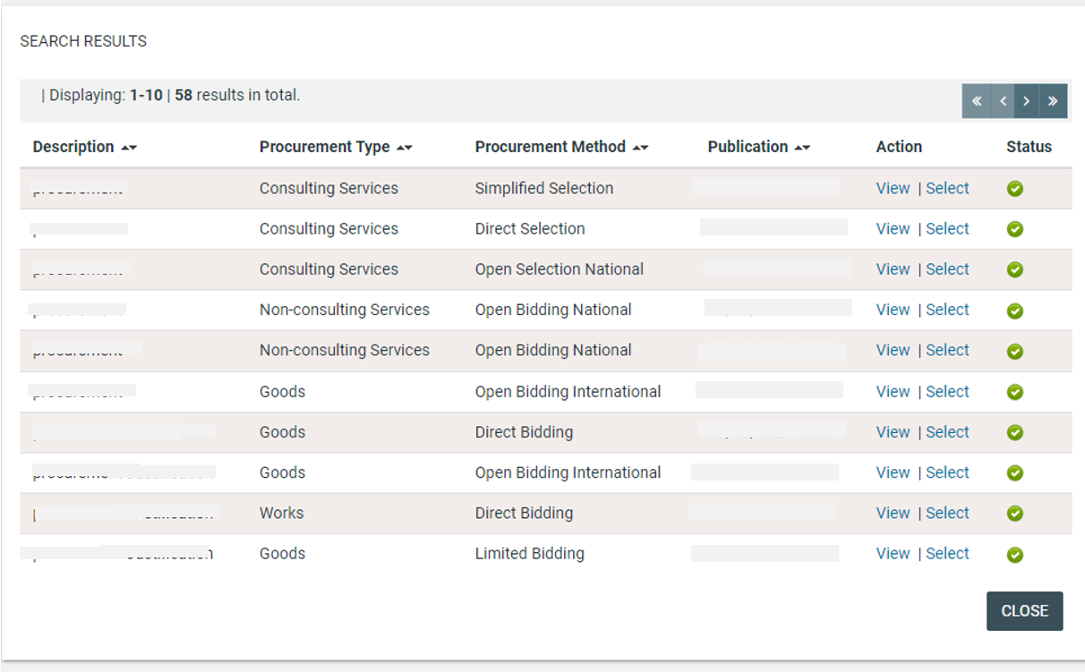
Figure 69: APP search results

The user now completes the remaining details required by the form in order to create the tender workspace. Different parameters need to be provided depending on the procurement method and procurement technique applicable to the tender.
If the suppliers are expected to provide a bid security as part of their response to the tender, the user can select whether the bid security should be a fixed amount or a percentage of the total bid value.
Once the user properly populates all required information the system will create the workspace. The user will receive a task to “Finalise Tender's Core Information”, before s/he is able to proceed with the publication. That user can edit the details before pressing “Save Changes”. (Figure 66)
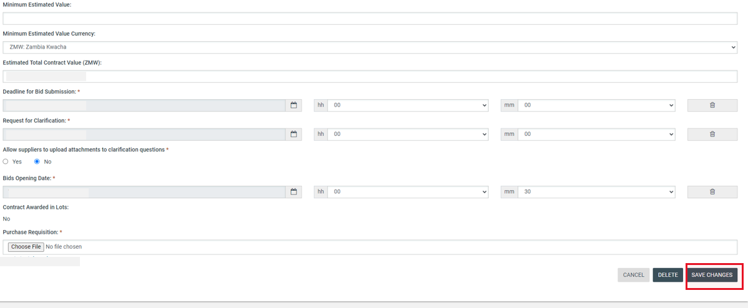
Figure 70: Save Changes

After clicking “Save Changes”, some of the details of the tender are not allowed to be edited. If the user identifies any errors in these fields, the tender workspace must be deleted and re-created with the correct values before proceeding. The APP Entry that the User Linked to the Tender during the creation of the Tender will be un-linked in case the workspace is deleted and can be used again.

Link APP on Tender Including the Reduced Floatation Justification

In case the APP is accepted by HCO and Published, the PO/TC user will be in position to proceed with Tender preparation by linking the APP entry that contains the justification. The system will not validate the bid submission period.

Association of Procuring Entity Users
In order to continue the procurement process, the user must then associate the following users with the tender:
- PO/TC. Procurement Officer Tender Coordinators (at least 1 user)
- PO/OS. Procurement Officer Opening Staff (at least 2 users)
- PO/ES and PO/ESR. Procurement Officer Evaluating Staff (at least 1 user). At least one of the evaluators will be associated as head of the evaluation committee (PO/ESR). If only a single evaluator has been associated with the tender his role must be PO/ESR.
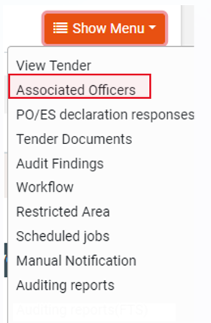
Figure 71: Associate officers

The following user role combinations are also permitted: PO/TC + PO/ES and PO/TC+ PO/ESR.
The procurement officers assigned with the roles PO/TC and PO/OS should belong to the Procuring Entity where the particular tender is published.

By default, the creator of the tender is assigned with the PO/TC role. However, more than one officers acting as PO/TC may be associated in the context of a tender. Assign a combination of roles and/or select other users to associate with the specific tender.

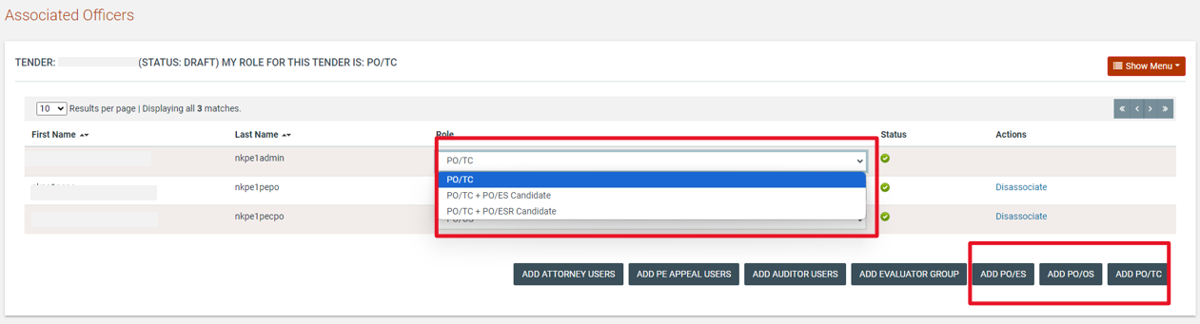
Figure 72: Define roles

System will offer a specific facility to search for users that are eligible for association with a specific role.

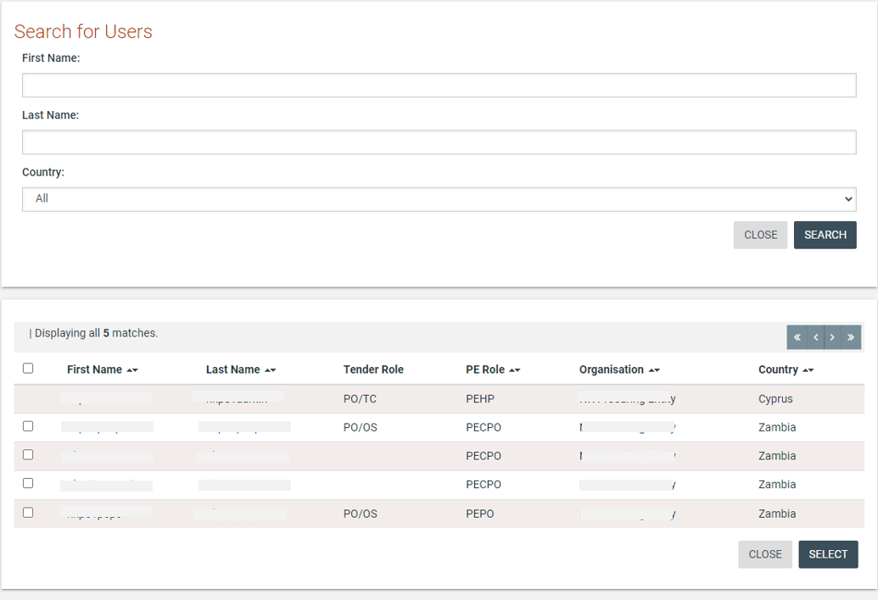
Figure 73: Search for user to be associated with a specific role

The associated procurement officers assigned with the PO/ES and PO/ESR roles can belong to other procuring entities.

The users and their roles under the particular tender can be modified at any time. Furthermore, a user can be disassociated from a particular tender by selecting the “Disassociate” link next to the user’s name (Figure 70).

Finally, an evaluator can be replaced at any time during the procurement process (Figure 70). In this case, all completed evaluations (draft or final) will be copied to the new user’s workspace. The status of all finalised evaluations will change to Draft, in order to allow the new user to edit and modify these evaluations.

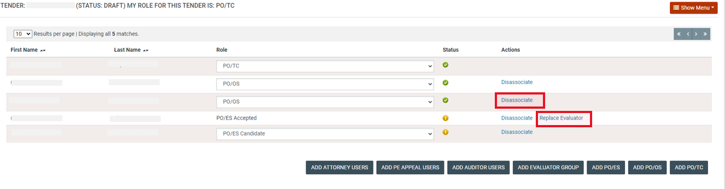
Figure 74: Modifying the role of an associated user

Code of Conduct
When users are initially added to the PO/ES or PO/ESR role, they are added as PO/ES Candidate or PO/ESR Candidate. The users need to review and accept the Code of Conduct which governs their behaviour as members of the Evaluation Committee. They need to indicate their acceptance of the Code of Conduct through the e-GP system by clicking on the task in their Task List.

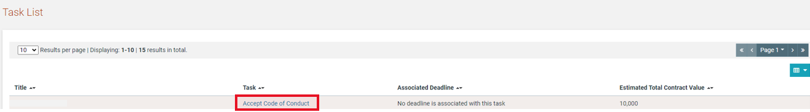

Figure 75: Task to accept code of conduct

The e-GP system provides standardised wording for the Code of Conduct. The candidate evaluator must indicate acceptance of the Code of Conduct. If they are not willing to abide by the Code of Conduct, a Comment explaining the reason for this is required. The user must click on “Save” in order to store their response to the Code of Conduct task.

An evaluator who declines the Code of Conduct must either be disassociated with the tender or must be replaced. In order to replace an evaluator, the replacement evaluator must have the same status as the original evaluator being replaced. For example, an evaluator whose status is PO/ES Candidate cannot replace an evaluator whose status is PO/ES Accepted.

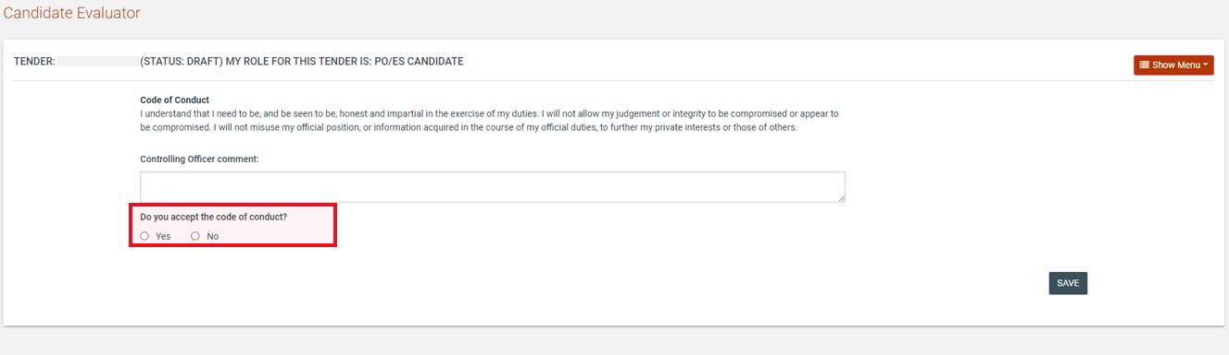

Figure 76: Code of conduct acceptance

The users allocated the PO/TC role are able to view the responses of members of the evaluation committee through the tender menu.

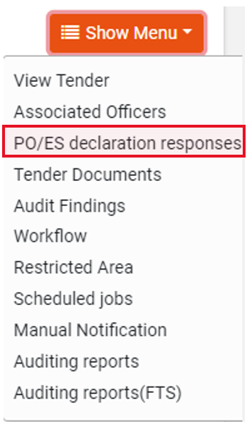
Figure 77: View PO/ES declaration responses

The response status of each member of the evaluation committee is shown in a table layout.

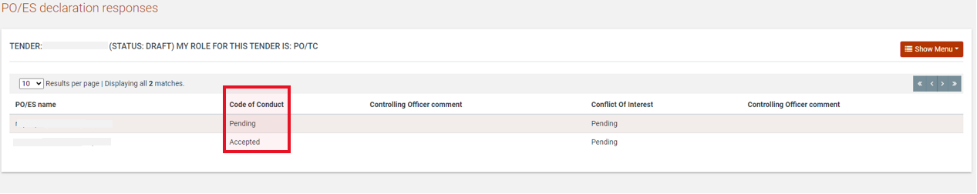

Figure 78: PO/ES declaration responses

Tender Documents
From the tender’s menu the users that are allocated the PO/TC role may create, edit or delete the tender’s documentation.

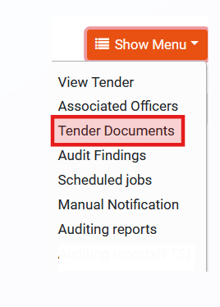
Figure 79: Menu option

The users assigned with the PO/TC role will be able to add and edit the desired documentation as needed.

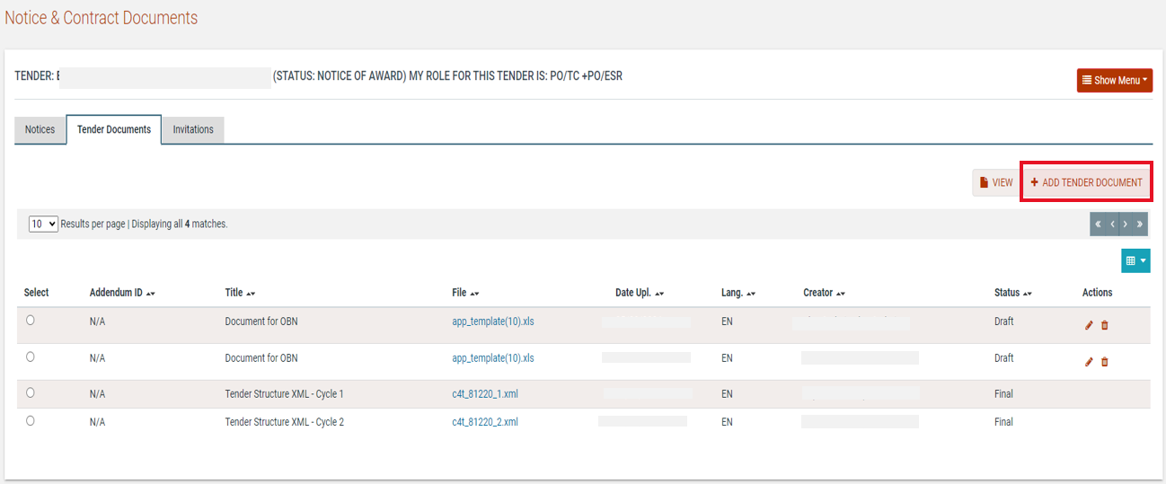

Figure 80: Add tender documents

The user may select to automatically upload all documents from a subfolder of the Template Library by clicking the “Create Templates” button. The system will process the request and update the tender’s documentation accordingly.
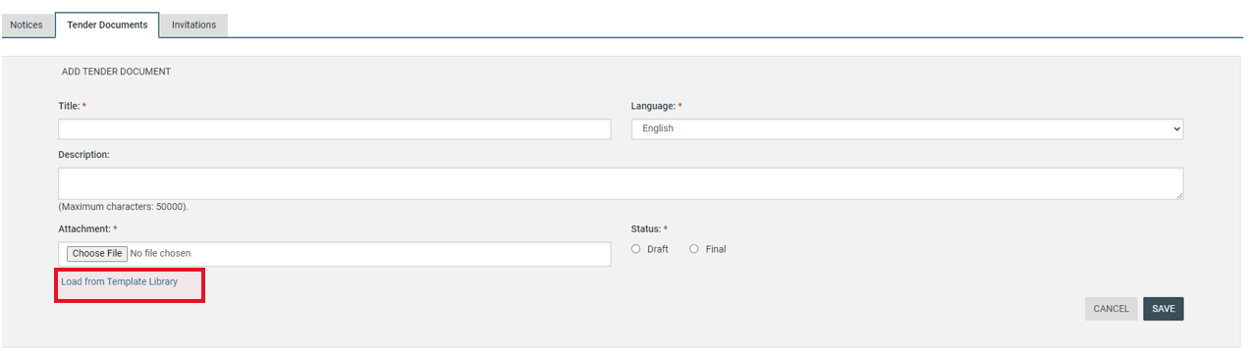

Figure 81: Create/load/edit document

The User may select to upload a document in Draft or Final Status. In order for the created documents with Draft Status to be available to the suppliers after the publication of the tender, the PO/TC will need to update said documents and set their Status to Final. The user selects the file and clicks the edit button, amends the status of the file and saves the modification.

In order to add other contractual documentation to the tender workspace the user should:
- Select the “Tender Documents” choice from the “Tender Menu”
- Select the “Tender Documents” tab
- Select the “Add Tender Document” button
- Provide the title of the document
- Provide the Language of the document
- Provide a description (non mandatory)
- Select the file to upload to the system
- Select the status of the uploaded file (final or draft)
- Select the button “Save”

In order to edit a contractual document, the user should press the button. The system enables the user to upload a new version of the document. The user should provide a textual description of the differences between the current and earlier version of the document. Selecting the button “Save” finalises the action.

In order to remove a tender document the user selects the document and then presses the button. The system always prompts the user to confirm his selection, prior to any deletion.

Define Workflow
The user defines whether the various steps of the tender will be performed online or offline.

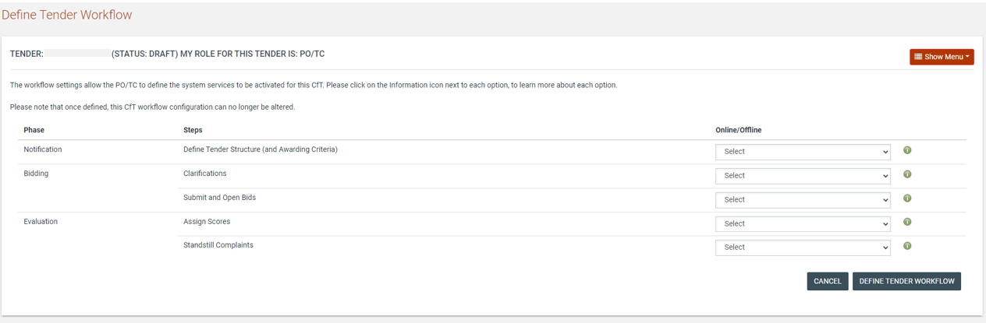

Figure 82: Define Workflow

Tender Documents Page – Draft Tender Document from Template Library

Following the definition of workflow for a new Tender, the e-GP system will check for all the Documents with status final from template library that the corresponding procurement procedure has been selected for them and copy them within the Tender Documents Area as draft.

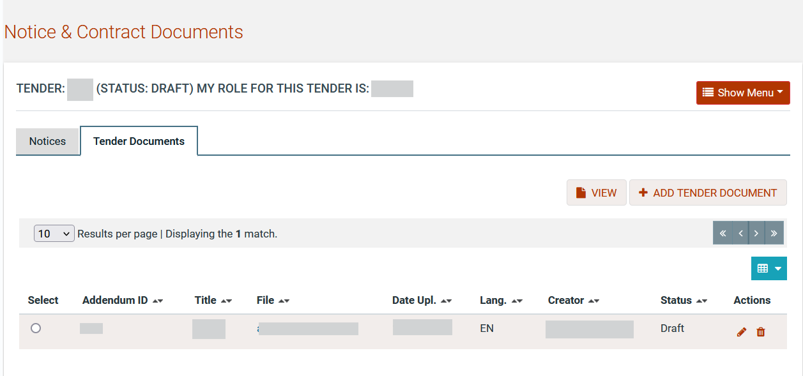
Figure 83: Tender Documents Page - Document from Template Library

Define Evaluation Criteria
The user is tasked to define the Evaluation criteria for the tender including weightings for tenders requiring evaluation on parameters in addition to price (if the “Define Tender Structure (and Awarding Criteria)” step is set to “Online” in the workflow).

Import Criteria
The criteria from a previous tender can be re-used, if they are similar to the criteria for the current tender, by importing an XML file that defines the criteria. The number of envelopes selected on the form should correspond with that in the XML file.

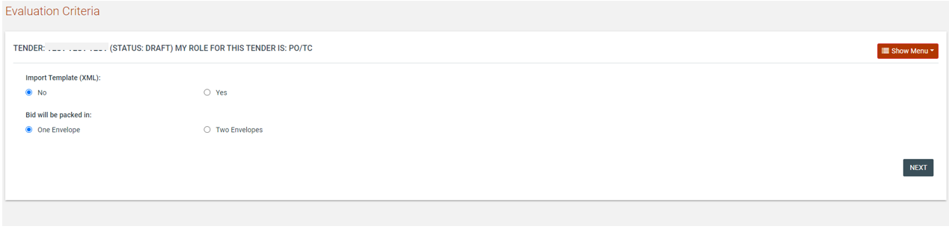

Figure 84: Import evaluation criteria XML file

The evaluation criteria XML file can be located by searching for prior tenders in the “Template Structures” option under the “Tender Creation” menu in the main navigation.

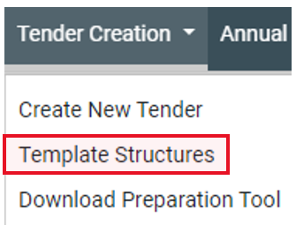
Figure 85: Template structures menu

Selecting this menu item provides the user with a search screen. After completing the search criteria the user clicks on the “Search” button to retrieve all tenders (across all procuring entities) that correspond with the criteria. If a large number of results are returned the search criteria may need to be refined further to the narrow the results.

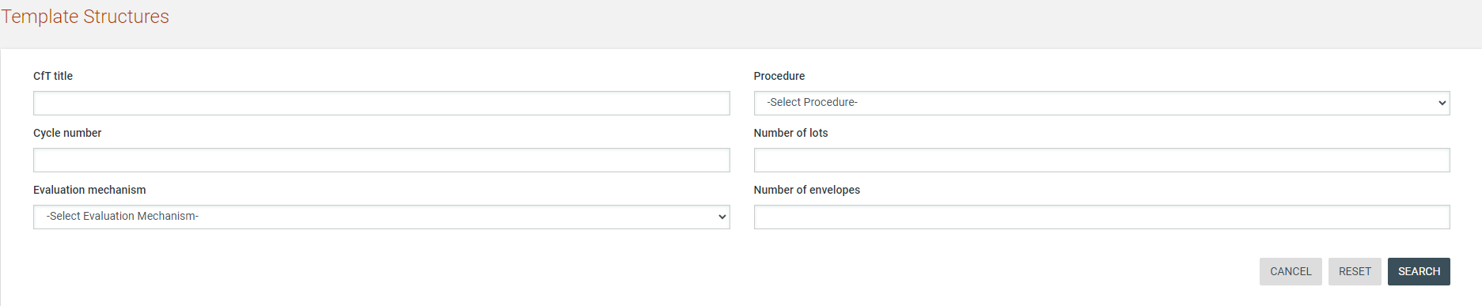
Figure 86: Search for previous tenders

The required XML file can be saved to the user’s local computer by clicking on the “XML Structure” link next to each tender. This file can then be uploaded in the screen to import the evaluation criteria.

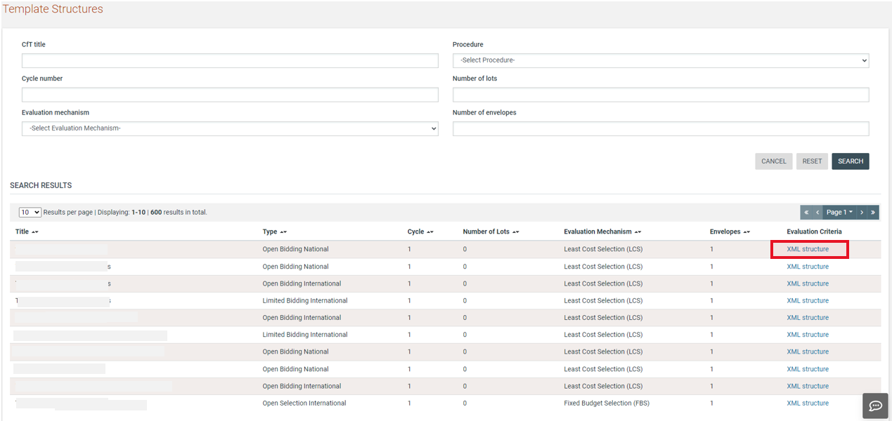

Figure 87: Template structures search results

Define Tender Criteria
Prior to the publication of the tender, the PO/TC users are required to create the Tender Structure that includes the questions that bidders need to answer, to participate in the tender. Some of these questions may constitute evaluation criteria for the tender. For simplicity, throughout this section, all questions or requirements created within the Tender Structure are referred to as “Criteria.” The criteria are defined in a structured way, separating them into three categories, which can be grouped into 1 or 2 envelopes.
- Preliminary Examination Criteria
- Technical Criteria
- Commercial Criteria
- Financial Criteria

The Preliminary Examination, Technical and Commercial parts of a Tender Structure are organised in sections and nested subsections which may contain numerous criteria.

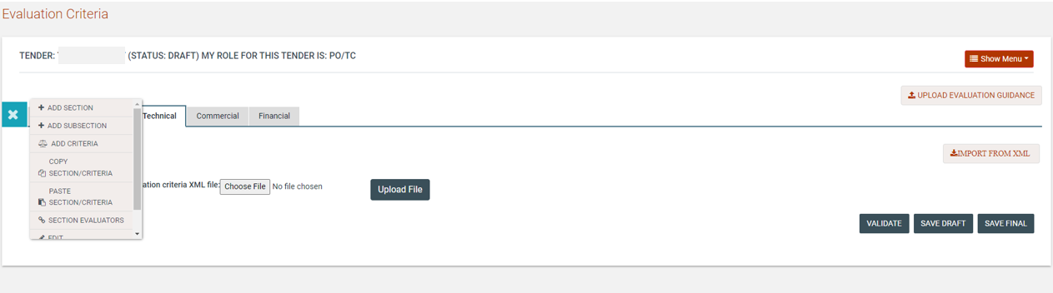

Figure 88: Definition and Management Menus

For each section or nested subsection, the following information is required:
- The label of the section;
- If the evaluation mechanism is a combination of Quality and Price, the weight of the section (the sum of all section weights should be equal to 100; sections in the Eligibility Criteria have associated weights only in case of procedures that include short-listing);
- The scoring threshold required for succeeding in the section (the supplier who scores less points than the threshold, is automatically disqualified).

To define a section, click on the “Definition”  menu button and then click on the “Add Section” option.
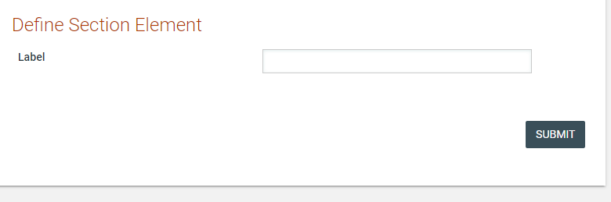

Figure 89: Define Section

Within each section or subsection, particular evaluation criteria types are available. The following types of criteria are supported:
- Text field
- Text area
- Number
- Date
- File
- List

The following properties are common between all types of criteria:
- The label of the criterion.
- If the criterion is mandatory or not (i.e. a response by the bidder is required for mandatory criteria in order for the bid to be considered by the System as complete and the submission as valid).
- Supplier Read Only. A response is not provided by the supplier in the bid and a score is provided during the evaluation.
- Textual Evaluation. This choice is enabled if textual evaluation will be used for the specific criterion.
- If the criterion is included in the evaluation. If yes,
  - Criterion weight. The sum of all criteria weights within a specific section must be equal to 100, so as to define their relative weights. This weighting mechanism is used in the case of Quality-Price, or when the procedure foresees the short-listing of Suppliers.
  - Criterion threshold. The required scoring threshold for a supplier to pass the criterion.

The following sections describe all the supported criterion types.

Criterion Type: Text Field
This criterion is used when the supplier is expected to provide short text response.

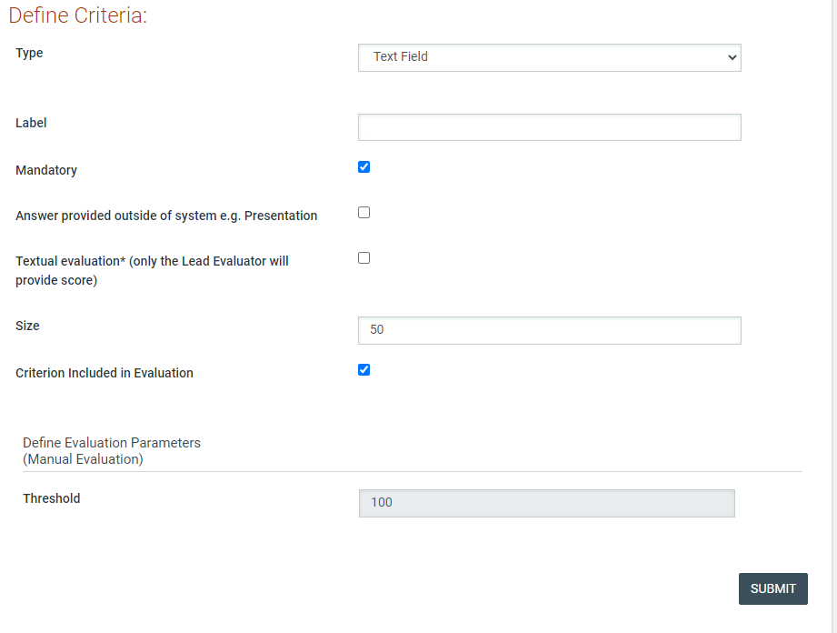

Figure 90: Criterion type: text field

Criterion Type: Text area
This criterion is used when the supplier needs to provide a longer text response which spans multiple lines and paragraphs.

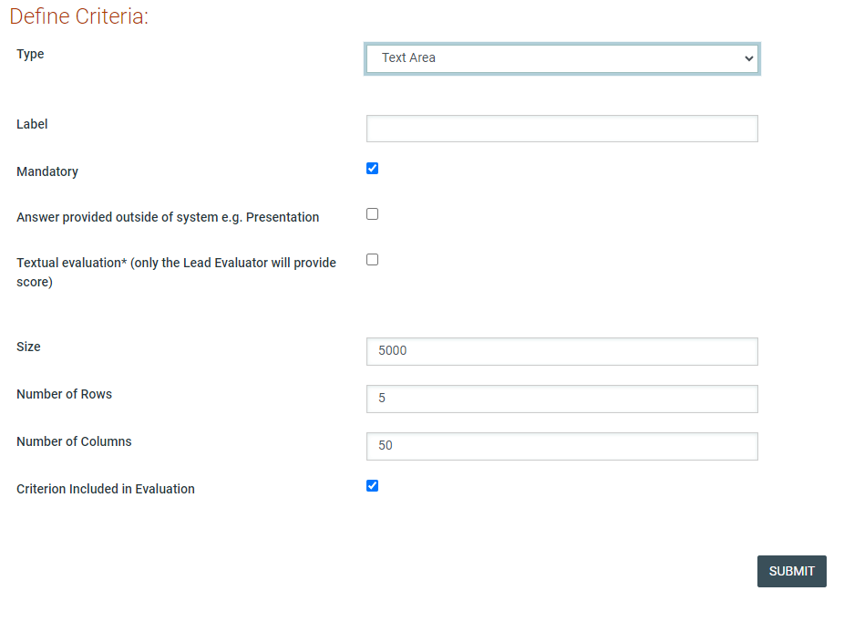

Figure 91: Criterion type: text area

Criterion Type: Number
The following parameters must be defined:
- Minimum and maximum range;
- Measurement units;
- Step.

As the System can support the automated scoring of any quantifiable criteria, the user may select the type of the evaluation formula to be used:
- Linear Formula: The user defines Lower and Upper Limits with their associated scores.
- Step Formula: The user defines value ranges and their associated scores. Selecting the buttons “Add” and “Delete” inserts and deletes scoring ranges.

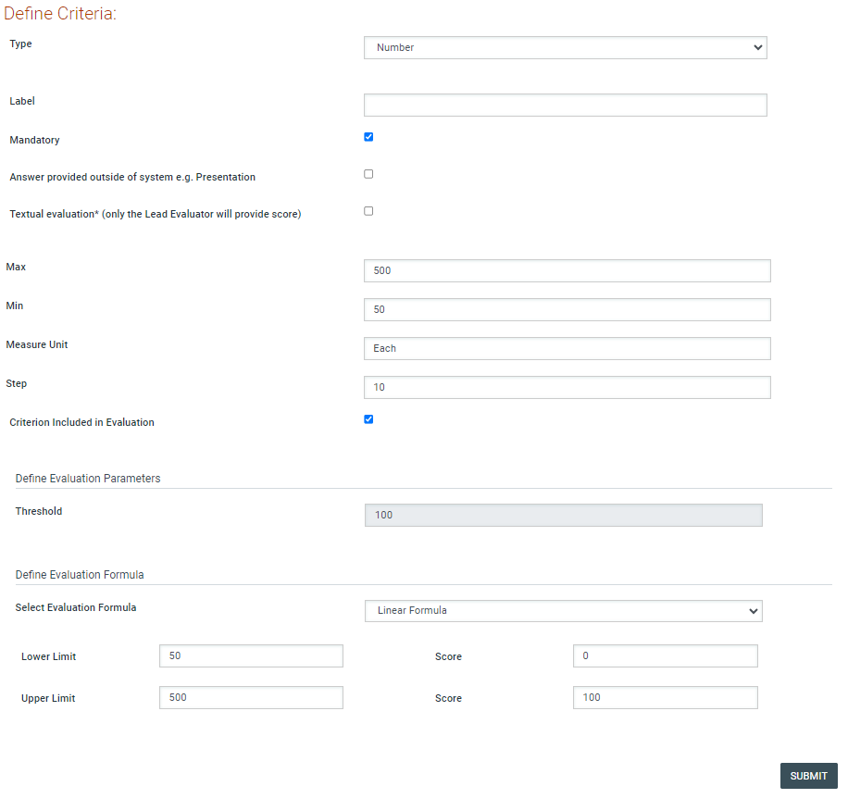

Figure 92: Criterion type: Number with linear evaluation formula

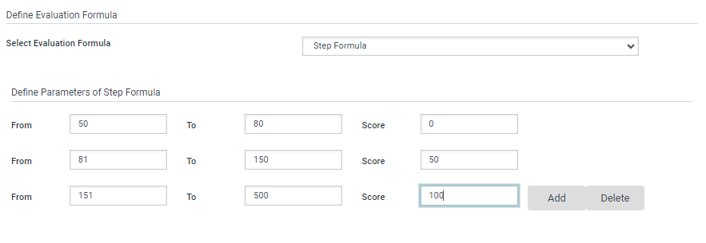

Figure 93: Criterion type: Number with step evaluation formula

Criterion Type: File
For this criterion type the user should define the maximum allowed size of the file to be attached.

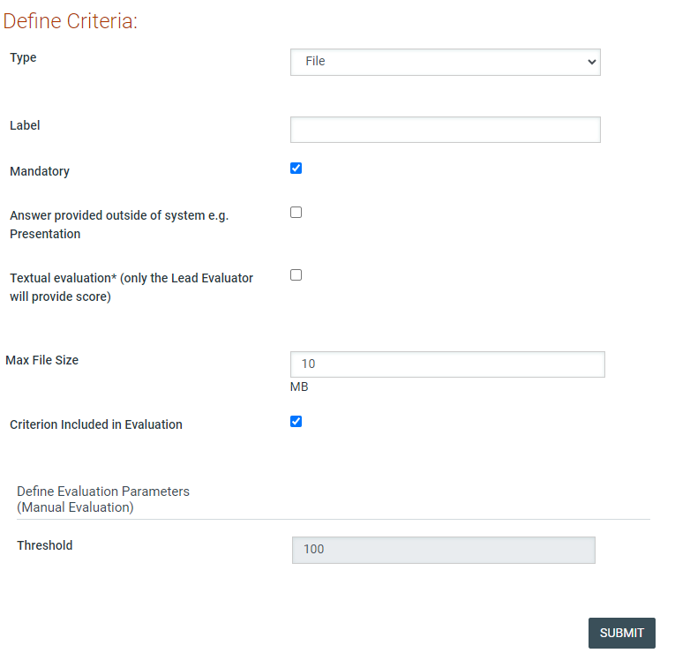

Figure 94: Criterion type: file

Criterion Type: List
In order to create a list, the following options should be defined:
- Type of list: A choice between radio buttons, check box and combination box;
- Number of options: The user provides the number of options that should be created ;
- Label: The label for each option created;
- Score: The automated evaluation score for each option.

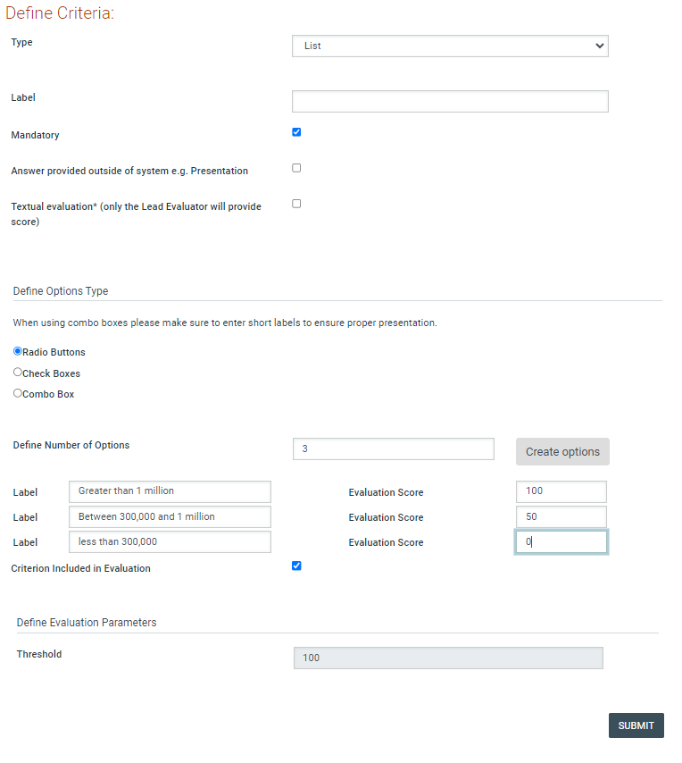

Figure 95: Criterion type: List

Criterion Type: Date
In order to create this criterion type, the user provides the following information:
- The minimum and maximum allowed values for the date criterion.
- The evaluation formula (linear formula and step formula), similar to Number criteria.

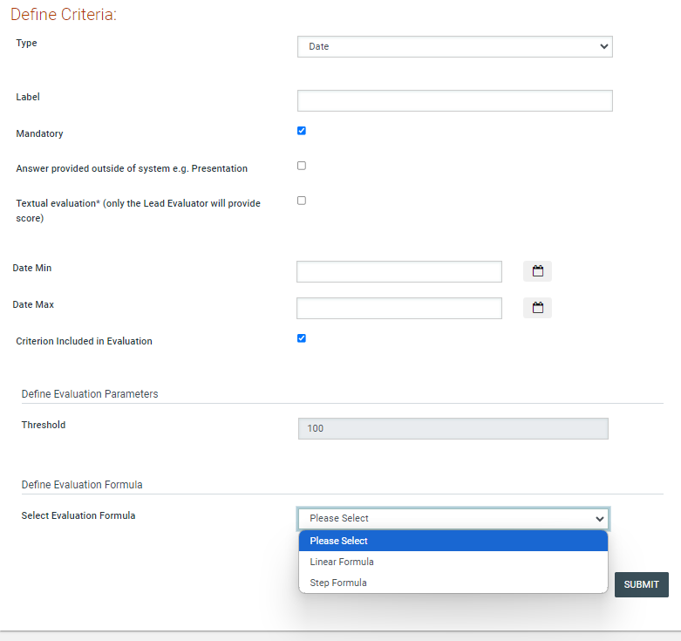

Figure 96: Criterion Type: Date

Supplier read only criteria
This choice is enabled for the criteria where the suppliers should not provide any answer (e.g. scoring of meetings, presentations, site visits, etc.). The supplier will view the existence of the criterion but the scoring will be provided directly by the evaluators. The automated evaluation mechanism will be disabled for all the supplier read only criteria.

In this respect, such criteria are “read only” for suppliers (they can see them but cannot provide answers to them) and “read/write” access is provided only to evaluators.
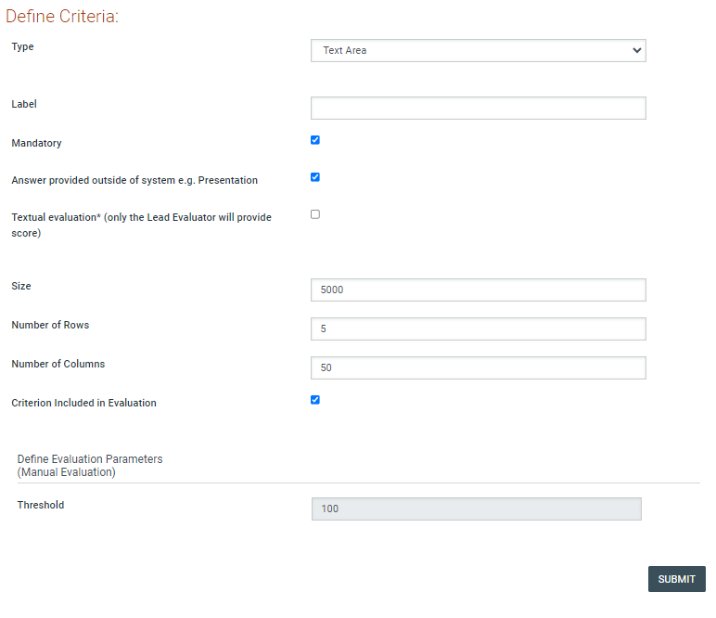

Figure 97: Supplier read only criterion

Definition of envelope weight
In order to define the weight of the envelopes (Technical and Financial) the user needs to select one of the envelopes and provide the relevant envelope weight. The following rules must be followed:
- The sum of the weights of the Technical and Financial envelopes must be equal to 100.
- The user needs to define the weight in only one envelope. The other envelope will be assigned the remaining weight.

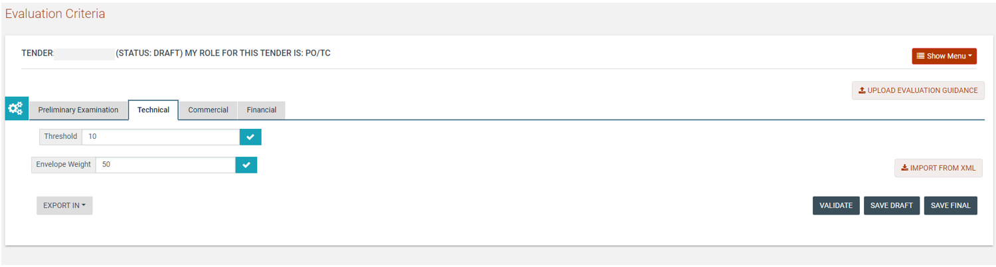

Figure 98: Technical Envelope’s weight

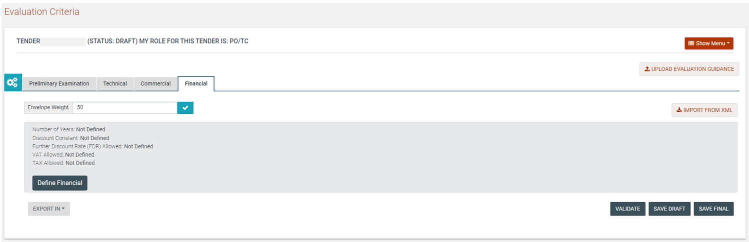

Figure 99: Financial Envelope’s weight

Financial Envelope
The definition of the financial envelope includes the definition of the Financial Element and the introduction of the financial criteria. After the successful completion of these, the financial envelope is considered as complete.

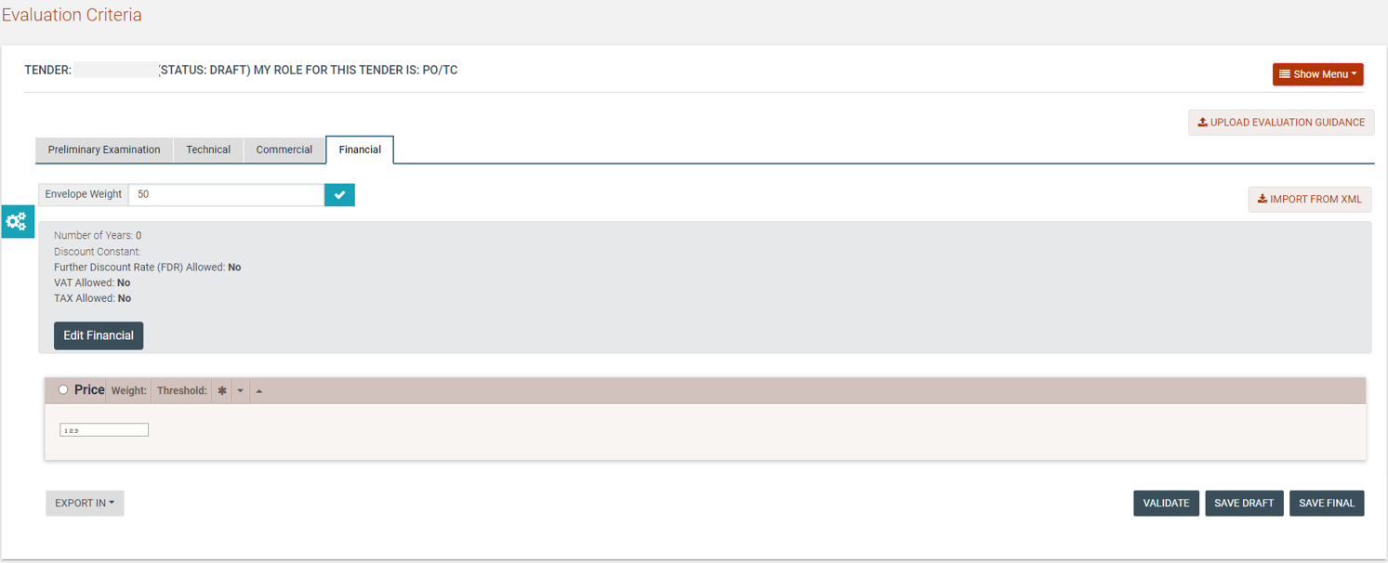

Figure 100: Example of the financial envelope

Definition of the financial element
In order to define the financial element, the user must provide the following information:
- Choice if calculation will be performed at present value.
- Number of years of the financial element (if more than one year, the present value calculation is automatically enabled);
- Discount constant: the constant (e.g. inflation rate) that will be used in order to discount the future prices into their current values;
- Further discount rate;
- Whether VAT should be provided separately;
- Whether other Taxes should be provided separately.

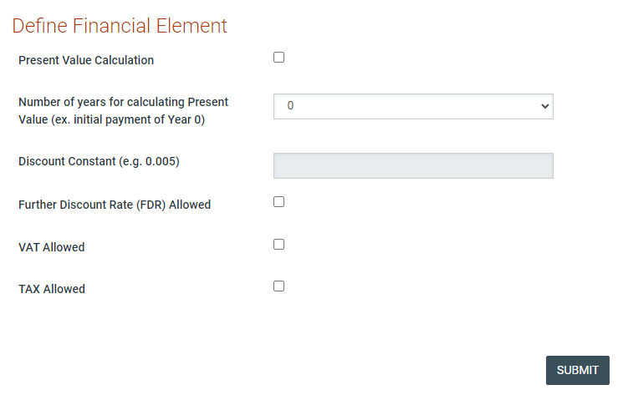

Figure 101: Definition of the financial element

The aforementioned advanced functionality of “present value calculation” permits evaluators to evaluate financial offers considering future payments through the contract years, also taking into account inflation and currency depreciation.

Setting financial criteria
In order to create financial criteria, the user inserts the following information:
- The name of the criterion ;
- Whether the criterion is mandatory or not (at least one financial criterion should be mandatory);
- Whether an attachment (containing a detailed price schedule) is mandatory or not;
- If applicable, whether the Domestic Preference Discount applies to this criterion.

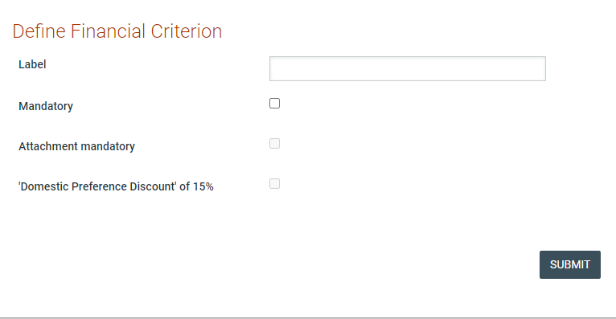

Figure 102: Define Financial Criterion

Validating and saving the Tender Structure
To validate whether the Tender Structure conforms to all the System evaluation rules, select the “Validate” option after clicking on the “Management” button. In case the Tender Structure is successfully validated, a relevant message is displayed. A different message is displayed if a validation rule is violated. In this case, the message also provides a description of the violation.

Figure 103: Successful tender structure validation

Figure 104: Violation of a validation rule in a tender structure

Of course, the validation rules relate only to the soundness and completeness of the Tender Structure and not its “business” content. The validation rules will, for instance, check whether the weights of criteria in a section sum to 100 and will check whether there is a list criterion for which the possible answers are not defined. But it cannot validate whether all business questions/requirements for a tender are included by the user or whether there is a missing financial criterion.

Create Tender Structure with Lots
In the event of a tender with Lots, the PO/TC user needs to specify the relevant tender parameters during the Tender Structure creation phase, in order to create a tender which can be awarded in Lots. Creating the Tender Structure for each separate Lot does not differ from creating a Tender Structure for a tender without Lots. As shown below, the user will be able to select the Lot to create and modify its structure.

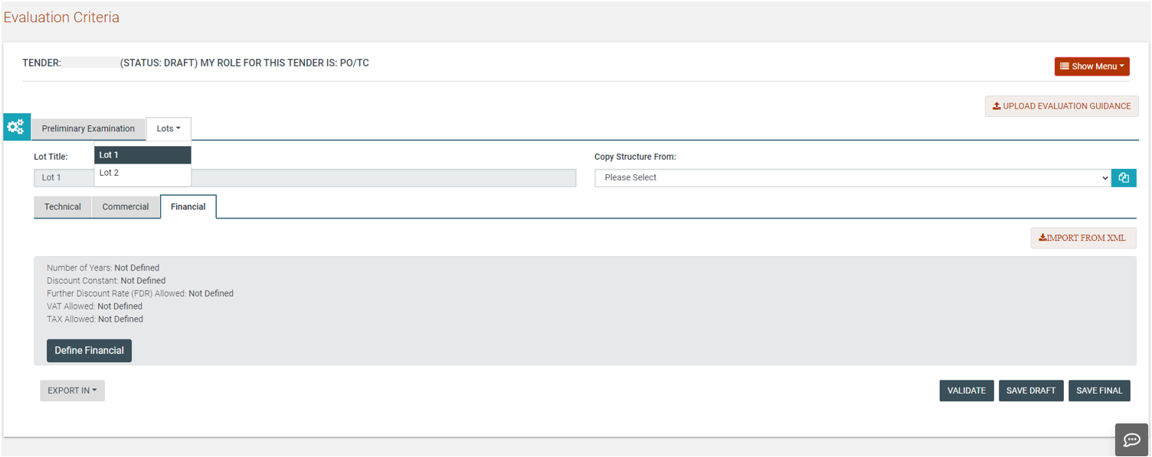

Figure 105: Selection of Lot

The only difference is that the Eligibility criteria are defined only once for all Lots, while the Technical and Financial criteria are specific to each Lot. After the selection of the appropriate Lot (already pre-defined during the tender workspace creation), the PO/TC user is able to add sections, subsections and criteria as for a tender that does not contain lots (section 8.7.2).

Copy Lot Structure between Lots
The System allows PO/TC users to copy the Tender Structure of one Lot to another Lot. This can be used when the evaluation criteria of one Lot are similar to one or more other Lots. The System allows the user, after copying criteria from one Lot to another, to then edit them, so that they are adjusted to the exact needs of each Lot.

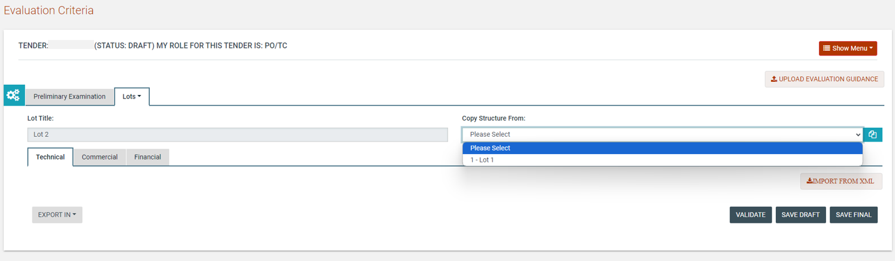

Figure 106: Copy Lot Structure

Create / Publish Tender Notice
Once all documentation is finalised the user may proceed to the creation and publication of the Tender Notice (for Open/Limited National/International Bidding/Selection procedures). A respective task will be available in the user’s task list. The user will navigate to the “Notices” tab in the Tender Documents tab of the Tender.

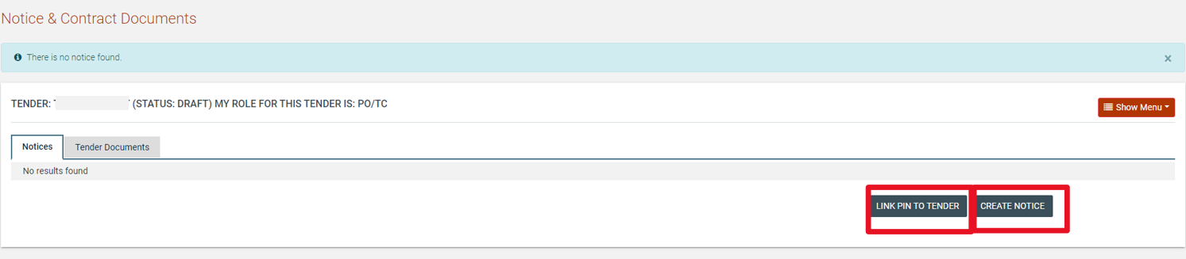

Figure 107: Create Tender Notice

In the pop-up window that opens when the user clicks on “Create Notice”, there is only a single option available for the user to select to create the Tender Notice. The form is loaded after the user clicks on the “Forms Module” button.

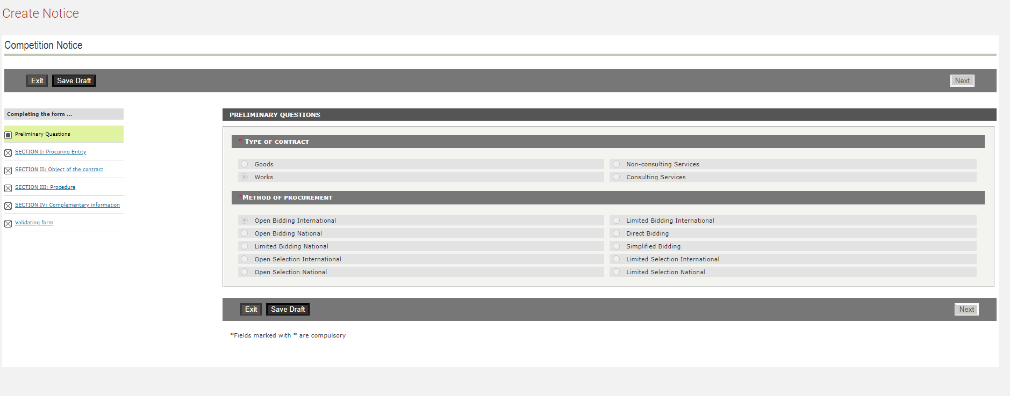

Figure 108: Form filling tool / notice details

Certain of the fields in the notice are drawn from the tender structure and cannot be edited by the user in the notice. After all the remaining details are populated, the user may save the notice as “Draft” or “Final”. Any notice saved in “Final” status is available for publication.

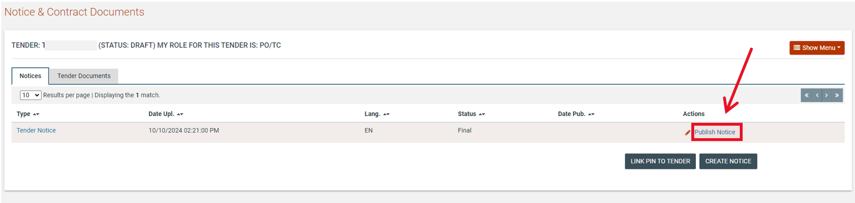

Figure 109: Contract notice publication

Invitations
Once all documentation is finalised the user may proceed to the creation and dispatch of invitations (for Simplified Bidding or Direct Bidding procedures). A respective task will be available in the user’s task list. The user will navigate to the Invitations tab in the Tender Documentation screen.

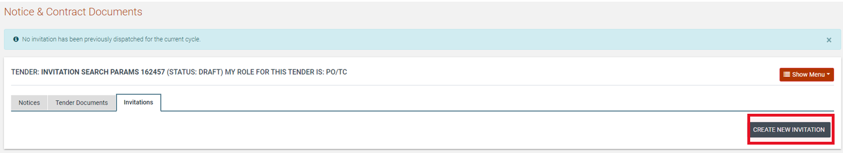

Figure 110: Invitations tab / Create new invitation

The user will need to click on “Create New Invitation” for the system to auto-generate the respective information

The system populates all fields with any core information. The list of Suppliers is populated by the user along with a description and any additional attachments.

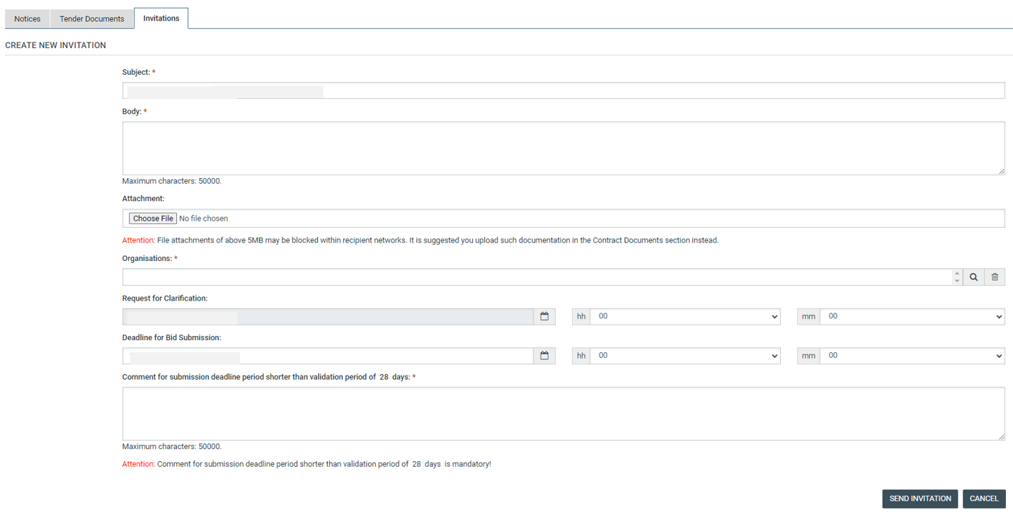
Figure 111: Invitation page

Upon clicking of the “Send Invitation” button the system will dispatch the invitation to all invited suppliers and will trigger the bidding process.

Approval of Flotation Period – Limited Selection Procurement Method

In case of Limited Selection procurement method, when the PO/TC user creates/ modifies an invitation by providing a bid submission deadline period that is lower than minimum 28 days validation period, the Compliance Monitoring Officer (CMO) user of the authority that manages the compliance monitory should review the modification before the bid submission deadline date is updated in the system.

A comment field will be available in the “Invitation” page. PO/TC has to provide a mandatory comment and select the button.

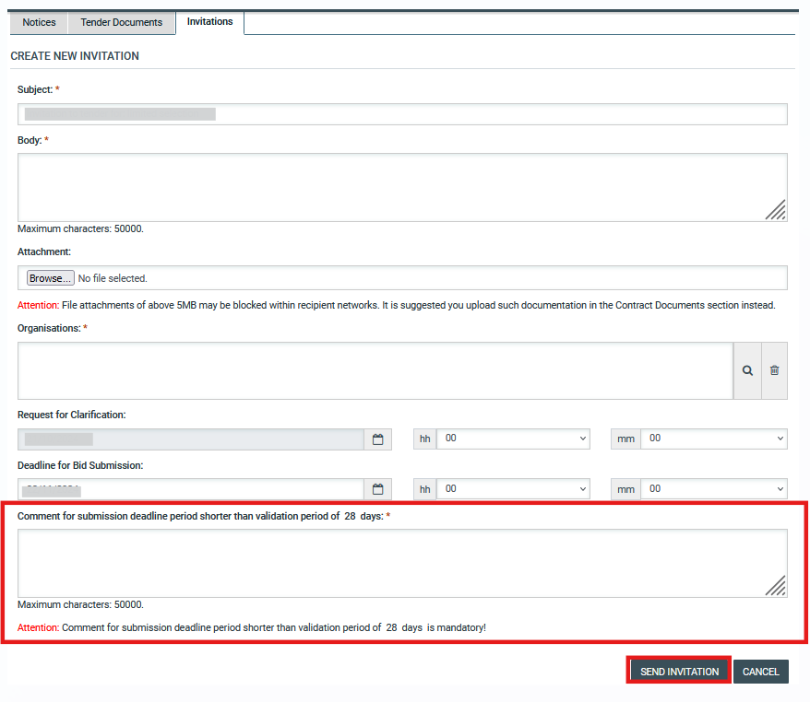

Figure 112 Send invitation for Review

Upon selecting the button the invitation will be sent for approval by CMO user the following message is displayed.

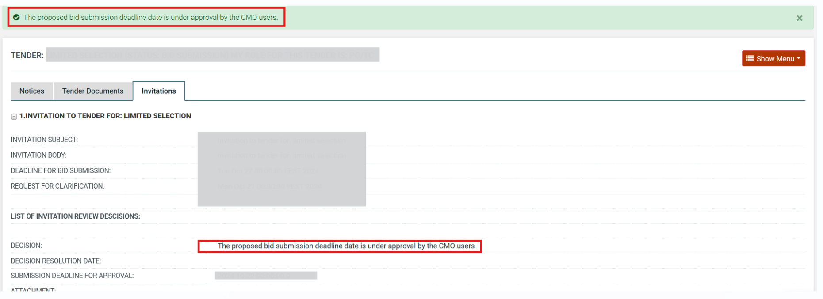

Figure 113 Invitation has been sent to CMO for Approval

The task “Review the Authority Response” will be available on CMO user’s task list.

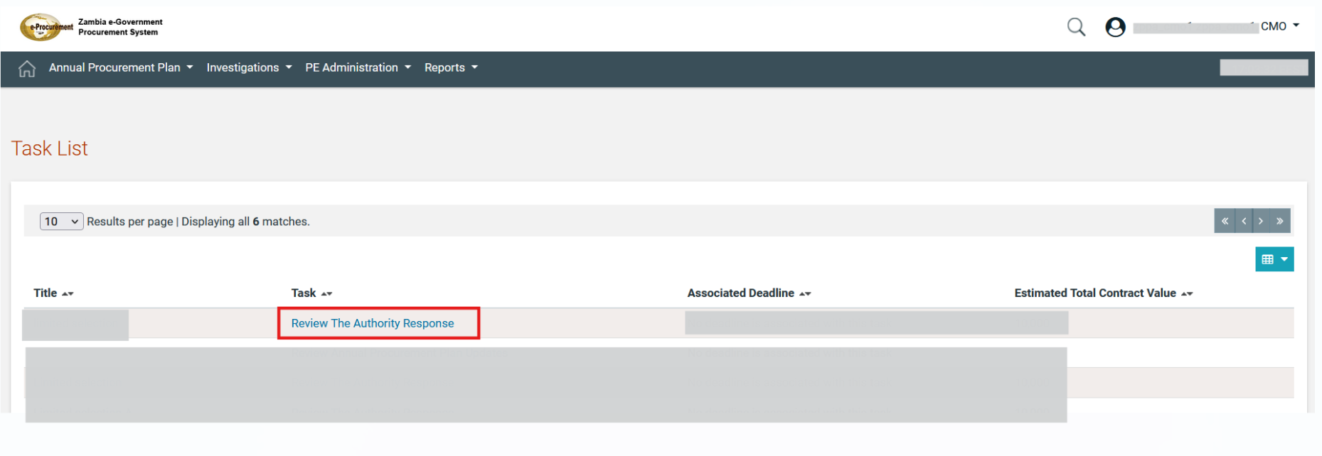

Figure 114 Review the Authority Response Task

Upon selecting the relevant task, the CMO user will be able to view the tender’s commencement date (if available), initial bid submission deadline (if available), new bid submission deadline date and the provided comment by the PO/TC. Also, the following options are displayed

- Approve bid submission deadline date: In case the CMO user approves the modification the TC user will be notified that the CMO user accepted the reduction request through email and the bid submission deadline will be updated.
- Reject bid submission deadline: In case the CMO user rejects the proposed bid submission deadline date the CMO user will have to also provide a mandatory comment, the PO/TC user will be notified that the CMO user rejected the proposed bid submission deadline date via email.

In order the user to provide the selected decision he/she has to select the button.
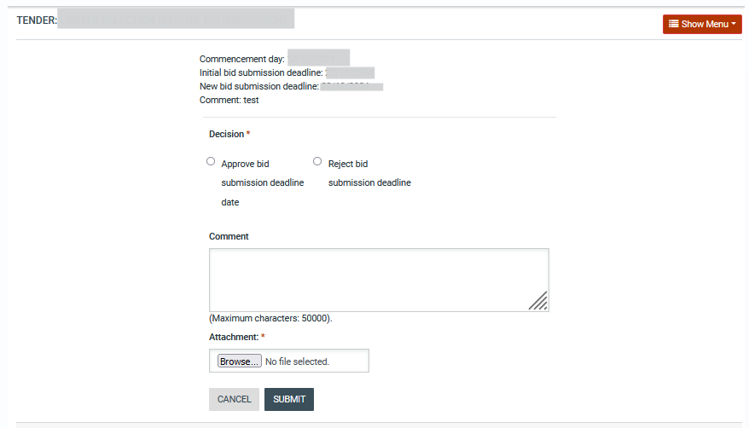

Figure 115 CMO approval flotation period page

The following mail notification will be sent to TC user including the attached file in case of acceptance of bid submission date.

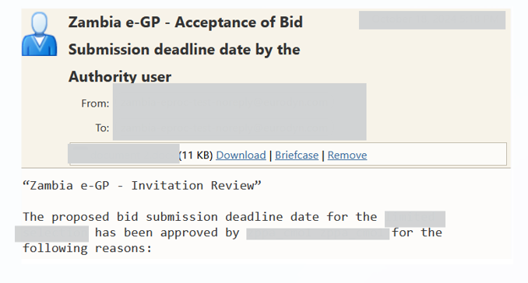

Figure 116 Email Notification - Accept bid submission deadline

The following mail notification will be sent to PO/TC user in case the rejection of Bid submission date.

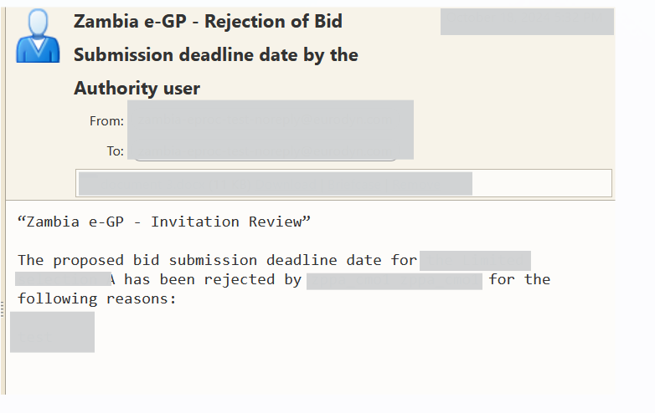

Figure 117 Email Notification – Reject Bid submission deadline

Modify Tender Structure

The PO/TC user will be in position to modify the tender structure during the bid submission period. The user selects the option “View Evaluation Criteria” from “Show Menu” drop-down menu for a specific tender.

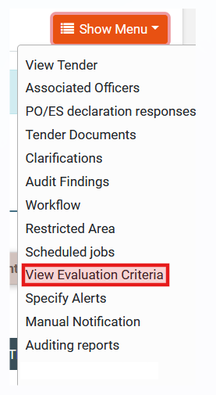

Figure 118 View Evaluation Criteria Option

On evaluation criteria page the user selects the  button in order to be able to modify the evaluation criteria

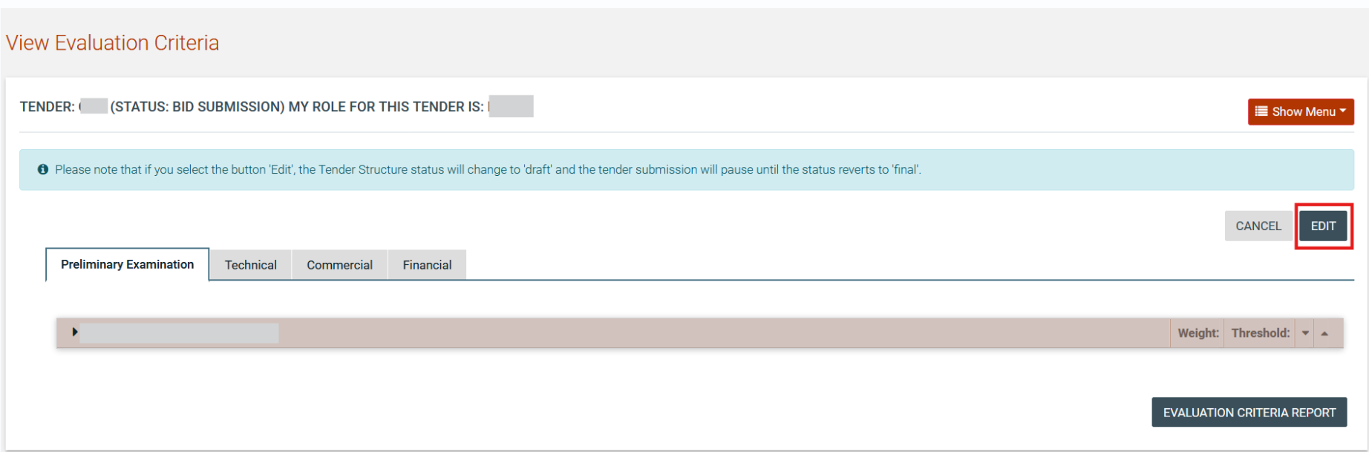

Figure 119 Edit Button

Following the selection of aforementioned button the user can modify the number of envelopes or to import an existing XML structure and the information of existing or create new criteria, sections for each tab (Preliminary, Technical, Commercial, and Financial).

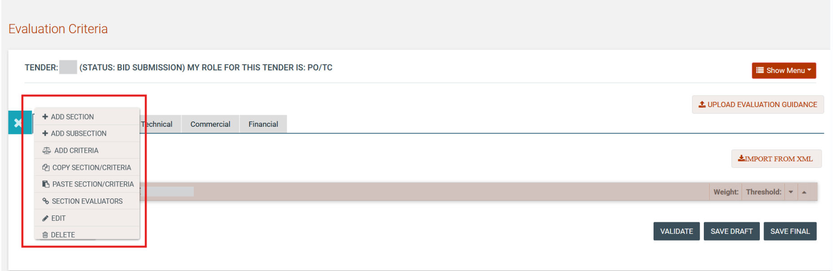

Figure 120 Modify evaluation criteria

The tender structure modification isn’t completed when the user selects to save the modifications as “draft” or just to select the “edit” button. Also the task “Finalisation of Pending Tender Structure” will be available in order the user to be informed to finalise the modifications of evaluation criteria.

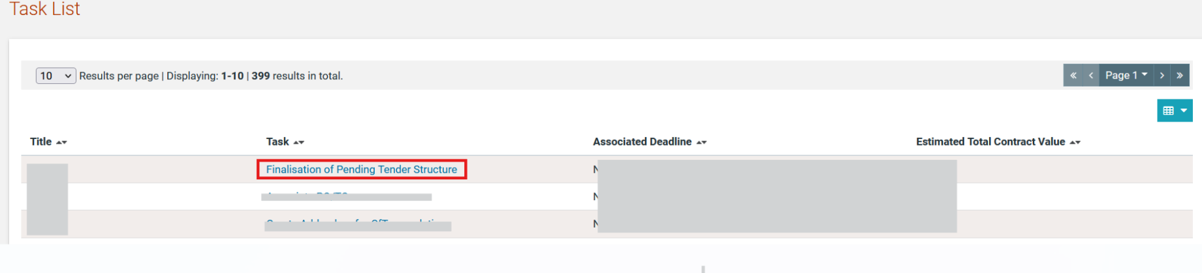

Figure 121 Finalisation of Pending Tender Structure Task

In this stage upon the user selecting the aforementioned task or the option “view evaluation criteria” from “Show Menu” drop-down menu will be able to finalise the structure by selecting the  button. Then, the modification of evaluation criteria will be completed

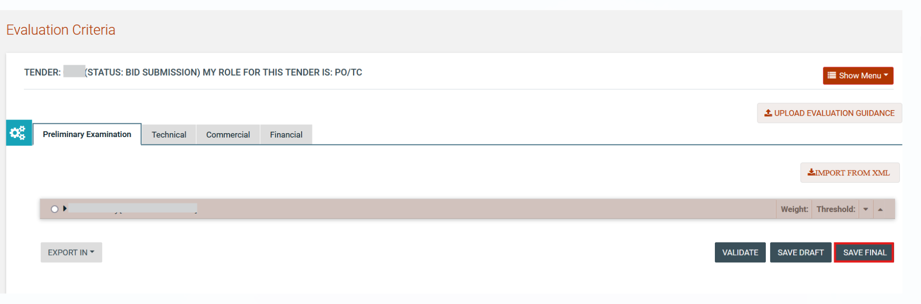

Figure 122 Finalise Modified Tender Structure

In case the tender structure is modified by the PO/TC user all the already submitted bids will be automatically marked as invalid and the supplier organisations that have already submitted their bids will be informed through an email notification in order to re-submit their bids.

Tender Cancellation

The system provides the addendum notice option to be done when the tender is cancelled at any point of the process. The cancellation button is available on tender details page. The user provides the reason of cancellation and selects the  button.

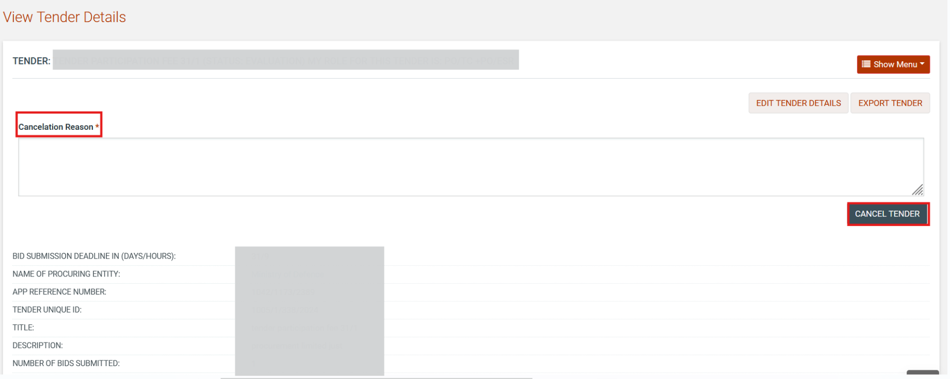

Figure 123 Cancel Tender

Following the tender cancellation the “Create Addendum for CfT cancelation “task is available

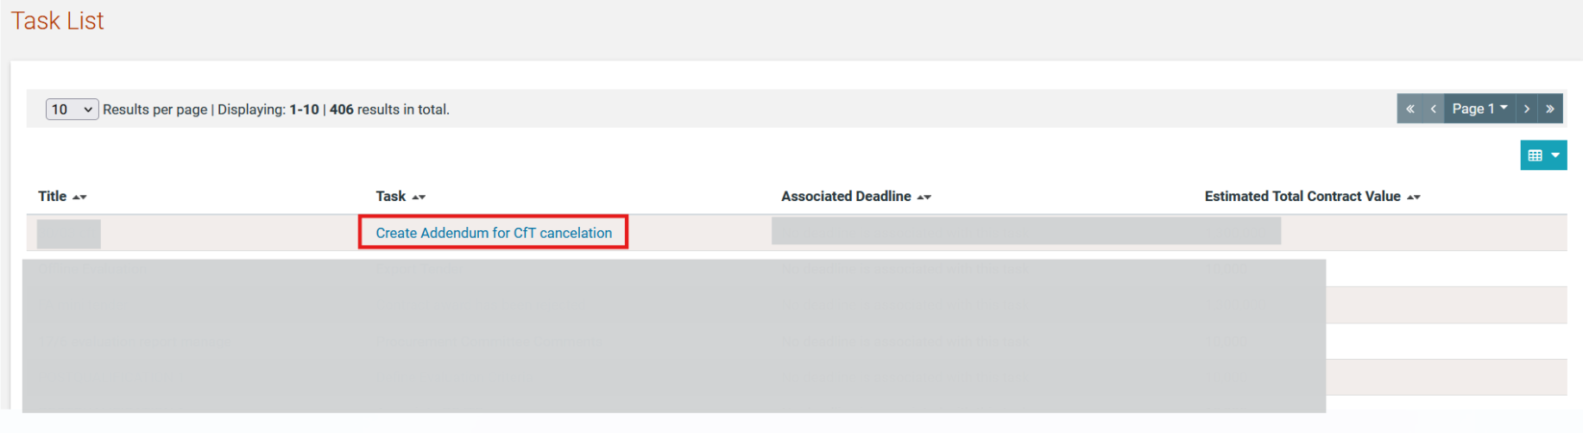

Figure 124 Create Addendum for CfT cancelation task

The PO/TC user will be able to create an addendum notice.

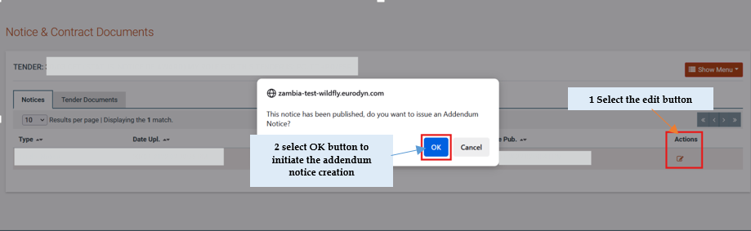

Figure 125 Create Addendum Notice (1)

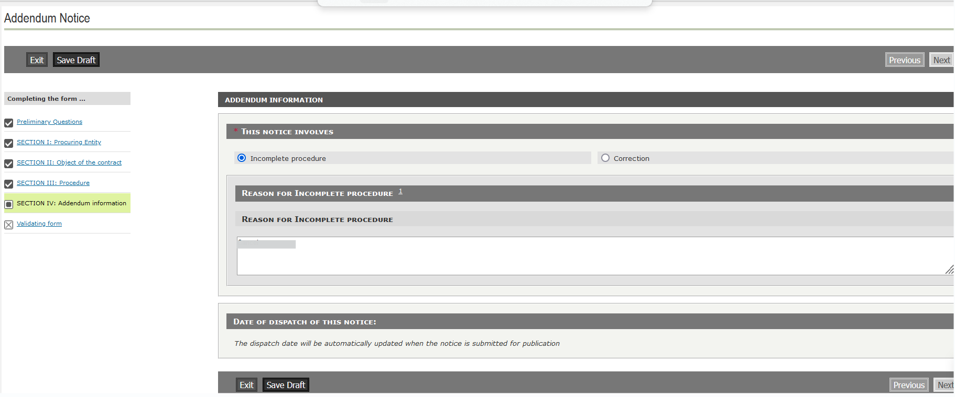

Figure 126 Create Addendum Notice (2)

The saved as draft addendum notice can be deleted or edited

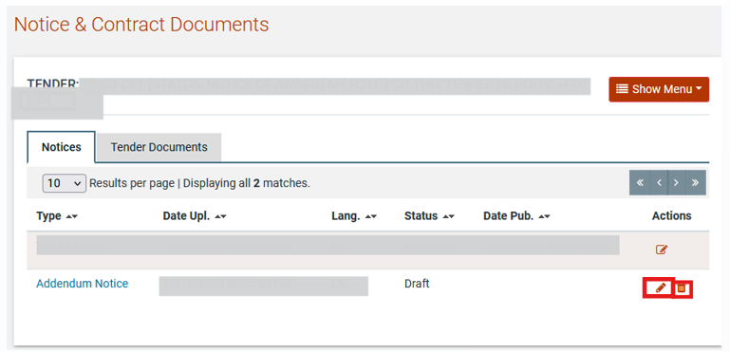

Figure 127 Edit/ Delete Addendum Notice

Addendum Notice with status “Final” can be edited or published. The status of tender will be changed to “Cancelled” following the publication of addendum notice.

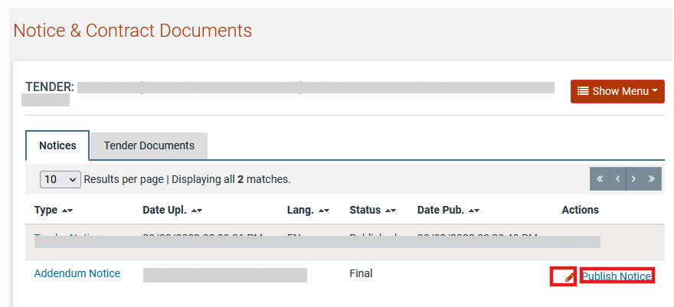

Figure 128 Edit/ Publish Addendum Notice

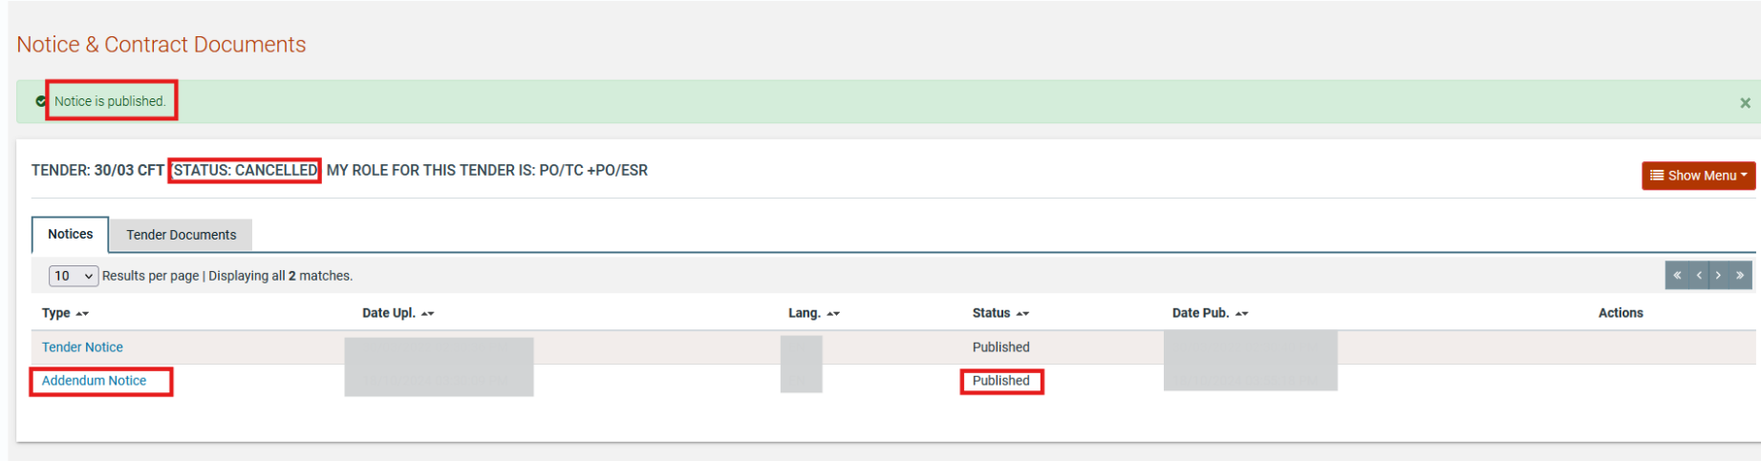

Figure 129 Publish addendum Notice

Clarifications
In the section of clarifications the system provides the following functionality to the user:
- To manage all clarifications which have been requested by Suppliers.
- To insert clarification requests which have been introduced by Suppliers offline.
- To provide information not associated with any particular requests.

Each clarification request has one of the following statuses:
The clarification request has not been answered
The clarification request has been answered
The clarification request has been published

Once the PO/TC of the tender receives a request for clarification a respective task will be created. The user may access the request and create an answer for it.

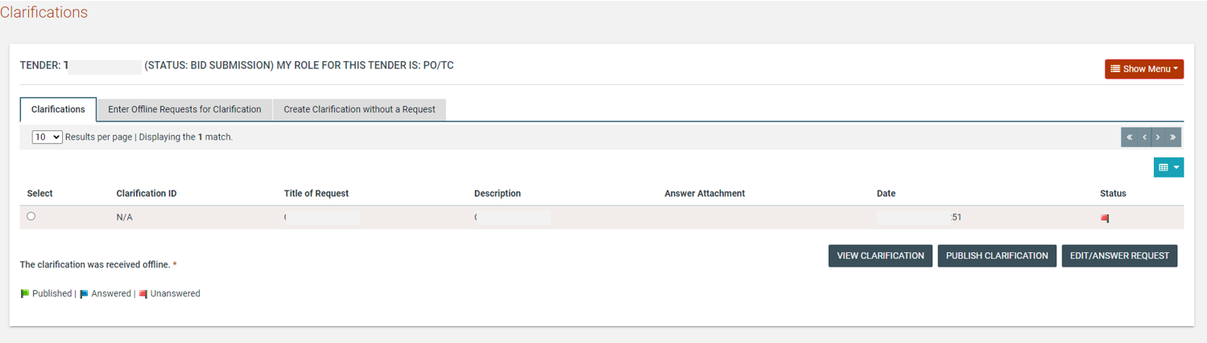

Figure 130: View clarification request

In responding to the request, the PO/TC user is able to edit the initial request as well as provide a response. The request may need to be edited in circumstances where it contains details that could identify the source of the request, as all clarifications should remain anonymous. In addition to providing a response to the clarification, an attachment may be added for suppliers to read. If more than one document needs to be sent, these should be combined into a ZIP file and this file should be uploaded with the clarification response.

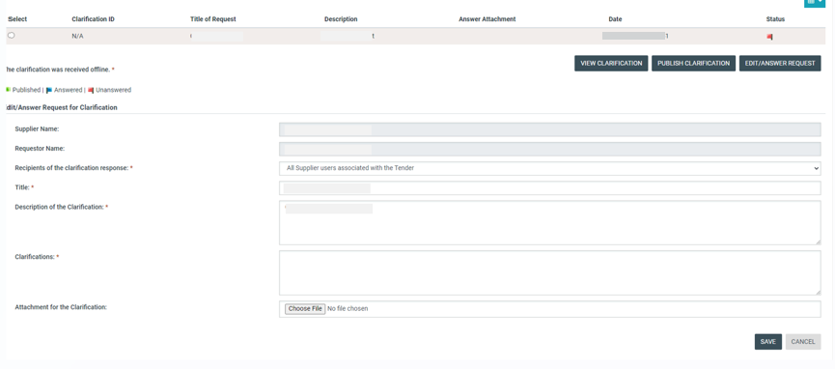

Figure 131: Reply to clarification request

Upon answering the clarification request, the response will still not be available to suppliers until the publication of the clarification by the PO/TC.

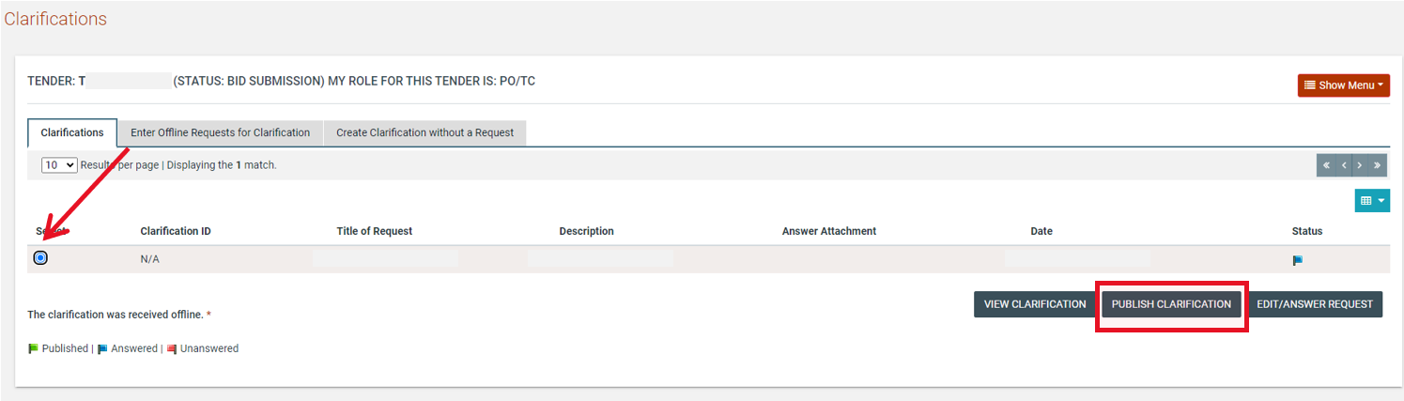

Figure 132: Publish clarification request

Once the clarification is published it will be made available to all suppliers associated with the tender and not only the supplier who initiated the request for clarification. The PO/TC user also has the option to download a PDF file with all published clarifications.

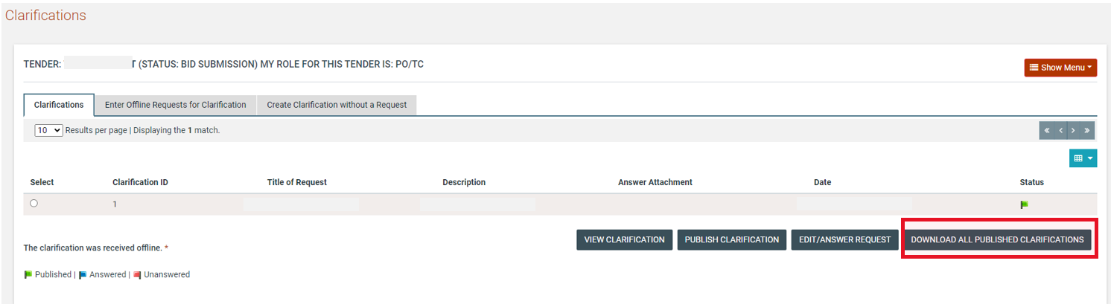

Figure 133: View published clarifications

Create an Offline Request for Clarification
In order to create a clarification request which was received offline, the user selects the “Enter Offline Requests for Clarification” tab. The user can then provide the following information (Figure 107):
- Title of the request.
- Language of the request.
- Description of the clarification request.
- Name of the requestor.
- City.
- Address.
- Post Code.
- Phone Number.
- Fax number

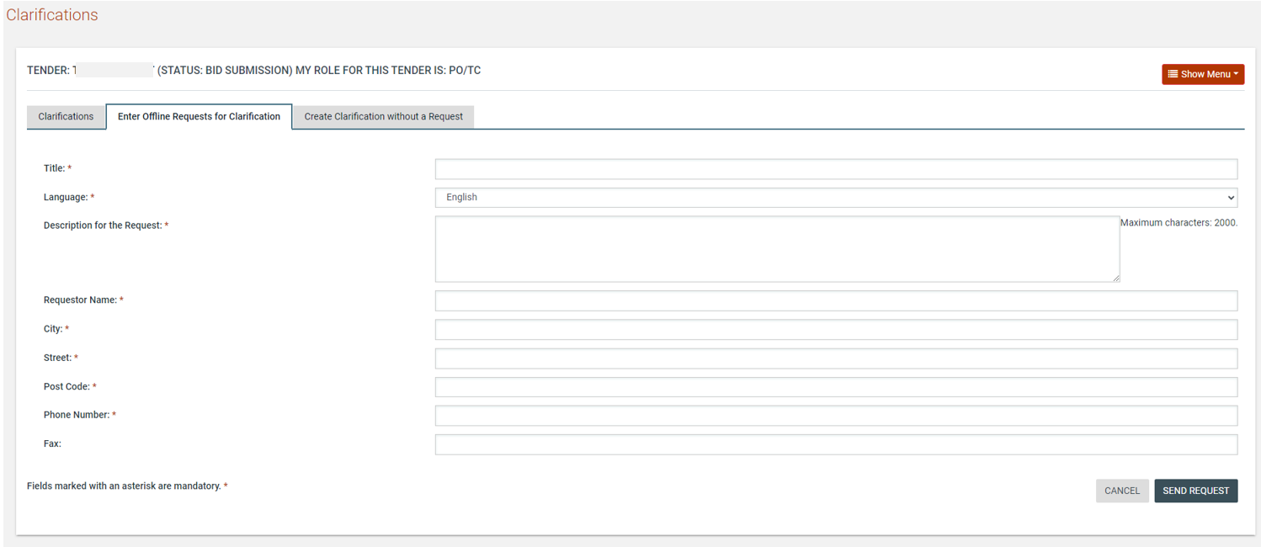

Figure 134: Offline request for clarifications

Creation of a Clarification Without Request
In order to create a clarification without a request, the user selects the tab “Create Clarification without a Request”. The user then provides the following information:
- Title of the clarification.
- Language of the clarification.
- Description of the request.
- Details (Body) of the clarification.
- Attached file for the clarification (optional).

The user selects the “Send Request” button to send the request.

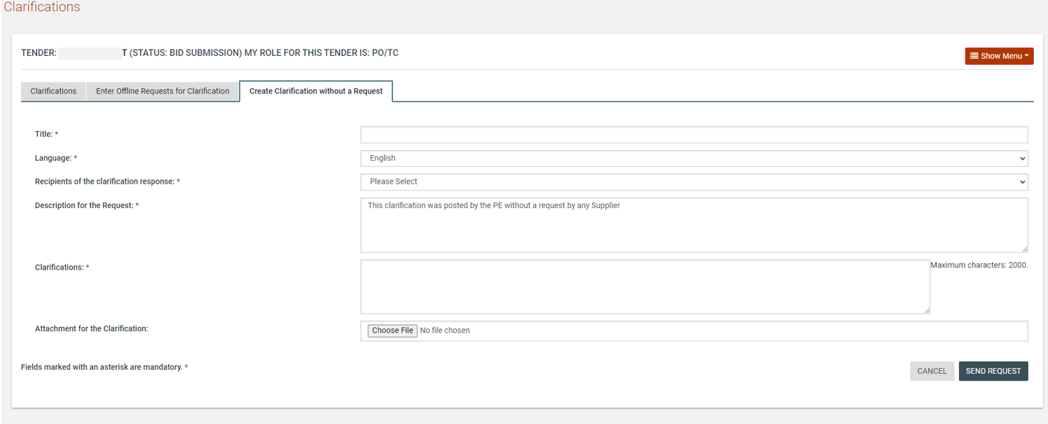

Figure 135: Clarification without a request

The PO/TC user will be in position to answer and publish his response on a supplier’s clarification request even after the end of bid clarification period. Additionally, PO/TC will be in position to raise a clarification without request even after the end of the bid clarification period, answer and publish his/her response on a supplier’s clarification request and raise a clarification without request until the bid opening expiration date.

Bid Opening
The opening of the bid documents is performed according to the four-eyes principle and requires the involvement of two procurement officers who have been associated as Opening Staff (PO/OS) to the specific tender.

The first PO/OS user submits the list of bid documents which he proposes to be opened. The second procurement officer has the choice to either approve or reject the first opener’s choice. All these actions are later registered in the automatically generated opening report. Where the bid requires a bid security, the bid security provided by each supplier is also recorded in the opening report.

Unlock Bids – 1st PO/OS
Once bid opening date is reached one of the PO/OS user will need to login. The user’s task list will be updated as per below.

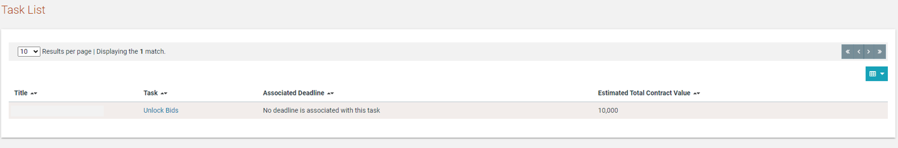

Figure 136: Open bids task

The user will be able to view the preliminary tender opening page either through the task or the respective menu item from the Tender Menu. Where the tender workflow specified Offline bid submission, the user must add information for bids received offline (section 9.2) before proceeding to authorise the opening.

Where the tender allows submission of bids in foreign currencies, the PO/OS needs to provide the exchange rate for each of the foreign currencies in relation to the Zambian Kwacha.

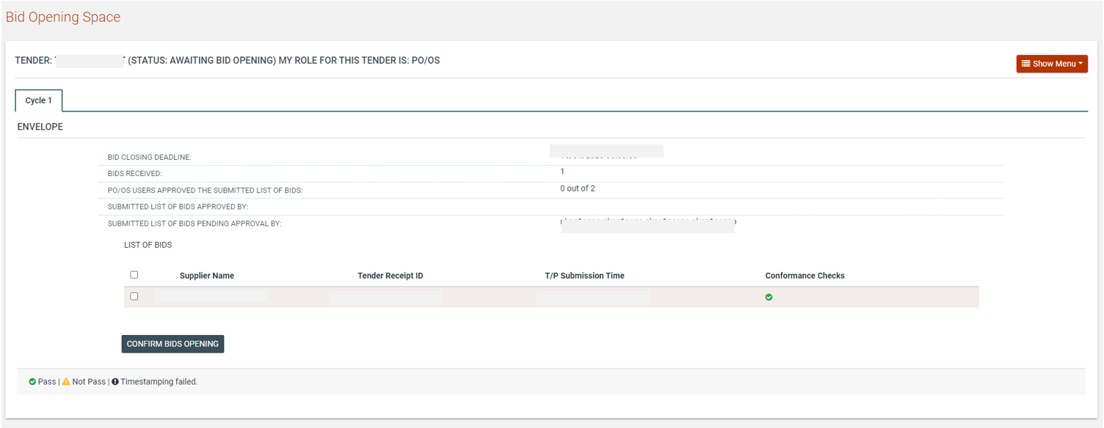

Figure 137: 1st PO/OS view

The PO/OS user should then proceed to select all the bids that should be opened and confirm the bid opening.

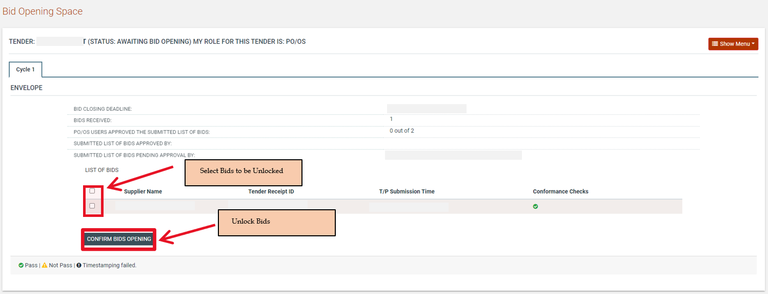

Figure 138: Confirm bids to be opened

Offline Bids
In case offline bids have been specified in the tender structure, the PO/OS may update the system with the respective information. The only limitation is that the Supplier that performed the offline submission must exist as a registered Supplier in the System.

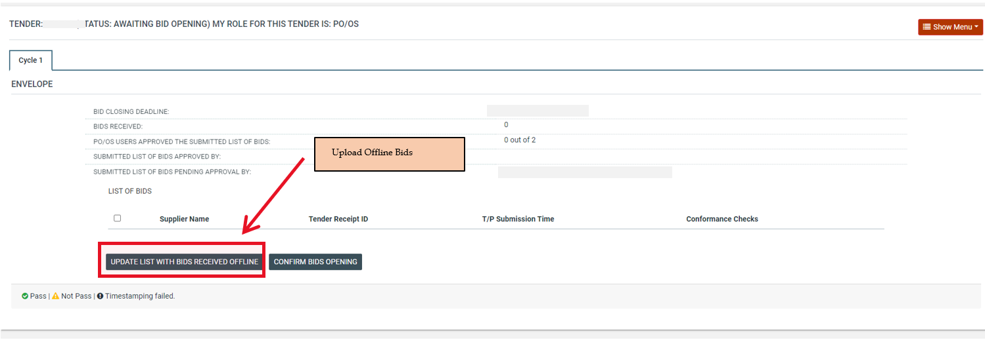

Figure 139: 1st PO/OS view for offline bid submission

The process may be repeated to capture the information for multiple supplier submissions.

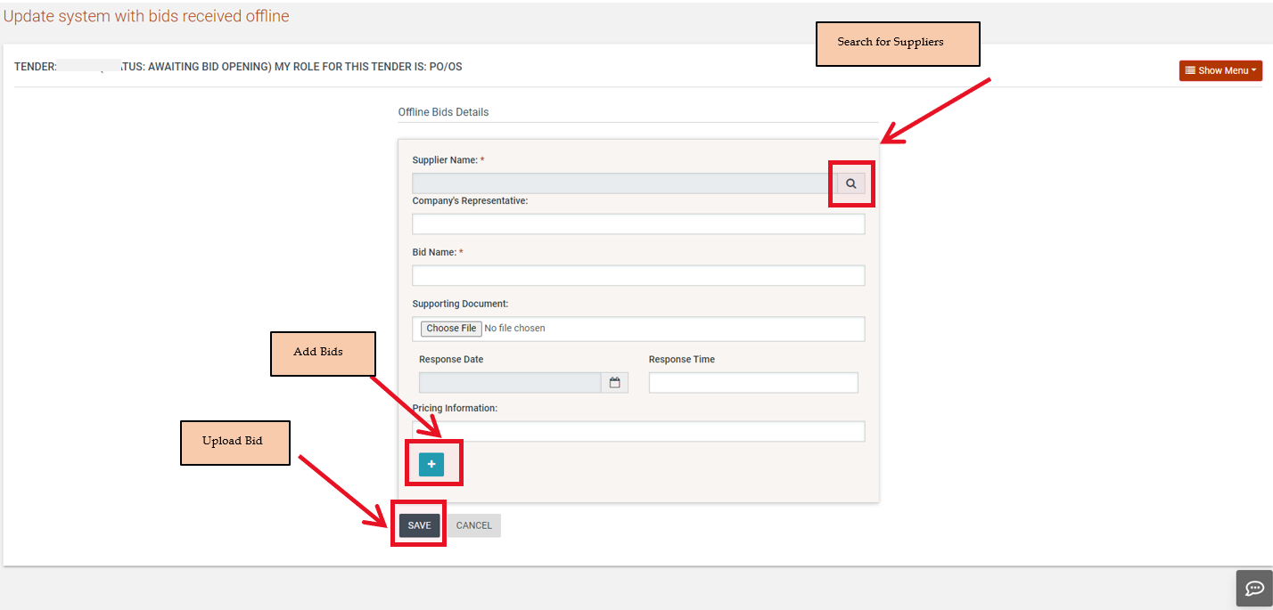

Figure 140: Add tender received offline

The PO/OS searches for the respective Supplier through a dedicated search facility. When the tender is initiated by invitation rather than by publication, only invited suppliers are available for selection by the PO/OS user.

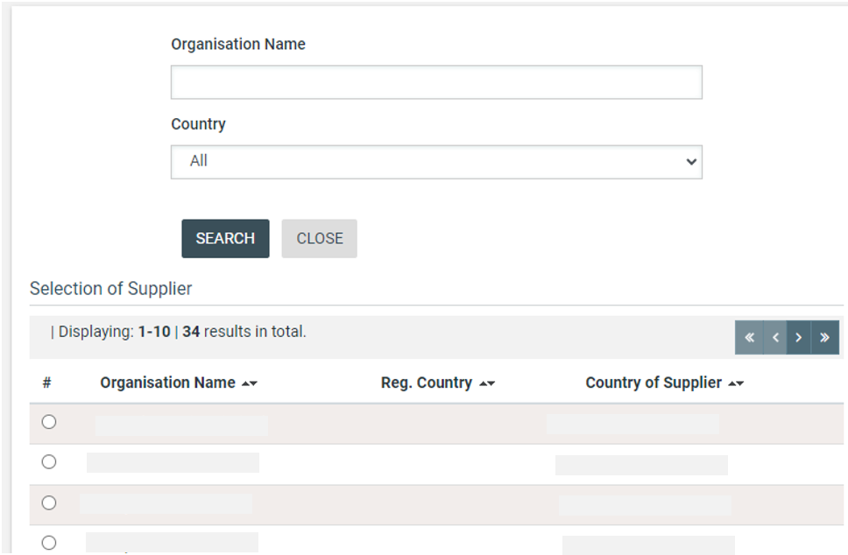

Figure 141: Search for the Supplier that submitted offline bid

Once all information is inserted the PO/OS will click the “Confirm Bids Opening” button to authorise the opening of bids.

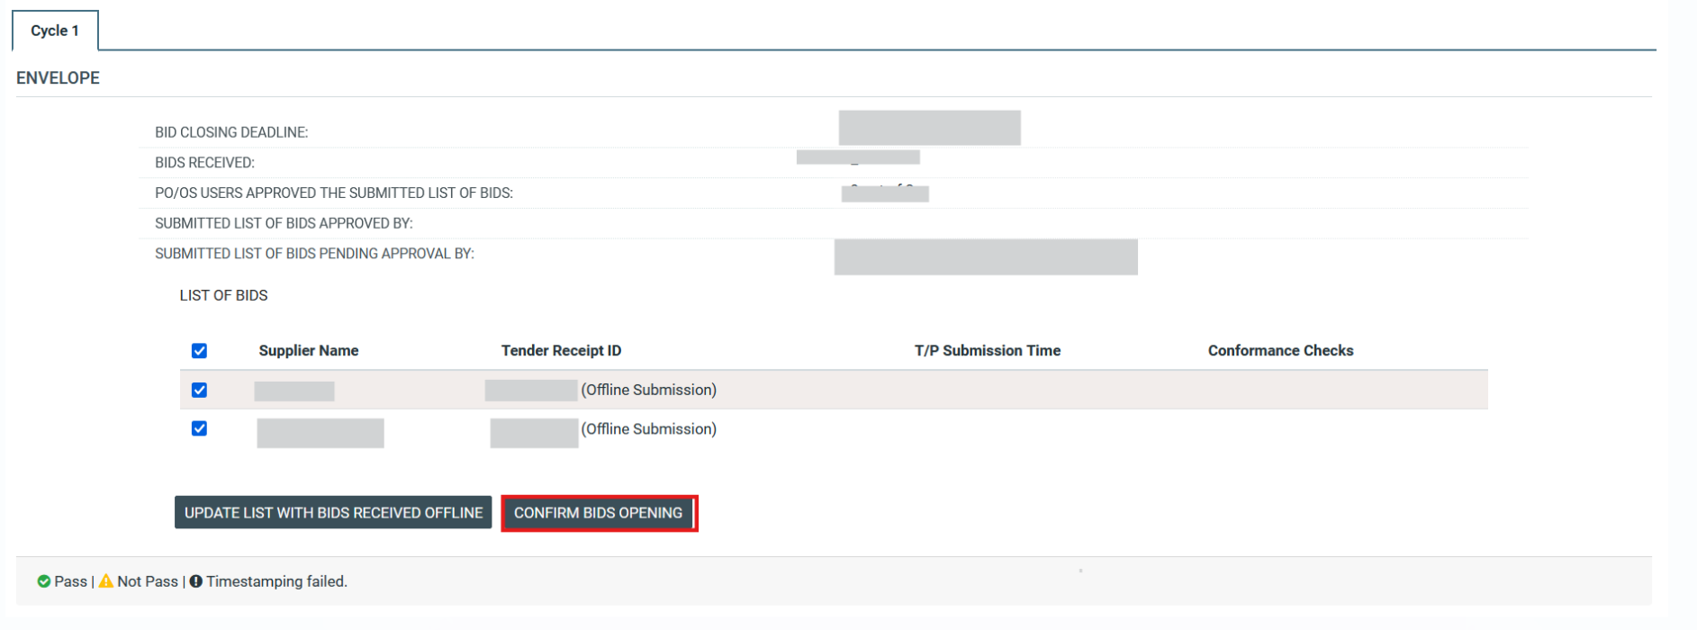

Figure 142: View of bids to be opened for offline submission

In case the user has grounds for not allowing a bid to be opened, then the respective bid should not be included in the list of bids to be opened (i.e. not tick the relevant entry).

Approve Unlocking – 2nd PO/OS
Once the 1st PO/OS authorises bid opening, the process reverts to the 2nd member of the opening committee.

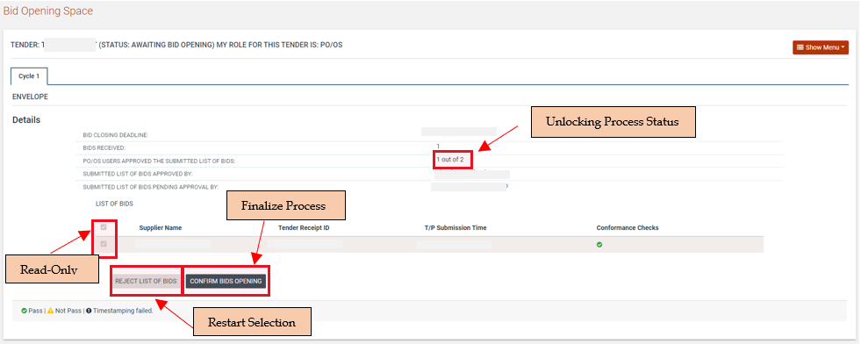

Figure 143: 2nd PO/OS view

The user either accepts the proposed bids opening or rejects the list of bids and proceeds in re-performing the selection process for the bids that are proposed to be opened. In the latter case, the flow will revert back to the 1st PO/OS again to accept the new proposal.

Once the opening is approved the System (after a few seconds pass) will display the list of opened bids along with the report of the opening ceremony.

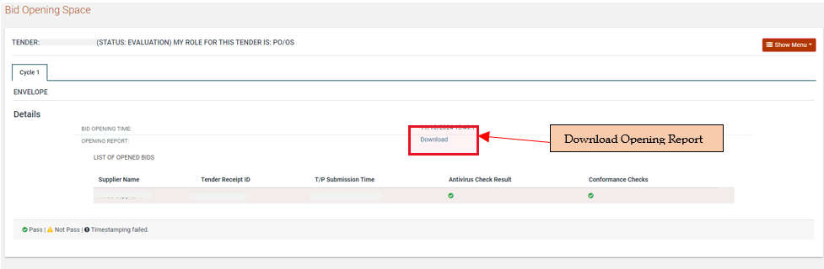

Figure 144: Opened bids list view and opening report

Evaluation of Bids
Through the task or the respective tender menu item, the PO/ES users proceed to the evaluation of the bids until the conclusion of the evaluation process.

Conflict of Interest Declaration
Before being granted access to the submitted bids to conduct evaluation, the members of the evaluation committee need to complete the conflict of interest declaration indicating that they are not in a conflicted position with regards to the suppliers who have submitted bids for the tender. A task will be added to the users’ task list on their homepage.

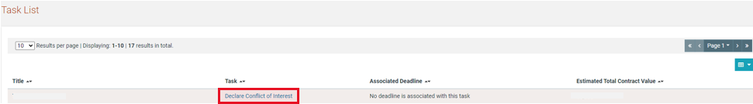

Figure 145: Conflict of interest task

Clicking on the task takes the user to the declaration screen, where they need to provide their declaration status. A comment may be provided if the user selects “Yes” for the perceived or actual conflict of interest question. In order to view the list of bidders the user selects the “View Bids” option through the provided link.

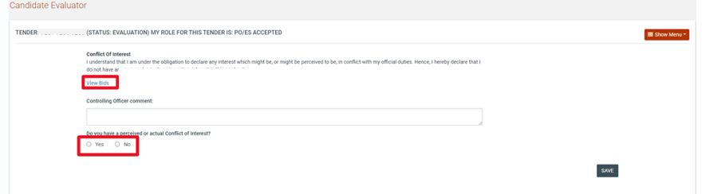

Figure 146: Conflict of interest declaration

Replace Evaluator
The PO/TC user is able to view the response status of all members of the evaluation committee from the Tender Menu by selecting the “PO/ES declaration responses” option.

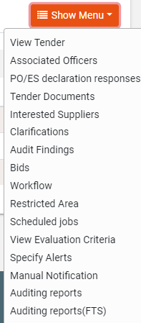

Figure 147: PO/ES declaration responses menu selection

The results are shown in a table layout indicating the “Code of Conduct” as well as “Conflict of Interest” status of each evaluator.

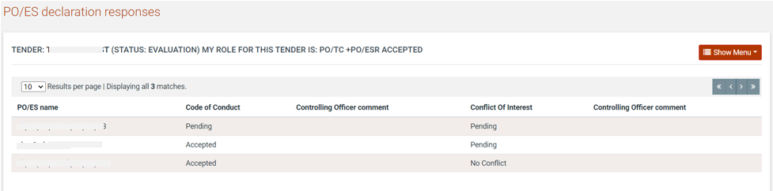

Figure 148: Evaluation committee member declarations

An evaluator who has declared a conflict of interest can be replaced by the PO/TC with another evaluator by accessing the Associated Officers option in the Tender Menu (Figure 63). The replacement evaluator must have the same status as the one being replaced, i.e. an evaluator who has not accepted the code of conduct cannot replace an evaluator who has accepted the code of conduct.

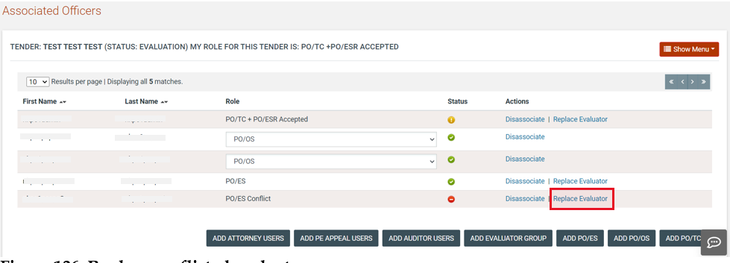

Figure 149: Replace conflicted evaluator

Clicking on the “Replace Evaluator” link launches a pop-up window that allows the PO/TC user to search for a replacement evaluator. Only eligible replacements are shown in the search results. If no results are found, then the desired user must be added to the PO/ES role and must accept the code of conduct declaration before they can be selected to replace the conflicted evaluator.

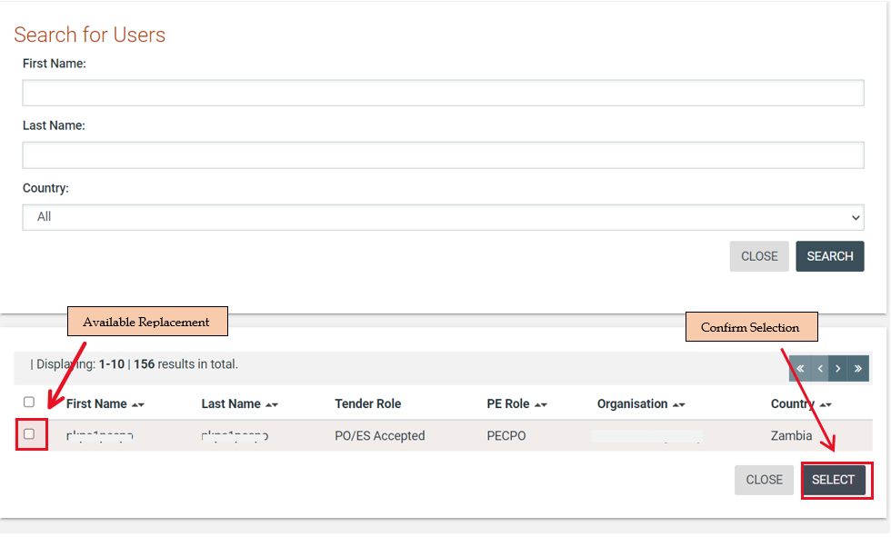

Figure 150: Search for replacement evaluator

Disassociate Evaluator
The PO/TC user also has the option to disassociate an evaluator from the tender without replacing them. In this case, the evaluation committee size is reduced by one member.

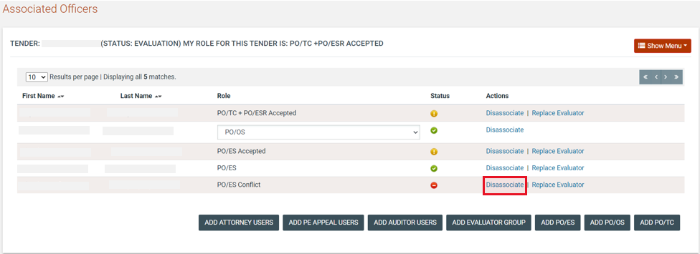

Figure 151: Disassociate conflicted evaluator

Clarifications During Evaluation
During the evaluation phase, the evaluation team of a tender may contact a supplier that has submitted a bid in order to request additional information and/or obtain clarifications for the bid. To do so, a user may access the “Clarifications” section under the Tender Menu.

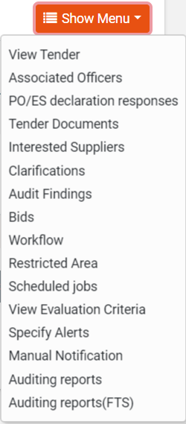

Figure 152: Clarifications link under the tender Menu

Once in the “Clarifications” section, the user must select the “Evaluation Clarifications” tab and then click on the “Requests for clarification” button. This will present to the user a new form for defining the clarification being sought, allowing the user to select the recipient supplier(s).

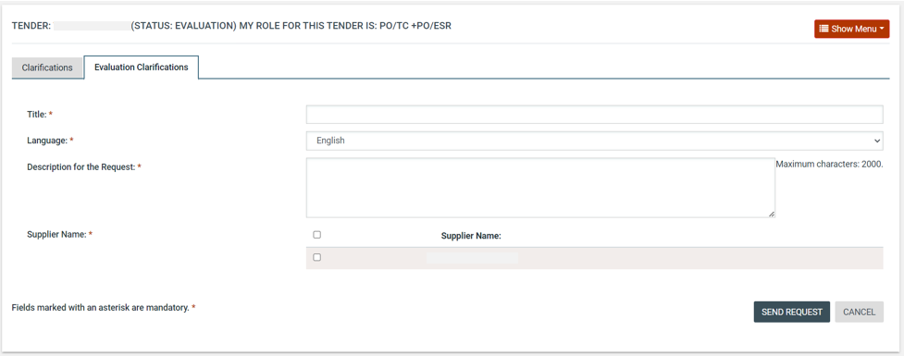

Figure 153: New clarification during evaluation

Once a response is provided by the supplier, a new task will appear in the Homepage of the user.

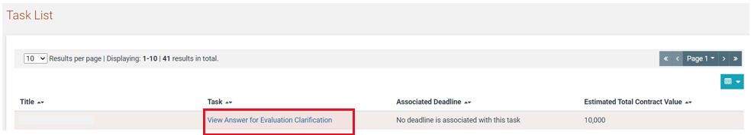

Figure 154: New task for clarification during evaluation

To view the full details of the supplier response, the user can click on the task “View Answer for Evaluation Clarification”. The PO/TC user also has the option to download a PDF file with all the evaluation clarification responses.

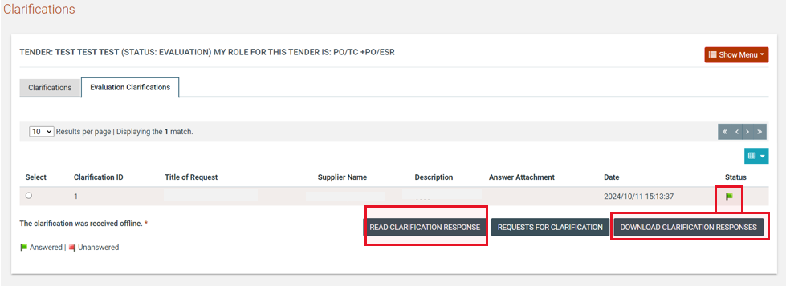

Figure 155: Evaluation clarifications list

Evaluation of Bids
Upon completion of the opening process, the system will generate the “Evaluate bids” task for online procedures or the “Enter offline results” for offline procedures. The user has access to the separate bid of each Supplier.

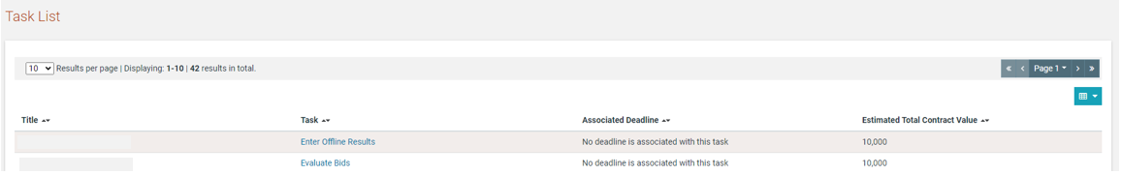

Figure 156: Evaluation task

The user opens each envelope of the bid and populates the respective scores for each criterion.

In case and the PO/ES or PO/ESR users give a Score that is under the current Threshold, the “Justification” field under the Evaluation Score is mandatory for both users. In case the Evaluation Score is over the Threshold given, the Justification is optional.
After all scores are provided, the PO/ESR user will then proceed in finalizing the evaluation process and generate the respective evaluation report. The PO/ESR user will be able to proceed to finalizing the evaluation process if at least one member of the bid evaluation committee has provided an evaluation for each supplier’s bid.

In case of the below procurement methods at least 3 evaluators should save their evaluation as final before the PO/ESR user become in position to finalise the corresponding envelope (Eligibility, Technical, Commercial and Financial)
- Open Bidding National
- Open Bidding International
- Open Selection National
- Open Selection International
- Limited Bidding
- Limited Selection

The evaluators are able to proceed with next envelope only in case the previous envelope is finalized.
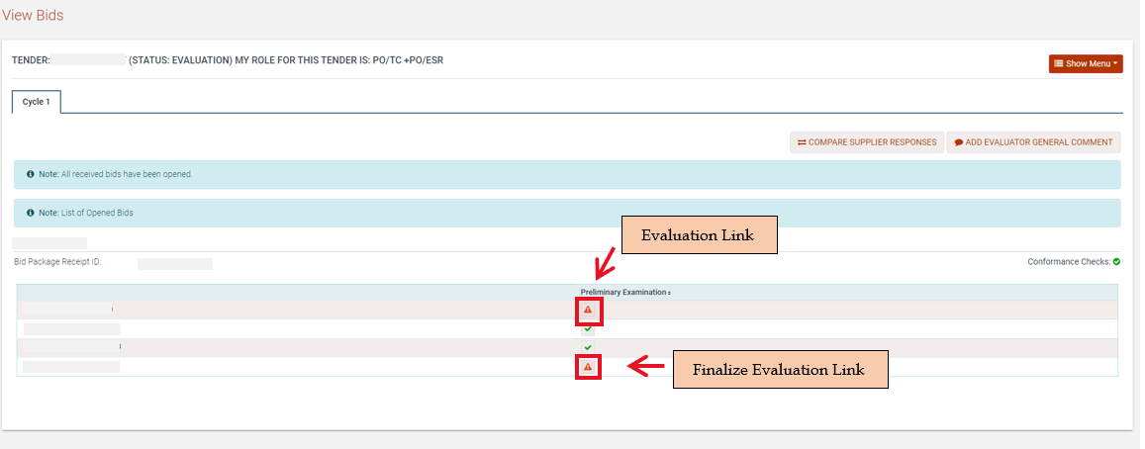

Figure 157: Preliminary Criteria Evaluation

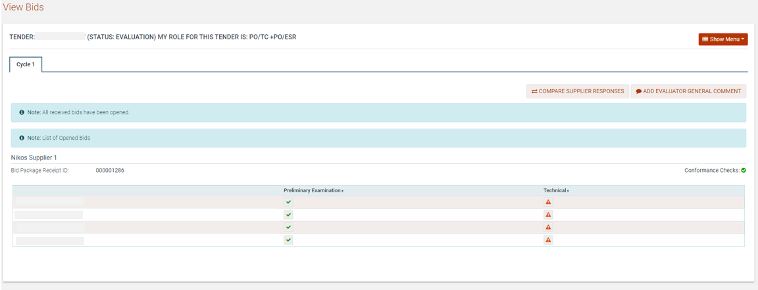

Figure 158: Technical Criteria Evaluation

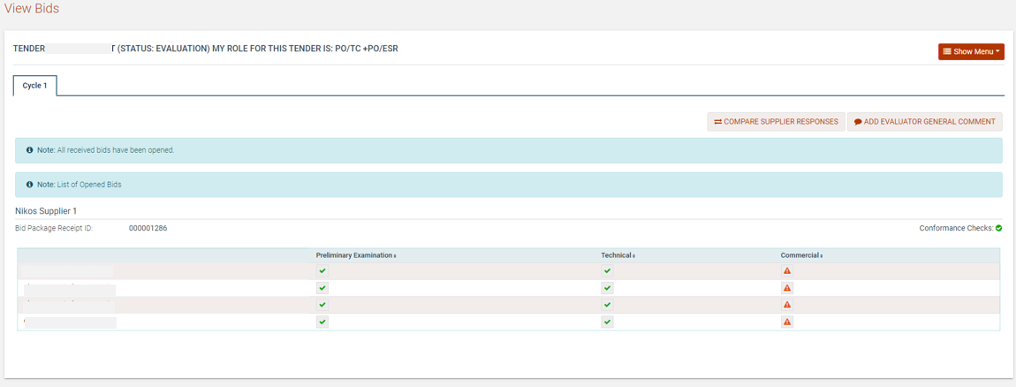

Figure 159: Commercial Criteria Evaluation

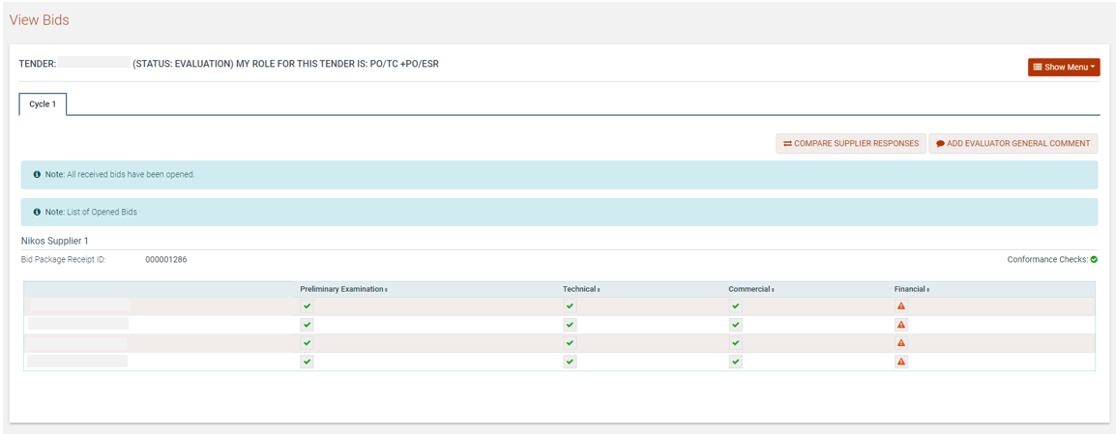

Figure 160: Financial Criteria Evaluation

In case the finalized financial value of the Supplier is modified during the evaluation, the corresponding Supplier admin user will be tasked to approve/reject the updated financial value. In case the supplier admin user selects the “accept” option, the financial value will be automatically updated. The PO/ES and PO/ESR users can be informed when they pass over the check icon.

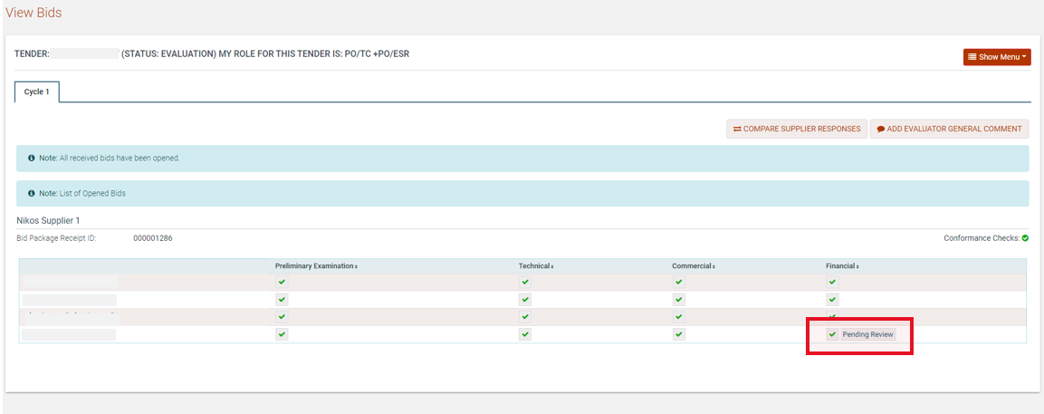

Figure 161: Financial Value Pending Review from Supplier

In case the supplier admin selects the “reject” option, the financial value will not be modified and the PO/ESR will have option to pass/fail the evaluation and select  button to finalise it.

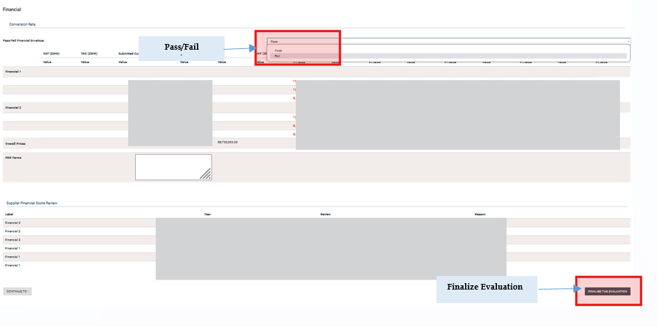
Figure 162 Supplier Rejection – PO/ESR options

Finally, the PO/ESR user can view the supplier response on overall evaluation page under the “Supplier Financial Score Review” section.

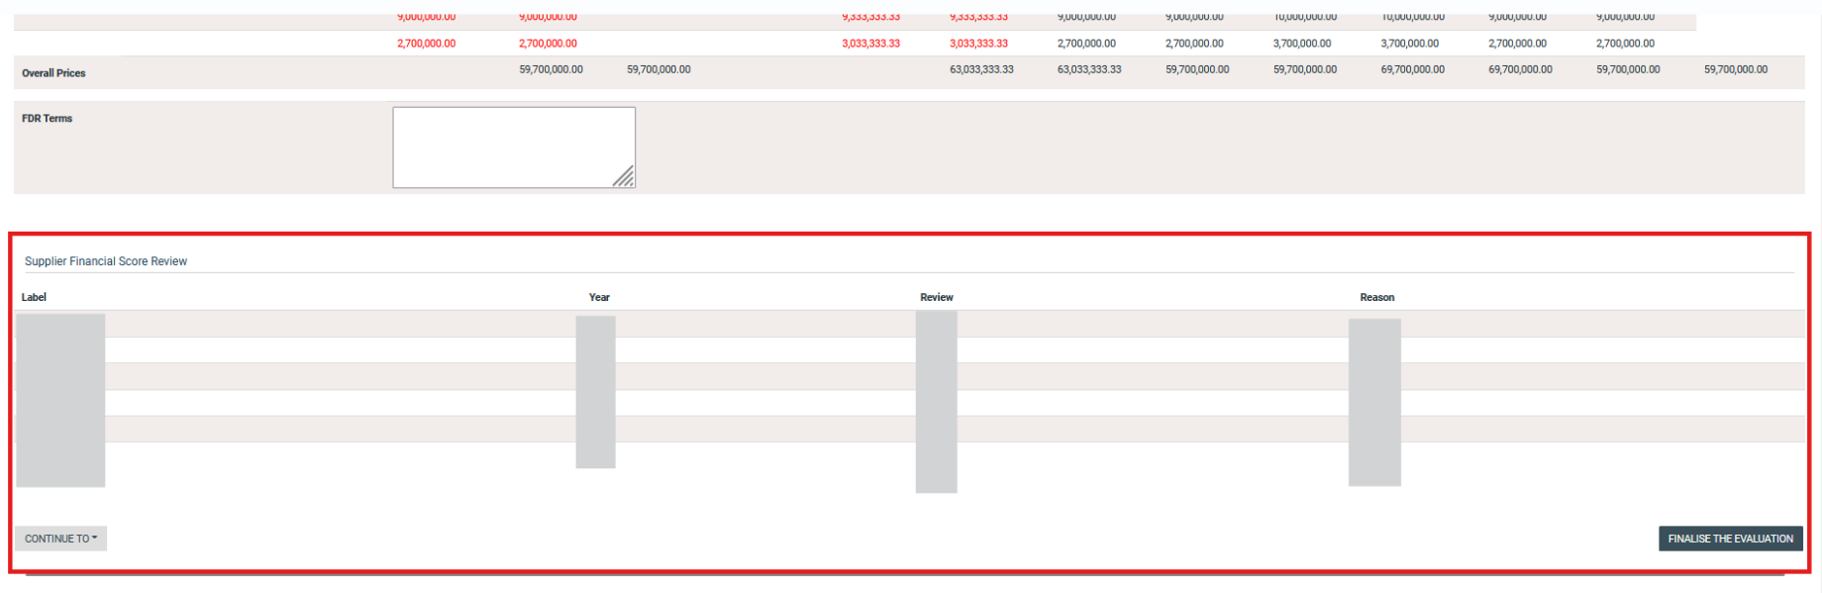

Figure 163 PO/ESR Supplier Financial Score Review

The PO/ESR user has three options available when reviewing the evaluations of each member of the bid evaluation committee:
Accept the information provided and finalise the evaluation;
Request re-evaluation by one or more evaluators;
Discard one or more evaluations from the results (the scores are recalculated by the system to remove these evaluations from the final results).

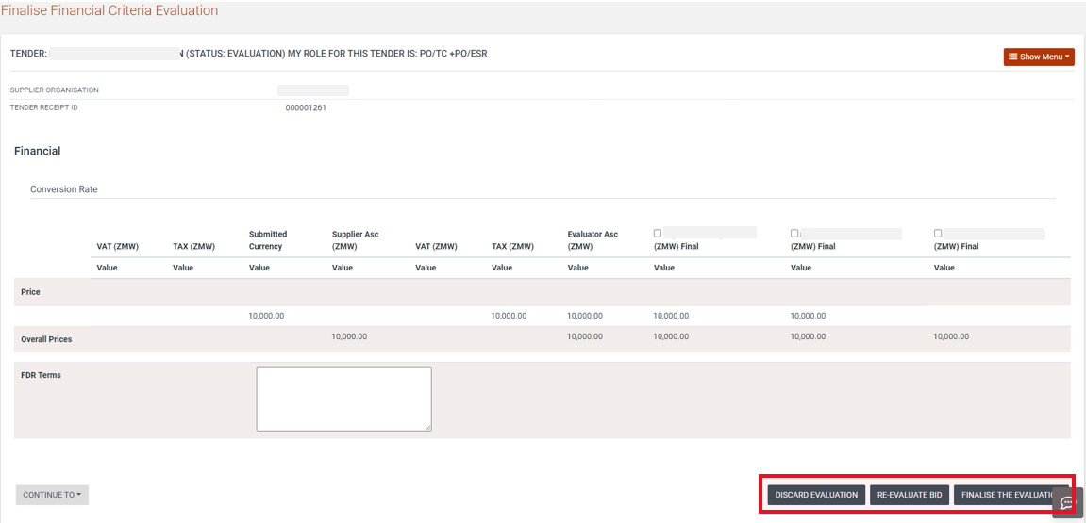

Figure 164: Review individual evaluations

Evaluation Report
Once evaluation results are finalised the “Generate evaluation report task is available on PO/ESR task list. The user select the “Generate evaluation report” button in order to proceed with evaluation report generation.

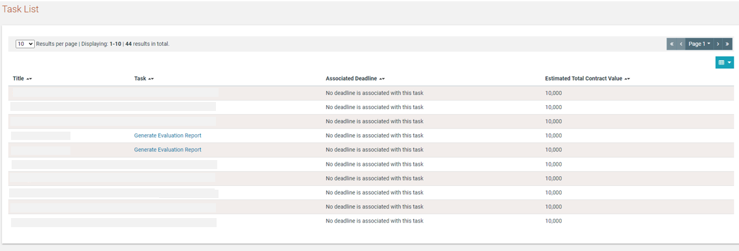

Figure 165: Evaluation report task

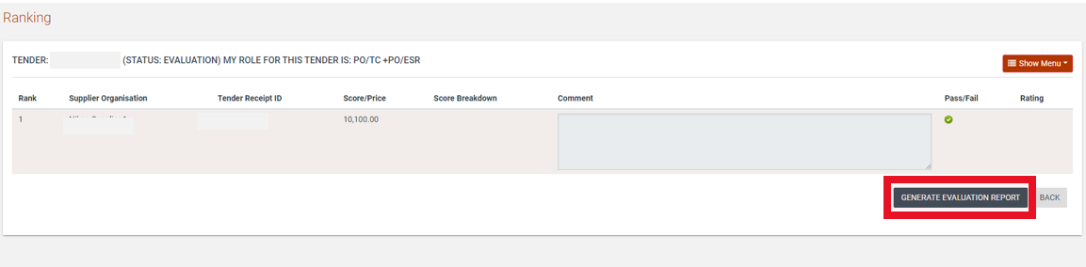

Figure 166: Generate Evaluation report

Approve evaluation report

When the Evaluation report is generated the PO/ESR and PO/ES users may approve the evaluation report or upload a new version of evaluation report by selecting the “Approve” or “Upload a new Version” buttons.

The PO/ESR user will be in position to view within the manage evaluation reports page whether a PO/ES user has approved the evaluation report or not.

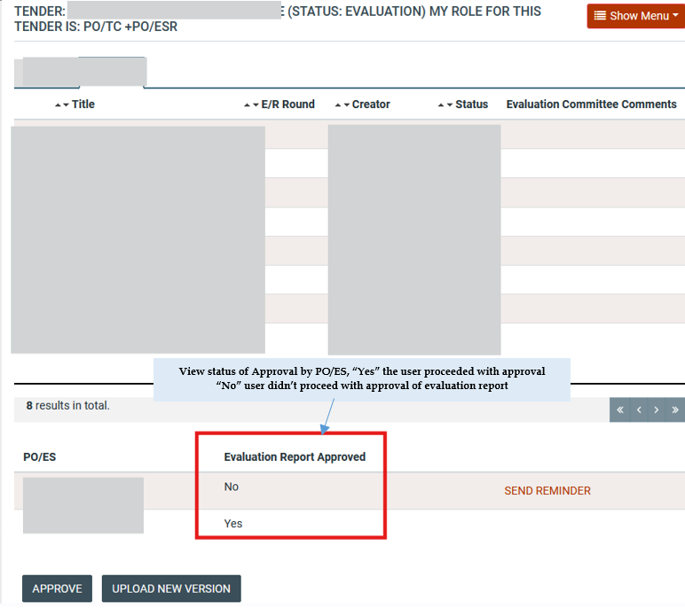

Figure 167 PO/ESR Manage Evaluation Report Page – Approval Status of PO/ES

Additionally the PO/ESR user will be in position to issue alert on PO/ES user that has not yet approved the evaluation report within the manage evaluation report page by selecting the “Send Reminder” option.

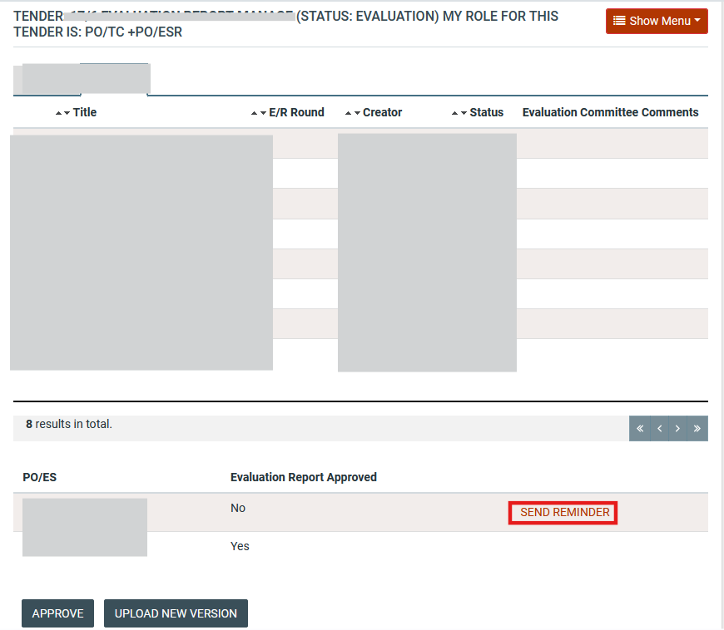

Figure 168 Send Reminder to PO/ES

Upon the PO/ESR selecting the “Send Reminder” option the below email notification will be dispatched to the PO/ES user.

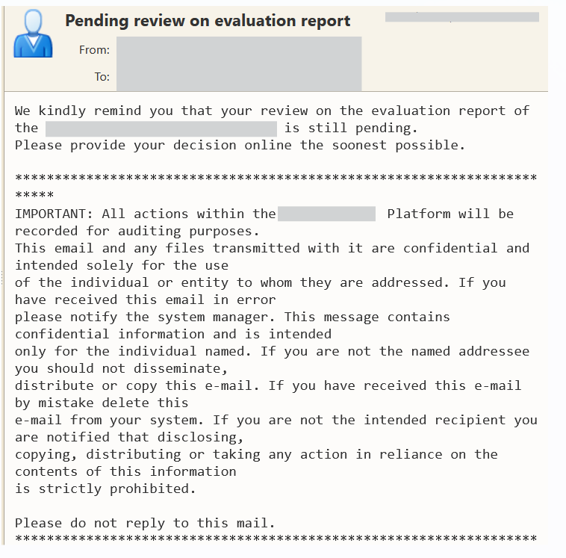
Figure 169 PO/ES Email Notification
In case the PO/ESR accepts the evaluation report, the flow will not expect the acceptances from the remaining PO/ES user but it will proceed with the “Manage evaluation Report” task of the PEHP user.

Manage Evaluation Report

In case the evaluators Approves the report, a new task will be made available for the PEHP User to “Manage Evaluation Report”. The User has the option whether to “Approve as Final” or “Reject and Request Re-Evaluation” the evaluation report.

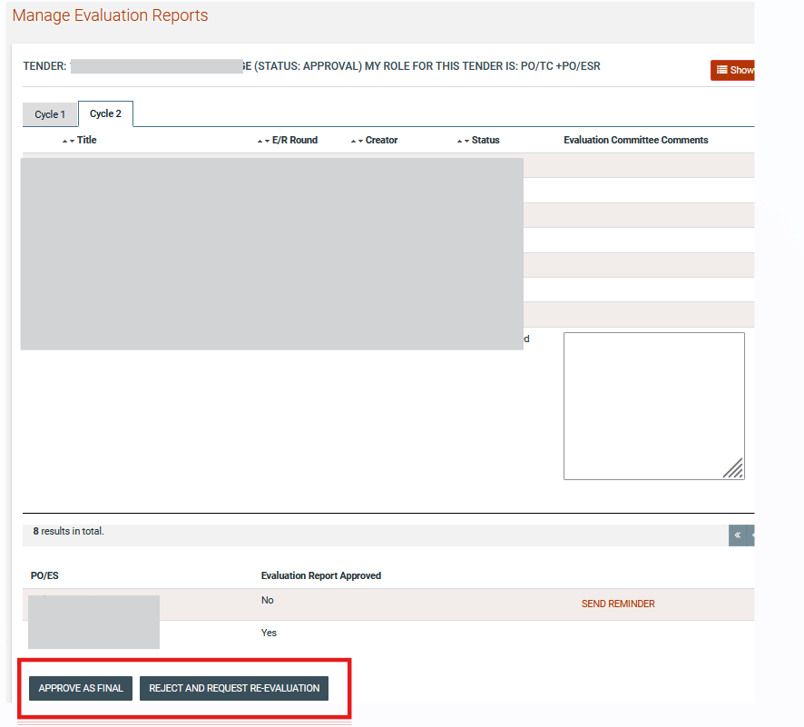
Figure 170: Approve as final/ Reject Evaluation Report

Upon the user selecting the button a pop-up window is displayed an the user will be able to select the stage (if the tender consist of 2 stages) the envelope (if the tender consist of 2 envelopes) and “revert to state” with the following options

- Tender Opening: upon selecting the aforementioned option the tender will be reverted to bids opening stage and PO/OS users will proceed with bids unlocking again
- Tender Evaluation: upon selecting the aforementioned option the tender will be reverted to bids evaluation stage and evaluators will proceed with bids evaluation again
- Evaluation Report Generation: upon selecting the aforementioned option the tender will be reverted to generate evaluation report stage and PO/ESR will proceed with generation of evaluation report again.

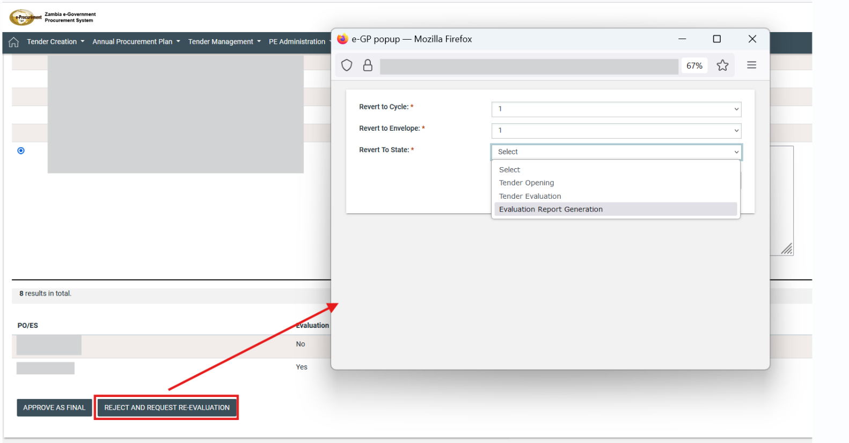

Figure 171 Reject and Request Re- evaluation Options

The user selects the  button in order to apply one of the above options.

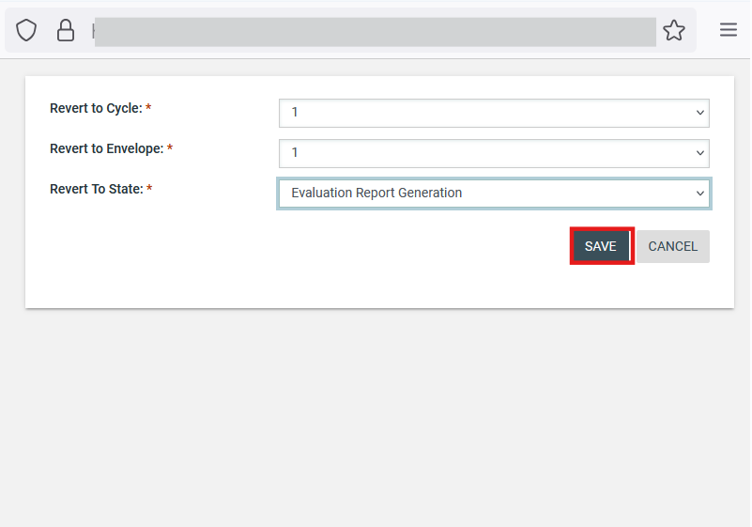

Figure 172 Apply Option

When the user select the button the tender will procced with the next step of approval that is documented on section 10.8

Conclude Evaluation

According to the configured threshold, the tender needs to be approved by the procurement committee. The PO/TC or CO of PE that the tender was created will be tasked to provide feedback from the procurement committee meeting.

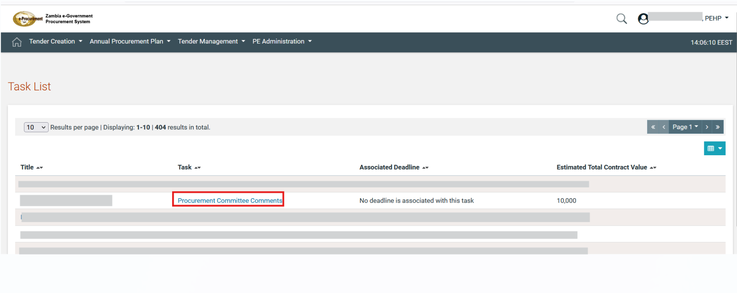

Figure 173 PO/TC Procurement Committee Comments Task

The user provides the comment as well as an attached file and selects the button.

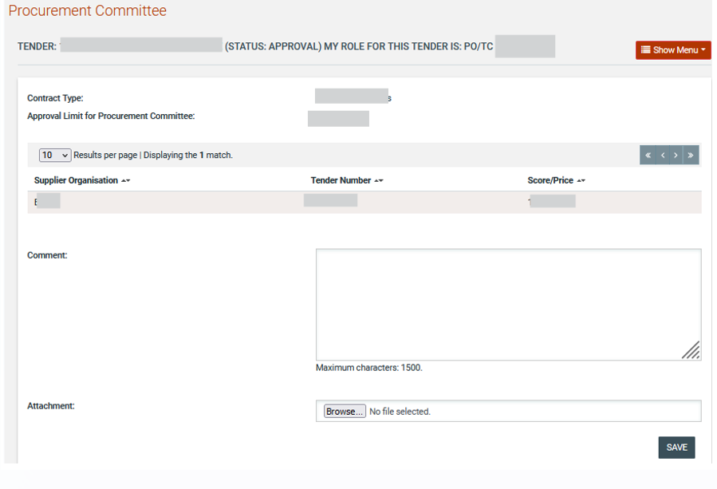

Figure 174 Procurement Committee Comments

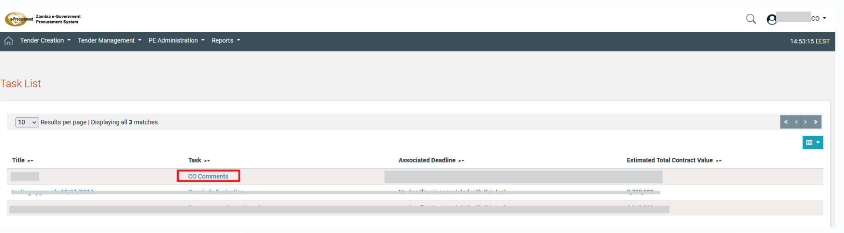
Figure 175 CO Comments Task

The user provides the comment as well as an attached file and selects the button.

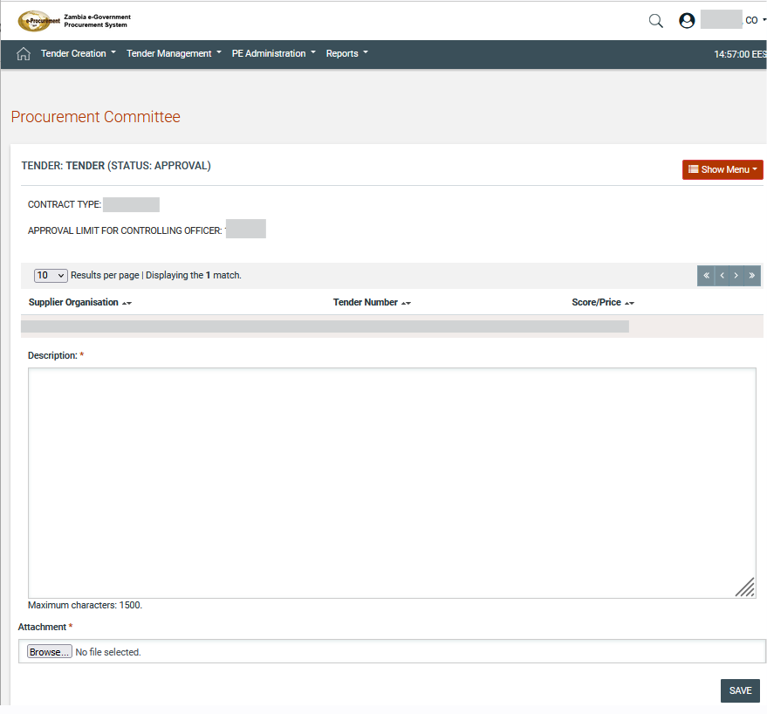

Figure 176 CO Comments

Following the provision of comments the task “Conclude Evaluation” is available to PEHP.

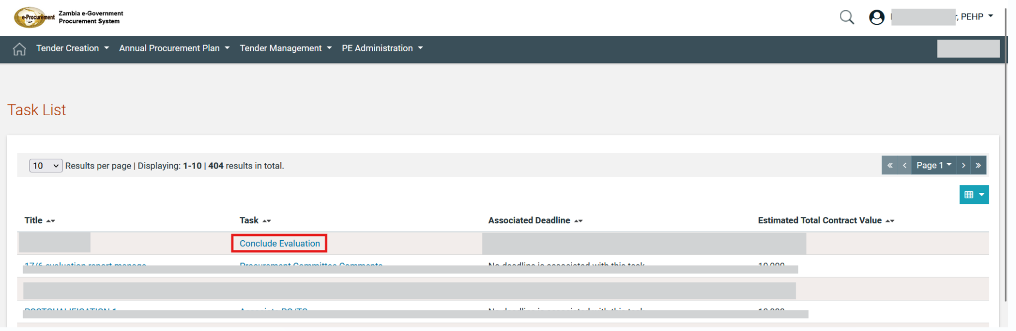

Figure 177 Conclude evaluation task
Depending on the comments from the procurement committee, the PEHP user can request the re-evaluation of the tender, can cancel the tender entirely or can proceed to the announcement of the results.

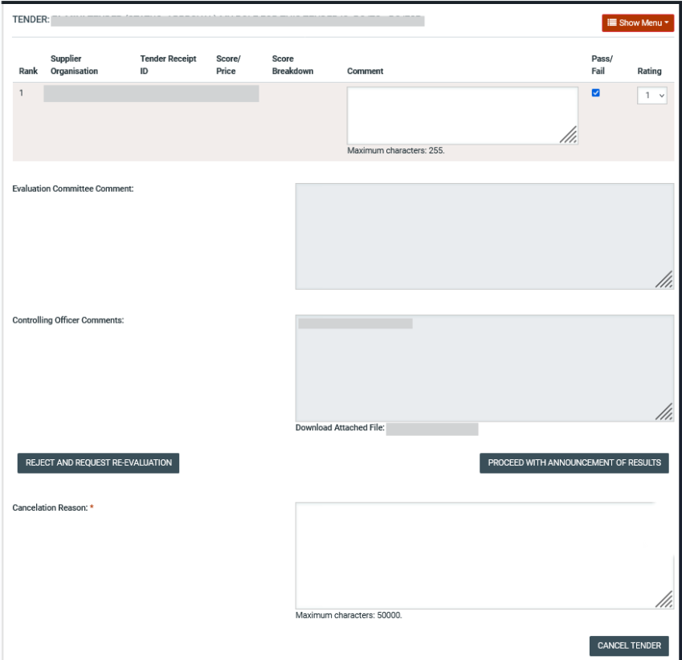

Figure 178 Conclude evaluation

Upon the user selecting the button a pop-up window is displayed an the user will be able to select the stage (if the tender consist of 2 stages) the envelope (if the tender consist of 2 envelopes) and “revert to state” with the following options

- Tender Opening: upon selecting the aforementioned option the tender will be reverted to bids opening stage and PO/OS users will proceed with bids unlocking again
- Tender Evaluation: upon selecting the aforementioned option the tender will be reverted to bids evaluation stage and evaluators will proceed with bids evaluation again
- Evaluation Report Generation: upon selecting the aforementioned option the tender will be reverted to generate evaluation report stage and PO/ESR will proceed with generation of evaluation report again.

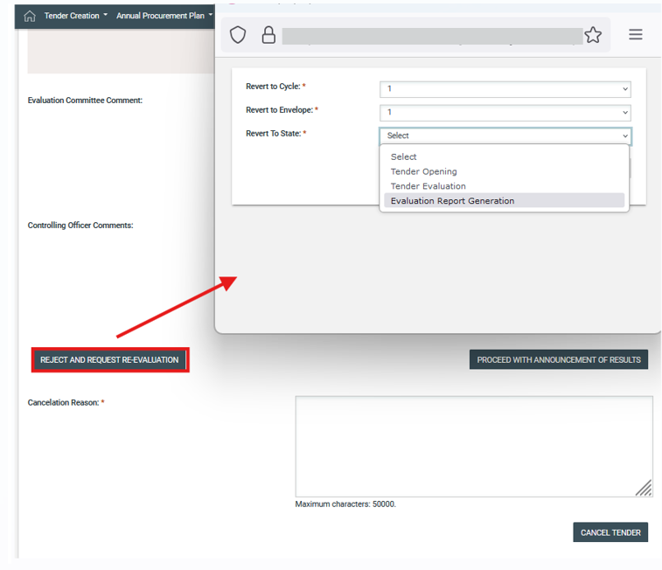

Figure 179 Reject and Request Re- evaluation Options

The user selects the button in order to apply one of the above options.

Figure 180 Apply Option

The PO/TC user is now tasked to communicate the results of the evaluation to the bidders. A “Message” is mandatory for both the qualifying suppliers as well as those that have been rejected. Additional attachments can be provided with the announcement.

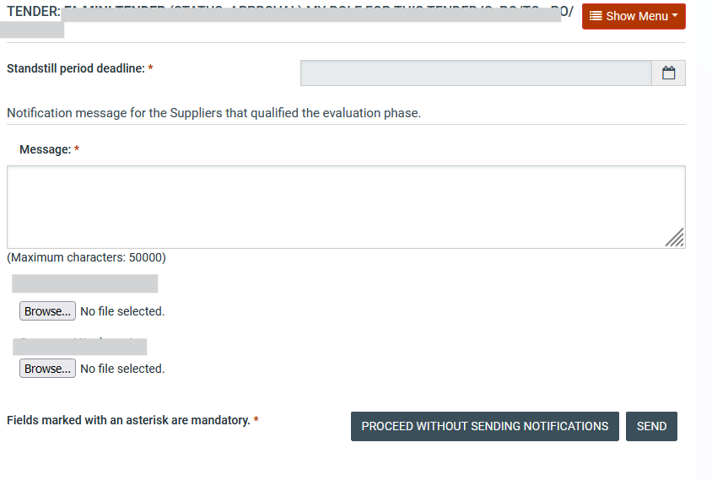

Figure 181 Announce evaluation results

Feedback
After the announcement of the evaluation results, a standstill period is in effect allowing suppliers to request clarification regarding the outcome of the evaluation. Through the respective task or the “Feedback” menu item in the tender’s menu the user may navigate to the respective page.
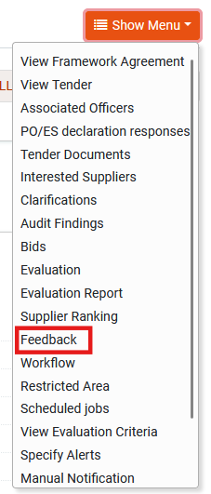

Figure 182: Feedback menu item

The submitted requests from suppliers are presented in a table layout.

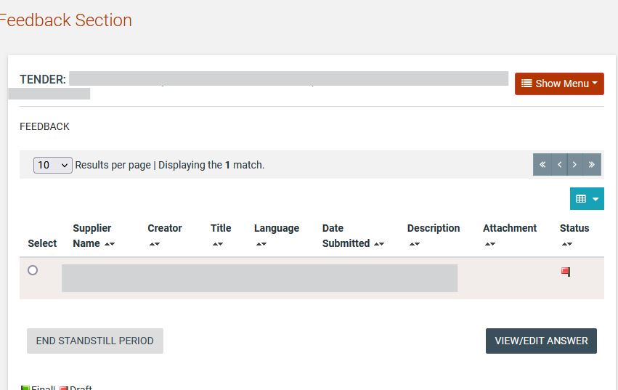

Figure 183: List of feedback requests

Saving the response in “Final” status makes it available to the supplier. If the PO/TC user needs to consult with other team members before finalising the response, it can be saved in “Draft” status until it is ready to be sent to the supplier.

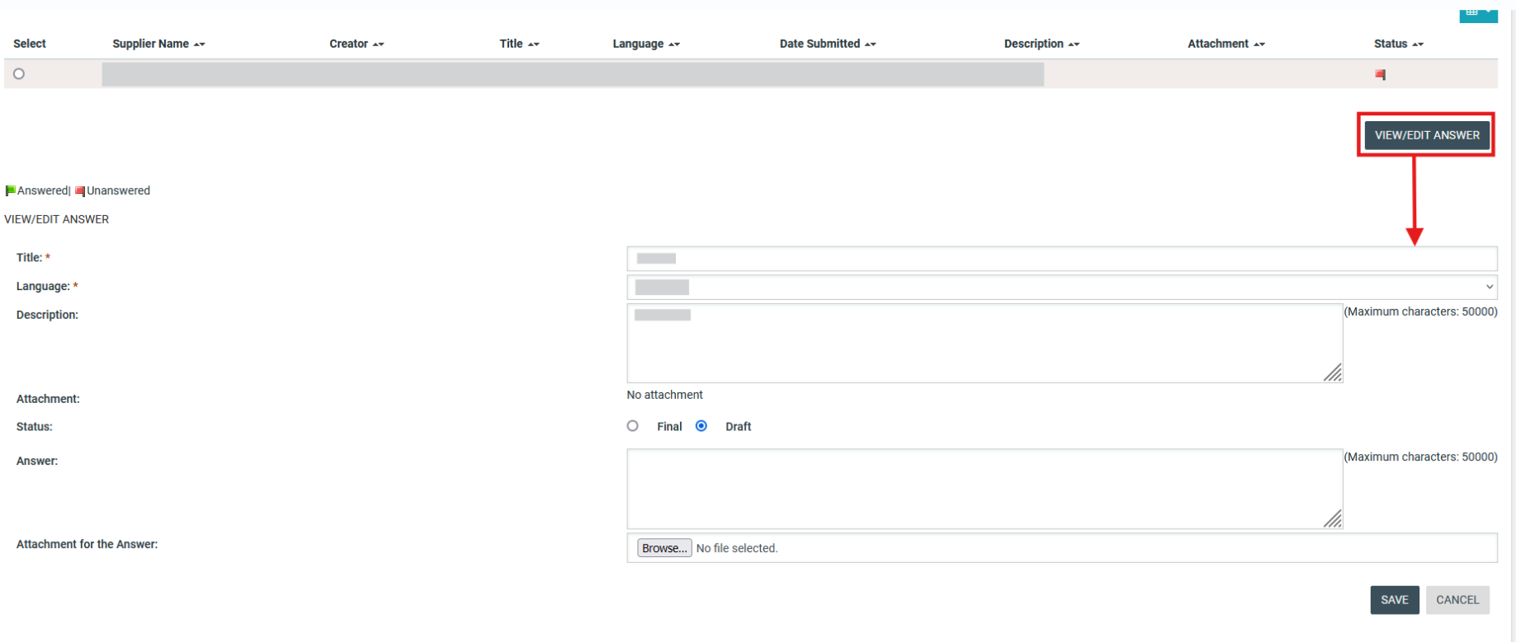

Figure 184: Respond to feedback request

Final Ranking
At the end of the standstill period, the PO/TC user needs to confirm the qualification and ranking of suppliers. The relevant task is available on user’s task list

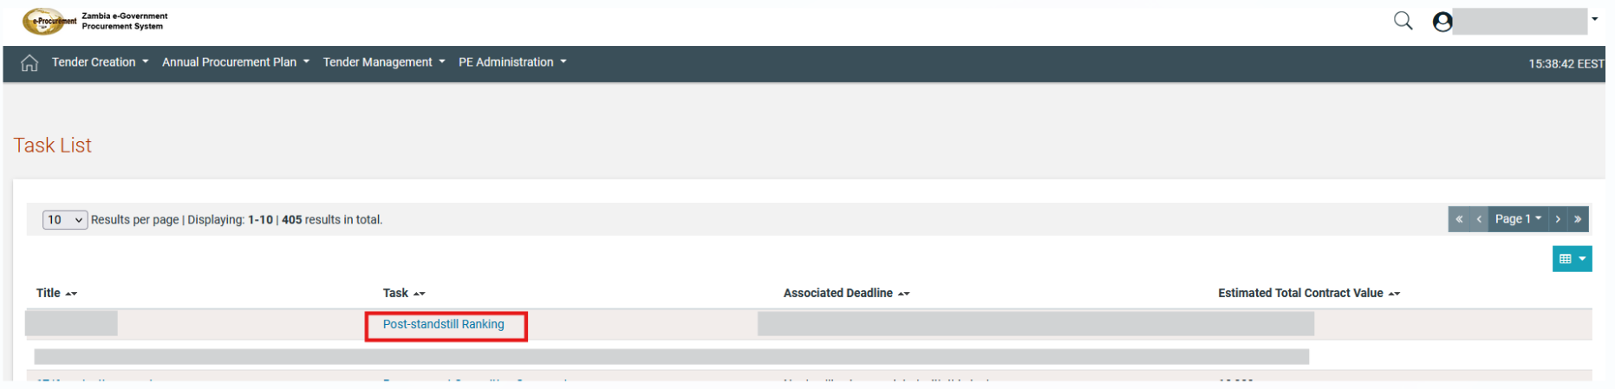

Figure 185 Post-standstill Ranking Task

This is the last opportunity to reject the evaluation process and revert the tender back to the opening, request re-evaluation, generate the evaluation report or to proceed to awarding stage by selecting the button.

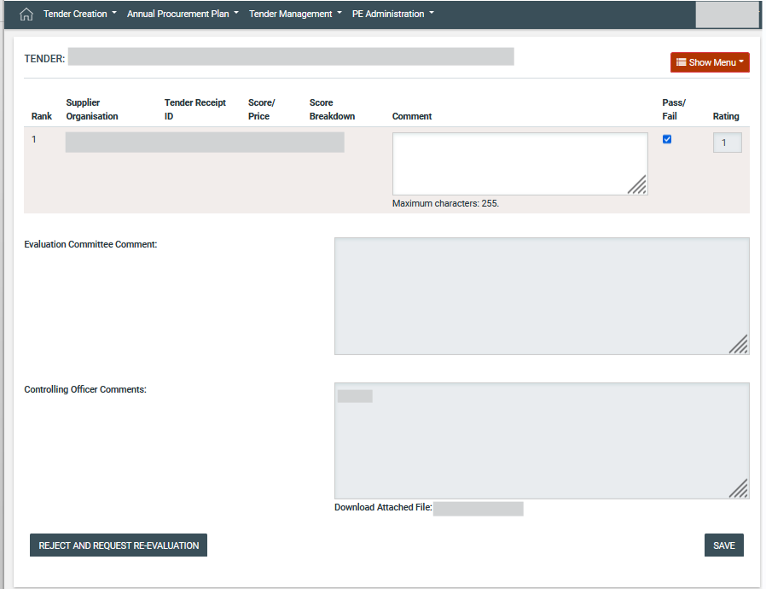

Figure 186: Confirm post-standstill ranking

Upon the user selecting the button a pop-up window is displayed an the user will be able to select the stage (if the tender consist of 2 stages) the envelope (if the tender consist of 2 envelopes) and “revert to state” with the following options

- Tender Opening: upon selecting the aforementioned option the tender will be reverted to bids opening stage and PO/OS users will proceed with bids unlocking again
- Tender Evaluation: upon selecting the aforementioned option the tender will be reverted to bids evaluation stage and evaluators will proceed with bids evaluation again
- Evaluation Report Generation: upon selecting the aforementioned option the tender will be reverted to generate evaluation report stage and PO/ESR will proceed with generation of evaluation report again.

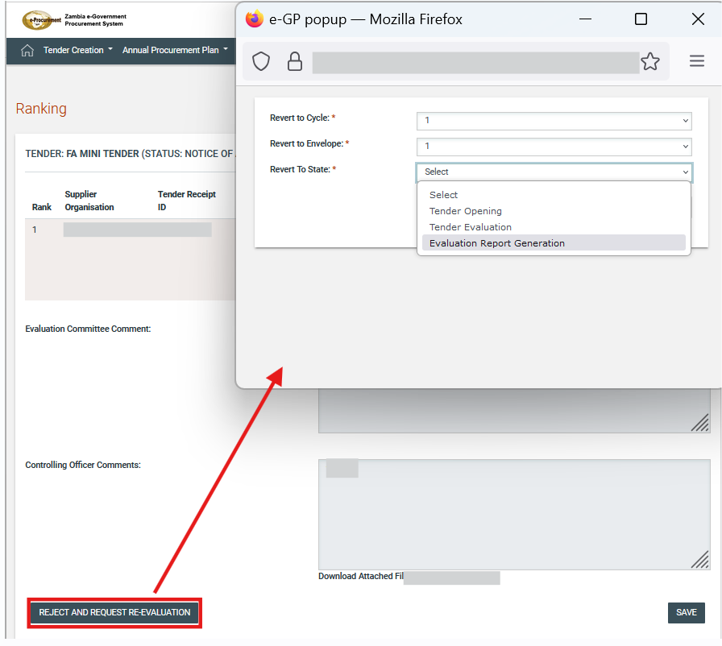

Figure 187 Reject and Request Re- evaluation Options

The user selects the button in order to apply one of the above options.

Figure 188 Apply Options

Postqualification

If the tender was configured to include a postqualification step, the members of the evaluation committee can access the respective page through the “Postqualifications” option in the Tender Menu.

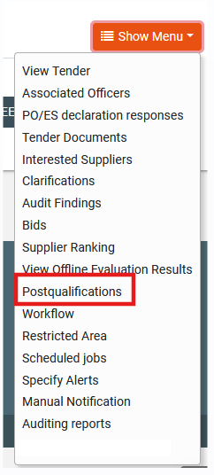
Figure 189: Postqualification menu selection

In the section of postqualifications the system provides the following functionality to the user:
To read all the postqualification responses which have been submitted by Supplier.
To insert postqualiciation requests to the Best evaluated Supplier.
To conclude the postqualifications period.

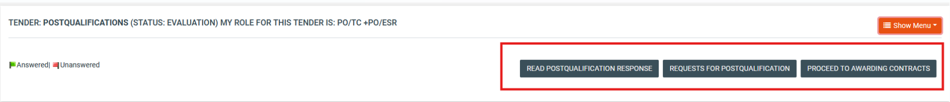
Figure 190: Postqualifications page

A request for postqualification must be compiled to be sent to the winning bidder by completing the form.

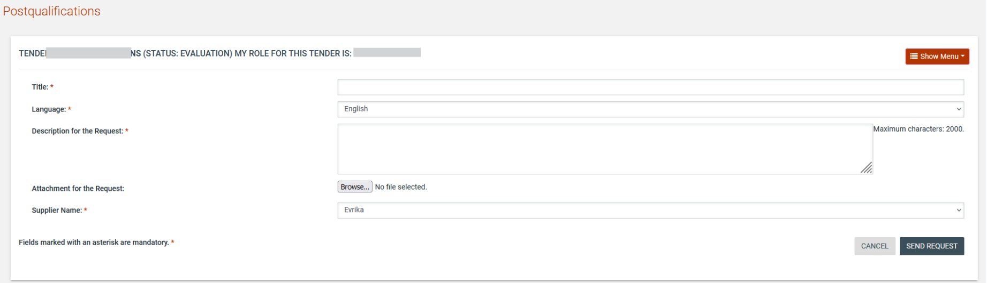
Figure 191: Request for postqualification

Through the respective task or the “Postqualifications” menu item in the tender menu the user may navigate to view the response provided by the supplier.

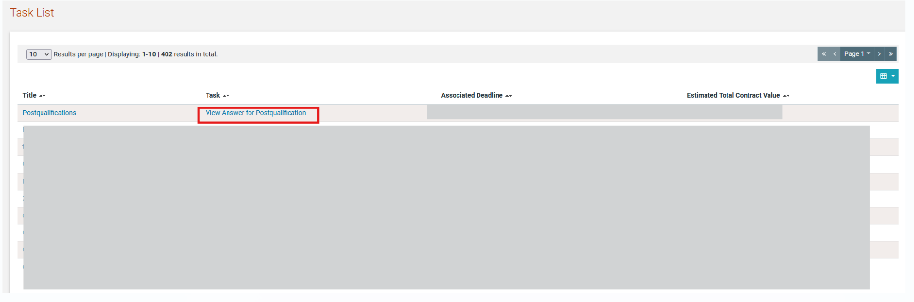

Figure 192 View Answer for Postqualification Task

If the response is acceptable, the user simply presses the “Back” button to acknowledge that they have read the response. If the response is not acceptable, the evaluator can disqualify the Supplier by clicking on the “Disqualify Supplier” button.

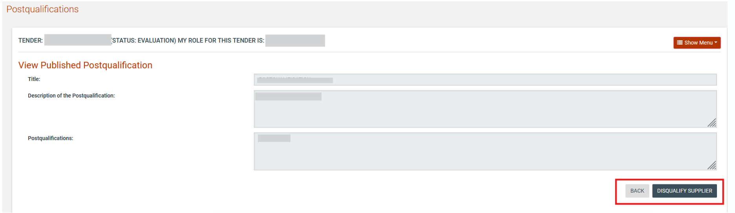
Figure 193: View postqualification response

The PO/ESR user needs to end the postqualification process by clicking on the “Proceed to Awarding Contracts” button. If there are still unanswered postqualification requests in the system, the PO/ESR user is prompted to confirm that these will be discarded before continuing.

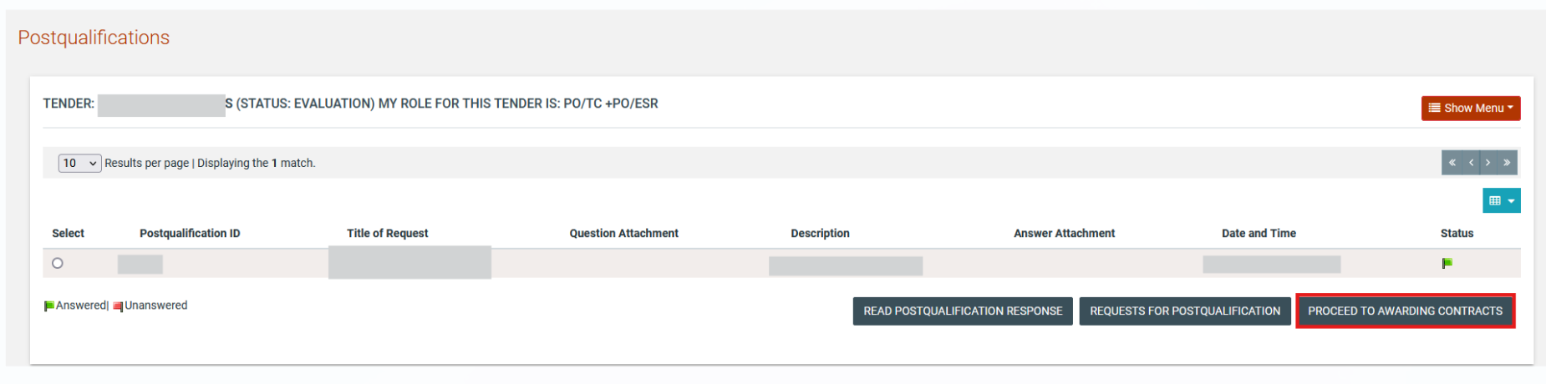
Figure 194: Conclude the postqualification phase

Offline Evaluation Results
When the tender is configured for offline evaluation, the evaluation process takes place outside of the system and only the final evaluation results are captured into the system. The PO/ESR user provides the price or the score for each bid received and indicates whether the bid is approved or rejected. The evaluation report should be attached to maintain the audit information in the system. Once all results are captured, the evaluation can be saved as final.

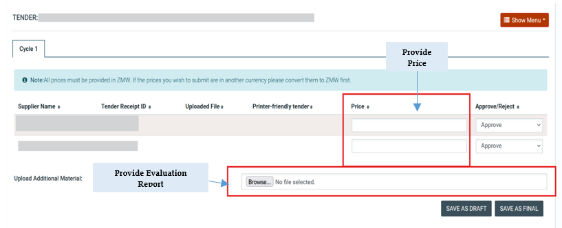
Figure 195: Provide offline evaluation results

The user then provides the supplier comments and rankings before proceeding to the announcement of results.

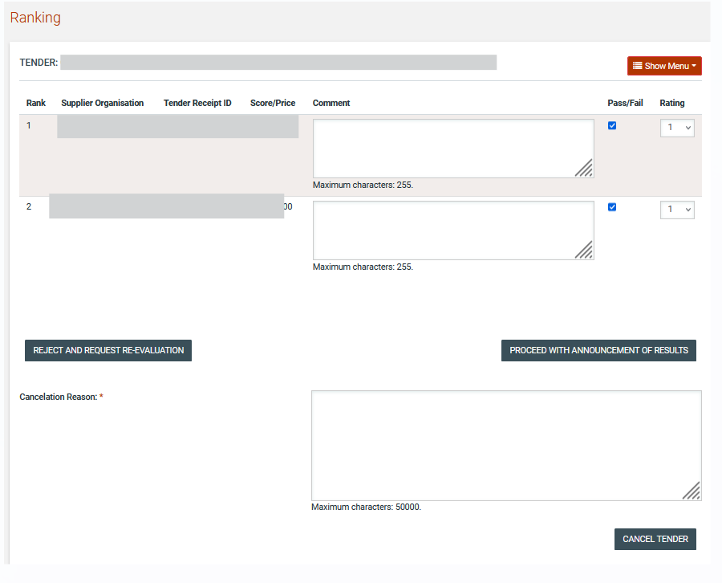
Figure 196: Offline supplier ranking comments

Framework Agreement

In case the tender includes an FA, once the Standstill Period Ranking results are announced, the TC user selects the “Award Contracts’” on order to proceed with the selection on Awarded Suppliers.

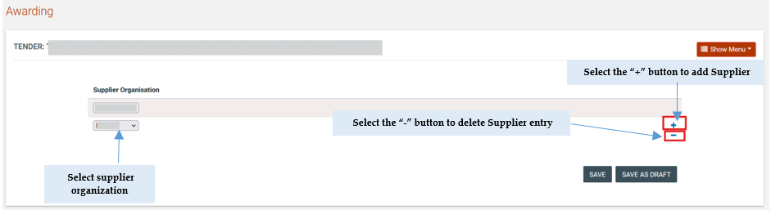

Figure 197 FA – Award Contracts page

Following the selection of awarded suppliers the task “Conclude Framework Agreement “is available to PO/TC user in order to conclude the FA.

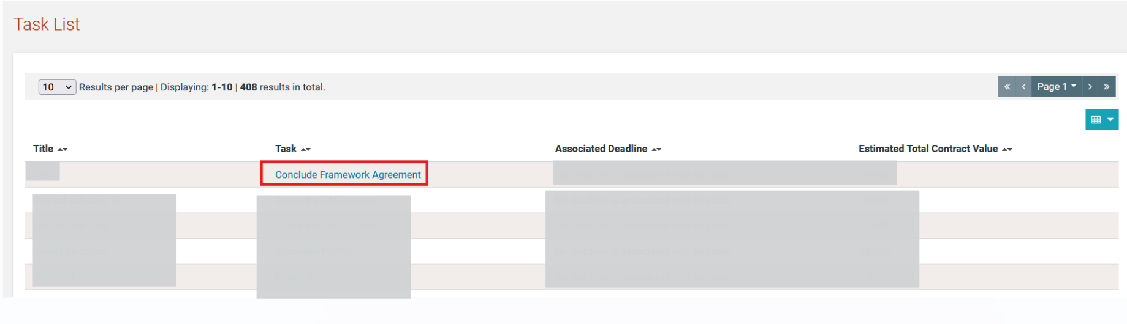
Figure 198 FA- Conclude FA task

The user selects the FA end date and the PE or PEs that will take part on FA

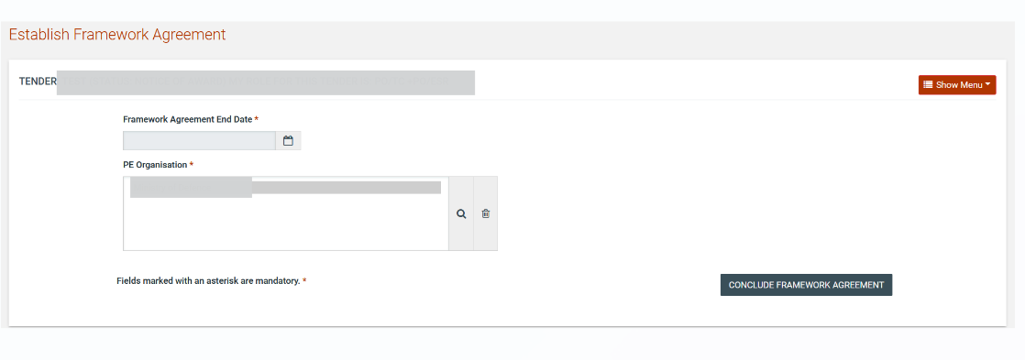
Figure 199 Establish FA Page

The user from PEs that participate the FA can initiate a tender according to FA the user selects the “Mini Tenders” option from tender menu

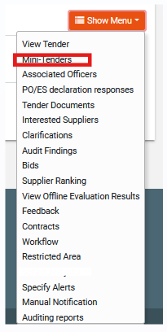
Figure 200 Mini Tenders Option

The user select the  button to initiate a tender

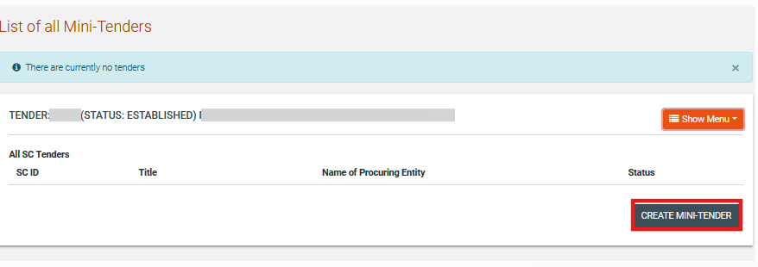

Figure 201 Mini tenders page – Create mini tender option

Contract Awarding

Draft Contract(s)
Once the Evaluation report is approved, the results are announced and the standstill period is over, the PO/TC will proceed to the Awarding phase. Either through the respective task or through the Tender’s details page, the user may navigate to the Awarding page.

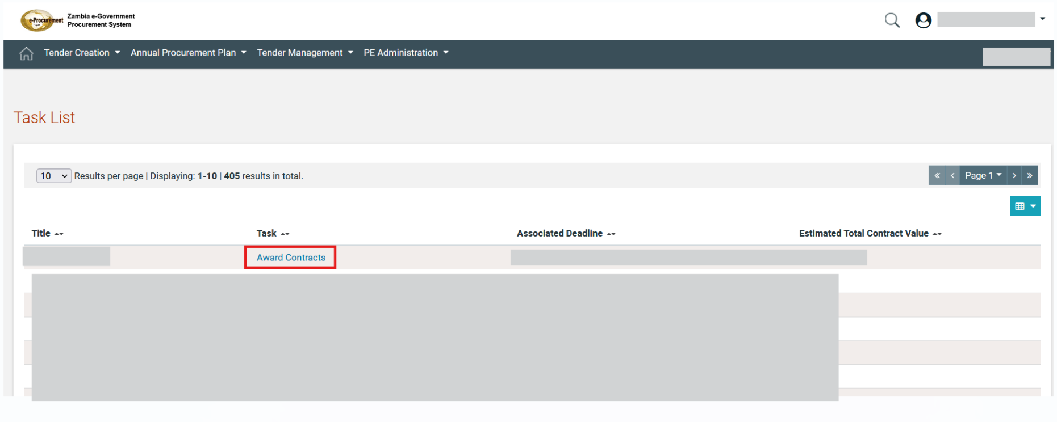
Figure 202: Award contracts task

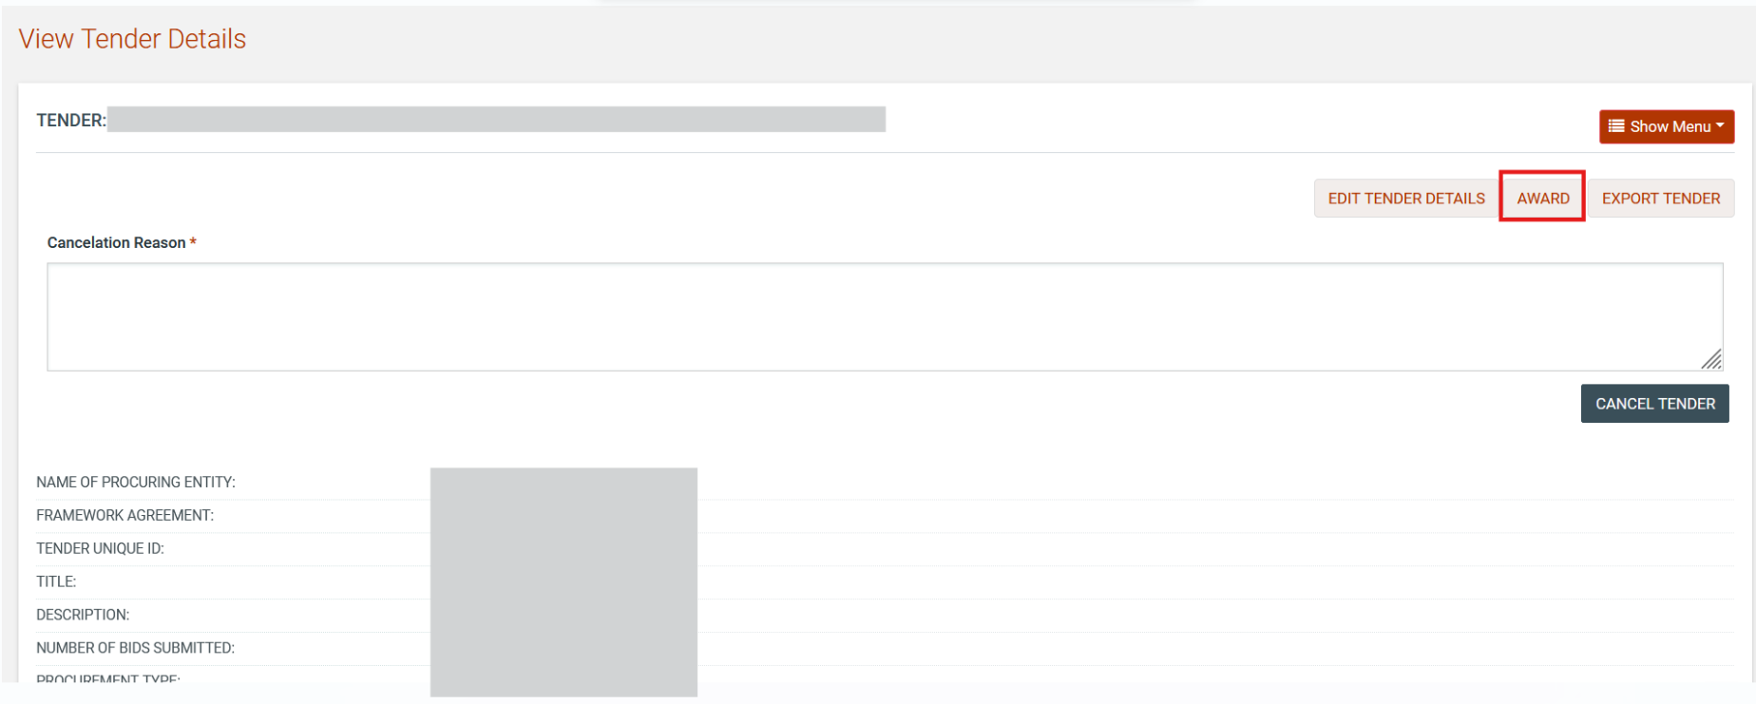
Figure 203: Proceed to awarding (through tender’s details page)

Once in the Awarding page, the user may create draft contract awards for the successful supplier(s) by clicking on the “Add Contract” button.

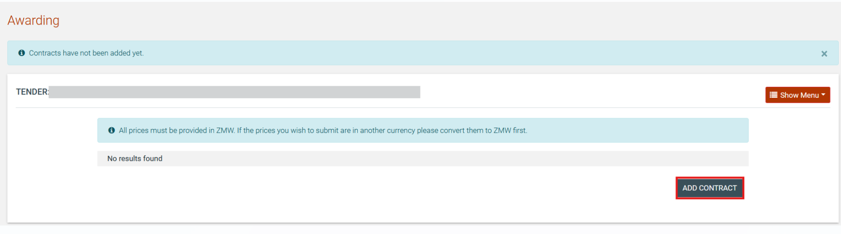
Figure 204: Tender contracts page

The user should select the supplier from the drop-down and the UNSPSC code that relates to the contract award. The contract award value will be automatically populated based on the financial offer of the supplier. If the award amounts needs to be adjusted for whatever reason, the user can click on the “CH” button to provide the amended amount as well as a justification for the adjustment. Additionally, the user must provide a Title and Description. The user creates the draft contract by selecting the  button.

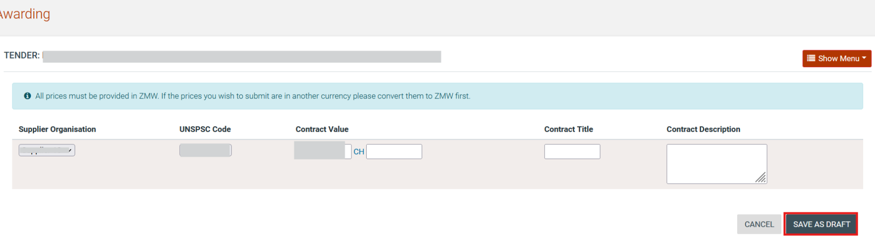
Figure 205: Awarding page

The user is also able to edit or to delete the draft contract.

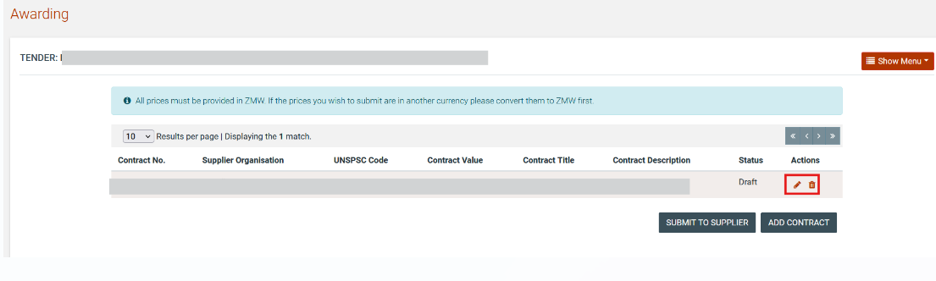

Figure 206 Edit /Delete Draft Contract

Submit to Supplier and Finalise contracts

Upon the draft contract or contracts have been created the  button will be available in order the awarded supplier organisation to approve or reject the contract awarding.

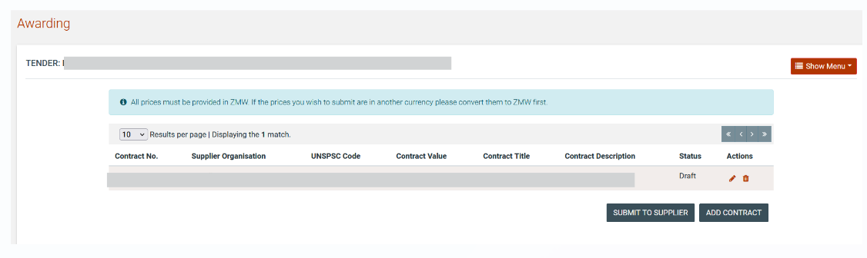

Figure 207 Submit to Supplier Button

The supplier organisation has to provide acceptance or rejection of contract awarding.

In case all contracts or a contract are rejected by suppliers the task "Contract award has been rejected" will be displayed on PO/TC.

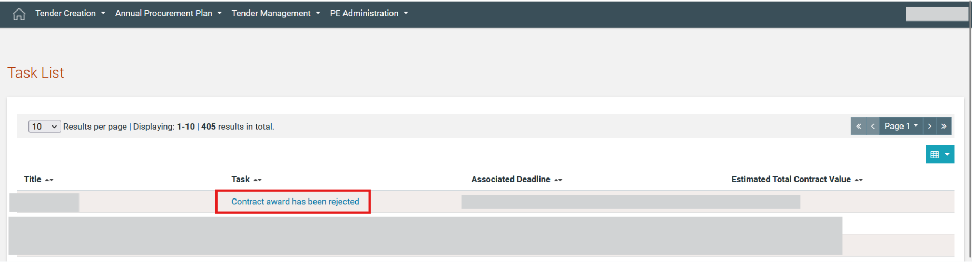

Figure 208 Contract award has been rejected task

Upon the user selecting the aforementioned task the following options (buttons) will be displayed

- Re-award: upon selecting the user the aforementioned option the user can create a new contracts with the remaining suppliers and edit or delete the rejected contract (rejected from supplier).
- Cancel Tender: the tender will proceed to cancellation task (addendum for cancellation task).

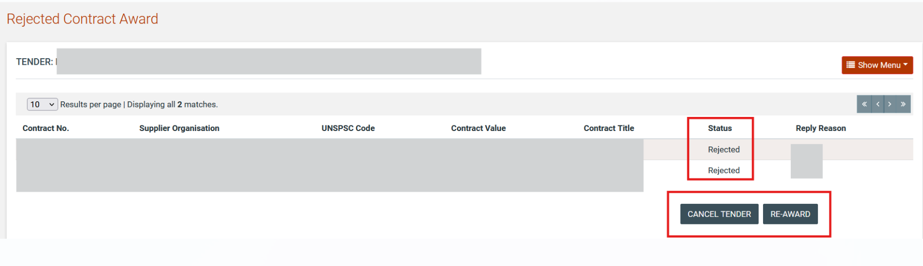

Figure 209 Cancel /Re – award Button

In case of more than one contracts with at least one contract accepted by suppliers the task “Contract award has been rejected" will be displayed on PO/TC. Upon the TC user selects the task "Contract award has been rejected" the following options will be displayed on PO/TC.

- Re-award: upon selecting the user the aforementioned option he/she can create a new contract with the remaining suppliers, edit or delete the rejected contract (rejected from supplier).
- Cancel Tender: the tender will proceed to cancellation task (addendum for cancellation task).
- Proceed Awarding: proceed to publication of CAN or Awarded status according to tender details.

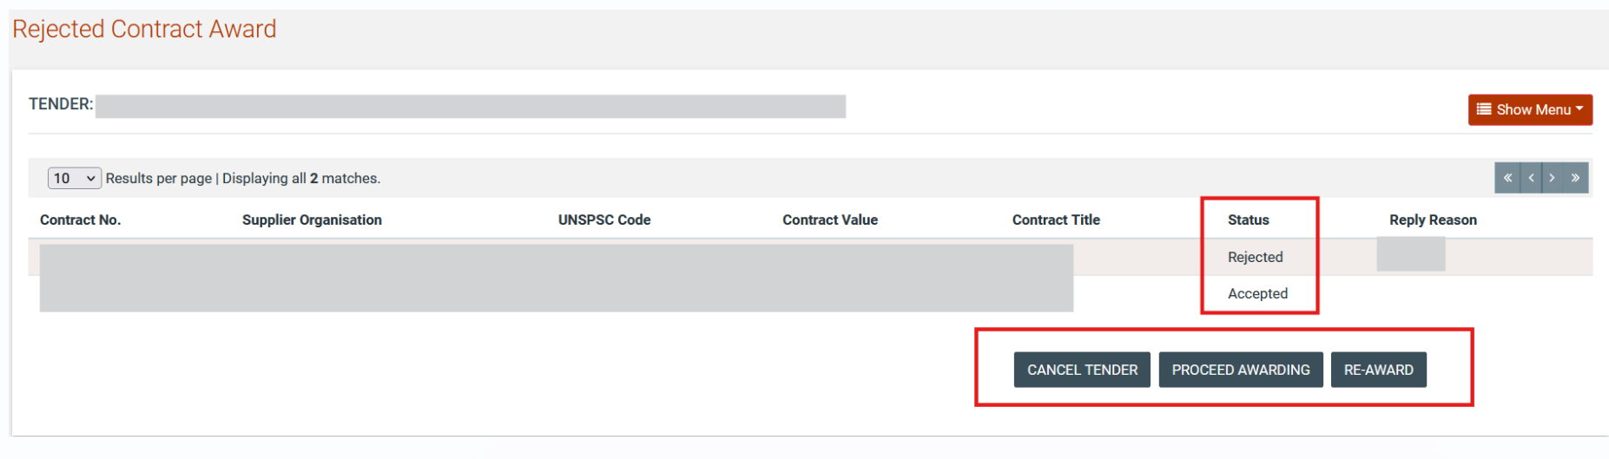

Figure 210 Cancel Tender/ Proceed to Awarding/ Re-award Buttons

In case the supplier organisation accepts the contract awarding the contract will be finalised.

Contract Award Notice Publication
The PO/TC user can proceed to the creation and publication of the Contract Award Notice by selecting the “Publish Contract Award Notice” that is available on PO/TC task list.

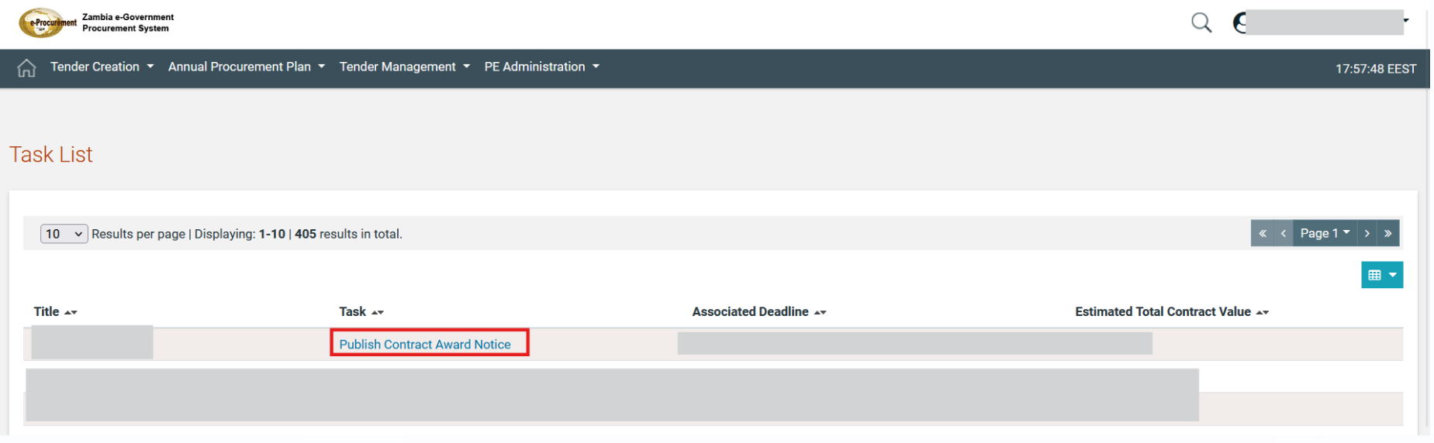

Figure 211 Publish Contract Award Notice Task

The user will navigate to the notices tab through the can also “Tender Documents” option in the Tender Menu.

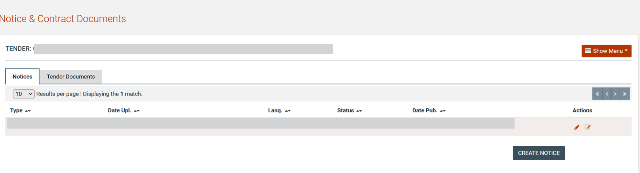

Figure 212: Create Contact Award Notice

The user selects the  in order to have access on Notice form.

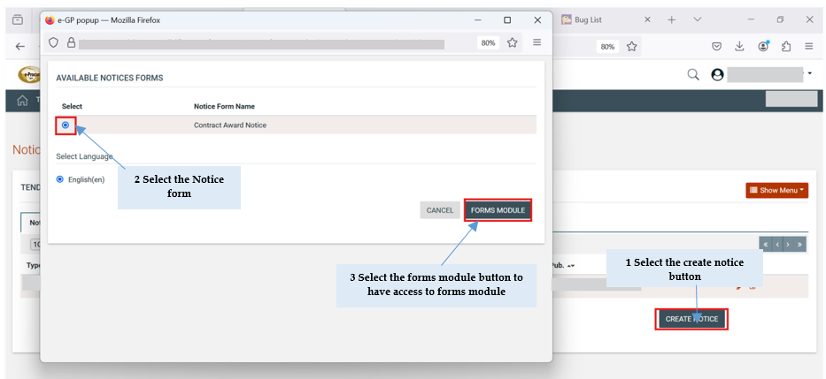

Figure 213 Steps to Access Notice

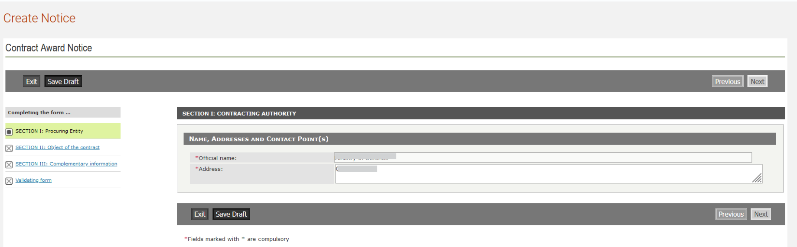

Figure 214: Form filling tool / notice details

After all the details are populated, the user may save the notice as “Draft” or “Final”. Any notice saved in “Final” status is available for publication.

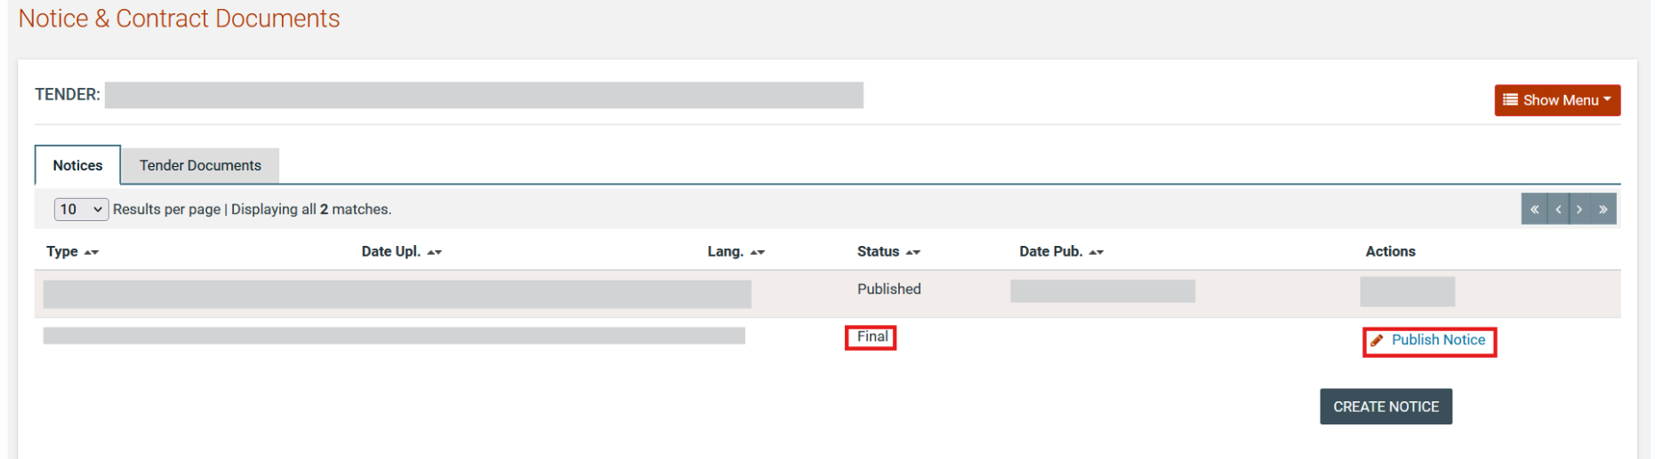

Figure 215: Contract award notice publication

Contract Management Functionality

Following the completions of contract awarding the task “Create Contracts” will be available in order the PO/TC to prepare the contract workspace.

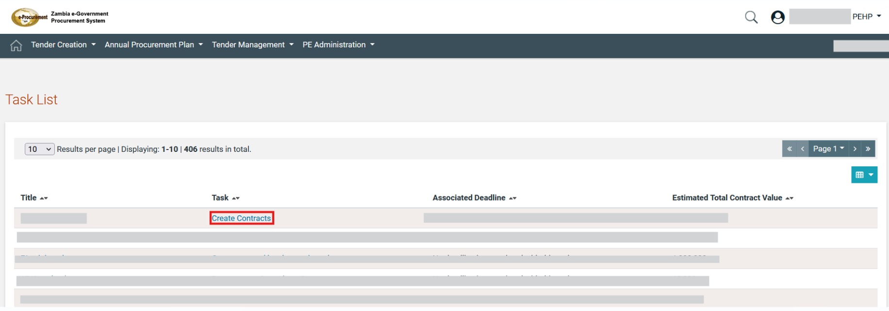

Figure 216 Create Contracts task

Upon the user selecting the aforementioned task the awarding page is available containing the outcome during the awarding stage. The “Create contract” will be available to awarding that accepted by supplier and finalized. Also the awarding that rejected will be displayed.

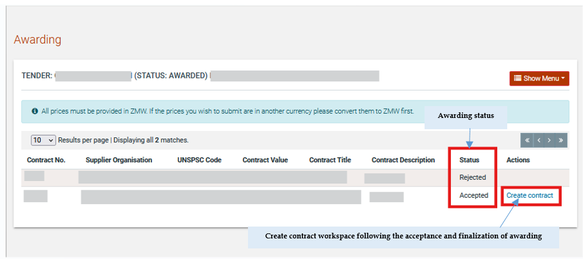

Figure 217 Create Contract link

Upon the user selecting the create contract link all available fields of the contract are displayed in order to be populated. In order the user to save the contract as draft selects the  button. Additionally the status is “Awaiting Finalization” meaning that the contract has been finalized (is draft).

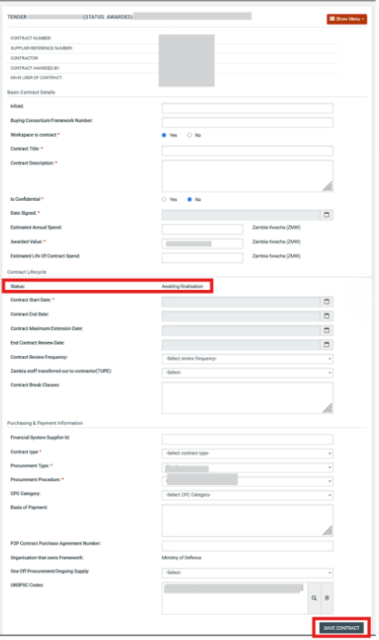

Figure 218 Create Contract workspace

The user populates the fields and selects the option. The following message is displayed that the draft contract has been saved successfully.

The  ,  and  buttons are available

Button: the user will be able to finalise the contract
Button: the user will be able to delete the draft contract
Button: the user will be able to edit the draft contract

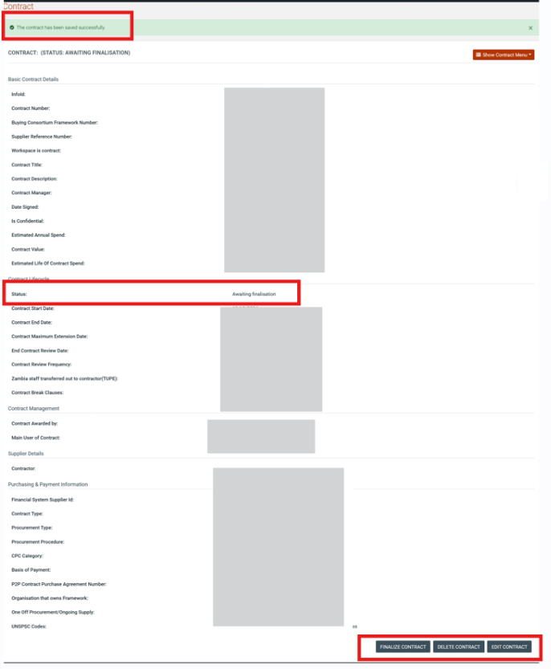

Figure 219 Save Contract as draft

Edit Draft Contract

The status of contract is “Awaiting Finalization” meaning that the contract is draft and all available details can be edited. The use selects the button.

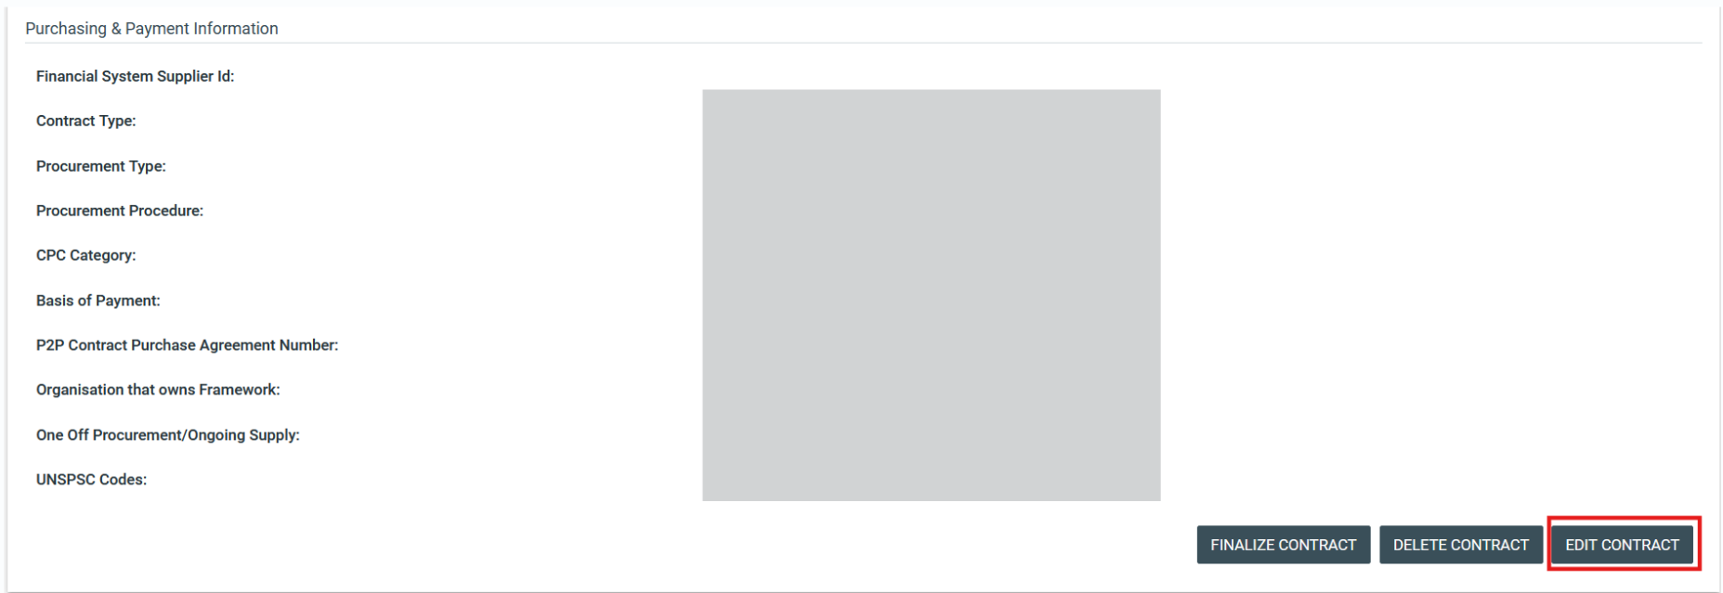

Figure 220 Edit Contract button

The user make all the necessary modifications on draft contract and selects the  button.

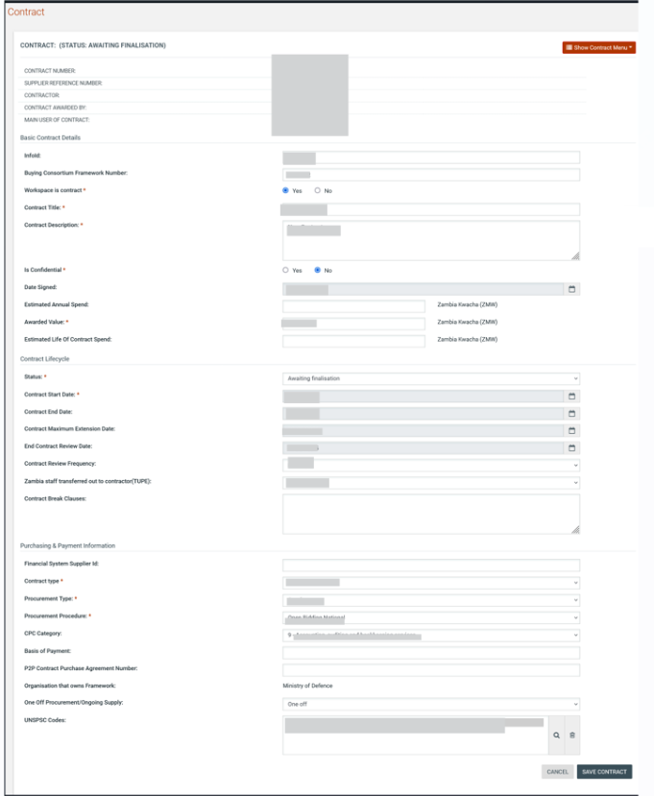

Figure 221 Edit Contract Page

Upon selecting the aforementioned button the following message is displayed

The user will also able to edit a draft contract from “My contracts” under the “PE Administration” drop-down menu.

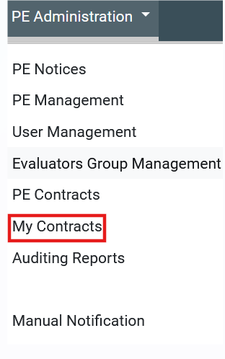

Figure 222 My Contracts Option

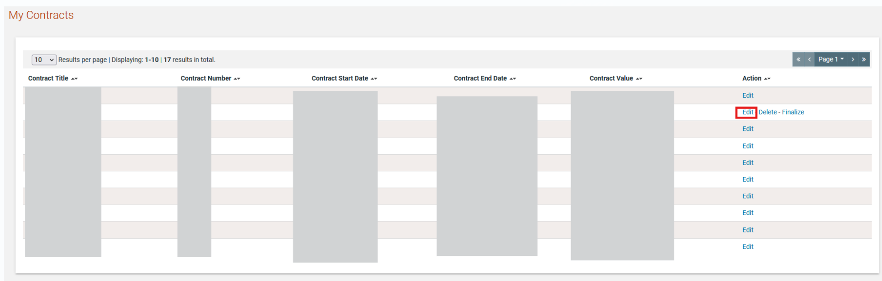

Figure 223 My contracts Page

Delete Draft Contracts

The user will be able to delete a contract from “My contracts” under the “PE Administration” drop-down menu.

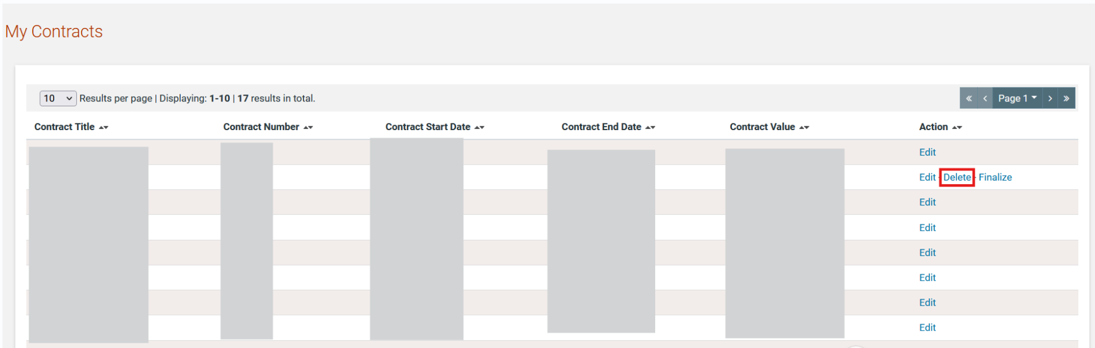

Figure 224 Delete Contract Option

Finalise Contract

The user will be able to finalise a contract from “My contracts” under the “PE Administration” drop-down menu.

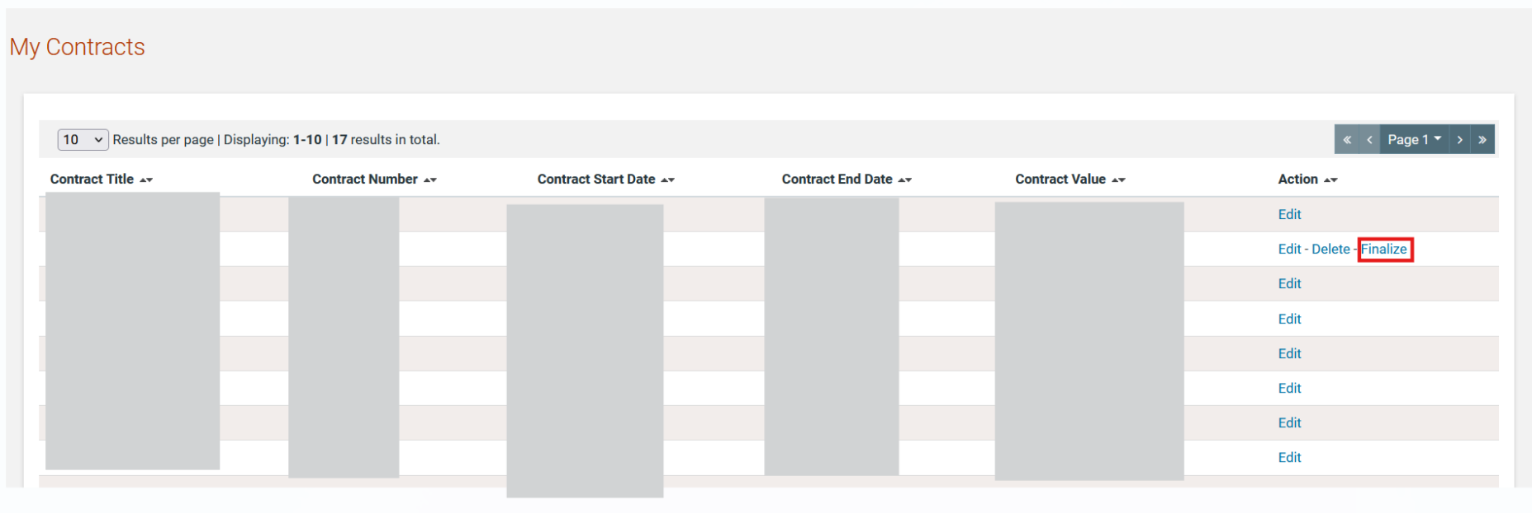

Figure 225 Finalize Contracts Option

Upon selecting the “Finalise” option a message containing the question “You are about to finalise your contract. Please click OK to proceed, otherwise please click Cancel” with “Ok” and “Cancel” button are displayed.

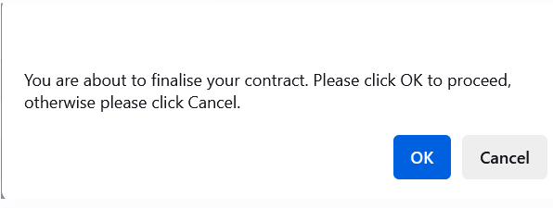

The user selects the  in order to proceed with finalisation of contract. The following confirmation message is displayed

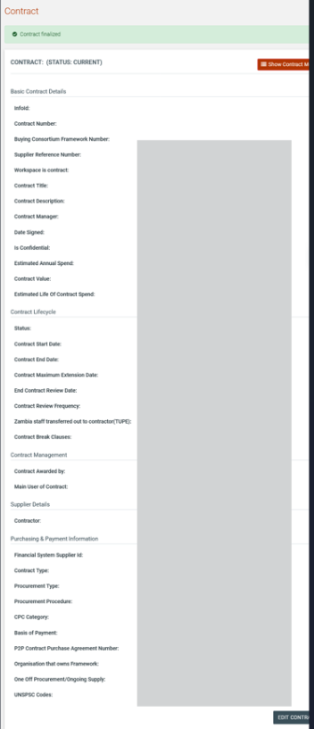

Figure 226 Finalized Contract

Edit Finalised Contract

The user can edit specific field of contract following finalisation (i.e. Status). Only the “edit” option is available for each finalised contract. The user will be able to edit a finalised contract from “My contracts” under the “PE Administration” drop-down menu.

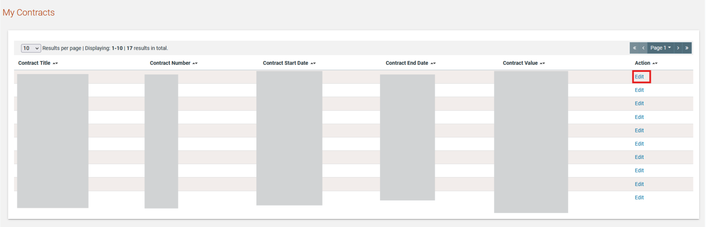

Figure 227 Edit Finalized Contract

The user edits the available fields and selects the  button.
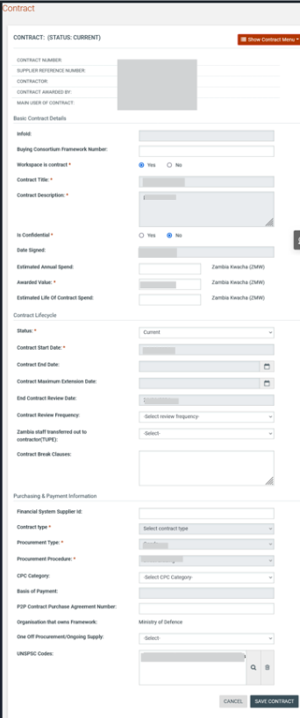

Figure 228 Edit finalized Contract Page

View PE contracts

The user can view the contracts available by PE by selecting the option “PE Contract” under the “PE Administration” drop-down menu.

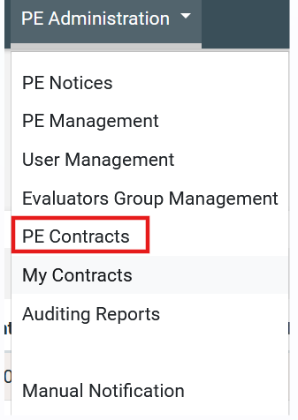

Figure 229 PE Contracts Option

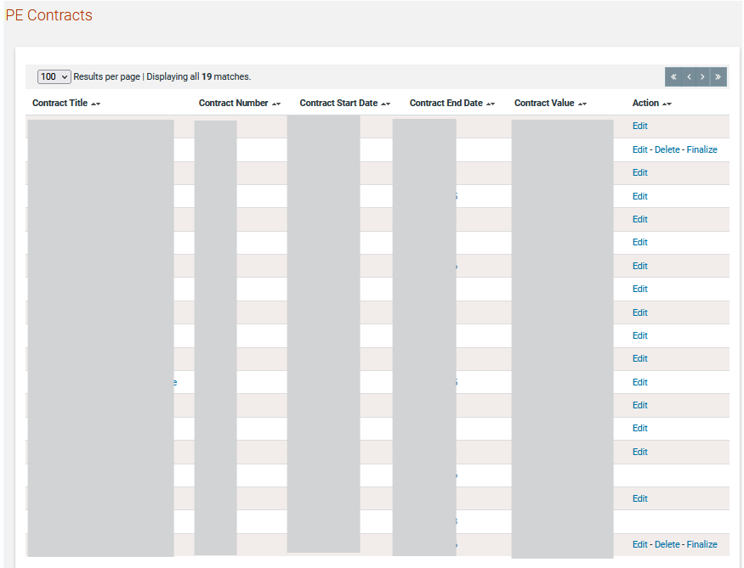

Figure 230 PE contracts Page

Show Contract Menu

The user will be able to view the available option on “Contract menu” by selecting the “Contract Title” links for a specific contract on “PE Contracts” or “My Contracts” menu.

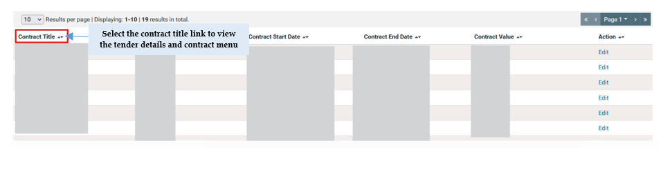
Figure 231 Contract Title Links

The following options are displayed on show menu

- Contract information: the user has access to contract workspace page
- Associated Contract Managers: user can associate/disassociate contract managers and contract users
- Contract Documents: user can manage the contract documents for the specific contract
- Restricted Area: user can view or upload a general document

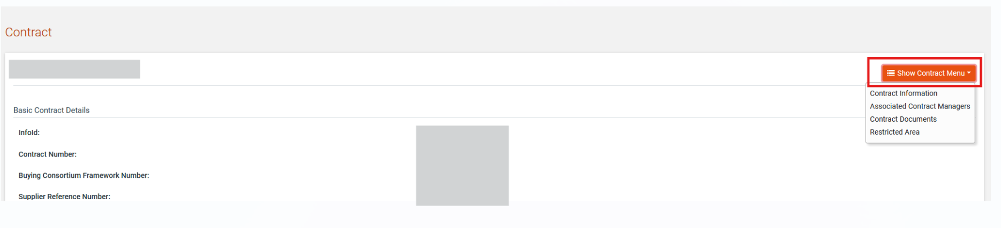

Associated Contract Managers and Users

PO/TC can associate/dissasociate contract manager and Contract user (Contract users are able to view details of contract)

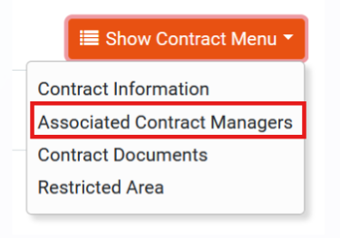

Figure 232 Associated contract managers option

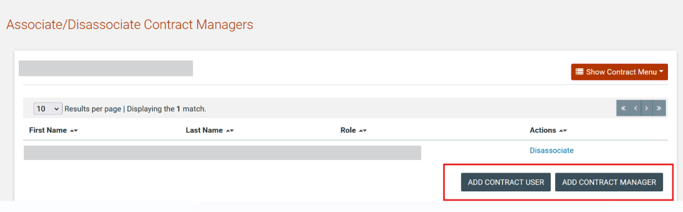

Figure 233 Associate Users

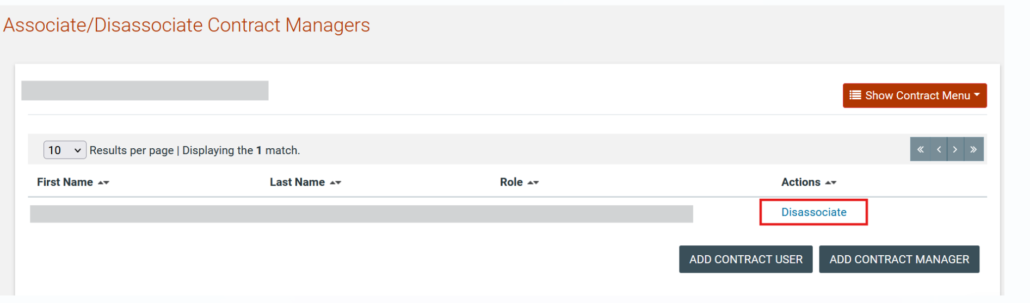

Figure 234 Disassociate Users

Manage Contract Documents

PO/TC (or Contract manager) will be able to manage the contract documents by accessing the “Contract Documents” Page.

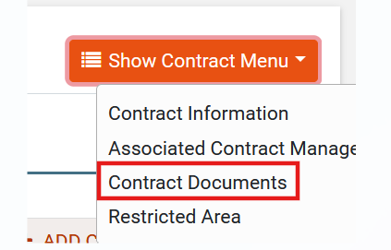

Figure 235 Contract Documents Option

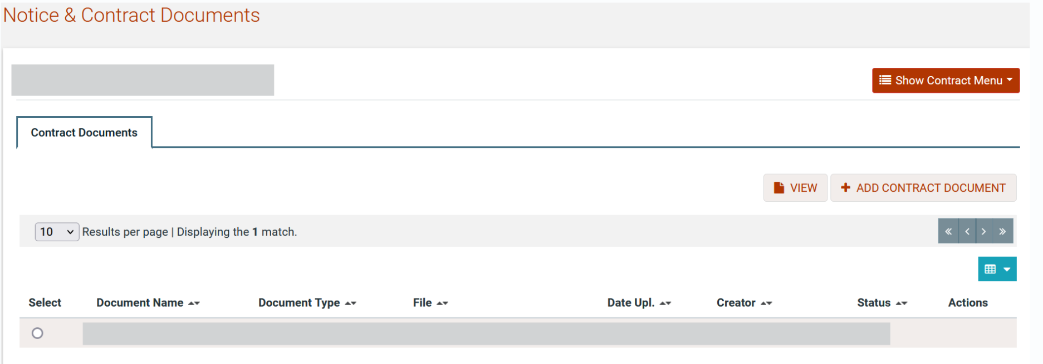

Figure 236 Contract Documents Page

Add Contract Document

User is able to add a new document by selecting the button.

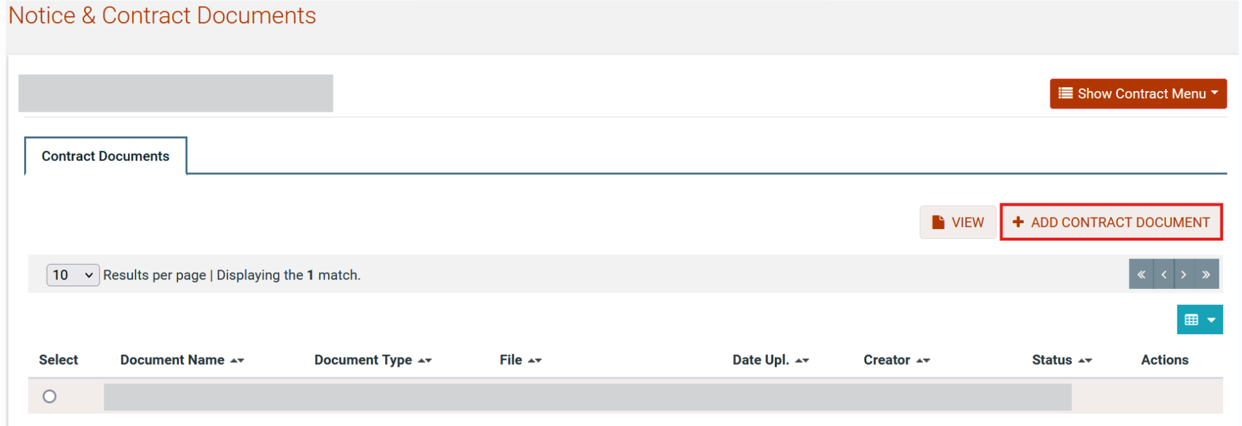

Figure 237 Add Contract Document Option

The user populates the available fields select to save the document as draft or as final and the option  in order to add the document.

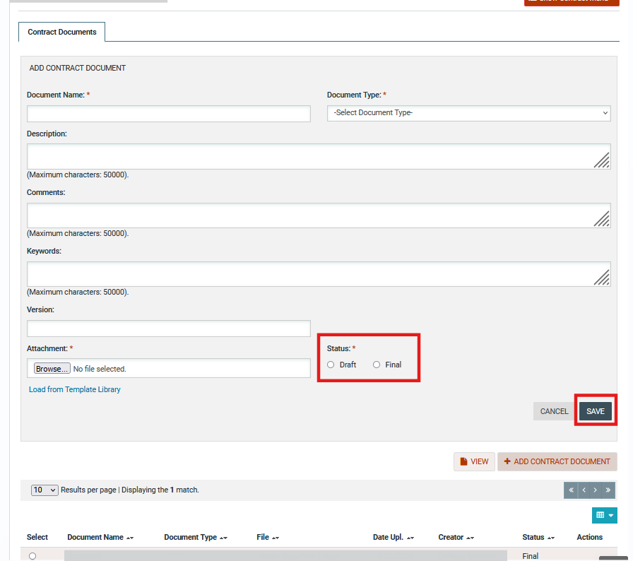

Figure 238 Add Contract Document

Edit Contract Document

The user selects the edit option in order to change the information for a specific document. Only documents on draft status can be edited.

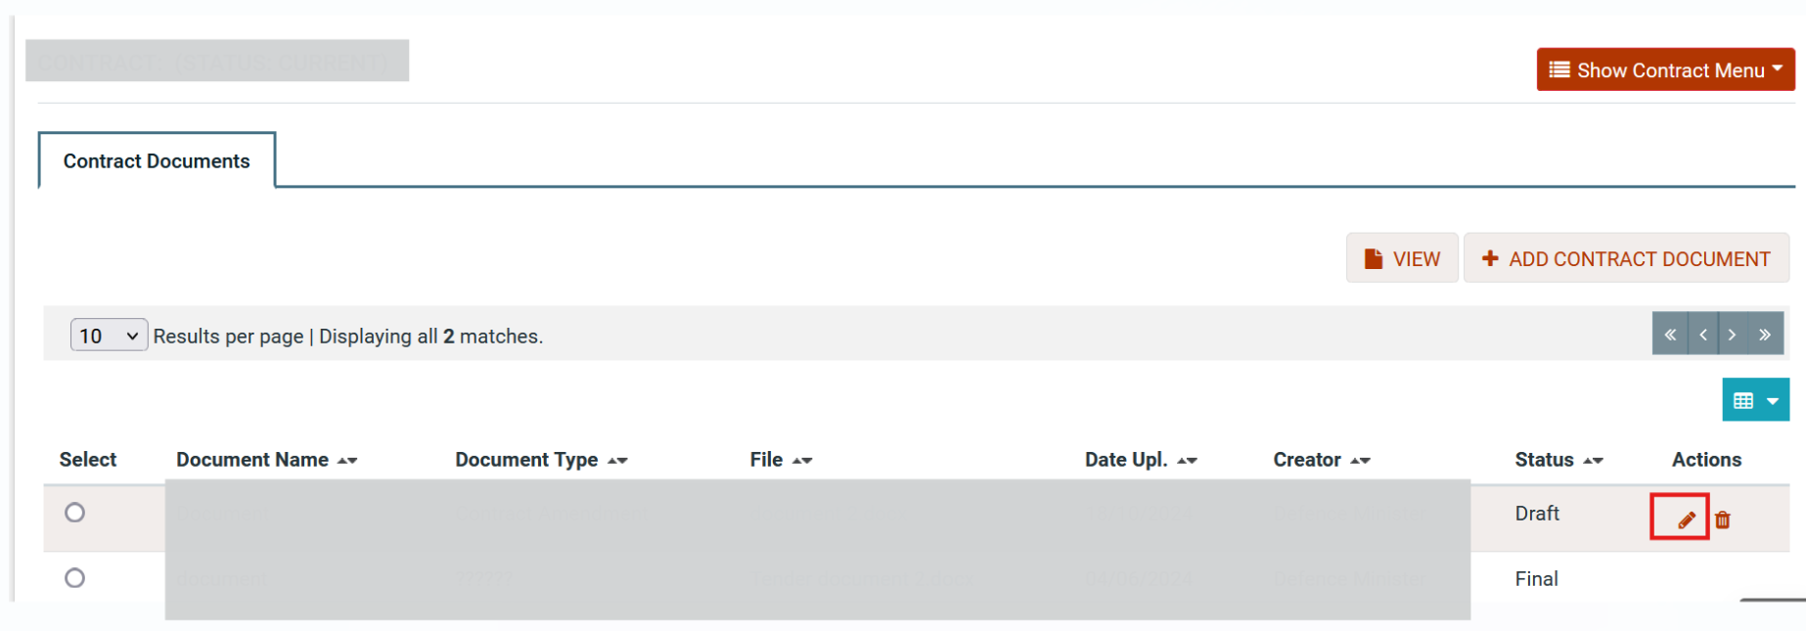

Figure 239 Edit Document Option

Delete Contract Document

The user selects the delete option in order to delete a specific document. Only documents on draft status can be deleted.

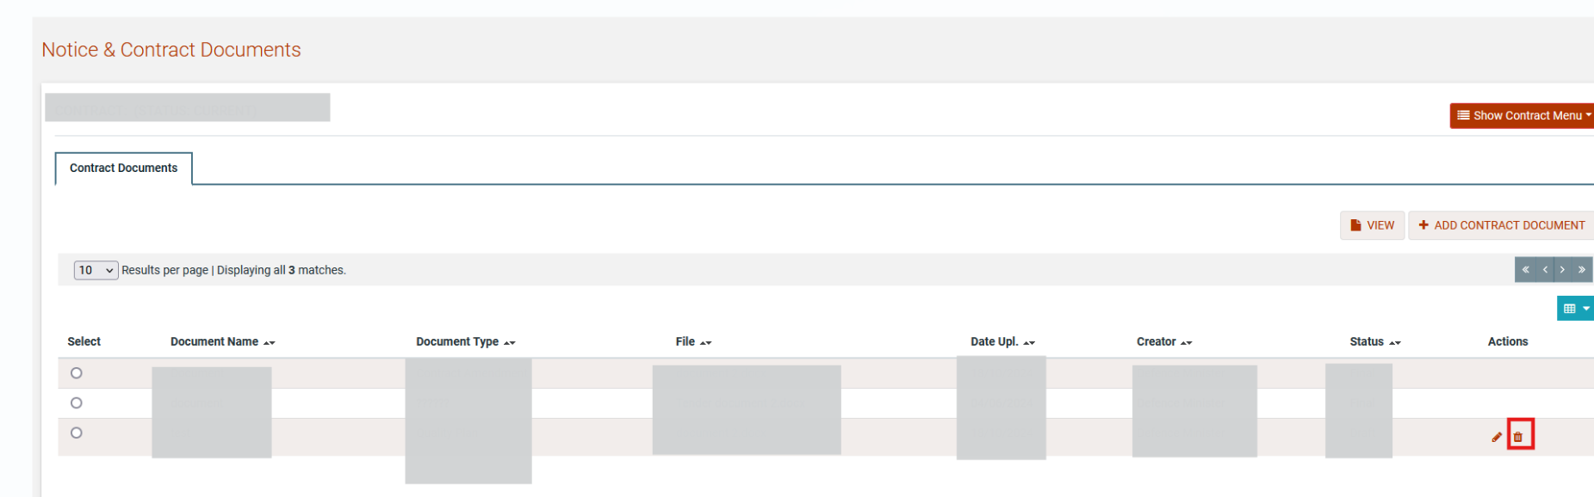

Figure 240 Delete Contract Document Option

View Contract Document

The user is able to view the details for a specific document. The user selects a document using the ratio button and the selecting the  button.

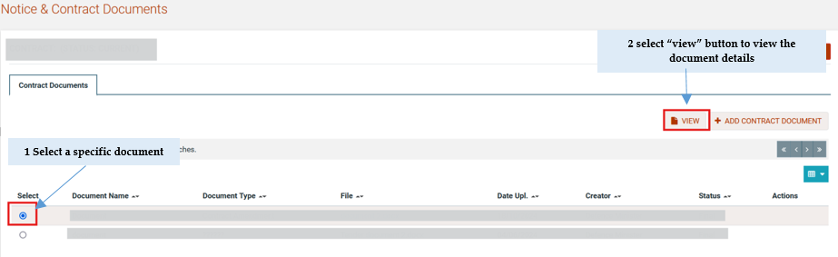

Figure 241 View document option

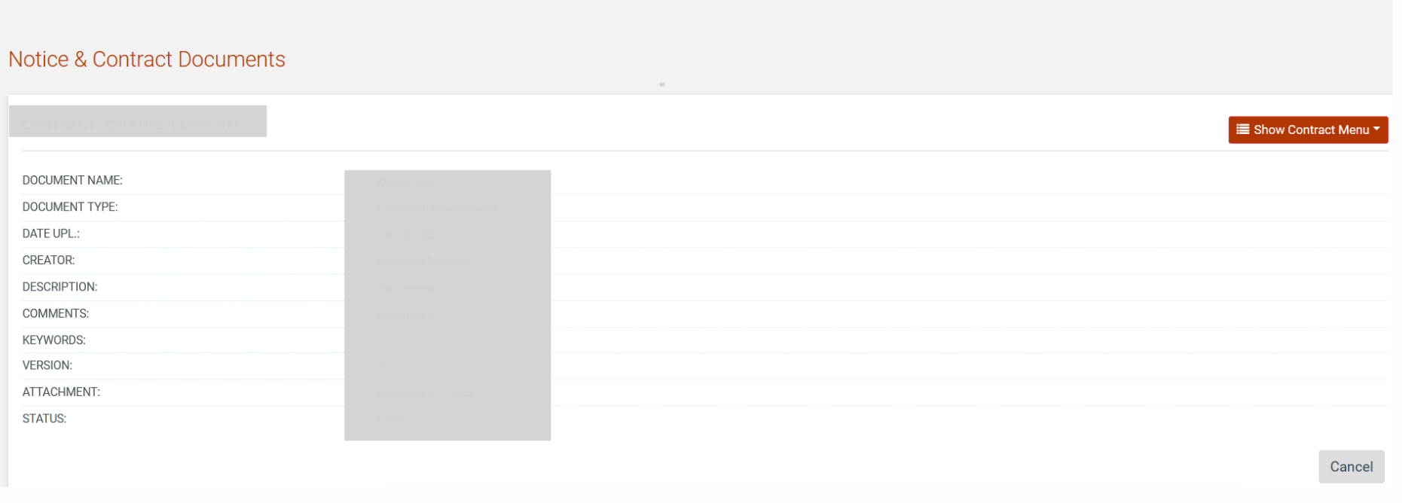

Figure 242 View Document details page

Search Contract

The users of PE haves also the option to search for contract using the the user can find the aforementioned option by selecting  button on the right and up side of the page. The user selects the “contracts” and provide a specific criteria such as Contact title. The results are displayed on tabular form

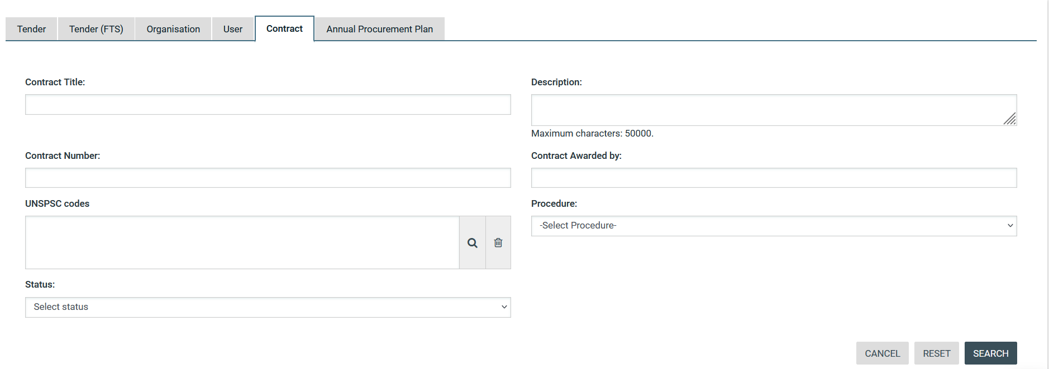

Figure 243 Contract Search

Helpdesk contact details
To contact the e-GP helpdesk the user may visit the “Contact Us” link.

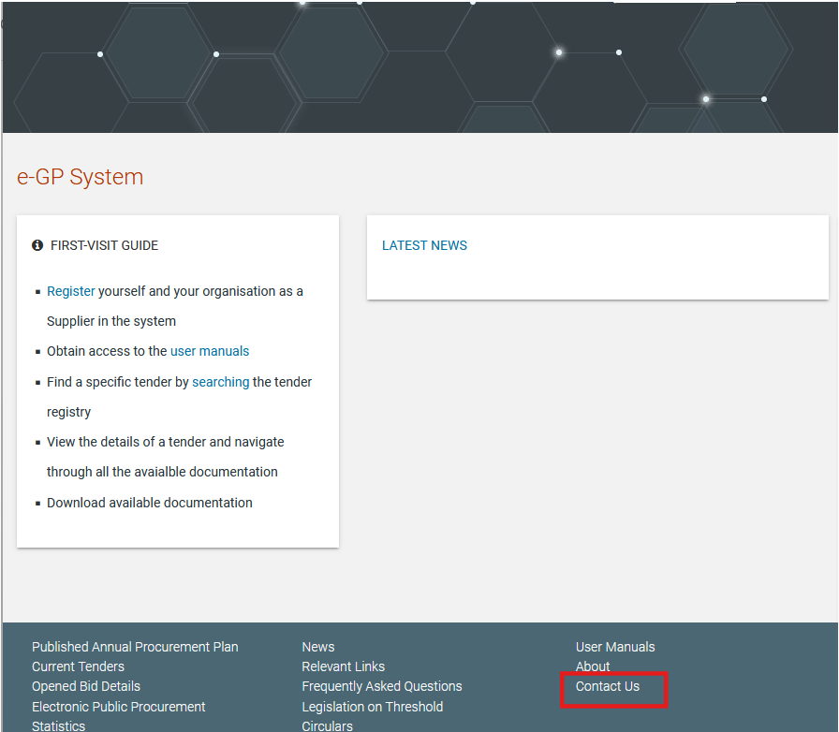

Figure 244: Contact us link

The user may either select to fill in an online form and send it through the system, or directly contact the helpdesk team via phone or email.

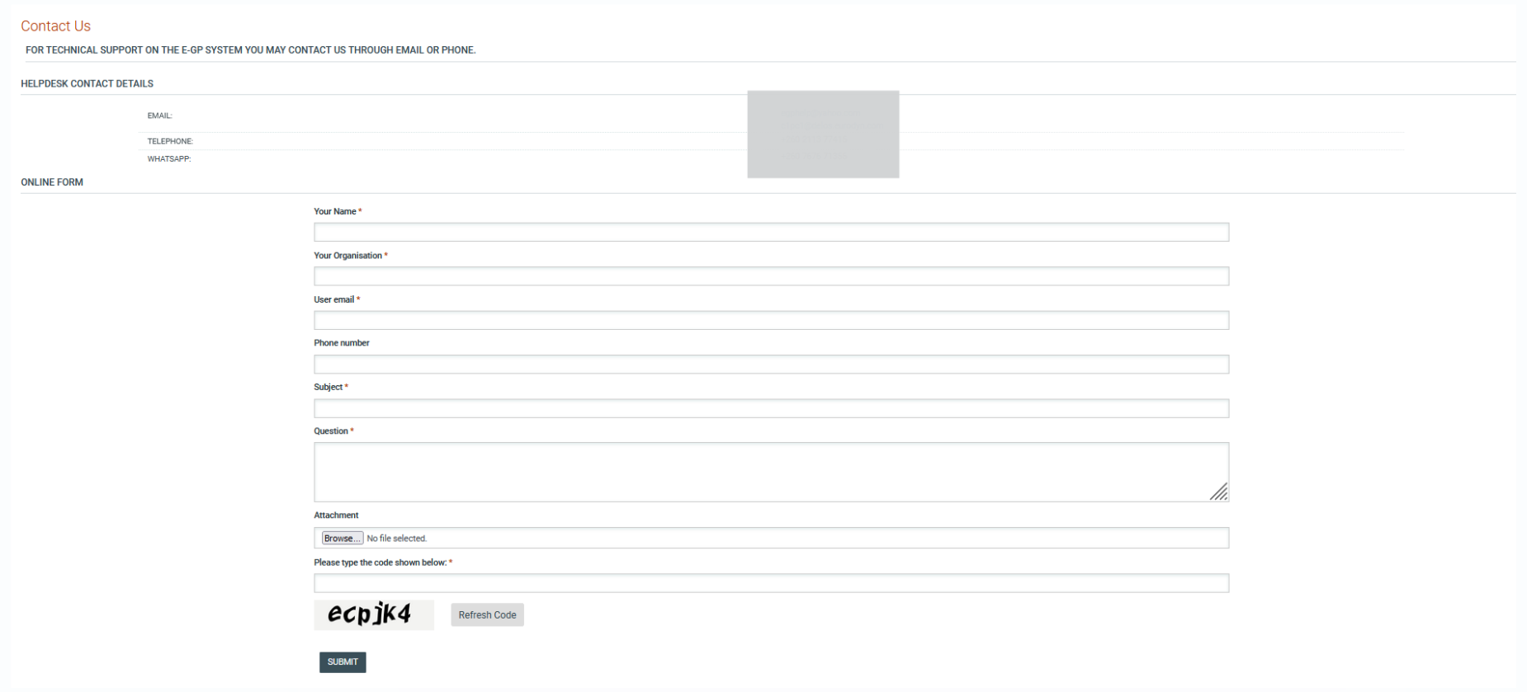
Figure 245: Contact us form

Live Chat
The System supports live chat with agents that will assist the User with their questions and needs. The user must click on the chat icon at the bottom right corner. The chat window can be accessed by pressing the Chat icon, which will trigger a pop-up window. This functionality operates in two modes depending on agent availability:
- Agent Online:
  - If an agent is available, the chat window will allow the user to input their name and email address.
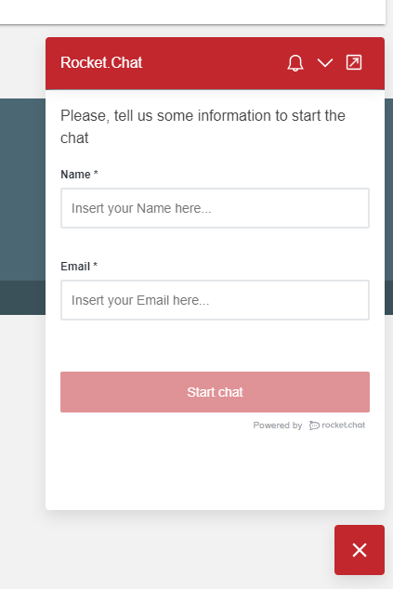

Figure 246: Starting chat when an agent is online

  - Once the details are submitted, the user presses the “Start chat” button and can immediately start a live conversation with the support agent.
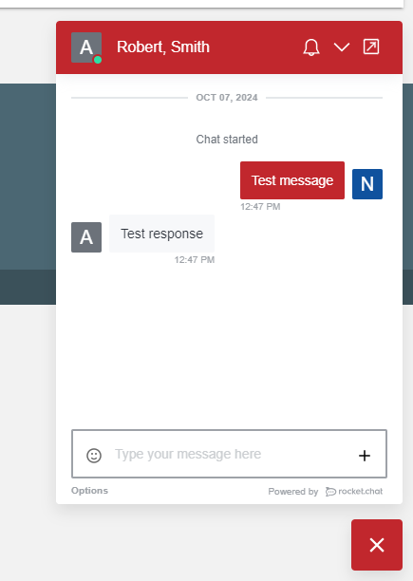

Figure 247: Chat when an agent is Online

- Agent Offline:
  - If no agent is available, the user will be prompted to provide their name, email address, and a message describing their issue.
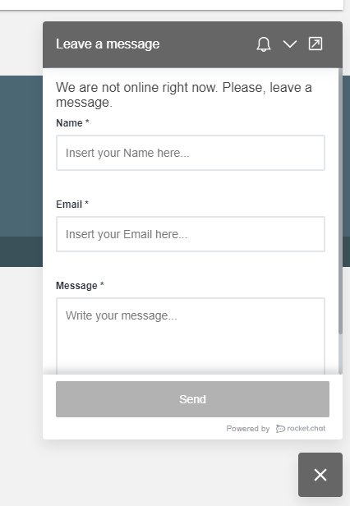

Figure 248: Starting chat when no agent is available

  - Once submitted, the message will be queued, and the agent's response will be sent directly to the user’s email once they become available.

This two-way communication ensures that users can always get in touch with the support team, even outside of live chat hours. For any urgent concerns, please allow some time for responses when agents are offline.

